**Teamcenter using the Citrix Server**

If you are doing this from off-site you will need to use Cisco Anyconnect to make a Fermi connection first.

In order to run Teamcenter using the Citrix Apps you will need to open <https://tcxen.fnal.gov> .

Enter your Fermi Domain Username and Password and select Log On.

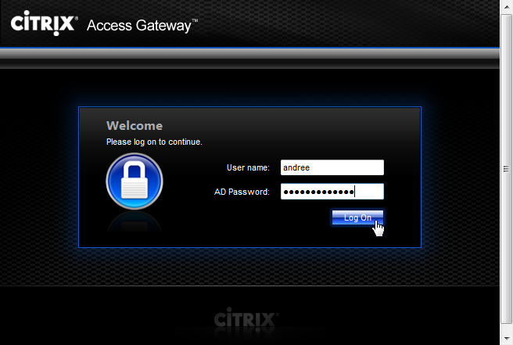

At various time you might see the Windows Logon screen, Select OK.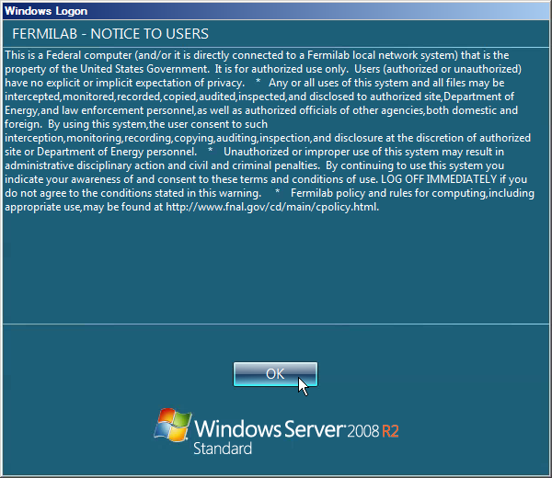

Once logged in select Apps for the published Applications.



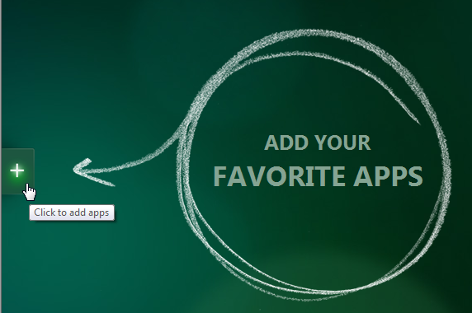

Click on the All Apps menu. 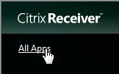

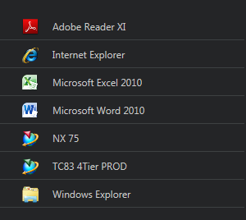

This is an example of what you might see for your current list of Apps available;

Now you can put other Apps on your Desktop. For example;

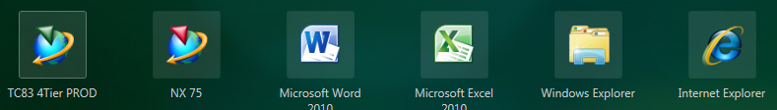

Once you click on any of those Apps the Citrix App Server runs them in your environment. If you have two Word’s open and you want to know which is the one being run from the Citrix App Server, hover over the Word icon and the one that says \\Remote is running from the Citrix App Server. 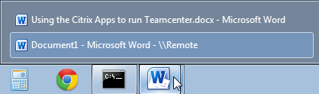

When you are finished running the apps, please log off so that others can use them.

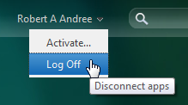

The first time you start Teamcenter it will open the Internet Explorer and prompt you to login. Remember this is your Service Username and Password.

If it pops up a Warning – Security window, click the Always trust… and Run

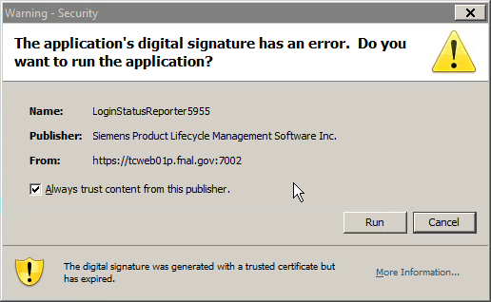

Also Enable the Java Plug-in add-on if it shows up.

