Suppressing the Electron Cloud Using a Solenoid

Sarah Pfluger

Fermi National Accelerator Laboratory

Summer 2011

Abstract: With the planned Project X upgrade at Fermi National Accelerator Laboratory, the potential issues of the electron cloud’s effect on the proton beam are more pertinent to investigate. It is also important to research ways to minimize those effects. A solenoid wrapped around the beam pipe can keep the electrons near the beam pipe, which theoretically not only decreases secondary electron yield, but also limits the effects that the electron cloud can have on the proton beam. A three-axis Hall probe was used to measure the magnetic field inside a 1 meter beam tube sample with a solenoid that was approximately 0.3 m long wrapped around it. Data was taken at 1, 2, and 5 amps. The results matched the expected results, so the concept of a solenoid as a solution to the electron cloud problem is valid. The next step will be to test a solenoid in the beam line.

Introduction

As Fermilab prepares to implement the Project X upgrade to higher intensity proton beams, the physicists work to predict potential issues that will arise with the upgrade. One such predicted issue is the build up of a cloud of electrons in the beam pipe. Currently a cloud of electrons does form in the pipe, but it does not buildup to such a level that it affects the beam or the detectors measuring various qualities and dimensions of the beam. However, with a higher intensity beam, it is expected that the electron cloud will become a problem. The interaction is displayed in Figure 1.

e-

p+

e-

e-

e-

e-

Figure 1 depicts the reaction of the electrons in the beam pipe with the proton beam bunches and the beam pipe wall.

The electron is attracted to the proton beam. As the bunch passes the electron passes through the center of the pipe then collides into the wall of the beam pipe. At the surface of the beam pipe an interaction occurs which sometimes produces more electrons than the number incident on the beam pipe. The difference between the number of incident electrons and the resultant number is the secondary electron yield (SEY). The more this occurs the larger the buildup of electrons into a cloud.

It was proposed that the magnetic field created by wrapping a solenoid around the pipe might be able to contain the electrons and possibly extinguish the electron cloud. The interaction would proceed as depicted in Figure 2.

p+

**B**

I

e-

Figure 2 exhibits a pictorial representation of the solenoid solution to the electron cloud issue. A solenoid with a counter clockwise current will create a magnetic field inside of the pipe pointing out of the page. This magnetic field will curve the trajectory of the electron back into the pipe.

The electron’s path is bent into the beam pipe wall by the magnetic field thus minimizing the effects of the proton beam on the electron. Thus the electrons are kept to the edges of the beam pipe. As the electron also has less energy when it hits the wall, there is minimal likelihood of secondary electron yield.

The magnetic field at the center of a solenoid is given by the following equation

,

where *B* is the magnitude of the magnetic field in teslas, is the permeability of free space, *I* is the current in the solenoid in amps, *N* is the number of turns in the solenoid, and *L* is the length of the solenoid in meters. For a 32 cm long solenoid with 92 turns and a current of 5 amps, the magnetic field is about 0.001806 T or 18.06 Gauss. The radius of an electron of various energies in this magnetic field can be determined using the following equations

 and 

where *m* is the mass of the electron in kilograms, *v* is the speed of the particle in meters per second, *q* is the charge of the electron in coulombs, *B* is the magnitude of the magnetic field in teslas, and *r* is the radius of the electron’s path in the magnetic field.

The magnetic field above will cause a 10 eV electron to have a path of radius 5.9 mm and a 1000 eV electron would have a path of radius 5.9 cm. These electrons would have velocities of 1875 km/s and 18750 km/s respectively. Increasing the magnetic field decreases the radius. This increase can be accomplished with larger currents or with multiple solenoid layers.

Setup

Using 48 m of 14 AWG copper stranded wire, I constructed a solenoid around a 1 meter section of 6” diameter beam pipe. The solenoid has a resistance of 0.4 ohms. Pictures of my first solenoid can be found in Figures 3 and 4.

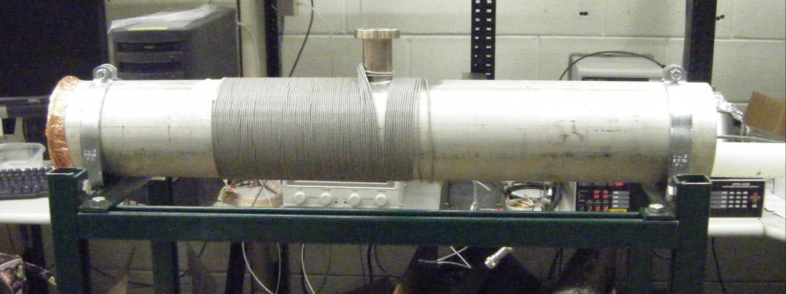

Figure 3 shows the first solenoid prototype.

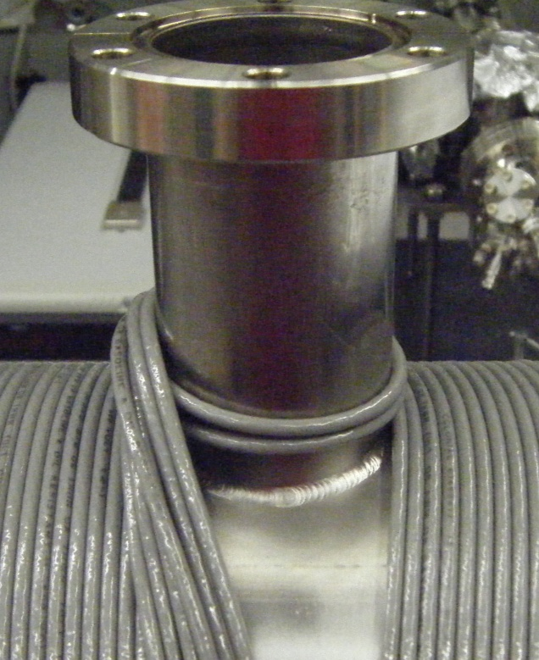

Figure 4 is a close-up of the wire wrapping around the port. The wire was wrapped around the port to increase stability of the wrappings around the main pipe.

This solenoid had 92 turns and was 31.4 cm long. I used this prototype to collect data at 1 A and 2 A. The solenoid spans 10 cm to about 41.5 cm with the port at positions 15-20 cm. Then I rearranged the coils so that the solenoid was more symmetric across the port and the coils were not wrapped around the port. Figures 5 and 6 display this second setup.

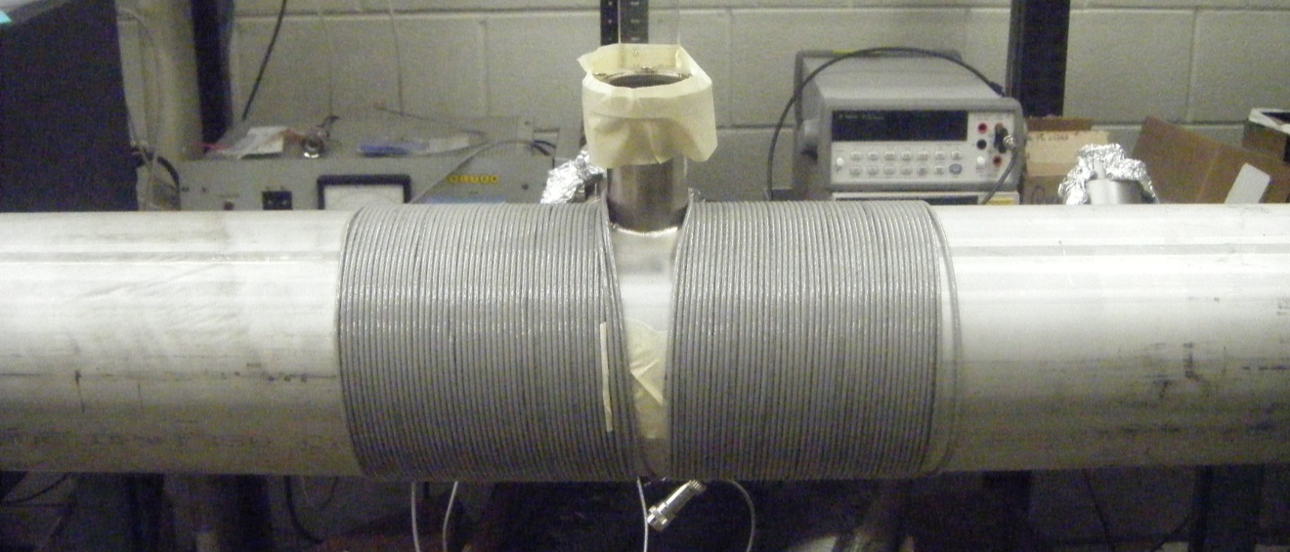Figure 5 shows the second solenoid prototype.

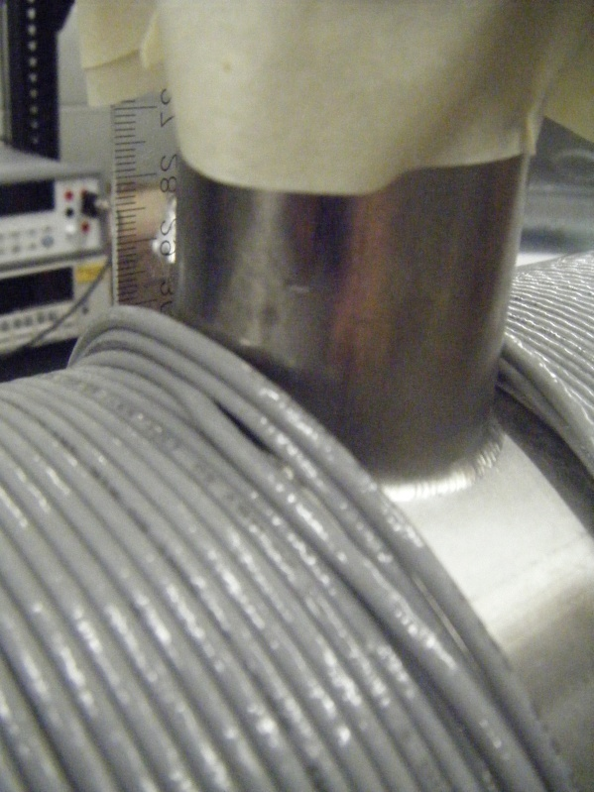

Figure 6 is a close-up of the port region of the pipe. Instead of being wrapped around the port, the wire is “stacked” next to it on both sides.

This solenoid had 92 turns and was 32 cm long. The solenoid started at position 1 cm and ends at 33 cm with the port at 14.5-19 cm. I used it to collect data at 5 A and to measure the magnetic field in the port. A Hall probe was used to measure the magnetic field in each orthogonal direction as well as the magnitude. To center the probe in the beam pipe, I affixed it to a small block of Styrofoam and a plastic tube. This measuring device setup, seen in Figure 7, was generally effective, but difficulties to keep it centered and straight led to some drift in my data. The probe was setup such that the x direction was horizontal, the y direction was vertical and the z direction was along the beam line.

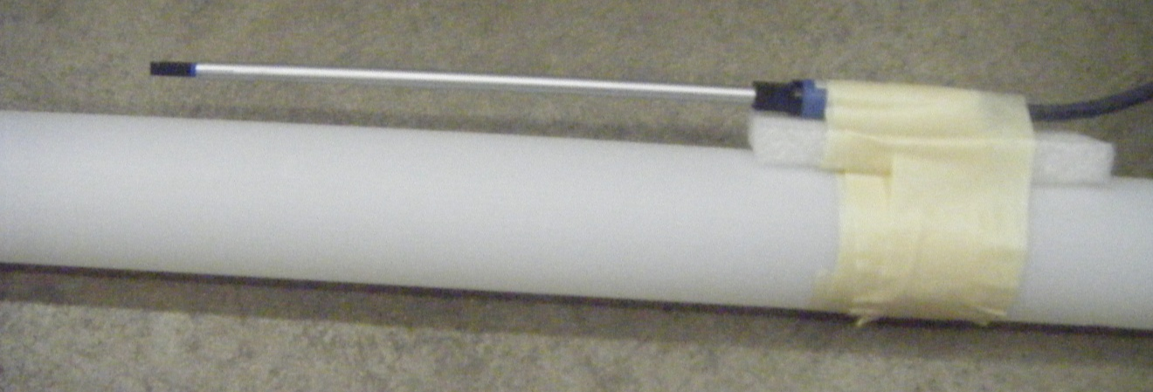

Figure 7 displays the arrangement of the Hall probe on the small block of Styrofoam and the plastic tube, which was used to measure the magnetic field inside of the solenoid-wrapped beam pipe.

To measure the magnetic field in the port, I used more Styrofoam and taped a ruler to the edge of the port to aid in position measurements. Pictures of the port probe can be seen in Figure 8. In this configuration the x direction was along the beam line, the y direction was horizontal and the z direction was vertical.

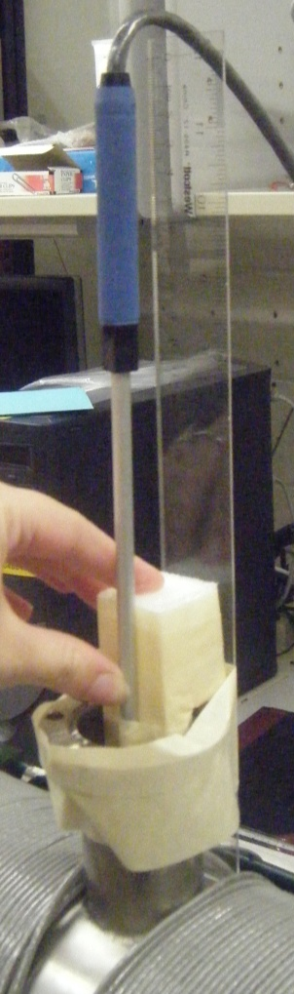 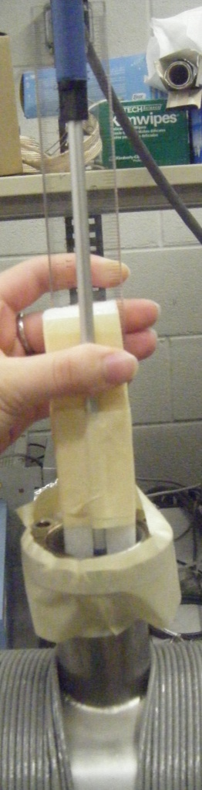

Figure 8 exhibits the setup I used to use the Hall probe in the port.

Data

With the first solenoid wrapped around my 1 meter section of beam pipe I ran 1 A through the wire and collected magnetic field data at different positions along the axis of the solenoid. At the same positions I collected measurements of the background magnetic field so that it could be subtracted from the measurements to obtain the magnetic field provided by the solenoid. Figure 9 displays the data at 1 A minus the background.

Figure 9 contains the graph of background subtracted magnetic field measurements at 1 A with the first solenoid prototype. The magnetic field in both the x and y directions is small as expected while the z field and magnitude are in the expected shape.

Next I ran 2 A through the coils and subtracted the same background presenting the data in Figure 10.

Figure 10 displays the graph of magnetic field data collected at 2 A with the first solenoid prototype. Once again the x and y fields are near zero and the z field and magnitude demonstrate the expected curvature.

Comparing the magnitude of the 1 A data with the 2 A data divided by 2 shows that the data is self-consistent. Figure 11 contains the graph comparing these curves.

Figure 11 shows that the magnetic field data collected at 1 and 2 A is self-consistent.

I rewrapped the solenoid to make it more symmetric, then ran 5 A through the solenoid. Since the rearrangement of the solenoid required a modified measurement system and it had been about 2 weeks since my last background measurement, I collected another round of background data. The data for 5 A minus background is displayed in Figure 12.

Figure 12 displays the graph of the background subtracted magnetic field data collected at 5 A with the second solenoid prototype. The x and y fields are still small, but larger than at lower current. The z field and the magnitude of the magnetic field display a dip at the port, so we will need to keep an eye on that.

With this same setup I removed the Styrofoam block so that the probe was sitting about half an inch below the center of the pipe. In this off axis position I collected data on the magnetic field. The background-subtracted data is exhibited in Figure 13.

Figure 13 displays the background-subtracted magnetic field data collected at 5 A with the second solenoid prototype and at a location about 0.5 in below the central axis of the solenoid. As might be expected the x and y fields are slightly altered in the off axis position, but the z field and the magnitude are very close and show the same shape as the on-axis data.

I also collected data about the magnetic field in the port on the port’s axis. Because the orientation of the probe was different and it was now measuring the field significantly off axis, I took new measurements of the background. The magnetic field in the port is displayed in Figure 14.

Figure 14 depicts the background-subtracted magnetic field measurements in the port at 5 A. The x-axis is along the beam line, the y-axis is horizontal and the z-axis is vertical. The stacked wrappings on the outside of the port are about 1.5 cm and 1.2 cm tall. The port is 7.5 cm tall/

We can see that the magnetic field along the beam line as well as larger transverse field components persist into the port to a point about 3 cm above the main beam pipe. These fields should not detrimentally change the efficiency of the solenoid to compress the electron cloud.

Comparison with Theoretical Results

Since we want the radius of the electrons’ paths to be as small as possible we want a large magnetic field, so I used the 5 A data since that induced the largest magnetic field of the three currents I tested. The solenoid used in my 5 A test was also more symmetric than the previous prototype. I used two slightly different methods to obtain theoretical results. First I setup an Excel spreadsheet to evaluate the magnetic field at a certain point while treating each coil of the solenoid as a single ring. I used this equation for the magnetic field on the axis of a single loop of current carrying wire:

,

where *B* is the magnetic field in teslas,  is the permeability of free space, *R* is the radius of the solenoid in meters, *I* is the current in the solenoid in amps, and *z* is the distance in meters along the axis of the loop from the center of the loop to the point in question. Summing these together gave me the total magnetic field at that point due to the solenoid as a whole. Evaluating that summation at each point that I had measured experimentally produced coordinate pairs that I could graph with my experimental results. I also integrated this equation, adding a few terms to accommodate the finiteness of my solenoid, to obtain this equation:

,

where *B* is the magnetic field in teslas,  is the permeability of free space, *I* is the current in the solid in amps, *N* is the number of coils in the solenoid, *L* is the length of the solenoid in meters, *R* is the radius of the solenoid in meters,  is the distance in meters from the point in interest to the center of the first coil and  is the distance in meters from the point in interest to the center of the last coil. Evaluating this equation for each measurement point provided another set of points to graph with the experimental data. The results are shown in Figure 15.

Figure 15 exhibits the three curves for the magnitude of the magnetic field along the axis of the solenoid. The curves match nicely except for the slight dip in the experimental data from the port.

These 3 curves mirror each other very well so we can conclude that the experimental solenoid is behaving as theoretically predicted. The only issue is the slight dip in the center of the experimental data from the port.

Further Work

Our next step is to install a solenoid in the tunnel and monitor the electron cloud to see if the solenoid works to decrease the electron cloud. Our intention is to put three layers of the solenoid around the beam pipe to increase the magnetic field while not raising the current and thus the voltage in the solenoid, which would likely increase heat dissipation to unwanted levels. The results from the port are a little disconcerting, but the area where we plan to first install the solenoid has a port on each side of the pipe so that may help to even out the field.