


Operating Systems

LAB MANUAL
Project Title: Banker’s Algorithm
Submitted to: Sir Umar Malik
Submitted By: Alina Liaquat
Roll No: BSCSM-A-23-19
Department of Computer Science
UNIVERSITY OF LAYYAH MAIN CAMPUS HAFIZABAD

ACKNOWLEDGEMENT
I extend my sincere gratitude to my course instructor Sir Umar Malik for providing me the opportunity to work on the "OS Deadlock Simulator" project. His guidance and expertise in Operating Systems, particularly in process management and deadlock handling, were invaluable throughout this project's development.
His mentorship helped me implement the Banker's Algorithm effectively and create a practical simulation that demonstrates core OS principles. This project has significantly enhanced my understanding of resource management and deadlock prevention strategies in operating systems.

PROBLEM STATEMENT

Background
In multiprogramming operating systems, multiple processes compete for limited resources. When processes request resources in a circular waiting pattern, a deadlock occurs, causing system stagnation. The Banker's Algorithm, developed by Edsger Dijkstra, is a classic deadlock avoidance algorithm that ensures system safety by carefully allocating resources.

Problem Definition
Design and implement an interactive Deadlock Simulator that:
- Visually demonstrates the Banker's Algorithm for deadlock avoidance
- Simulates real process behavior with modern application names
- Provides real-time safety analysis and deadlock detection
- Offers an intuitive interface for resource request management
- Shows step-by-step execution of safety algorithms

Objectives
- Implement Banker's Algorithm with proper safety checks
- Create visual representations of allocation matrices
- Simulate deadlock scenarios and their resolutions
- Provide educational insights into OS resource management
- Demonstrate practical application of theoretical concepts

THEORETICAL CONCEPTS

1. Deadlock Conditions (Coffman Conditions)
Four necessary conditions for deadlock:
- Mutual Exclusion: Resources cannot be shared
- Hold and Wait: Processes hold resources while waiting for others
- No Preemption: Resources cannot be forcibly taken
- Circular Wait: Circular chain of processes waiting for resources

2. Banker's Algorithm Components
Data Structures:
- Available[m]: Available instances of each resource type
- Max[n×m]: Maximum demand of each process
- Allocation[n×m]: Currently allocated resources
- Need[n×m]: Remaining resource needs (Max - Allocation)

3. Safety Algorithm
The algorithm determines if the system is in a safe state by finding a safe sequence where all processes can complete execution without deadlock.

4. Resource-Request Algorithm
Handles resource requests by checking:
- Request ≤ Need
- Request ≤ Available
- Temporary allocation simulation
- Safety check after allocation

ALGORITHM STEPS

A. Banker's Safety Algorithm
Step 1: Initialize
Work = Available
Finish[i] = false for all processes i
Step 2: Find a process i such that:
Finish[i] == false AND
Need[i] ≤ Work for all resources
Step 3: If such process exists:
Work = Work + Allocation[i]
Finish[i] = true
Add i to Safe Sequence
Go to Step 2
Step 4: If Finish[i] == true for all i:
System is in safe state
Return safe sequence
Else:
System is unsafe

B. Resource Request Algorithm
Step 1: If Request[i] > Need[i]:
Error: Process exceeded maximum claim
Terminate
Step 2: If Request[i] > Available:
Process must wait (resources not available)
Step 3: Tentatively allocate:
Available = Available - Request[i]
Allocation[i] = Allocation[i] + Request[i]
Need[i] = Need[i] - Request[i]
Step 4: Run Safety Algorithm
If safe: Allocation made permanent
If unsafe: Rollback allocation

C. Deadlock Detection Algorithm
Step 1: Initialize
Work = Available
Finish[i] = (Allocation[i] == 0) for all i
Step 2: Find process i where:
Finish[i] == false AND
Request[i] ≤ Work
Step 3: If found:
Work = Work + Allocation[i]
Finish[i] = true
Repeat Step 2
Step 4: Processes with Finish[i] == false
are deadlocked

FLOWCHARTS

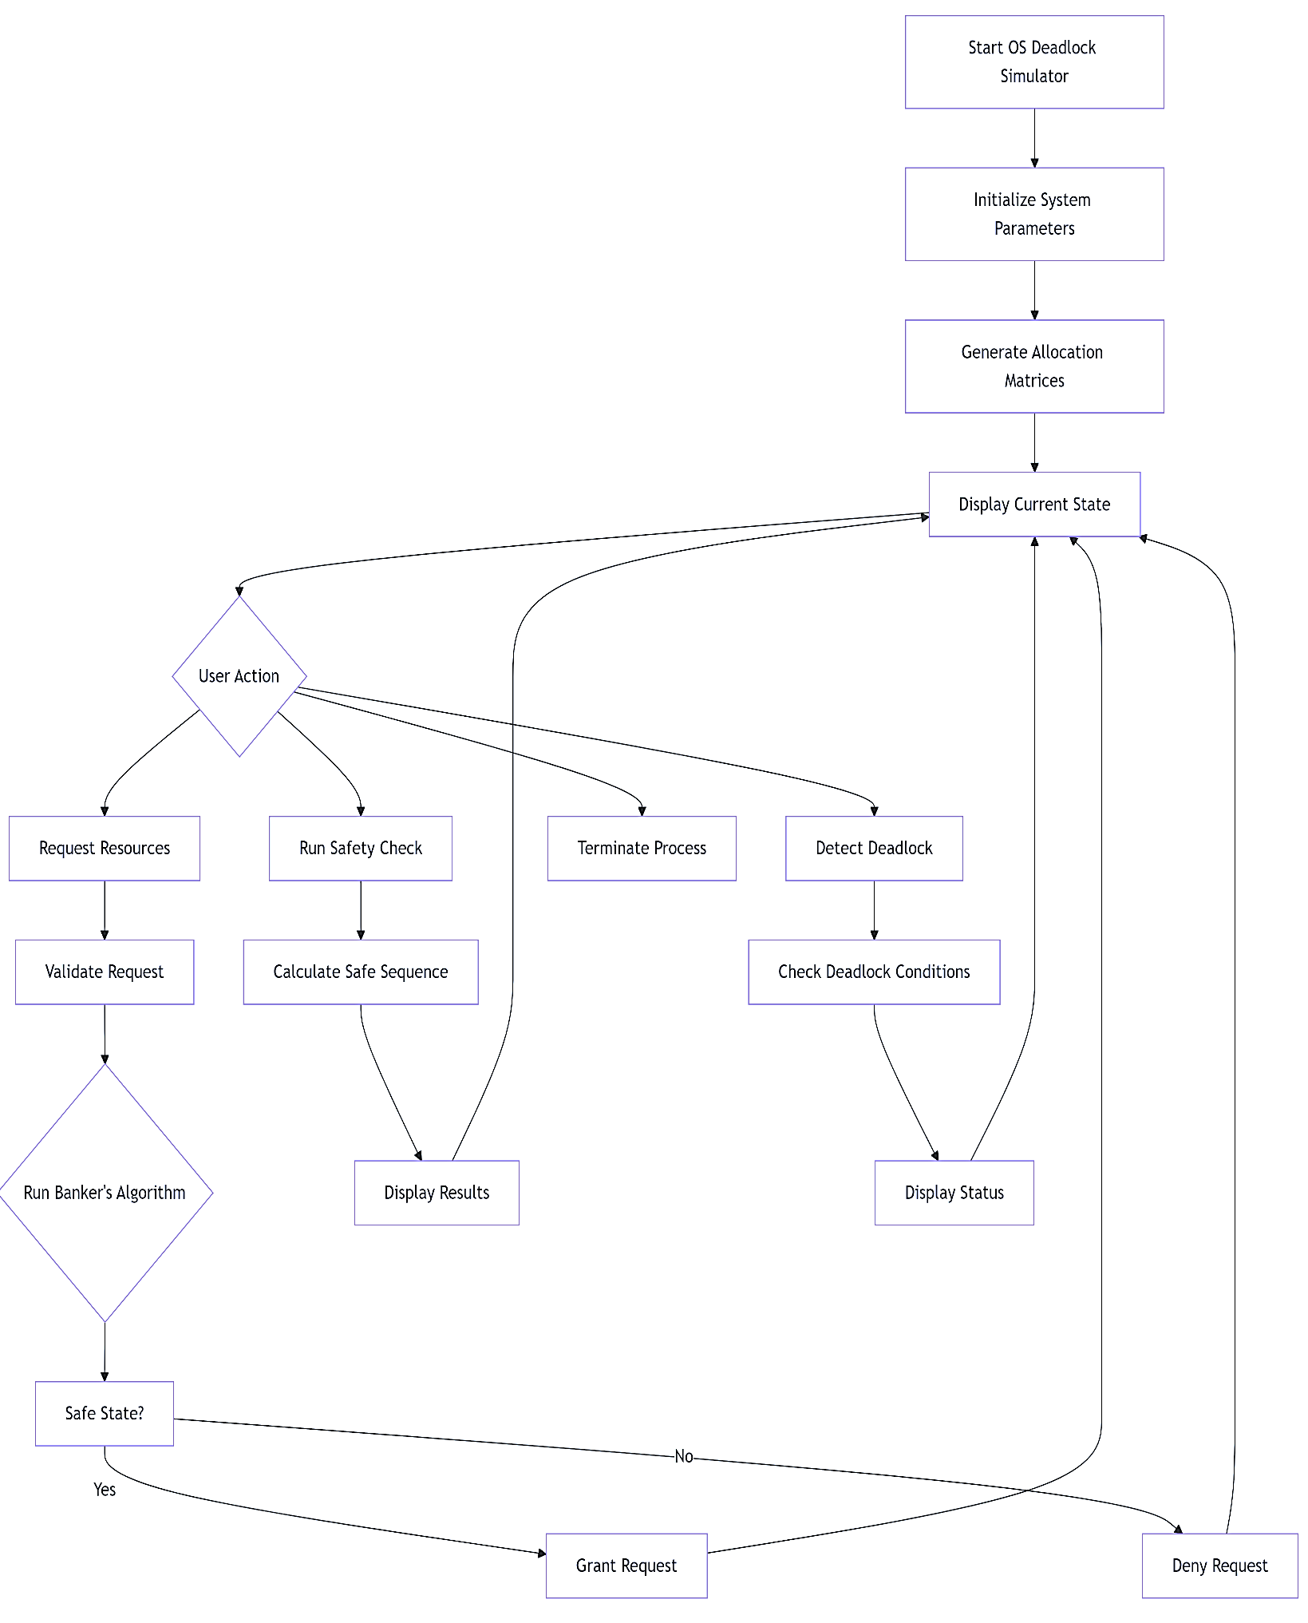
Overall System Flow

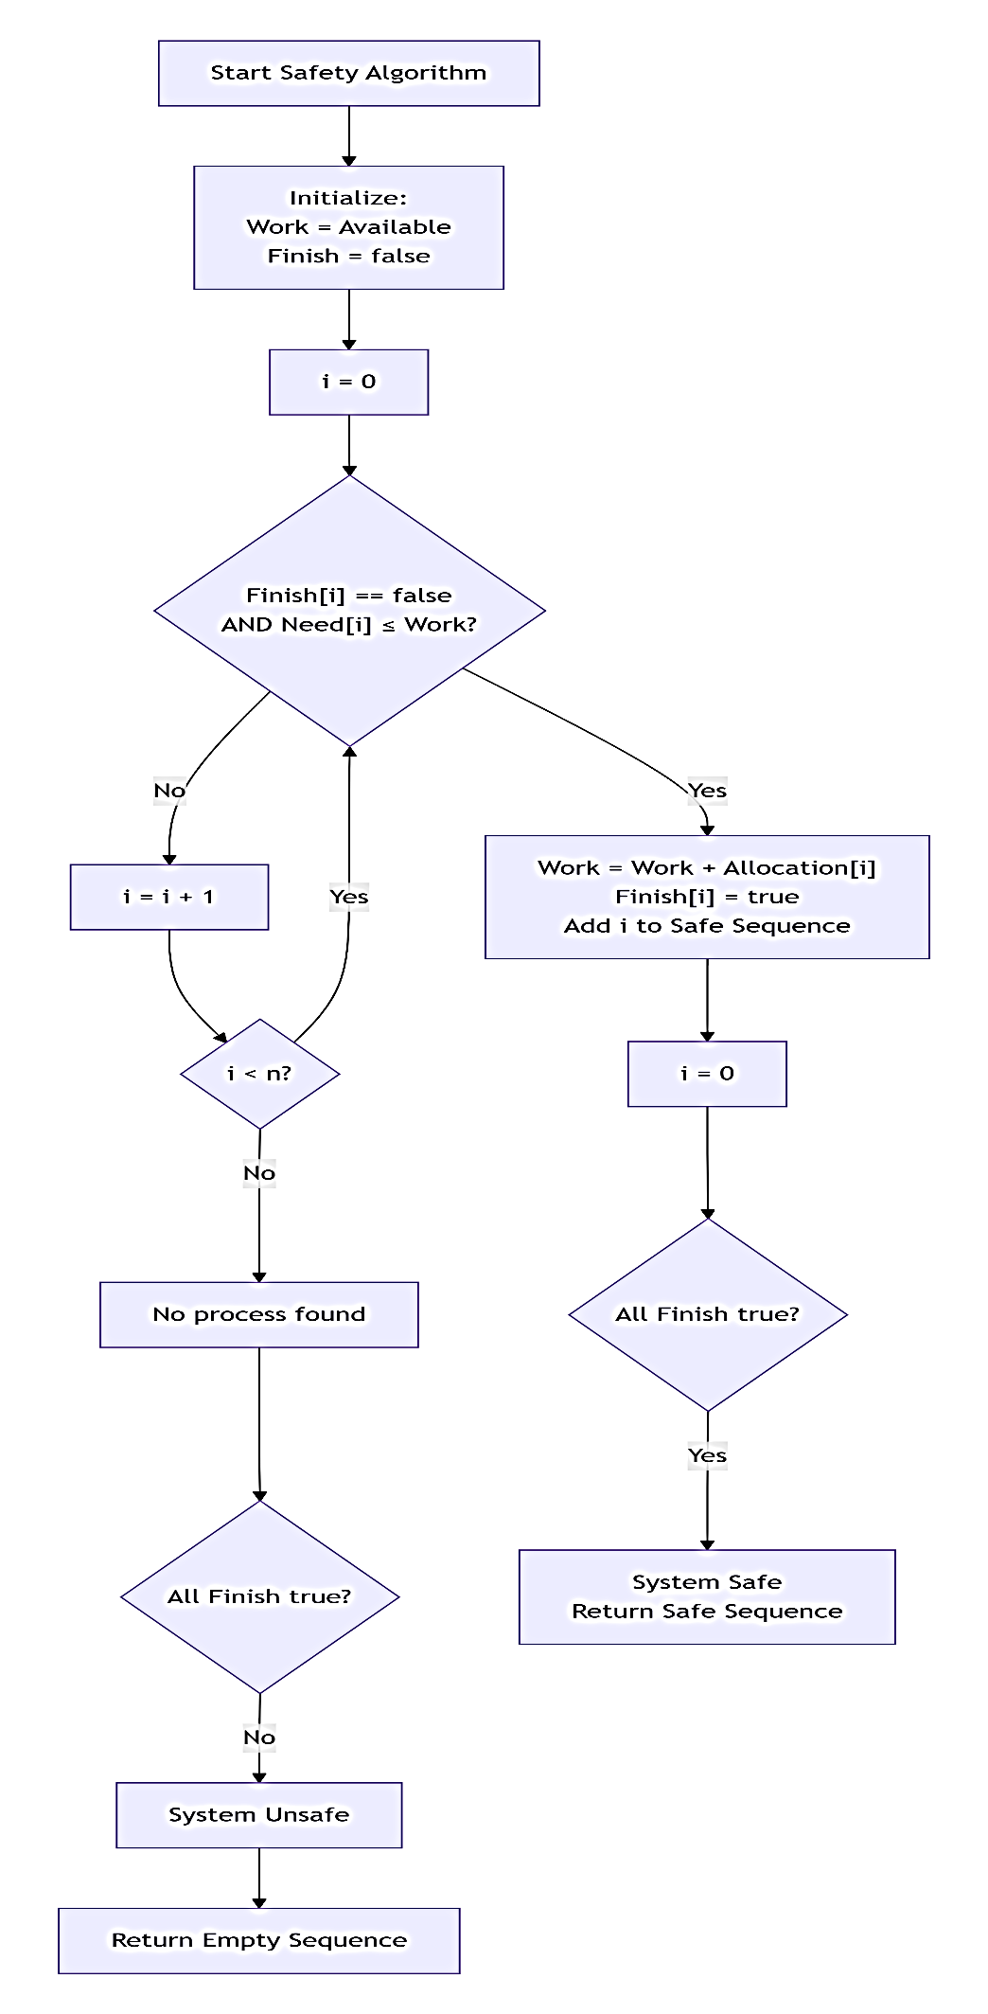
Banker's Safety Algorithm

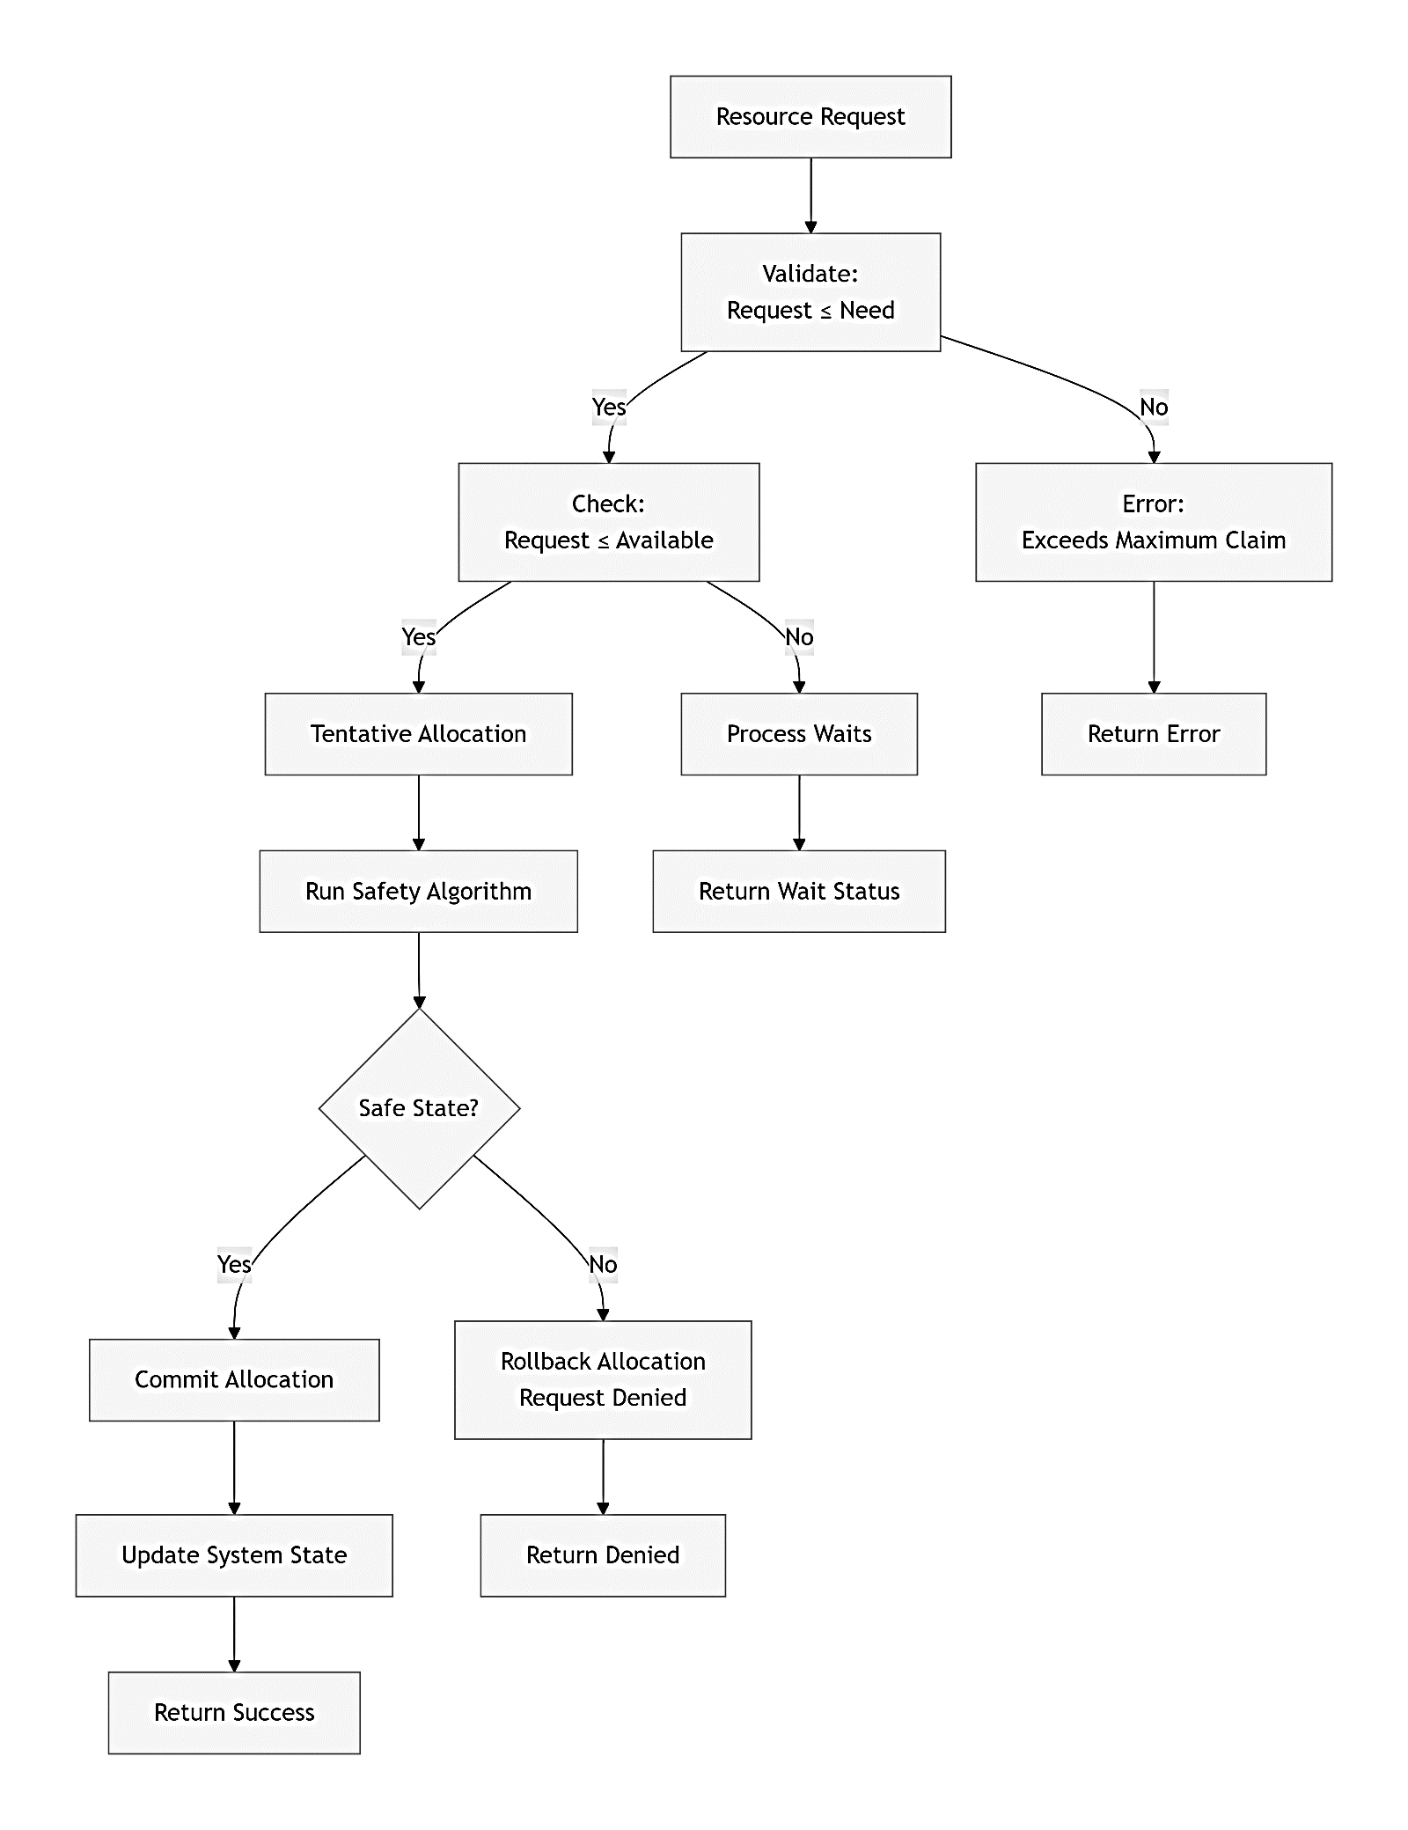
Resource Request Handling

Deadlock Detection Process

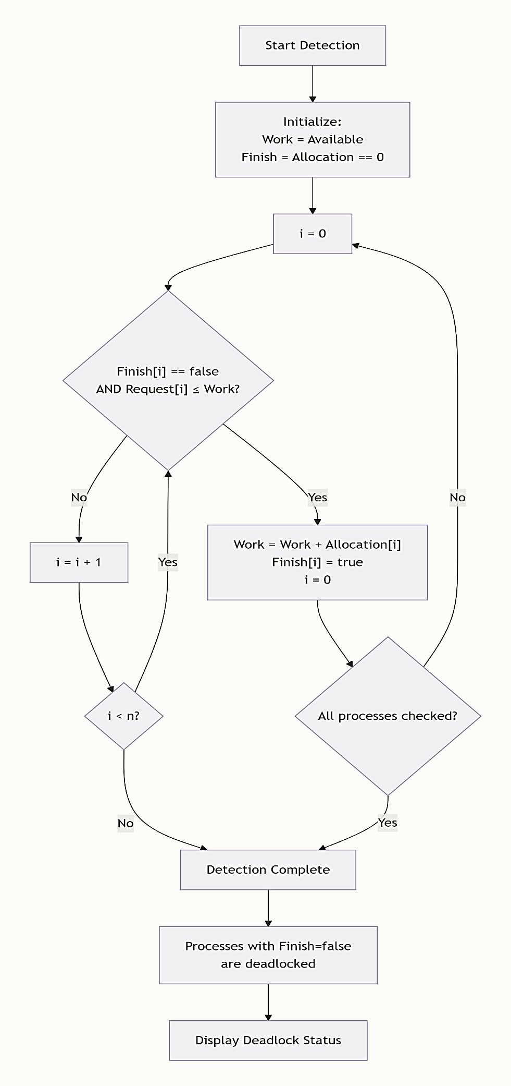

IMPLEMENTATION DETAILS

System Architecture
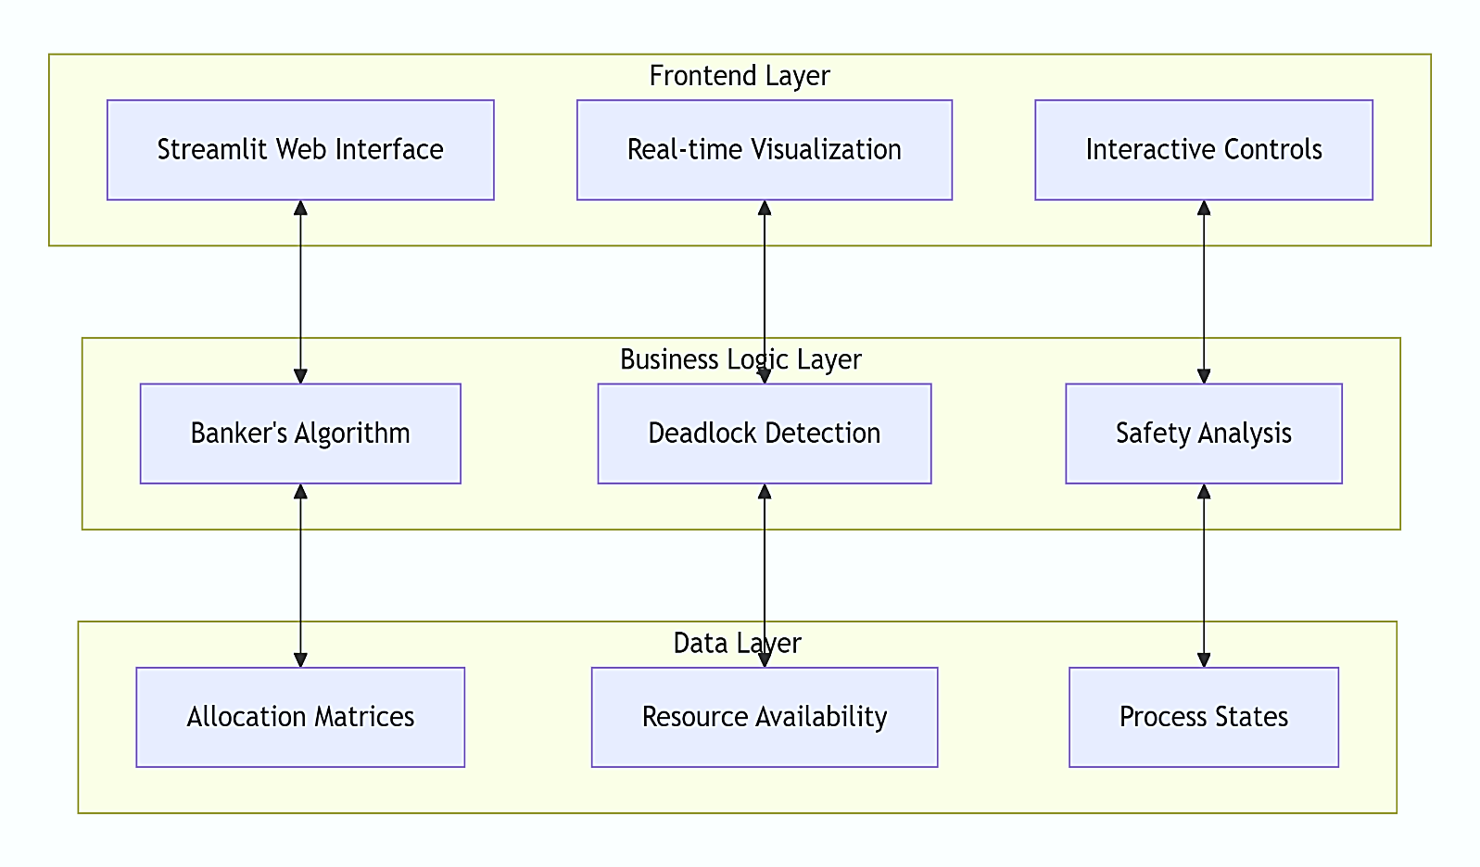

2. Key Features Implemented
- Dynamic System Initialization: Configurable processes and resources
- Real Process Simulation: Modern application names (Chrome, VS Code, etc.)
- Visual Matrices: Real-time display of allocation states
- Safety Analysis: Instant safe sequence calculation
- Deadlock Detection: Automatic scanning for circular waits
- Resource Request Management: Interactive request handling
- Historical Tracking: Request history with timestamps

EXPERIMENTS AND OBSERVATIONS

Experiment 1: Safe State Verification

Input Configuration:
- Processes: 5
- Resources: 3
- Allocation: Random
- Maximum: Random (higher than allocation)
Observation:
System calculates safe sequence
All processes can complete execution
No deadlock detected

Experiment 2: Deadlock Creation
Simulation Steps:
1. Allocate all resources
2. Make circular requests
3. Run detection algorithm
Observation:
Deadlock detected
Circular wait identified
Termination option provided

Experiment 3: Resource Request Handling
Test Cases:
1. Valid request within need → Granted
2. Request exceeds available → Denied
3. Request leads to unsafe state → Denied
Observation:
Banker's algorithm prevents unsafe allocations
System maintains safe state

SAMPLE OUTPUTS

Output 1: System Initialization
OS Deadlock Simulator Initialized
---------------------------------
Processes: 5
Resources: 3
Allocation Matrix Generated
Available Resources: [4, 3, 2]
System Status: SAFE
Safe Sequence: P1 → P3 → P4 → P2 → P0

Output 2: Resource Request

Process: Chrome Browser
Request: [1, 0, 1]
Checking Safety...
Request GRANTED
New Safe Sequence: P3 → P1 → P4 → P2 → P0

Output 3: Deadlock Detection
Deadlock Scan Initiated...
DEADLOCK DETECTED!
Blocked Processes:
- VS Code Editor
- Spotify Player
- Discord Client
Suggestion: Terminate one process

CONCLUSION
This lab successfully implemented a comprehensive Deadlock Simulator using the Banker's Algorithm. The project demonstrates:
- Practical Implementation of theoretical deadlock concepts
- Visual Learning through interactive matrices and status indicators
- Analysis of system safety and resource allocation
- Educational Value in understanding OS resource management
The simulator effectively bridges the gap between abstract algorithmic concepts and practical system behavior, providing valuable insights into how operating systems prevent and handle deadlocks in real-world scenarios.

