

Operating Systems



Assignment 03
Title: Deadlock handling methods & Prevention
Compiled By: Alina Liaquat
Roll-No: BSCSM-A-23-19
BSCS-MORNING-5th(A)
Submitted to: Sir Umar Malik

UNIVERSITY OF LAYYAH MAIN CAMPUS HAFIZABAD

DEADLOCK HANDLING METHODS

1. OBJECTIVE
The objective of this practical assignment is to understand:
- What deadlock is
- How synchronization mechanisms (mutex, semaphore) control concurrent access
- Methods to prevent deadlocks
- Implementing a C++ program that causes a deadlock and another that prevents it

2. WHAT IS DEADLOCK?
Deadlock occurs when two or more processes/threads are permanently blocked, waiting for resources held by each other.
Consider a one-way road with two cars approaching from opposite directions, blocking each other. The road is the resource and crossing it represents a process. Since it’s a one-way road, both cars can’t move simultaneously, leading to a deadlock.
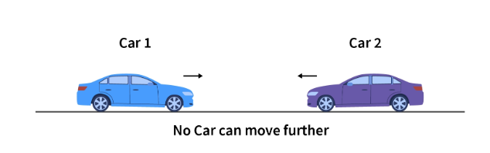

3. CONDITIONS FOR DEADLOCK
Deadlock happens only when all 4 conditions are true:
- Mutual Exclusion
- Hold and Wait
- No Preemption
- Circular Wait
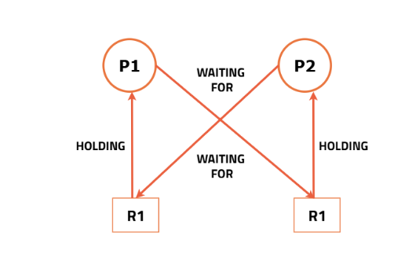

4. DEADLOCK DEMONSTRATION (C++ Program)
We first create a deadlock example using two mutex locks

4.1 LOGIC
- Thread 1 locks resourceA then waits for resourceB
- Thread 2 locks resourceB then waits for resourceA
- Both wait forever deadlock

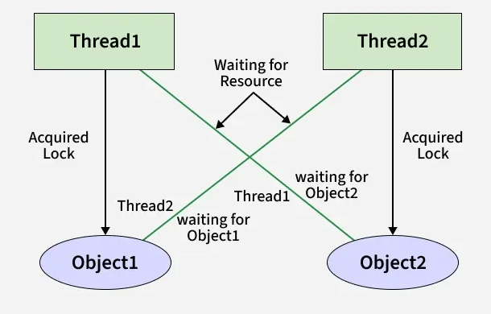

4.2 C++ CODE (DEADLOCK EXAMPLE)
#include <iostream>
#include <thread>
#include <mutex>
using namespace std;

mutex resourceA;
mutex resourceB;

void task1() {
lock_guard<mutex> lockA(resourceA);
cout << "Task 1 locked Resource A\n";

this_thread::sleep_for(chrono::milliseconds(100));

cout << "Task 1 waiting for Resource B...\n";
lock_guard<mutex> lockB(resourceB); // waits forever
cout << "Task 1 got Resource B\n";
}

void task2() {
lock_guard<mutex> lockB(resourceB);
cout << "Task 2 locked Resource B\n";

this_thread::sleep_for(chrono::milliseconds(100));

cout << "Task 2 waiting for Resource A...\n";
lock_guard<mutex> lockA(resourceA); // waits forever
cout << "Task 2 got Resource A\n";
}

int main() {
thread t1(task1);
thread t2(task2);

t1.join();
t2.join();

return 0;
}

Output
Task 1 locked Resource A
Task 2 locked Resource B
Task 1 waiting for Resource B...
Task 2 waiting for Resource A...
(Hangs forever – deadlock)

5. DEADLOCK PREVENTION
We fix the problem by using a global resource ordering rule:
All threads must lock resources in the same order
Example: Always lock A then B
This breaks Circular Wait, preventing deadlock

5.1 C++ CODE PREVENTING DEADLOCK
#include <iostream>
#include <thread>
#include <mutex>
using namespace std;

mutex resourceA;
mutex resourceB;

// Both functions lock A → B order
void safeTask1() {
lock_guard<mutex> lockA(resourceA);
cout << "Task 1 locked Resource A\n";

this_thread::sleep_for(chrono::milliseconds(100));

lock_guard<mutex> lockB(resourceB);
cout << "Task 1 locked Resource B\n";
}

void safeTask2() {
lock_guard<mutex> lockA(resourceA);
cout << "Task 2 locked Resource A\n";

this_thread::sleep_for(chrono::milliseconds(100));

lock_guard<mutex> lockB(resourceB);
cout << "Task 2 locked Resource B\n";
}

int main() {
thread t1(safeTask1);
thread t2(safeTask2);

t1.join();
t2.join();
return 0;
}

Output
Task 1 locked Resource A
Task 1 locked Resource B
Task 2 locked Resource A
Task 2 locked Resource B
(No deadlock)

6. SYNCHRONIZATION TECHNIQUES USED

6.1 MUTEX
- Ensures only one thread enters a critical section
Use case: resource protection
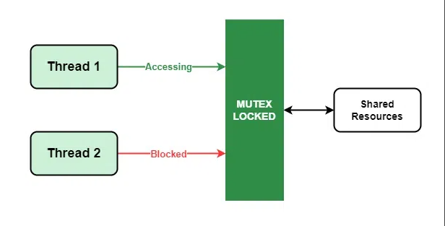

Method | Explanation
Deadlock Prevention | Break one of 4 conditions (we break circular wait)
Deadlock Avoidance | Banker’s Algorithm (not implemented here)
Deadlock Detection | Allow deadlock detect recover
Synchronization | Mutex/semaphore prevents race conditions

7. DEADLOCK HANDLING METHODS SUMMARY

CONCLUSION
In this assignment, I have:
- Observed how deadlock occurs
- Implemented a real deadlock in C++
- Prevented it using proper synchronization
- Understood mutex usage and ordering rules
This demonstrates the fundamental concept of process synchronization and deadlock prevention in operating systems

