

Operating Systems



Lab #01
Title: Read System Call
Compiled By: Alina Liaquat
Roll-No: BSCSM-A-23-19
BSCS-MORNING-4th(A)
Submitted to: Sir Umar Malik

UNIVERSITY OF LAYYAH MAIN CAMPUS HAFIZABAD

1.1 Objectives
- To understand what a system call is and how user programs interact with the operating system
- To learn how the read(), open(), write(), and close() system calls work in Linux
- To observe how file descriptors are created and used by the OS
- To practice using the nano editor and basic terminal commands
- To analyze the system call flow using a simple C program

1.2 Concept
A system call is an interface that allows a user program to request a service from the operating system.
User programs cannot directly access hardware or kernel memory, so they use system calls to perform tasks
such as file handling, process creation, memory allocation, and input/output operations.
The read() system call is used to transfer data from a file into a buffer in memory.
To read a file, it must first be opened using open(), which returns a file descriptor.
The write() system call sends data to an output stream (e.g. screen or file).
The close() system call is used to release the file descriptor after operations are completed. This lab introduces how low-level file operations work behind high-level functions.

1: READ SYSTEM CALL

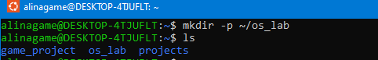

Explanation:
- mkdir = make directory
- -p = makes sure error would not occur even if directory already exists
- ~/ = home folder
- os_lab = folder name

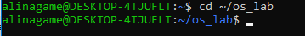

Opens nano , terminal text editor where we can read/write/copy/paste the programs.
After running above command following interface opens

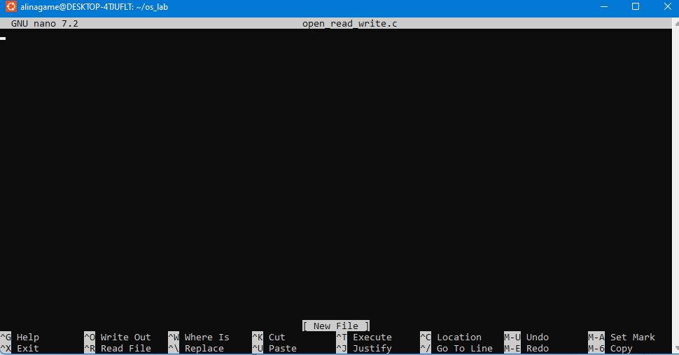

Nano Shortcuts:
Key | Meaning
Ctrl + O | save (Write Out)
Enter | confirm file name
Ctrl + X | exit

Copy/Paste Code
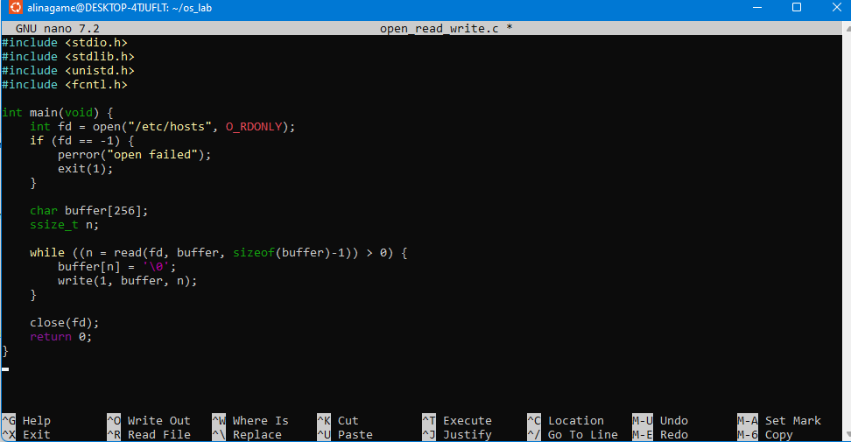

Ctrl + O → Enter
Exit: Ctrl + X
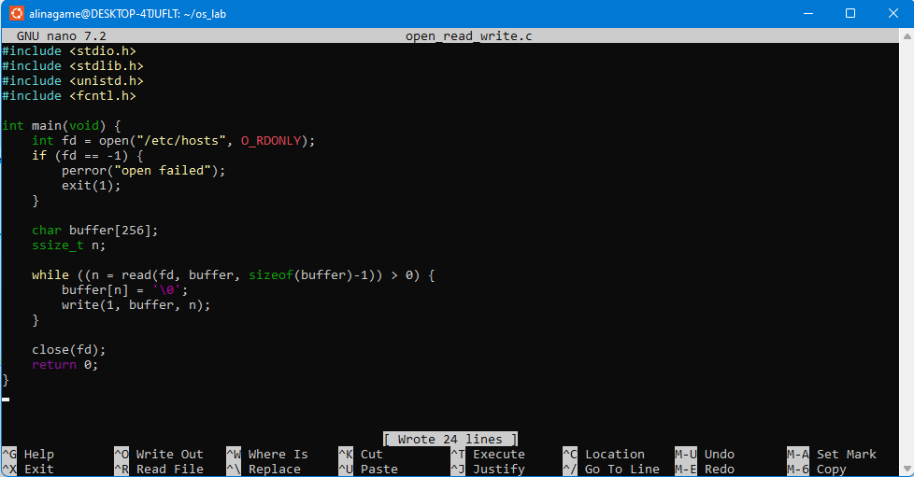

Line | Meaning
open("/etc/hosts", O_RDONLY) | OS request: file open
fd | file descriptor: OS Number which represents file
read() | OS request: bring file data to buffer
write(1, ...) | 1 means screen
close() | file close

We use gcc (GNU C compiler)
There was no error it means code is error free
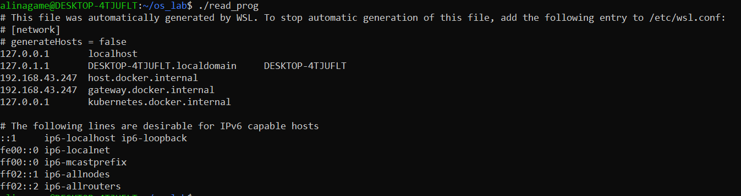
Run Program:

2: WRITE SYSTEM CALL
Open nano:

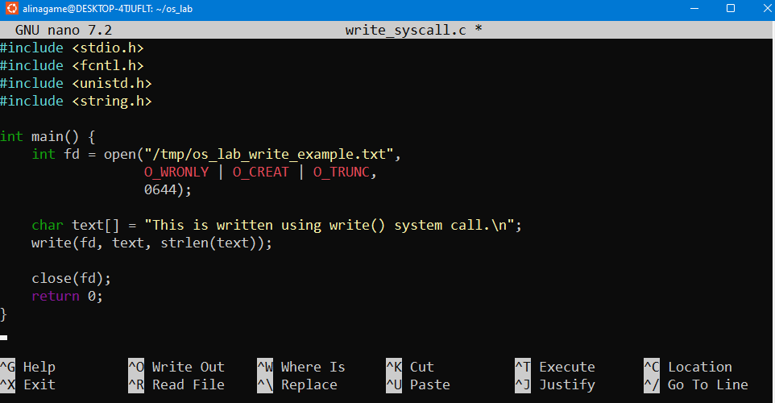
Paste Code

Save + Exit
Ctrl+O → Enter → Ctrl+X
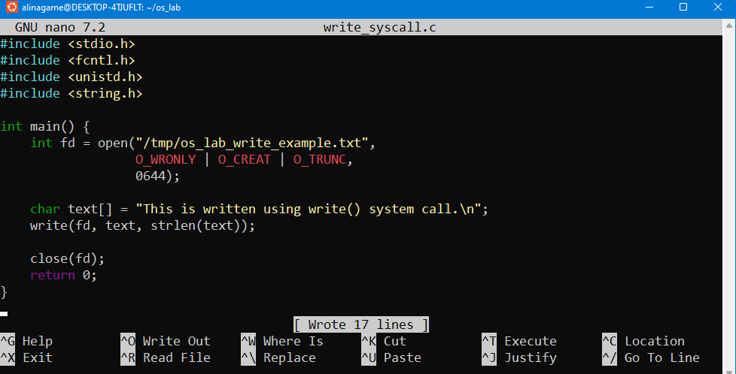

Compile & Run:

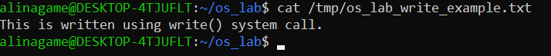
Verify file was created:

3: Fork + Exec

Paste Code
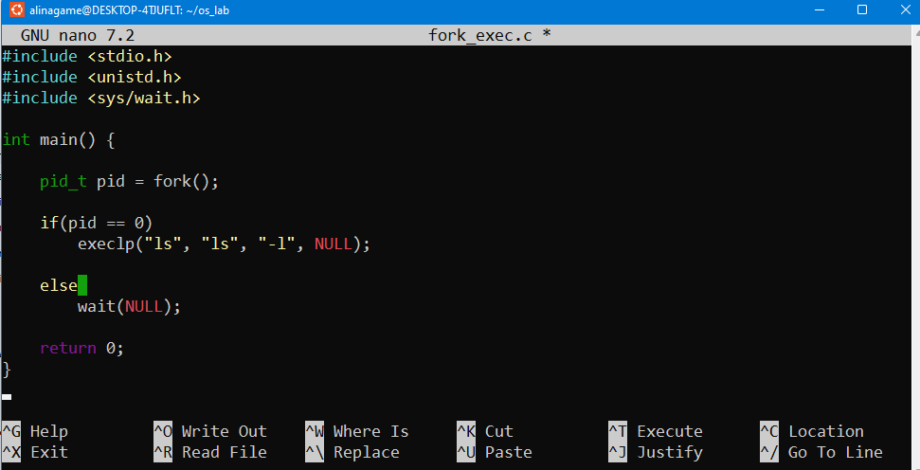

Save & Exit the code
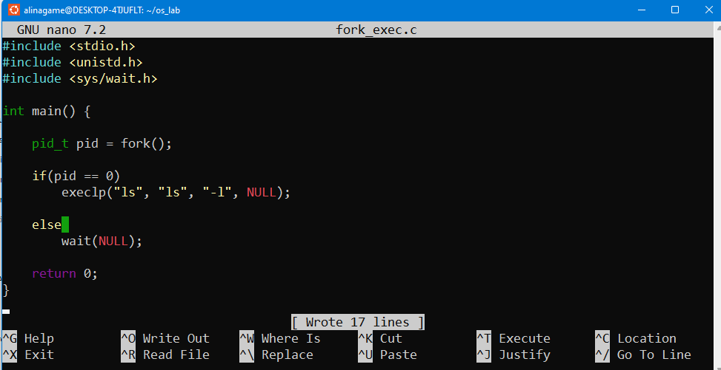

Compile & Run
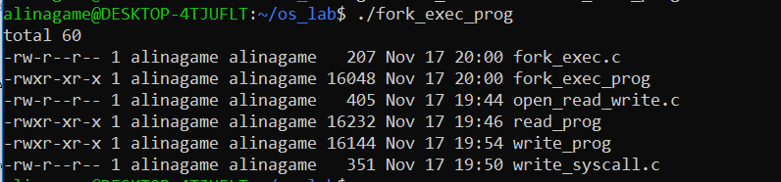

Strace traces system level calls
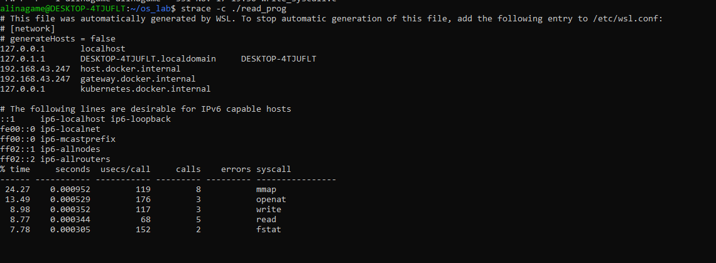

Open nano
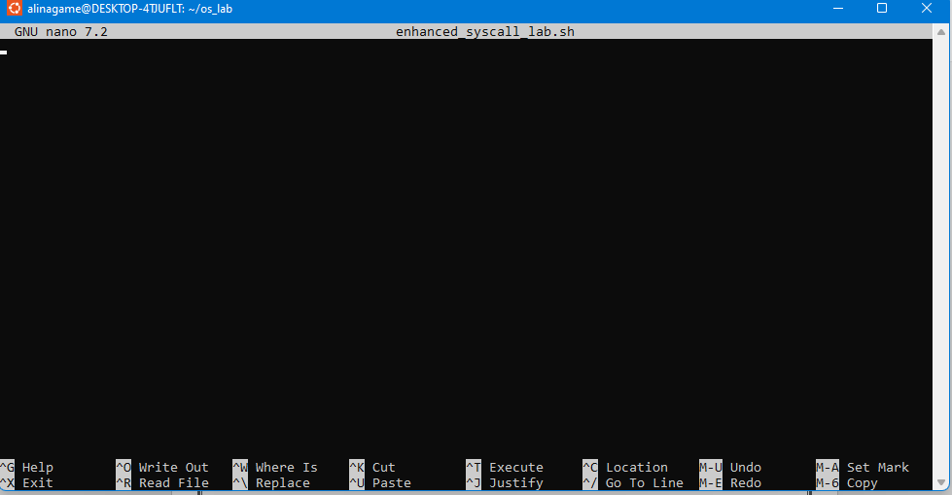

Create Script
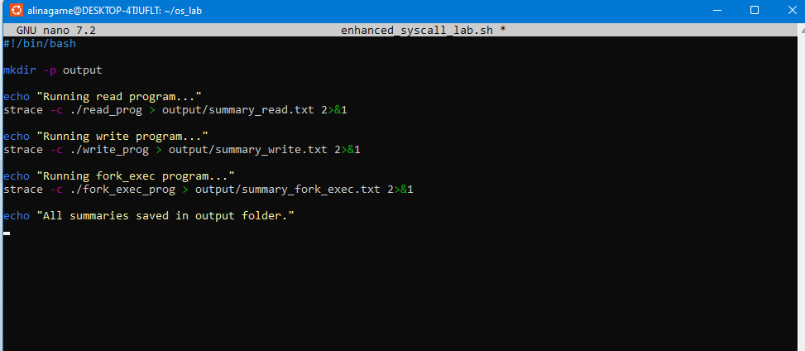

Pasting the commands
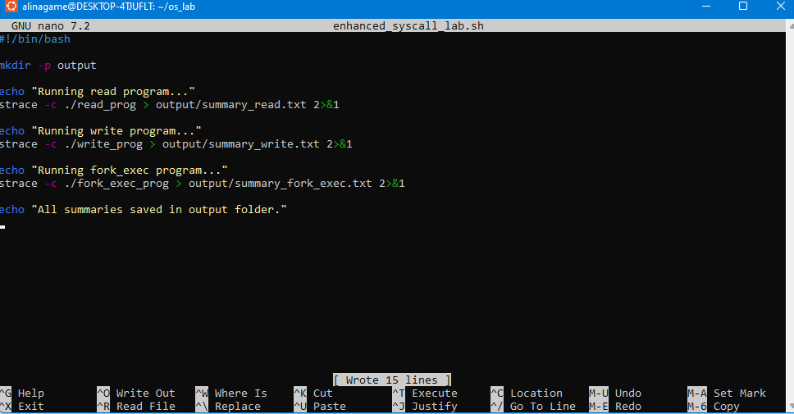

Making it executable

Run
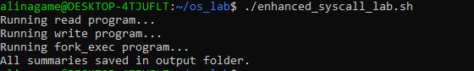

CONCLUSION:
In this lab, I’ve learned how the write() system call works and how files are created and modified at the kernel level. I observed how system calls differ from normal library functions and understood how Linux handles low-level file output.

