DOCKER

Containers:
A single bundle or unit in which we combine our application along with its dependencies. We will share this single unit with our friends and deploy it as well. It will make the process of replicating local environment simple. The containers could be easily run regardless of the operating system is being used.

Properties:
- Portable: Container as a unit can be shared across teams. In docker technical terms we don’t share container as a container instead to share docker container we share the docker images.
- Light Weight: It as very less overhead which makes easier to update, delete the containers or to have multiple containers on a single machine. The entire becomes similar. It’s size is very smaller as compared to a virtual machine.
- If we want to build 2 applications of Streamlit on our system one of version 2.0 and other of version 3.0 then on same system maybe the version 3.0 is installed, but the docker container can handle this situation easily such as Container 1 will handle the 1st application of version 2.0 while the Container 2 will handle of version 3.0

Docker Images:
The docker image is not exactly an image or a picture rather this is an executable file. This file contains the instructions to build the container. The docker image has the purpose of building containers. The relation between the docker image and docker contain is similar to the relation between the class and the object. Class is a blueprint that helps us create multiple objects. Similarly, the docker image is the blueprint that helps us multiple containers. We can create multiple containers from a single docker image.
In case of class and objects the objects occupy space in memory not the class itself. Similarly, in case of docker images the docker containers occupy the system’s resources not the docker images. The size of docker container is itself very small.

docker run –it ubuntu
docker
docker –v

Starting docker with very simple commands:
Docker images
1: hello world image on the docker hub
Commands:
- docker pull IMAGE_NAME (to pull docker images to our system) Note: When we are accessing the docker images from the docker hub then we can copy the commands given three
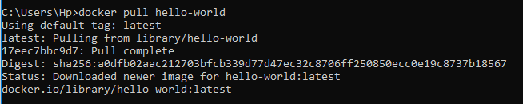

- docker images (to check docker images)

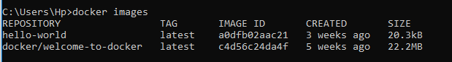
TAGS
There are some tags along with our images which are basically different versions for the docker images
We can see the images that have been created in the following in docker desktop:
- Image size is very small (20.34 KB) that’s why the docker is light weight technology
- Docker image has unique ID such as following Hello World image has a0dfb02aac21

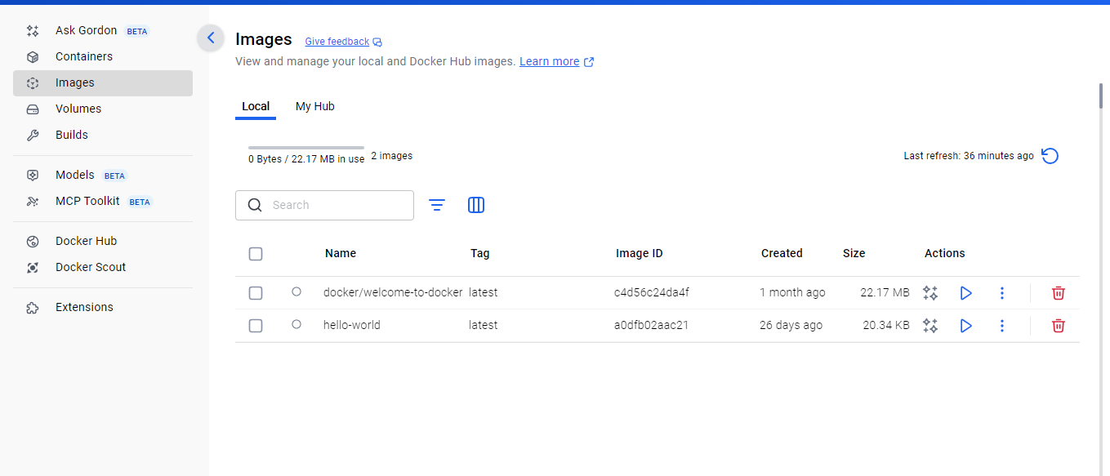

Now as image has been created so through the image we create the Docker Container
Command:
- docker run IMAGE_NAME (For creating the container from the image)
- To generate this message docker took the following steps: Basically these are the actual steps which shows how our container is created

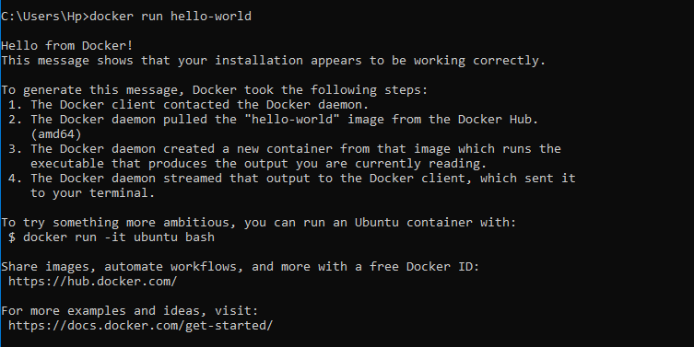

Docker gives any random name to the docker container
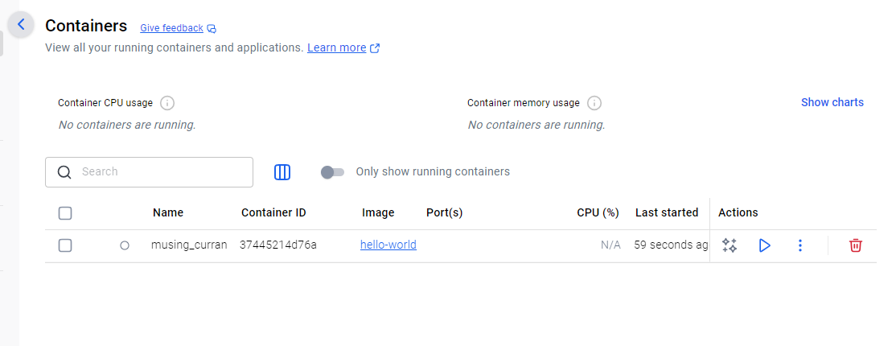

Green Dot on Docker Image means that this image has been used to create some docker container

Running docker containers in interactive mode
- Docker run –it IMAGE_NAME (interactive mode allows us to access the container terminal which helps us input/output anything)
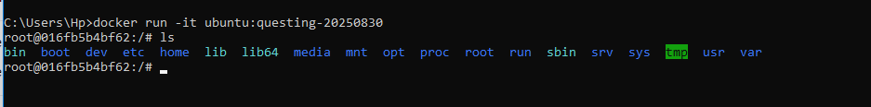
Running the linux commands on ubuntu container

Creating the new directory in same environment named alina_linux

Printing the environment variables

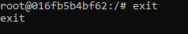
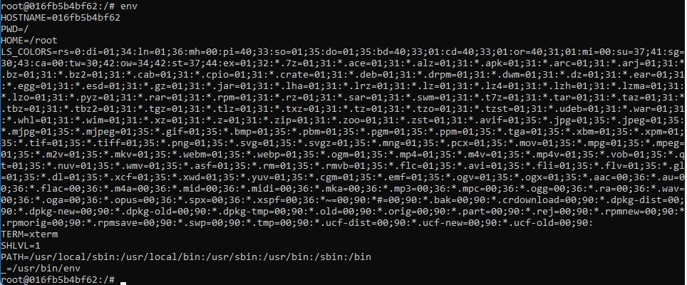
- exit command stops the container

To check how many images exist
- docker ps –a (-a means all)

- docker ps (to see the running containers)

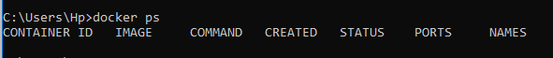
- docker start CONT_NAME or CONT_ID (to restart any existing container)

- docker stop CONT_NAME or CONT_ID (to stop any existing container)

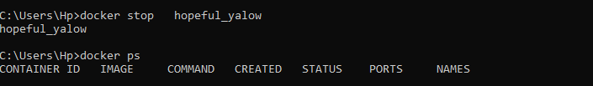

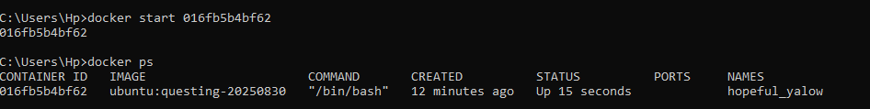
- docker rmi IMAGE_NAME (to remove image)
- Docker rm CONT_NAME (to remove docker container)

VERSIONS IN DOCKER IMAGES
- If we don’t specify the version while pulling the image then the latest version of that image is pulled

Additional commands:
docker ps - - all
docker container - -help
docker build - -help

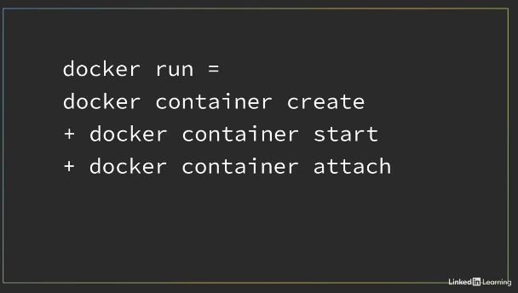

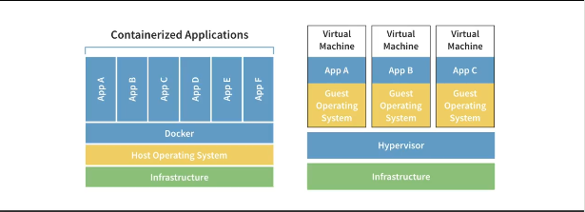

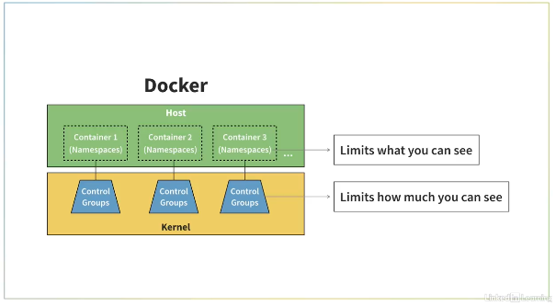

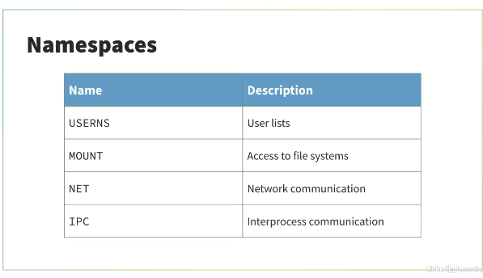

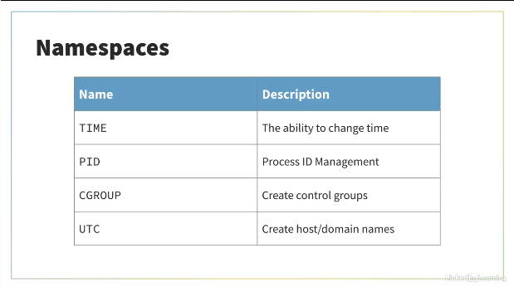

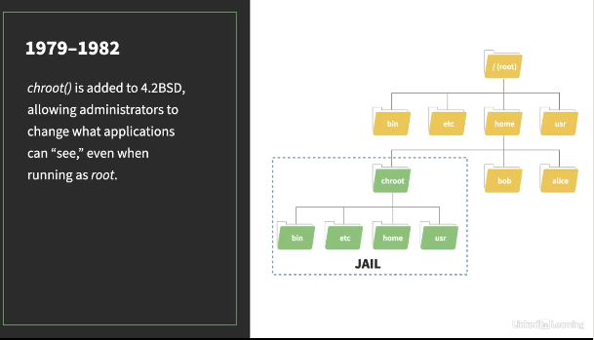

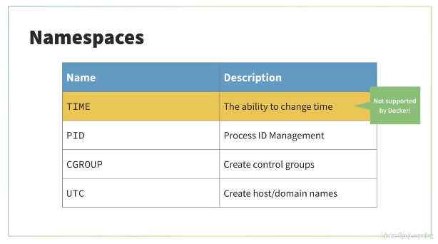
.

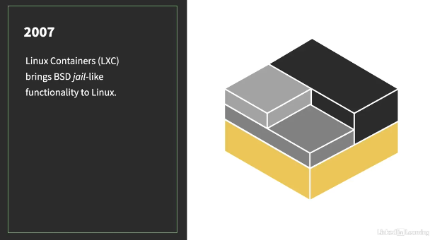
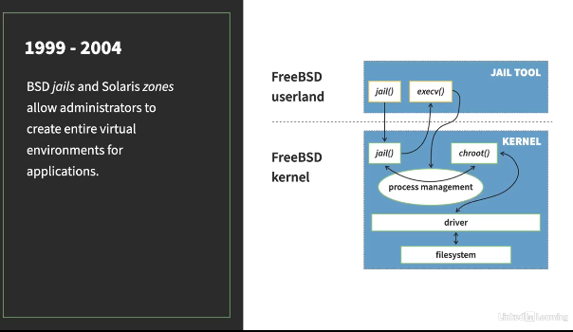
.
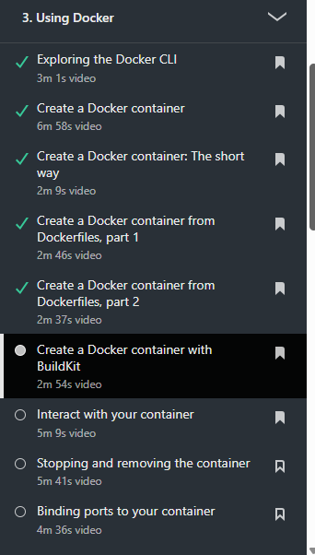
Ways for Creating Docker Containers

.




