Session 16 Assignment – IAM Best Practices
Name – Precious Nwafor
USER GROUPS CREATED
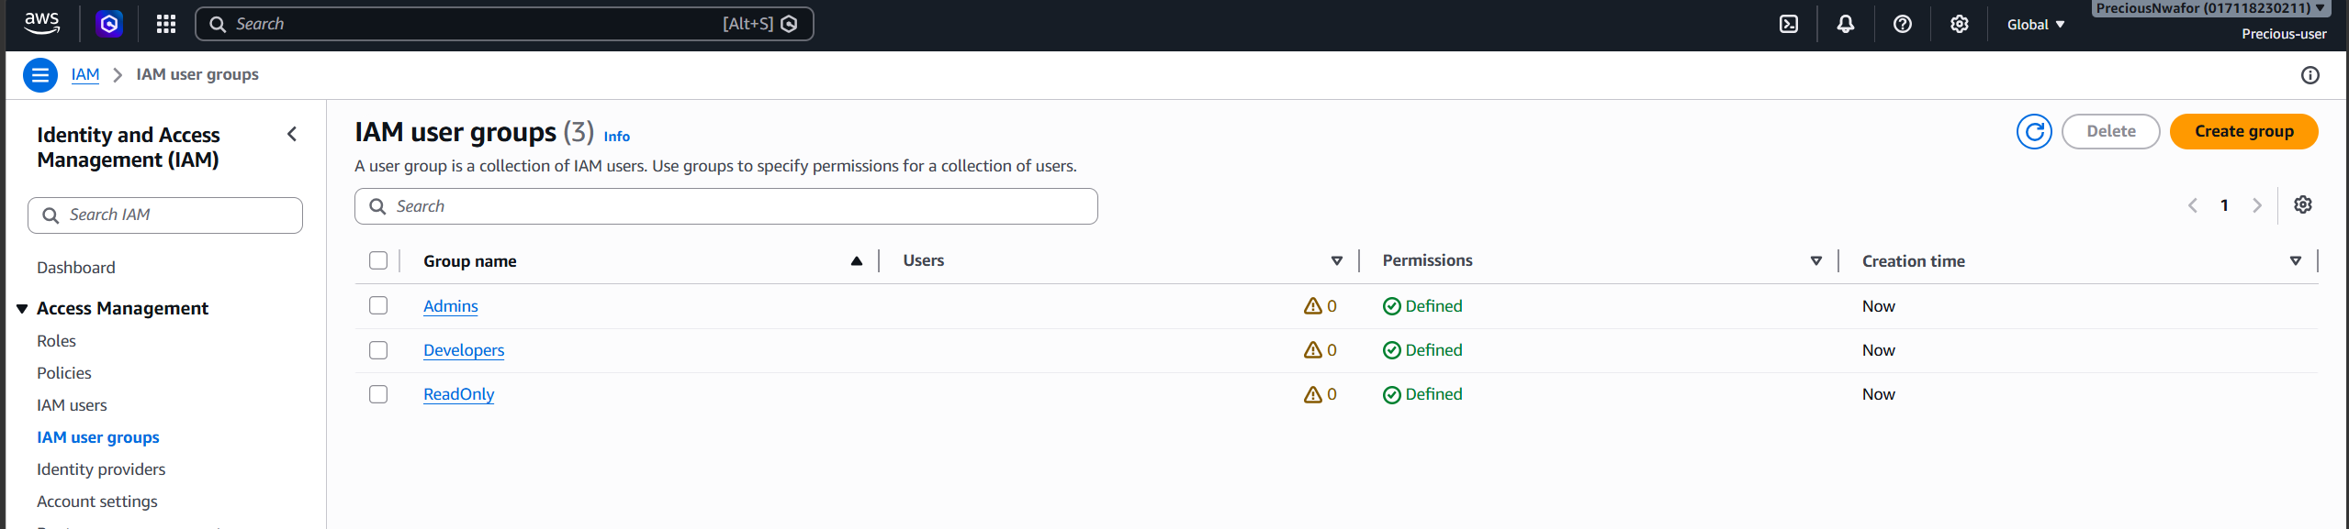
ADMIN USER POLICY
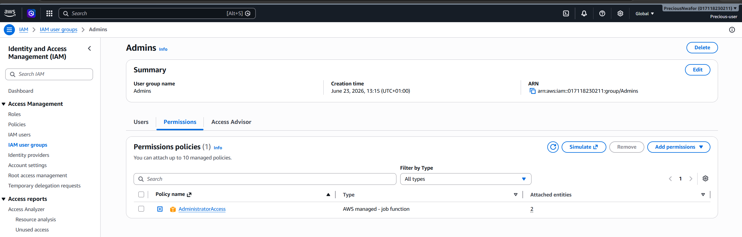
DEVELOPER USER POLICY
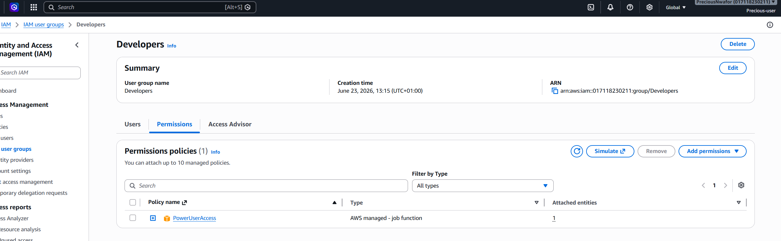

READ-ONLY USER POLICY
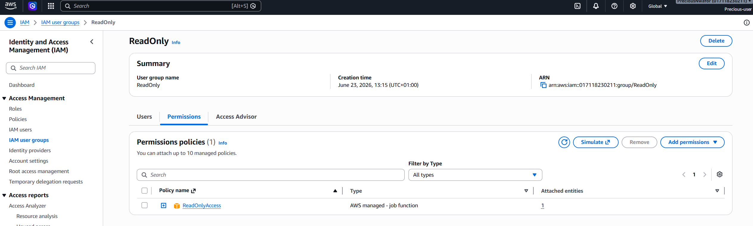
MFA ASSIGNED TO ALICE-ADMIN
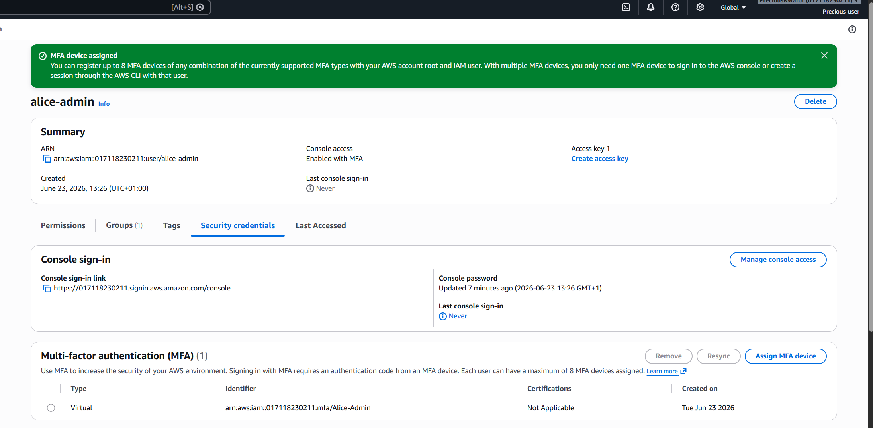

MFA ASSIGNED TO BOB-DEVELOPER
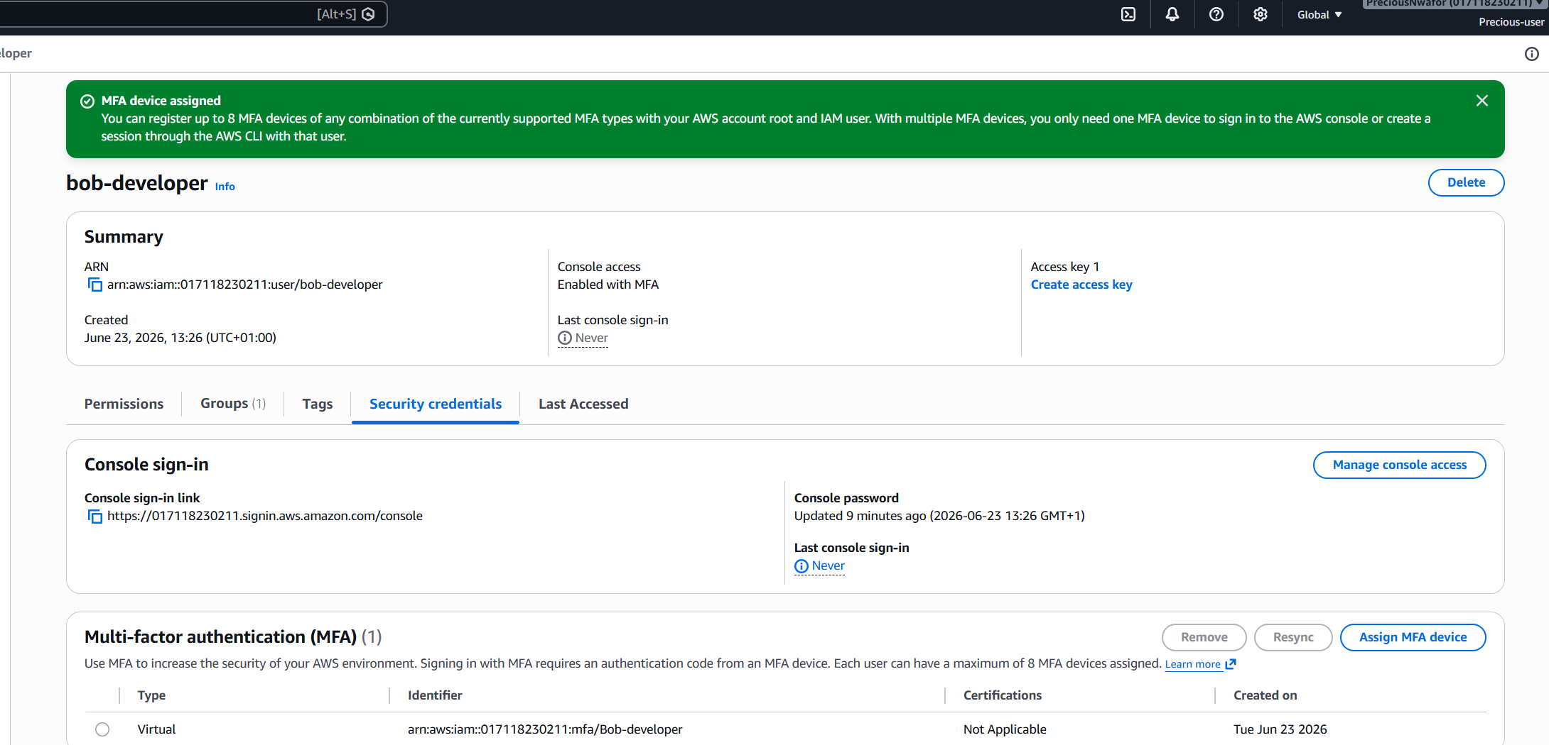

MFA ASSIGNED TO CAROL-READONLY
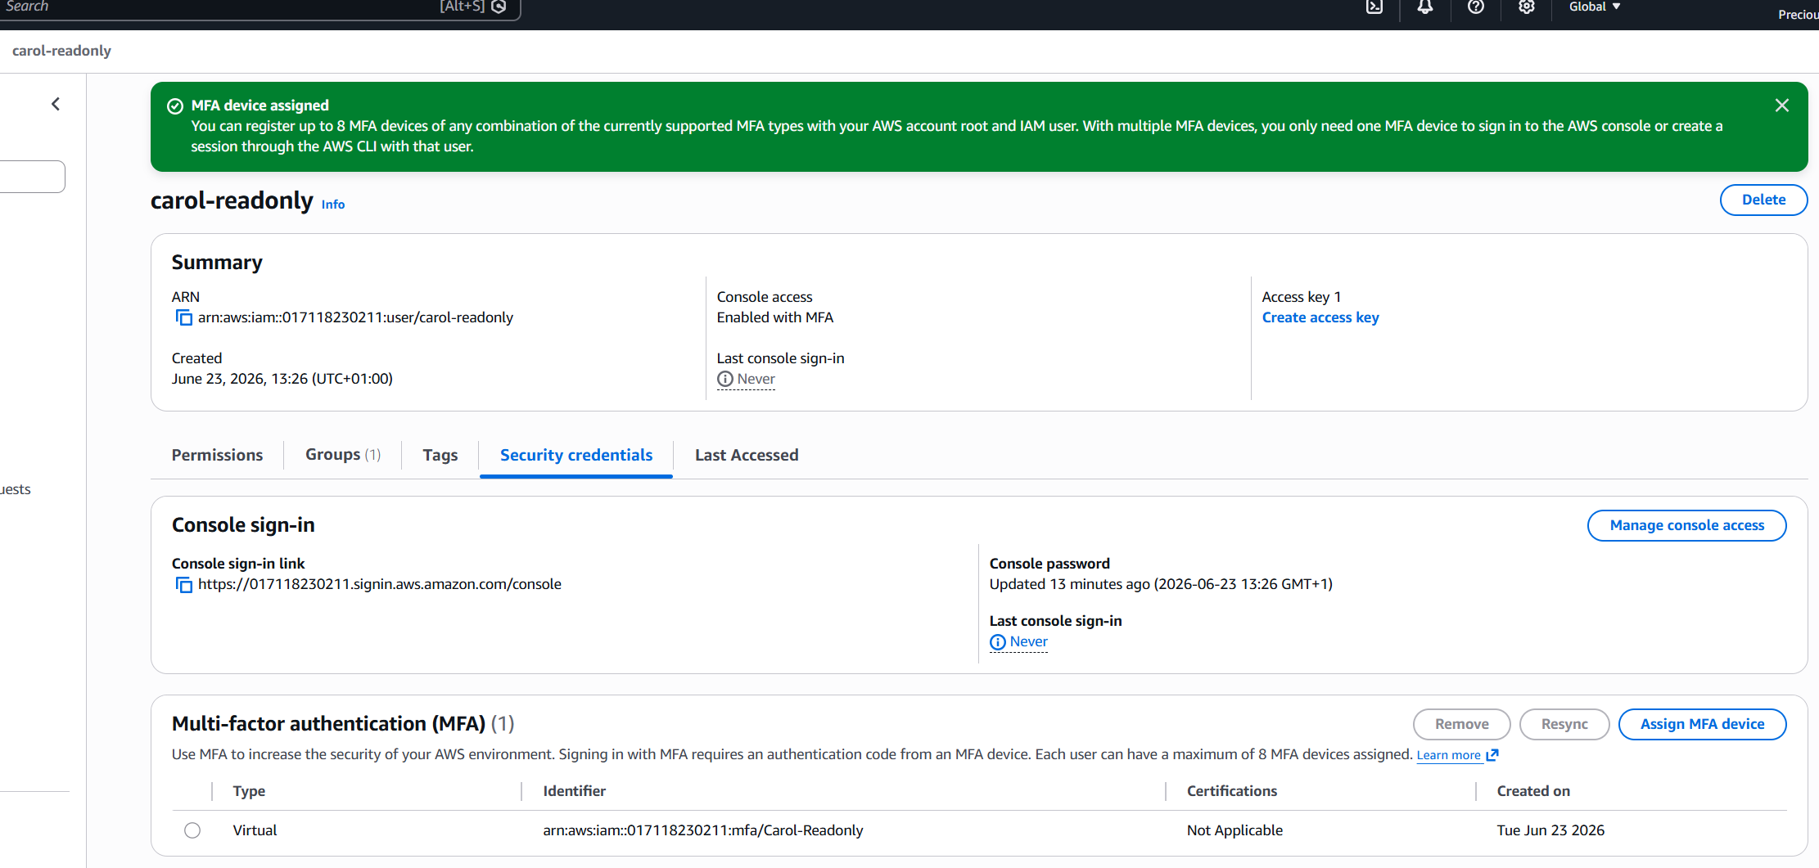
CREATE EC2 IAM ROLE WITH S3 READ ACCESS
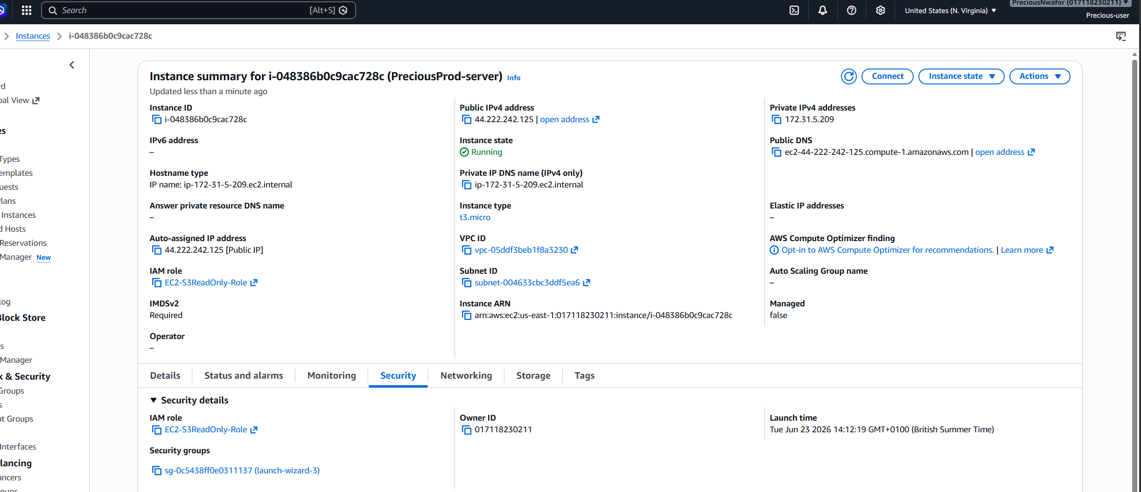

SSH into EC2 AND RUN AWS S3 LS (IT WORKS WITHOUT ANY AWS CONFIGURE)
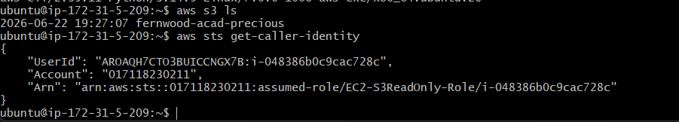

DOWNLOAD IAM CREDENTIAL REPORT
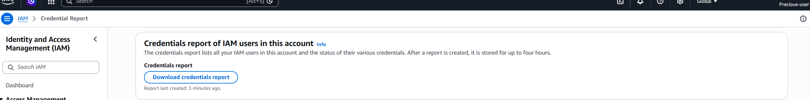

IAM CREDENTIAL REPORT
