Session 17 Assignment – S3 AND STORAGE
Name – Precious Nwafor
CREATE BUCKET
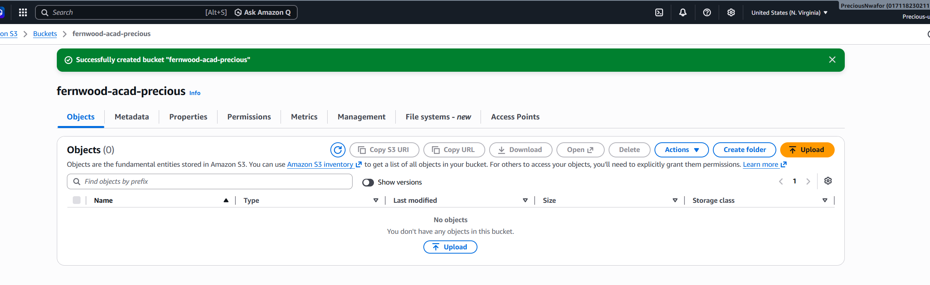

ENABLE BUCKET VERSIONIING
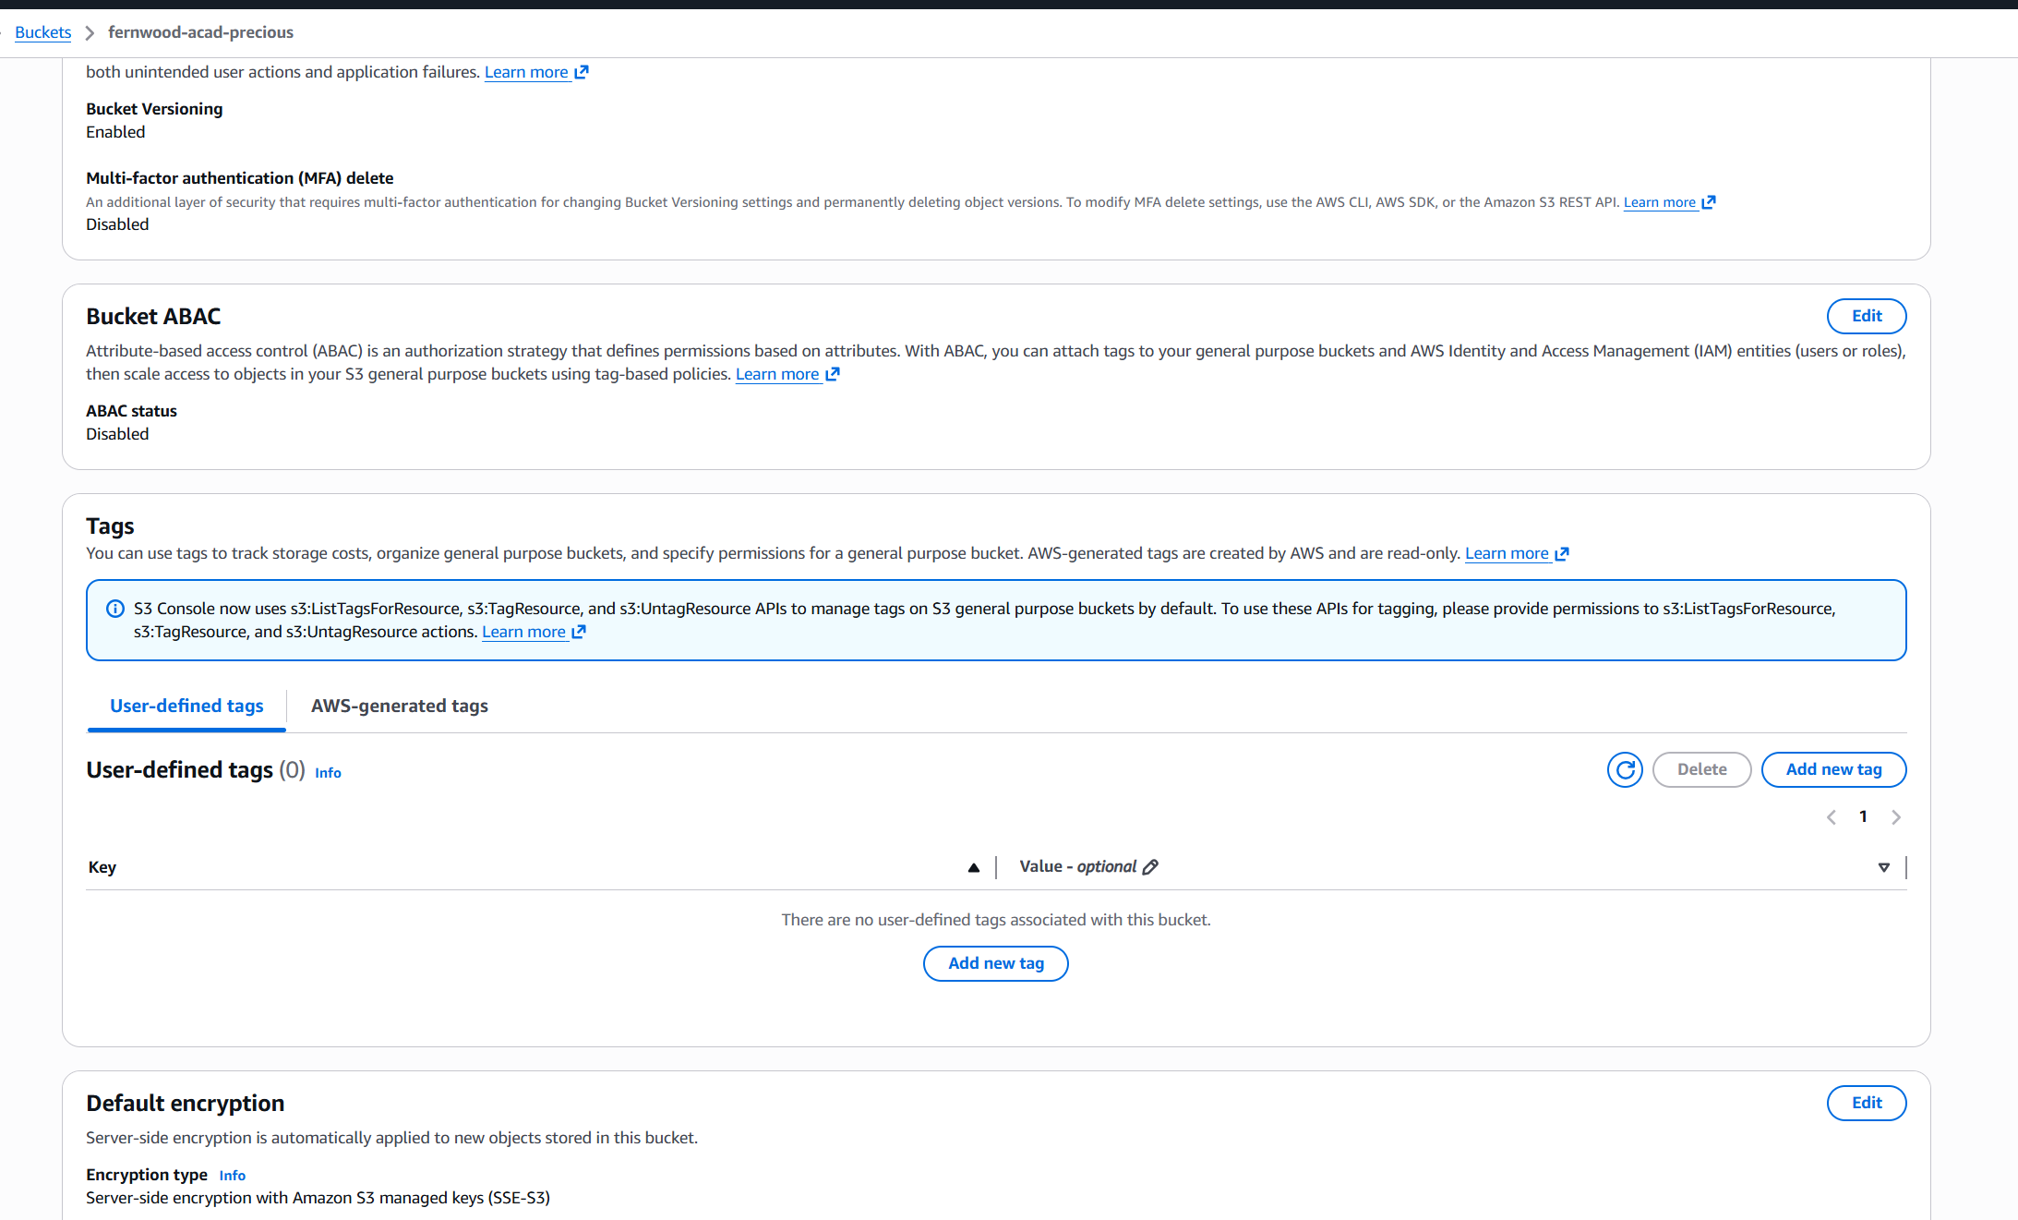

GENERATE PRE-SIGNED URL FOR ONE OBJECT EXPIRING IN ONE HOUR

HTML PAGE WITH NAME AND BIO AS A STATIC WEBSITE
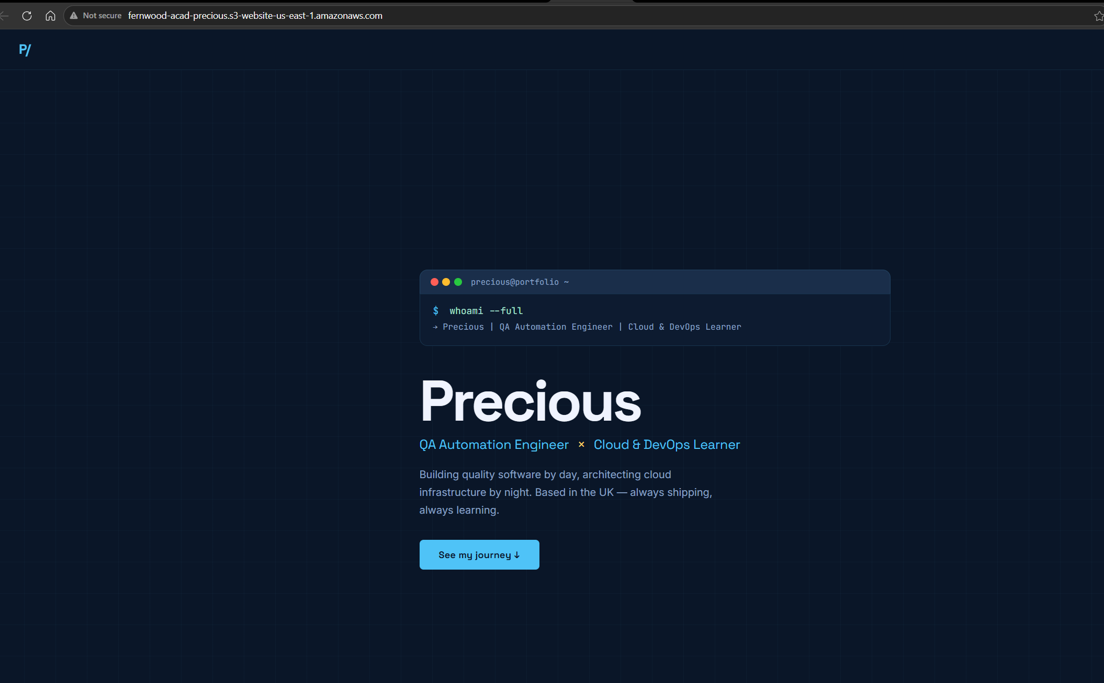

LIFECYCLE RULE
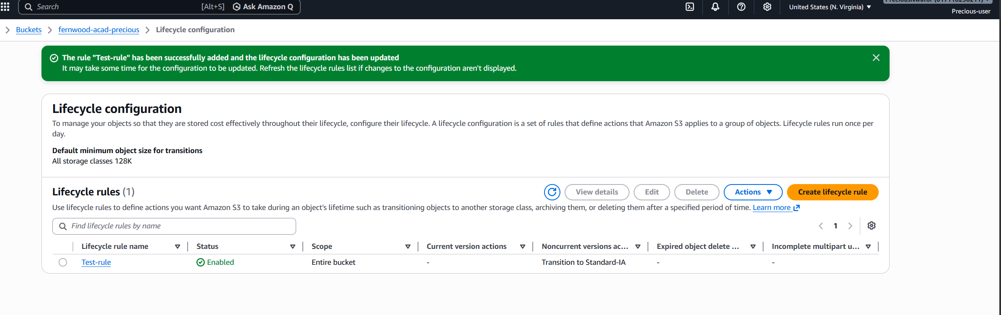

LIFECYCLE RULE TO TRANSITION OBJECTS TO STANDARD-IA AFTER 30 DAYS
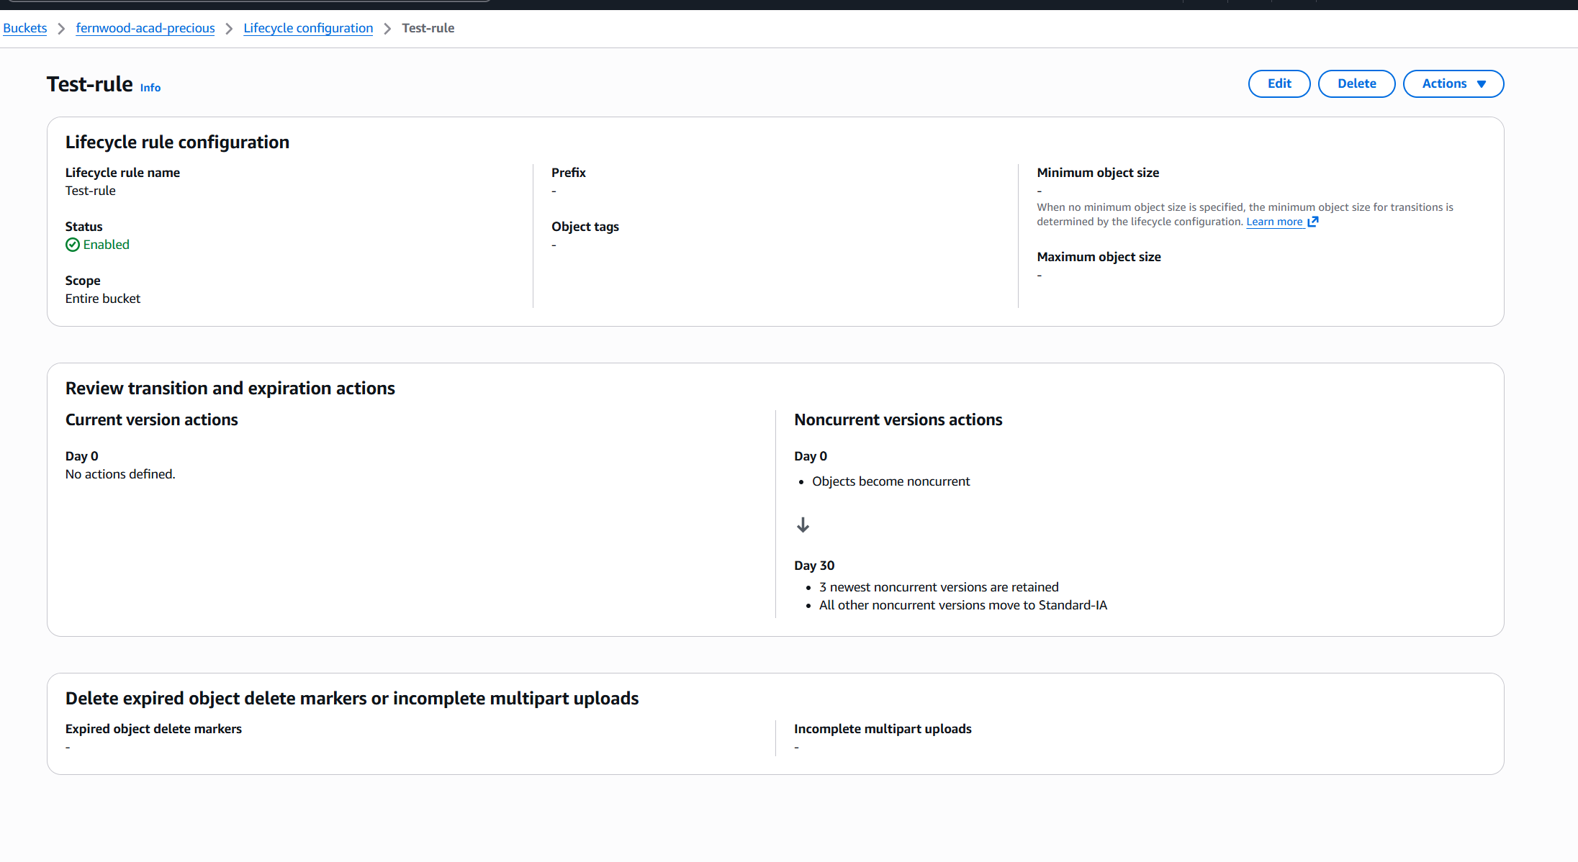

CLOUDFRONT
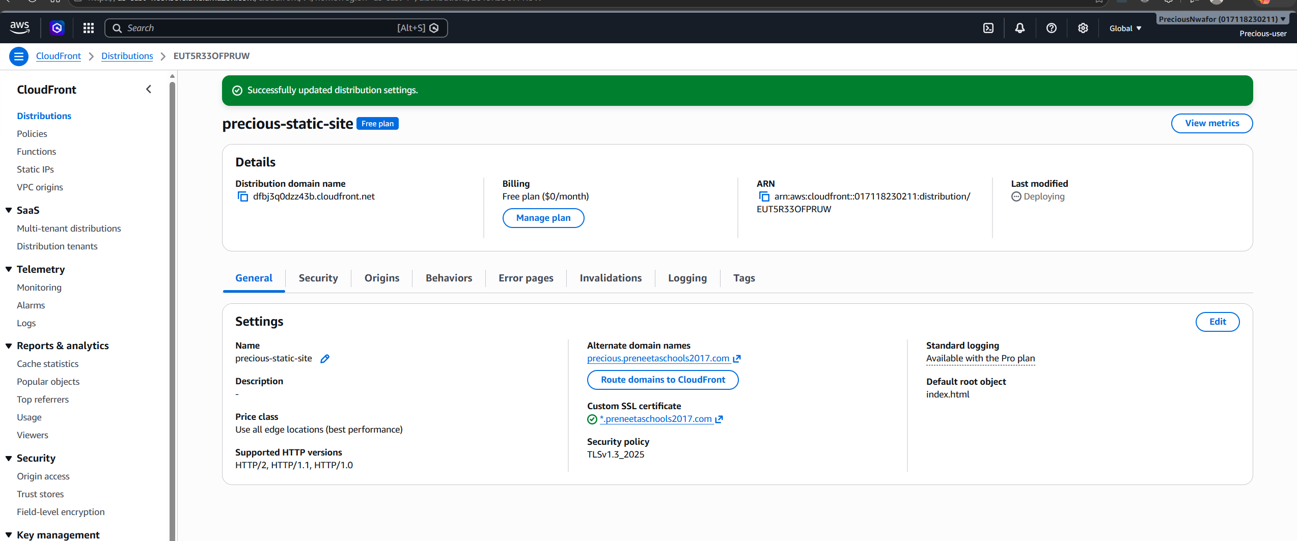

MY PUBLIC WESITE URL
https://precious.preneetaschools2017.com/

