Session 21 Assignment – Security Best Practices and Cost Control
Name – Precious Nwafor

ENABLE GUARDDUTY (30-DAY FREE TRIAL)
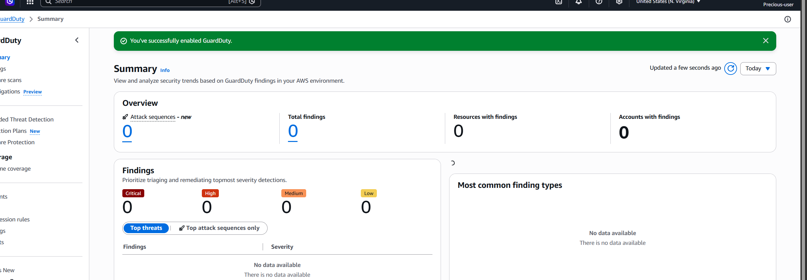

CREATE A CLOUDTRAIL TRAIL WRITING TO AN S3 BUCKET
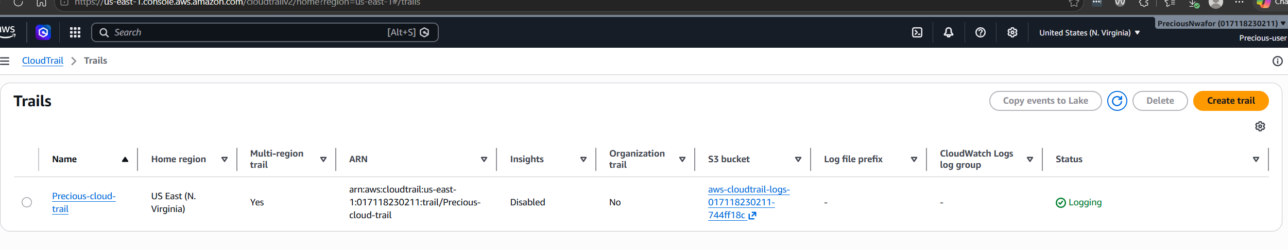

SET UP A ROOT-LOGIN CLOUDWATCH ALARM WITH SNS EMAIL
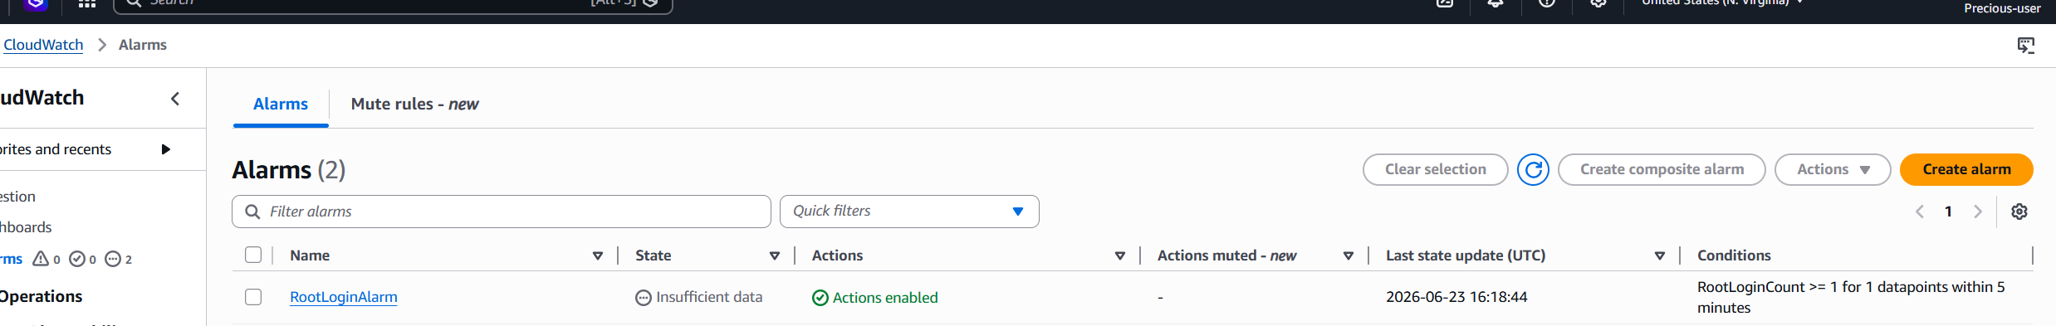

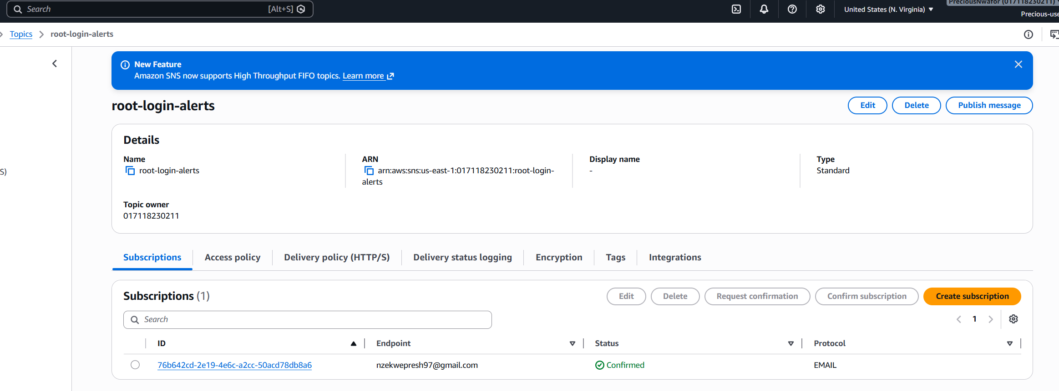
REVIEW YOUR BILLING DASHBOARD AND FIND THE TOP 3 SOURCES OF SPEND THIS WEEK
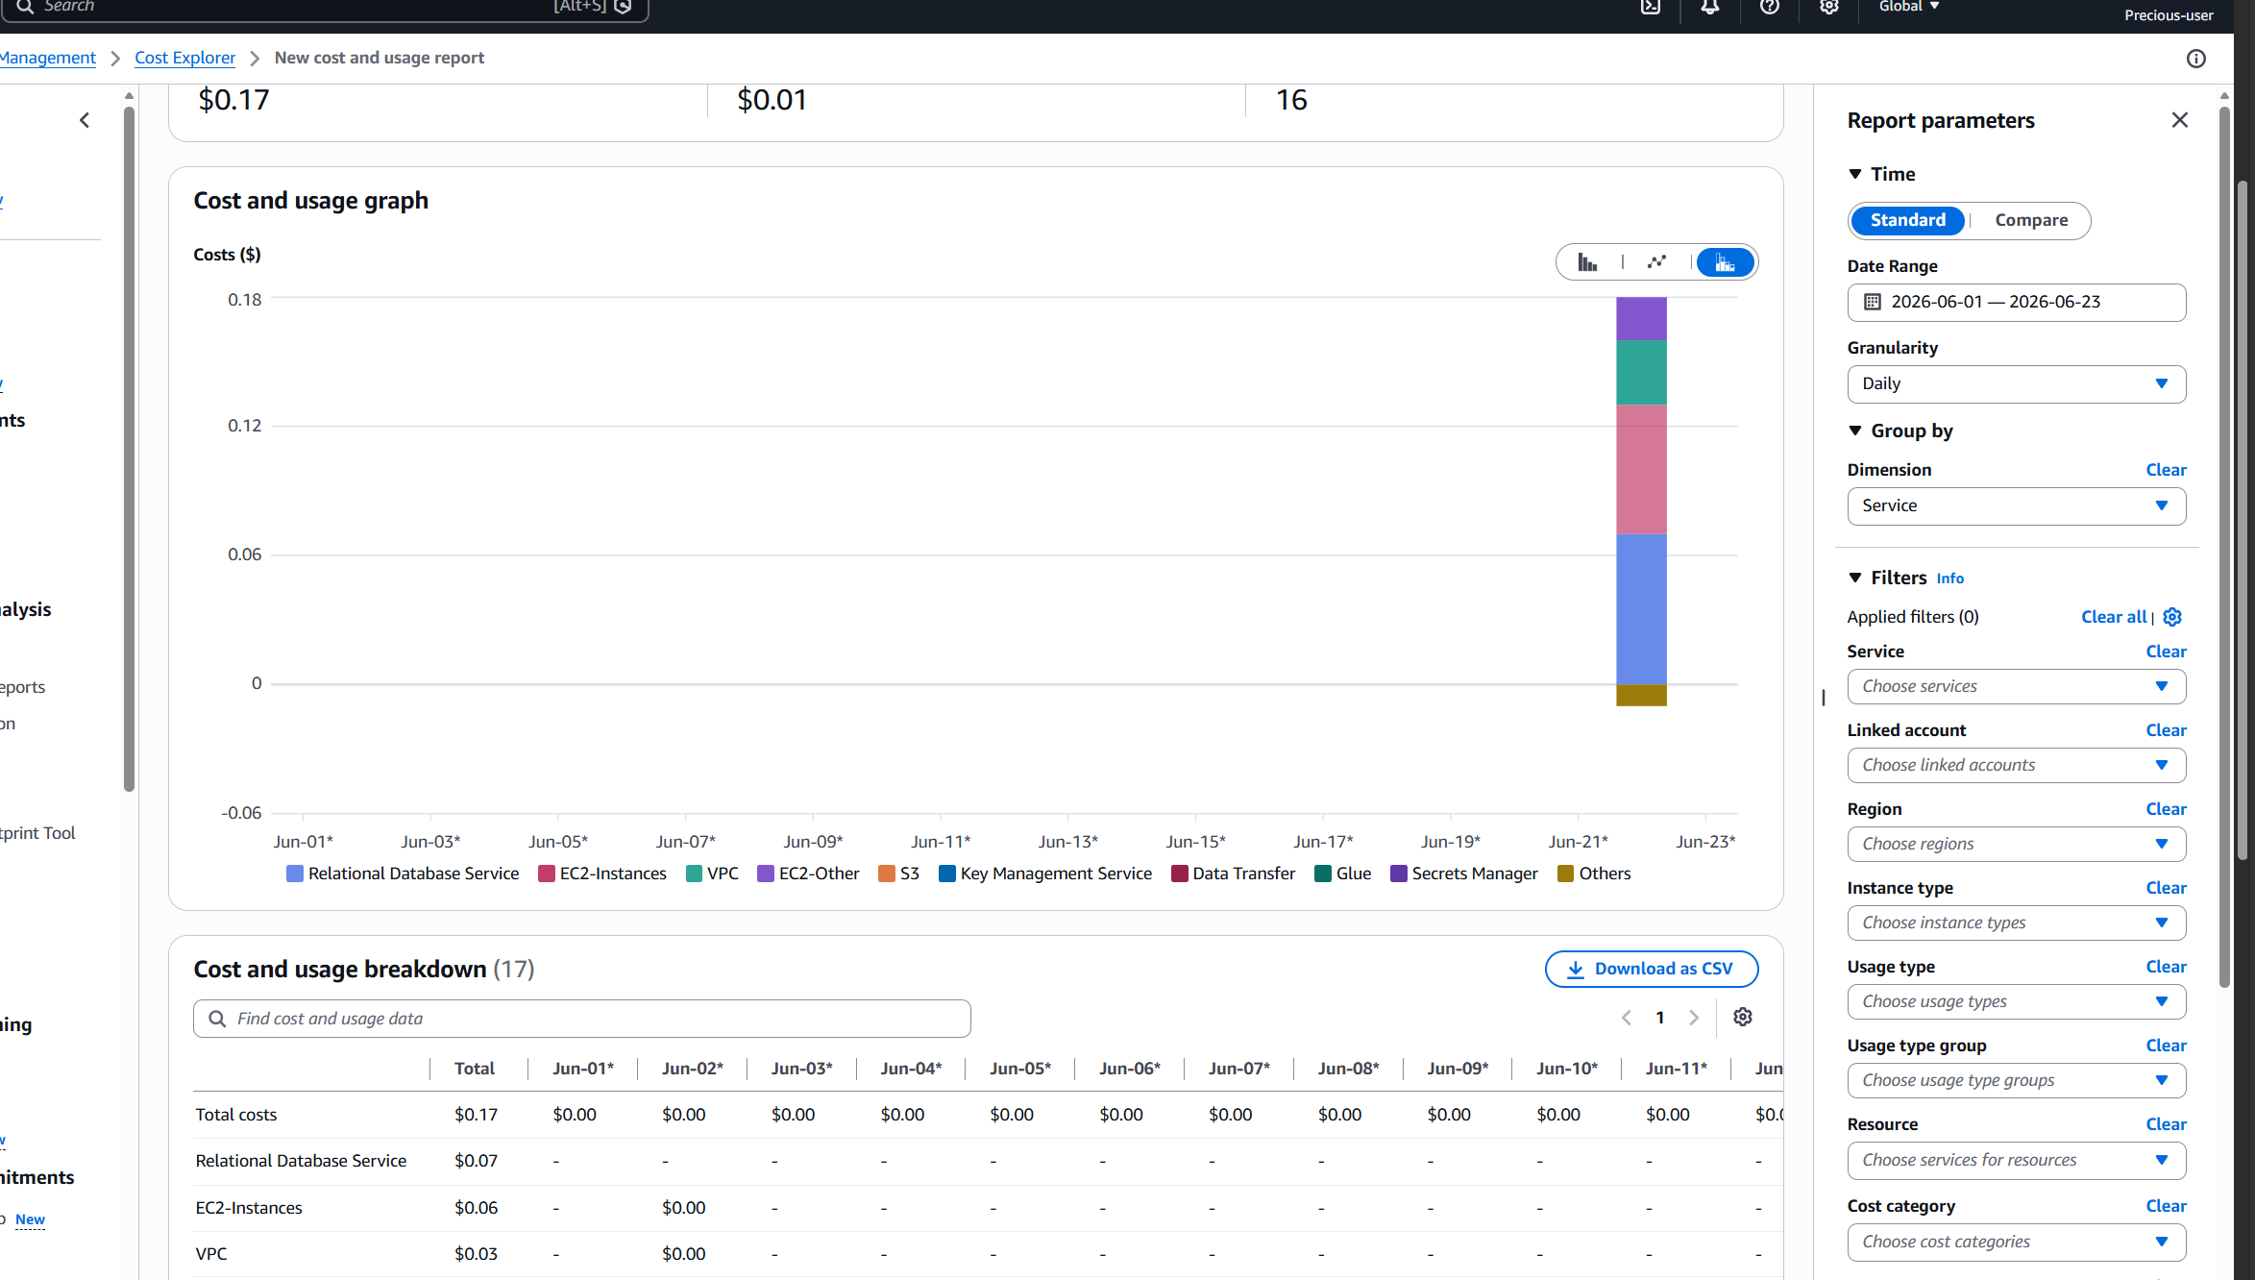

CREATE AN AWS BUDGET FOR $10/MONTH WITH EMAIL ALERTS AT 80% AND 100%
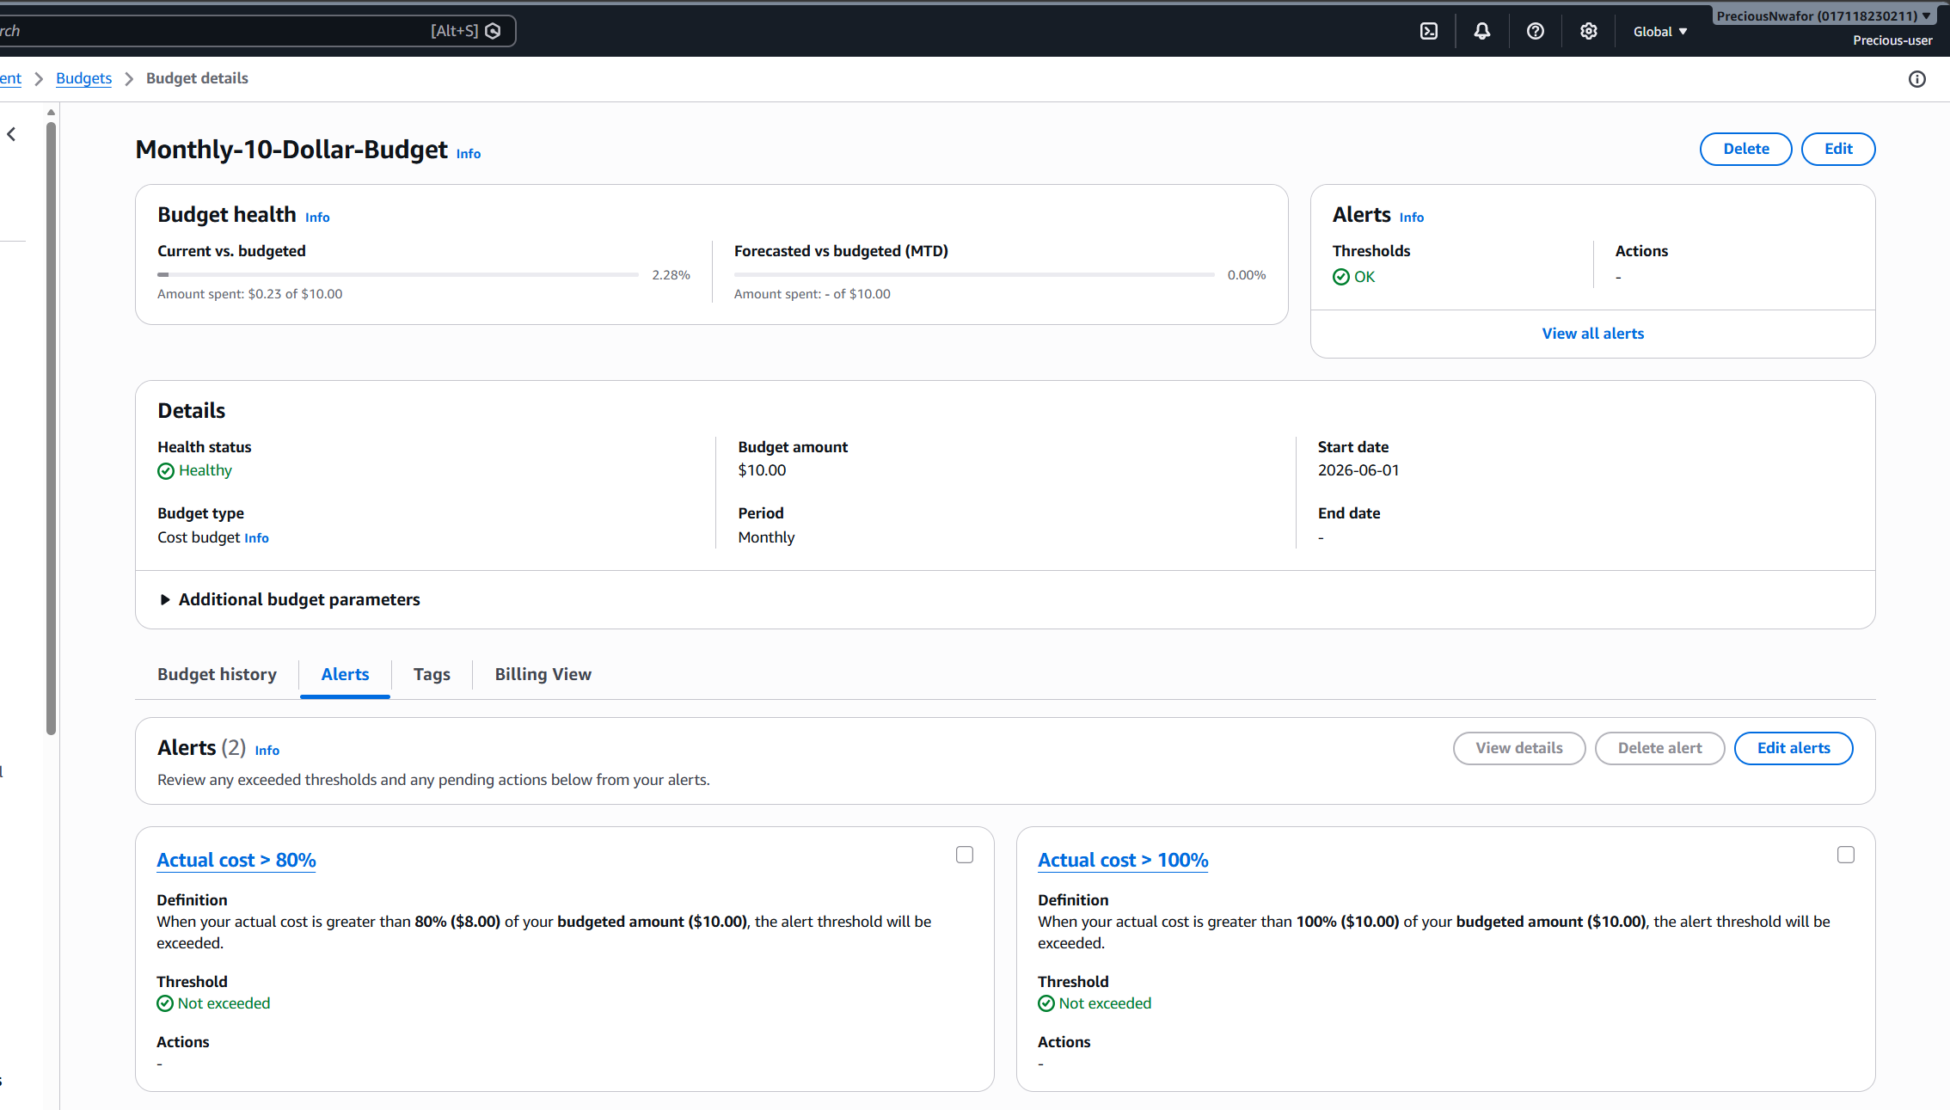

RUN TRUSTED ADVISOR AND SCREENSHOT ANY SECURITY WARNINGS
