Session 18 Assignment – RDS
Name – Precious Nwafor
- RDS launched and available
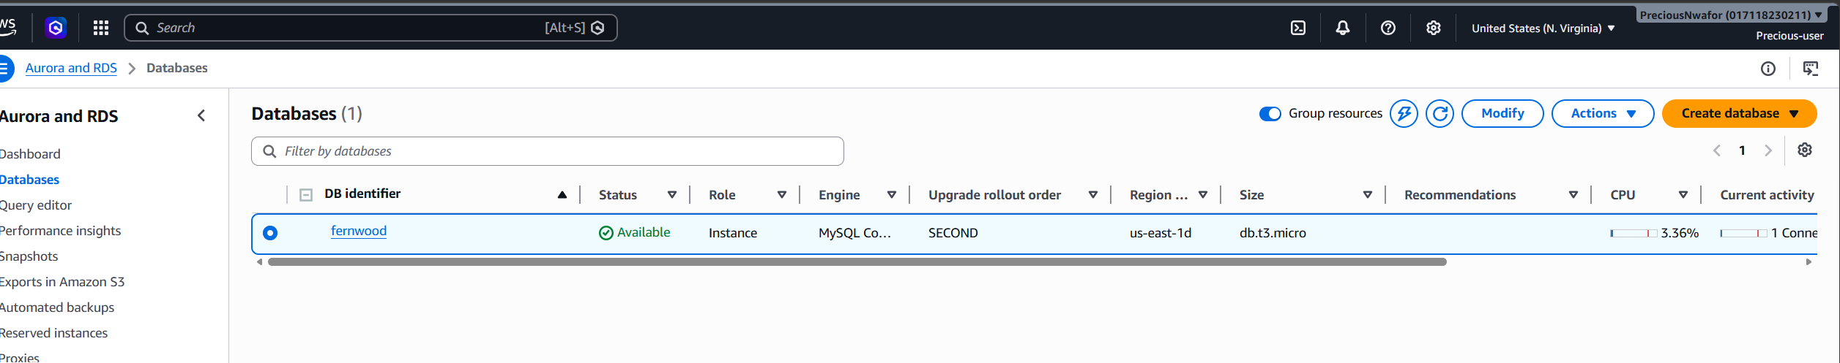

- Screenshot of Projects table
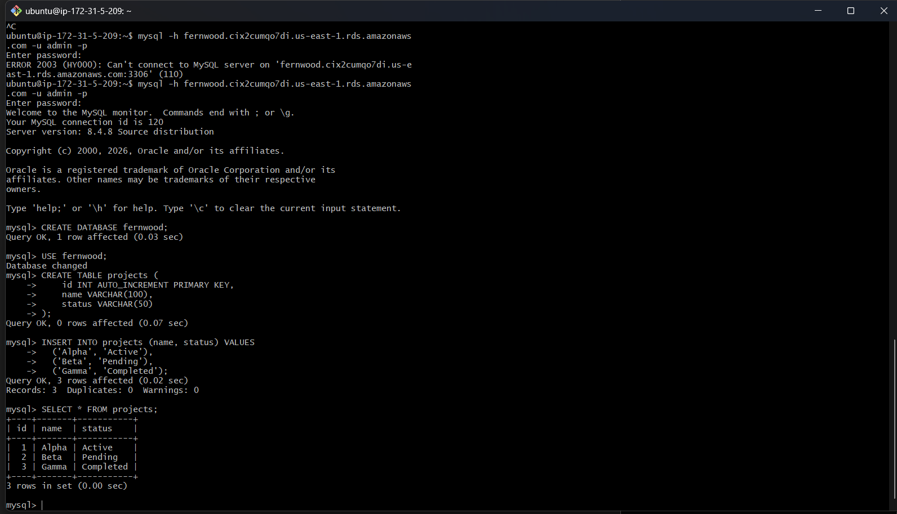

- RDS instance deleted
