NAME: PRECIOUS NWAFOR
WEEK 5- Introduction to Cloud Concepts, IAM & VPC Networking
Ai) Enable MFA on root
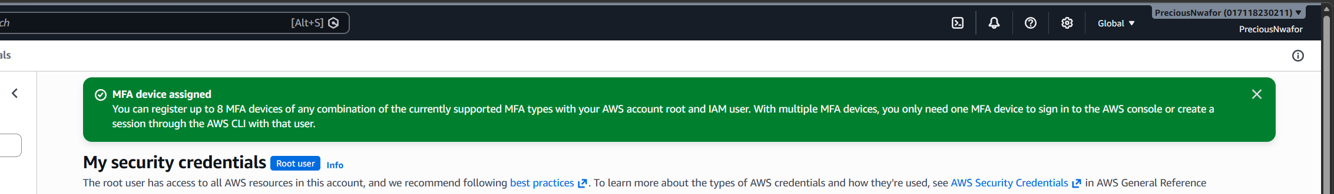

ii) Create an IAM admin user with MFA
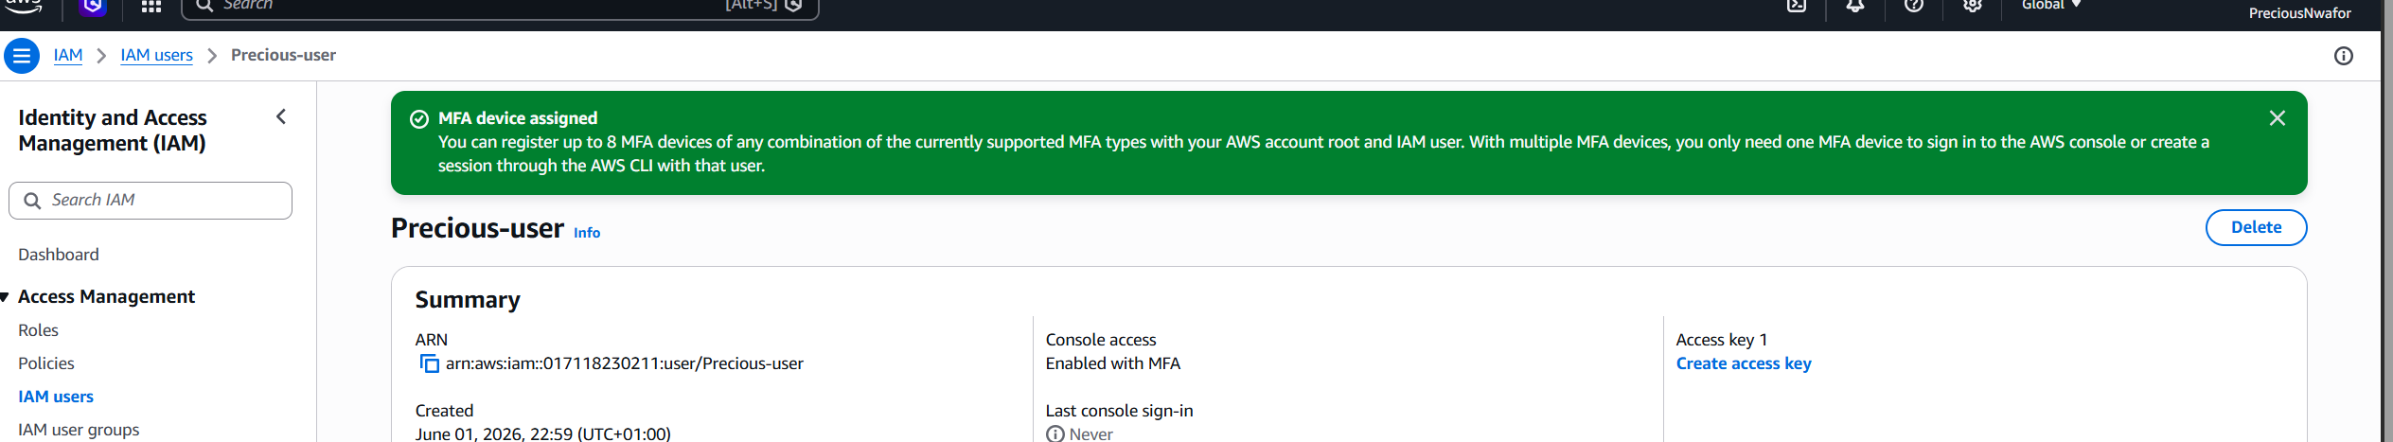

iii) Create a Billing Alert for $10
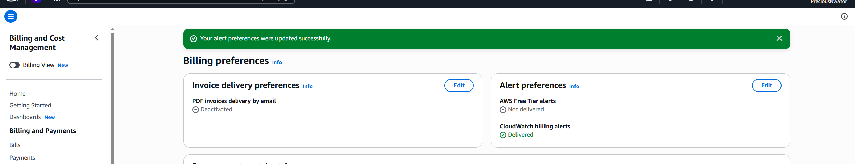

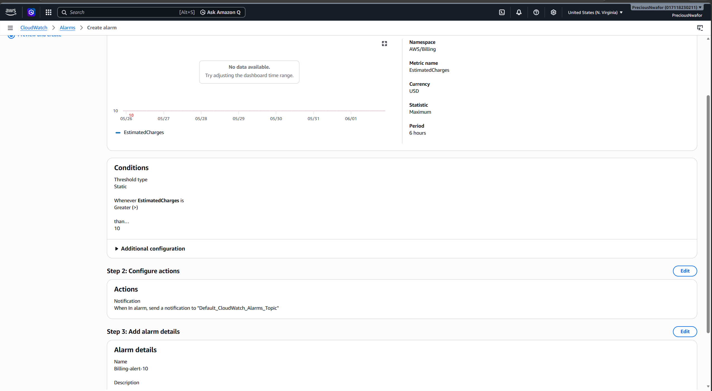
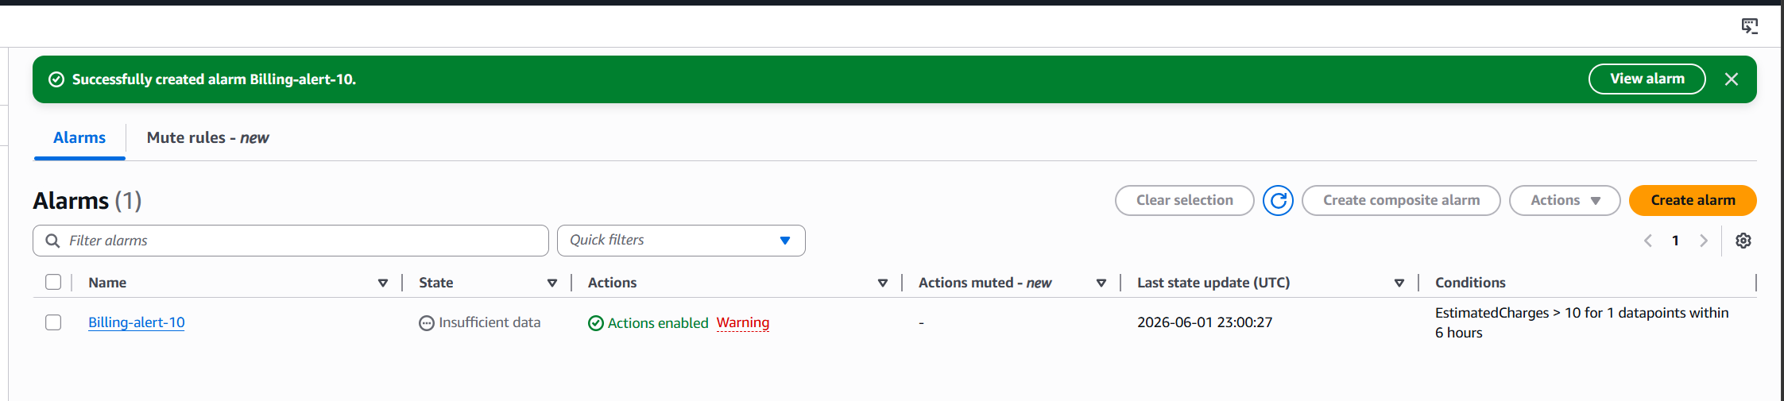

iv) Log in as your IAM admin user and confirm it works
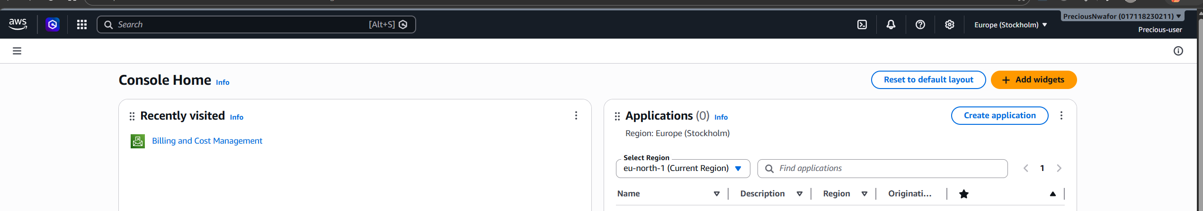

B) Introduction to VPCs and Networking
i) Create Vpn
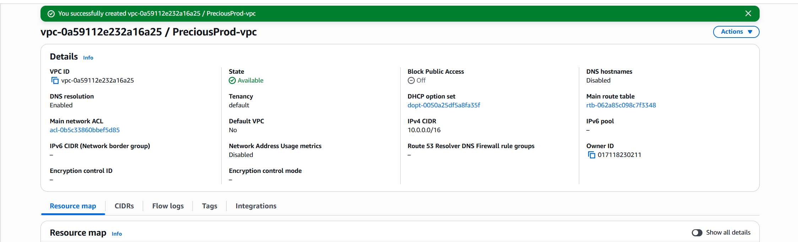

ii) Create public and private subnet

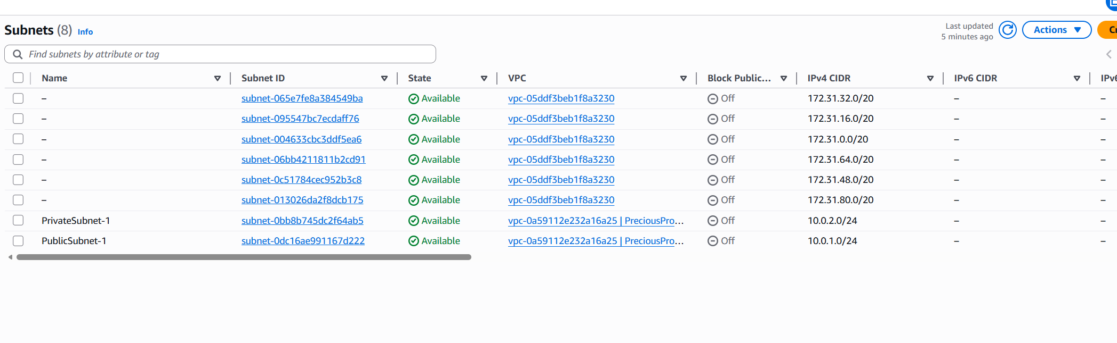

iii) Create internet gateway
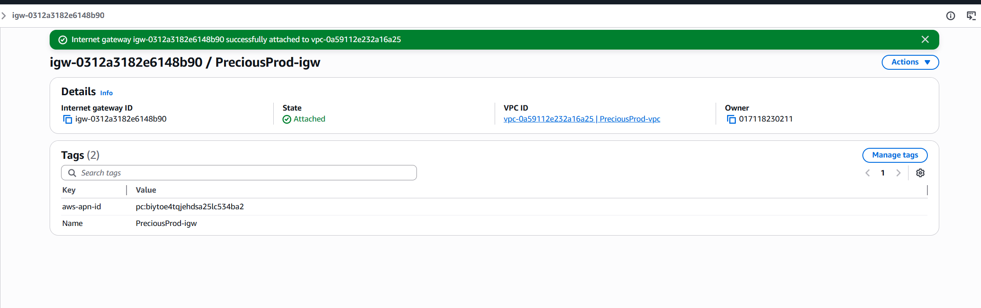

iv) Create Route table and associate subnet
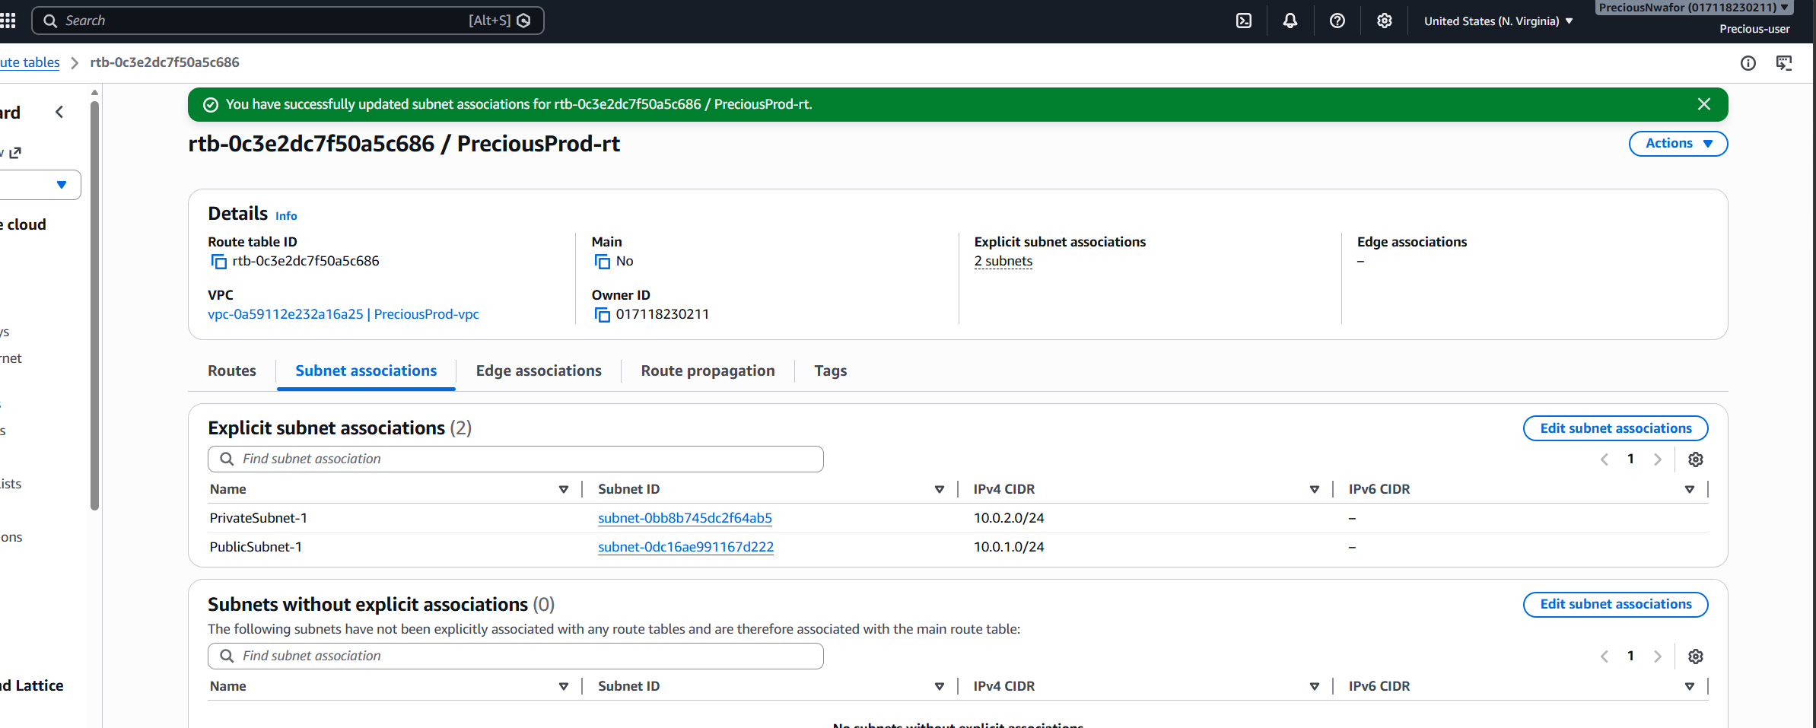

v) Launch instance

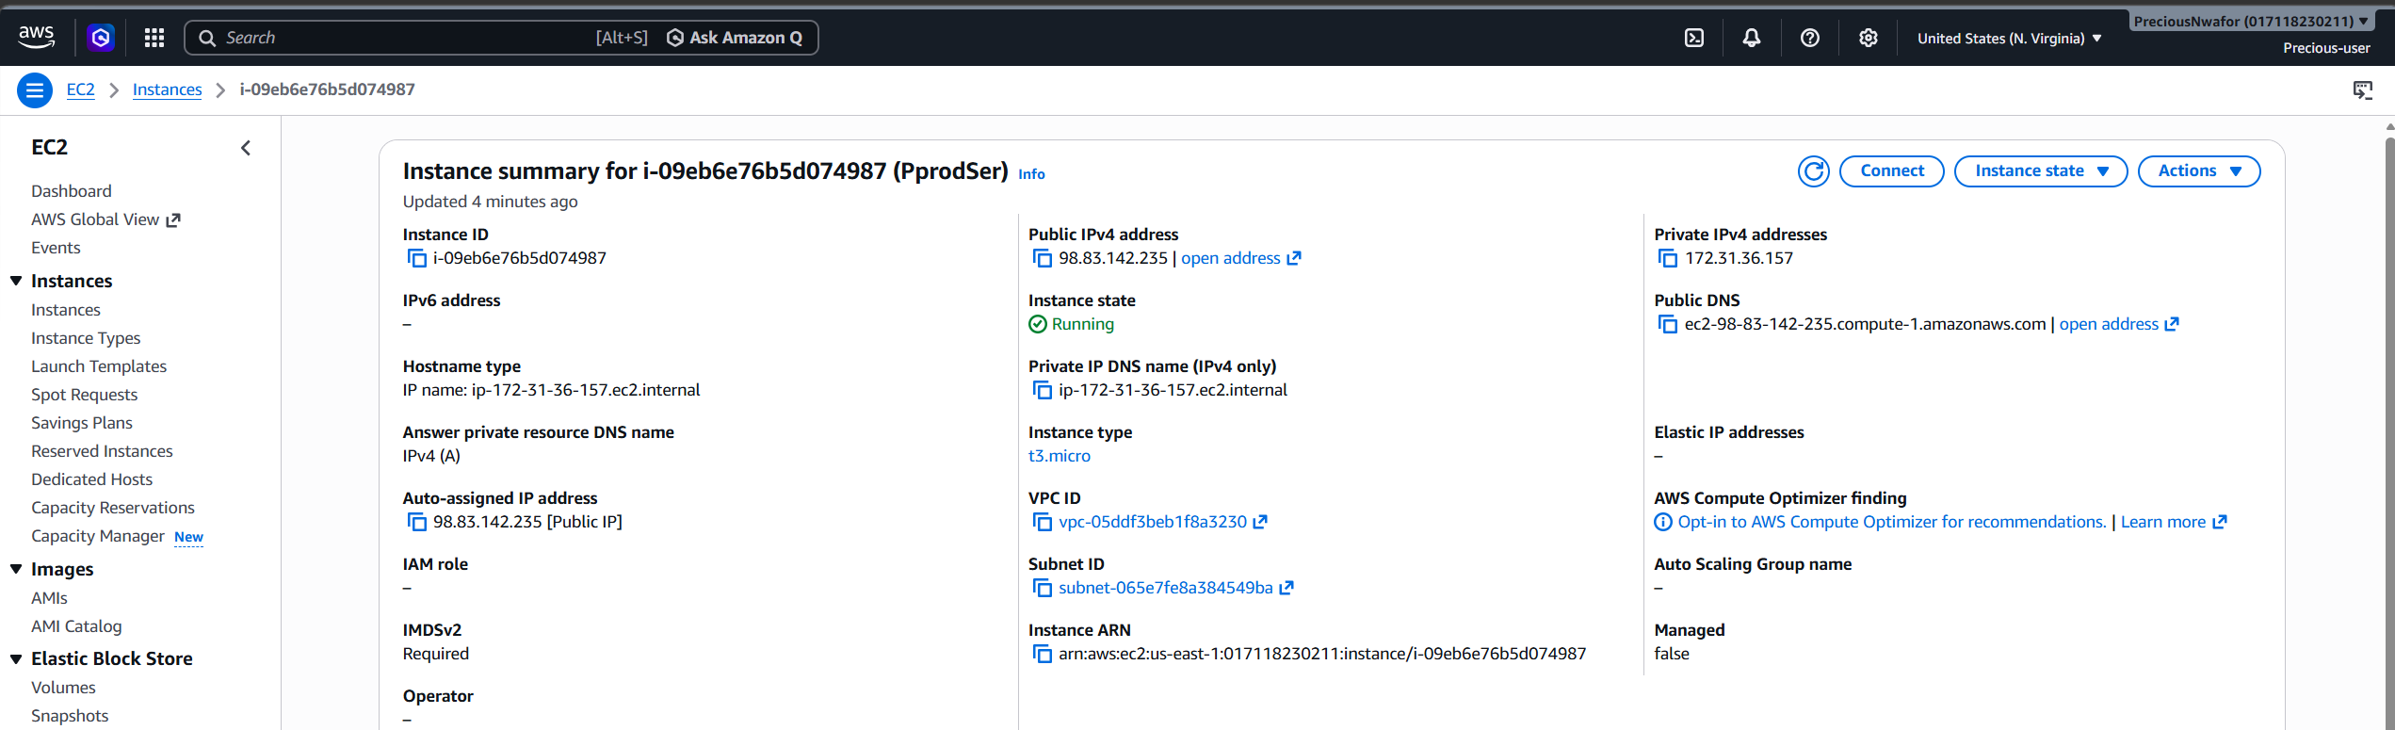

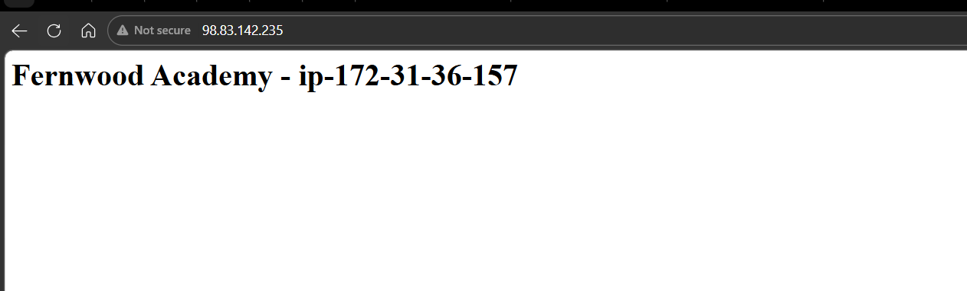

vi) Instance stopped
