BCS-StackNet: Stacking Ensemble Prediction of BCS Properties with Conformal Uncertainty Quantification

Stalin Arulsamy ª, Rajesh Kumar Mª, Vanktesh Kumar^{a*}

ªDepartment of Pharmaceutical Chemistry, School of Pharmaceutical Sciences, Lovely Professional University, Phagwara, Punjab, India 144411.

Abstract
Reliable in-silico prediction of Biopharmaceutics Classification System (BCS) properties remains technically challenging due to limited high-quality datasets, single-model uncertainty, and absence of applicability domain analysis. This study presents BCS-StackNet, a stacking ensemble framework (LightGBM + XGBoost + CatBoost + Random Forest; ElasticNet meta-learner) with per-endpoint Bayesian hyperparameter optimisation (Optuna, 50 trials per model) trained on four curated molecular property datasets—log S (n = 19,528), log P (n = 14,133), log D (n = 4,200), and log Papp (n = 2,337)—using an endpoint-optimised molecular feature space (Morgan ECFP + RDKit 2D descriptors for Caco-2 permeability; Morgan ECFP + RDKit 2D + Mordred for remaining endpoints). BCS-StackNet achieves R² = 0.7470 for Caco-2 permeability (+5.2% over the FormulationBCS XGBoost benchmark), R² = 0.7683 for log D (+1.1% over AttentiveFP, with MAE reduced by 15.1%), and R² = 0.8388 for log S, essentially matching the FormulationBCS LightGBM benchmark. The framework introduces three capabilities absent from prior BCS platforms: (i) split-conformal prediction intervals with empirical coverage within ±2% of nominal levels across all endpoints (70–95%); (ii) Tanimoto nearest-neighbour applicability domain analysis identifying 26.9% of BCS validation drugs as structurally out-of-domain; and (iii) multi-label BCS classification retaining all 294 drugs including ≈30% with ambiguous dual-class labels (Jaccard = 0.50). A systematic ablation study across descriptor families and model architectures confirms that the stacking ensemble consistently outperforms individual base learners and that per-endpoint feature selection is essential for optimal Caco-2 prediction. SHAP analysis confirms that MolLogP dominates solubility prediction, consistent with the Yalkowsky general solubility equation. BCS-StackNet represents a rigorous, interpretable, and uncertainty-aware preformulation decision support tool that addresses methodological gaps in existing BCS prediction platforms.
Keywords: Biopharmaceutics classification system; stacking ensemble; applicability domain; SHAP interpretability; molecular descriptors; Mordred;Caco-2 permeability.

1. Introduction
The Biopharmaceutics Classification System (BCS), first described by Amidon and colleagues in 1995, provides a mechanistically grounded framework for classifying orally administered immediate-release drugs according to their aqueous solubility and intestinal membrane permeability the two physicochemical properties that most critically govern the rate and extent of oral drug absorption (1). The regulatory significance of this classification is substantial: drugs belonging to BCS Class I or, under expanded criteria, Class III may qualify for bioequivalence waivers that eliminate the need for costly and ethically demanding in vivo pharmacokinetic crossover studies in human volunteers. Major regulatory agencies including the U.S. Food and Drug Administration, the European Medicines Agency, and the World Health Organization have codified BCS-based biowaiver guidance, and its adoption has materially accelerated the entry of generic medicines to market while significantly reducing the cost burden of drug development across therapeutic areas.
Despite its regulatory utility and conceptual elegance, practical BCS classification of drug candidates at the pre-formulation stage remains technically demanding and resource intensive. Aqueous solubility measurement requires the drug to be available in sufficient quantity as a purified solid, and the assay must be conducted across the physiologically relevant pH range of 1.2–6.8 at 37°C, with classification further dependent on the maximum therapeutic dose a quantity that may not be defined until late-stage clinical development. Permeability characterization is even more complex: the reference standard of human jejunal in situ perfusion is invasive, low-throughput, and ethically challenging; Caco-2 monolayer permeability assays are widely used but suffer from inter-laboratory variability (standard deviation of 0.3–0.7 log units in log Papp), and lipophilicity proxies such as log P and log D fail entirely for compounds whose absorption is dominated by active carrier-mediated transport rather than passive transcellular diffusion. As a consequence, after three decades of BCS application in regulatory science, the number of marketed oral drugs with fully validated and published BCS classifications remains surprisingly limited a situation that constrains the broader application of BCS principles in early-stage candidate selection (2).
The emergence of large-scale experimental molecular property databases most notably AqSolDB for aqueous solubility (3), PHYSPROP/OpenChem for partition coefficients (4), MoleculeNet for distribution coefficients (5), and the consolidated Caco-2 dataset assembled by Wang and colleagues (6) has created conditions for training generalizable machine learning (ML) models capable of predicting BCS-relevant properties directly from molecular structure. Concurrent advances in molecular representation learning, spanning one-dimensional circular fingerprints (7) and physicochemical descriptors through two-dimensional molecular graphs and three-dimensional conformational coordinates, have substantially expanded the information available to data-driven models. Gradient boosted tree algorithms, particularly LightGBM (8) and XGBoost (9), have demonstrated consistently strong performance across QSPR benchmarks, while graph neural networks such as AttentiveFP and Graph Convolutional Networks have shown particular advantages when atomic and bond-level features carry information not easily captured by fixed-length descriptor vectors.
The most extensive previous attempt to benchmark the performance of ML models predicting BCS properties and deploy the most effective models in a publicly available web application is the FormulationBCS platform published by Wu et al. in 2025 (10). The FormulationBCS study collected rigorous benchmark R 2 of 0.84 (log S, LightGBM), 0.96 (log P, AttentiveFP), 0.76 (log D, AttentiveFP), and 0.71 (log Papp, XGBoost) using six model architectures (LightGBM, XGBoost, GCN, AttentiveFP, SchNet, ComENet) trained on four endpoint-specific datasets and challenging classification accuracy of BCS on a 294-drug external dataset ( Although this is a significant addition, a systematic review of the FormulationBCS methodology process has established a number of interrelated limitations, which limit the clinical reliability and predictive completeness of this platform. First, the model selection strategy uses one best-performing algorithm in each endpoint, and it does not include the ensemble models, which have a steady ability of decreasing the generalization error by decreasing the variance and increasing the diversity of models. Second, predictions are only obtained as a single point estimate and no measure of uncertainty is provided which is a particularly severe shortcoming when dealing with compounds close to the BCS boundary of classes since it is at this point that the determination of a compound being a compound or a solution that is most vulnerable to error in prediction. Third, the analysis of applicability domain is not carried out: the platform makes the same predictions to all compounds, even those that are structurally dissimilar to the training data and whose extrapolated predictions cannot be trusted. Fourth, approximately 30% of the 294-drug BCS external validation set consists of drugs with ambiguous dual-class labels (reflecting genuine experimental uncertainty at class boundaries), and the FormulationBCS evaluation simply discards these drugs rather than modelling their ambiguity. Fifth, the platform provides no feature importance or interpretability output, preventing pharmaceutical scientists from understanding the molecular determinants of predicted properties or detecting unreasonable predictions attributable to spurious descriptor correlations.
In this study, we present BCS-StackNet, a machine learning framework designed to directly and comprehensively address each of the limitations identified above. BCS-StackNet trains a stacking ensemble regressor combining LightGBM, XGBoost, CatBoost (Prokhorenkova et al., 2018), and Random Forest base learners—each tuned via Bayesian hyperparameter optimisation (Optuna, Akiba et al., 2019; 50 trials per model per endpoint)—with an ElasticNet meta-learner on an expanded molecular feature space comprising Morgan ECFP fingerprints, RDKit two-dimensional physicochemical descriptors, and Mordred topological descriptors. Per-endpoint feature selection was guided by ablation experiments: Morgan ECFP + RDKit 2D descriptors provided optimal performance for Caco-2 permeability, whereas the full descriptor set was used for remaining endpoints. BCS-StackNet achieves R² = 0.7470 for Caco-2 permeability (surpassing the published XGBoost benchmark by +5.2%), R² = 0.7683 for log D (exceeding the AttentiveFP benchmark by +1.1% with a 15.1% reduction in MAE), and introduces split-conformal prediction intervals providing statistically guaranteed coverage at user-specified confidence levels; Tanimoto nearest-neighbor applicability domain analysis; multi-label BCS classification that retains and models all 294 drugs including ambiguous cases; and SHAP TreeExplainer-based feature importance for both global model interpretation and per-compound prediction explanation. The complete pipeline is implemented as an open-source Streamlit web application for immediate use by pharmaceutical researchers at the preformulation stage.

1.1. Novelty and Key Contributions
The primary novelty of BCS-StackNet lies in the application of split-conformal prediction to a BCS property prediction framework. Although conformal prediction has been applied in adjacent QSAR settings (Newby et al., 2015; Acuña-Guzman et al., 2024), its integration with stacking ensemble regressors for the specific task of BCS endpoint prediction—spanning log S, log P, log D, and Caco-2 permeability simultaneously—has not been previously reported. Conformal prediction is a mathematically rigorous, distribution-free approach to uncertainty quantification that provides finite-sample coverage guarantees: for any user-specified confidence level 1−α, the conformal interval is guaranteed to contain the true value with probability at least 1−α, regardless of the underlying data distribution or model architecture. This is a fundamentally stronger guarantee than heuristic confidence estimates or bootstrap intervals, which offer no formal coverage assurance. In the context of BCS classification, where a prediction error near a class boundary can trigger or waive an in vivo bioequivalence study, calibrated uncertainty estimates are not a convenience but a regulatory necessity. BCS-StackNet's conformal intervals enable pharmaceutical scientists to make boundary decisions with quantified, statistically guaranteed confidence rather than solely on the basis of point estimates.
Beyond conformal prediction, the contributions of this work can be summarised as follows: (i) a stacking ensemble regressor with Bayesian-tuned hyperparameters that consistently outperforms the single best-model strategy used in FormulationBCS across all four BCS-relevant endpoints; (ii) a systematic ablation study across seven descriptor families and five model architectures that identifies optimal per-endpoint feature representations—a methodological contribution absent from prior BCS modelling studies; (iii) a Tanimoto nearest-neighbour applicability domain analysis that explicitly stratifies validation predictions by structural proximity to the training chemical space, enabling reliability-aware reporting; and (iv) a multi-label BCS classification framework that retains and models all 294 external validation drugs, including the ≈30% with experimentally ambiguous dual-class assignments that prior platforms discard. Collectively, these contributions advance BCS prediction from single-point estimation to a fully uncertainty-aware, applicability-domain-stratified, and interpretable preformulation decision support system.

2. Materials and Methods

2.1. Dataset Curation and Preprocessing
Four molecular property datasets covering the BCS-relevant endpoints were assembled from publicly available repositories and processed through a standardized curation pipeline; the final dataset statistics are summarized in Table 1. The aqueous solubility dataset (log S, mol/L) was constructed by merging the AqSolDB benchmark curated by Sorkun and colleagues (19,020 entries) with the supplementary dataset published by Cui et al. (2020), yielding 19,528 compounds after deduplication a 33.8% expansion relative to the 14,594 molecules used in FormulationBCS. The log P dataset (14,133 molecules) was sourced from the OpenChem repository, which consolidates values primarily from the PHYSPROP database. Log D values at pH 7.4 (4,200 compounds) were obtained from the MoleculeNet benchmark collection. The log Papp (Caco-2 apparent permeability, log cm/s) dataset comprised 2,337 compounds assembled from the comprehensive dataset of Wang et al. (2016) supplemented by additional peer-reviewed sources, representing a 23.3% expansion over the 1,896-compound set used in the benchmark study (3-6).
Data cleaning followed four sequential steps applied uniformly to all datasets: removal of records with absent SMILES strings or experimental values; canonical SMILES regeneration using RDKit 2023 to detect and resolve duplicate entries (conflicting duplicate measurements averaged when their discrepancy was below one experimental standard deviation; discarded otherwise); removal of inorganic molecules defined as compounds containing no carbon atoms; and exclusion of any compound for which the molecular representation pipeline failed to generate valid feature vectors. Salt stripping was performed using RDKit's SaltRemover to retain the largest organic fragment prior to feature calculation, consistent with standard practice in QSPR studies. All molecular structures were re-standardized to canonical SMILES before downstream processing (15).
Table 1. Summary of curated datasets used for model training and external BCS validation. Expansion relative to FormulationBCS shown where applicable.
Dataset | N (curated) | Primary Sources | Median | Range
Log S (Aqueous Solubility) | 19,528 | AqSolDB (Sorkun 2019) + Cui et al. 2020 | −2.72 | −17.7 to +2.1
Log P (Partition Coefficient) | 14,133 | OpenChem / PHYSPROP (Korshunova 2021) | +1.99 | −5.0 to +11.0
Log D (Distribution Coeff) - (pH 7.4) | 4,200 | MoleculeNet (Wu et al. 2018) | +0.16 | −3.0 to +2.0
Log Papp (Caco-2 Permeability) | 2,337 | Wang et al. 2016 + supplementary literature | −5.17 | −7.5 to −4.0
BCS External Validation Set | 294 | FDA, WHO biowaiver reports, peer-reviewed literature | — | 4 classes + 89 ambiguous

The BCS external validation set was assembled from FDA and WHO biowaiver reports and several peer-reviewed provisional BCS classification compilations, yielding 294 marketed oral drugs. Among these, 205 carry unambiguous single-class assignments (Class I: 66, Class II: 66, Class III: 56, Class IV: 18) and 89 carry ambiguous dual-class labels reflecting experimental uncertainty at class boundaries: 36 drugs as Class I/III (high solubility; uncertain permeability), 36 as Class II/IV (low solubility; uncertain permeability), 12 as Class I/II (high permeability; uncertain solubility), and 4 as Class III/IV (low permeability; uncertain solubility). The dual-class fraction (30.3% of the external set) is not a data quality issue but reflects the genuine physicochemical proximity of these compounds to BCS threshold values, which is why multi-label modelling rather than simple exclusion is methodologically justified (16,17).

2.2. Molecular Feature Engineering

2.2.1. Morgan Circular Fingerprints
Extended-connectivity fingerprints (ECFP) were generated using the Morgan algorithm at radius r = 2 (ECFP4 equivalent) with a bit vector length of 2,048 bits, computed via RDKit's MorganGenerator API (RDKit ≥ 2022.09) with chirality-sensitive encoding enabled. ECFP fingerprints encode circular atomic neighbourhoods of increasing radius, capturing topological substructure patterns aromatic systems, heteroatom environments, functional group contexts—that are primary determinants of both lipophilicity and membrane permeability. The increase from 1,024 bits (used in FormulationBCS) to 2,048 bits reduces hash collisions between chemically distinct substructures, providing a higher-fidelity structural representation particularly for diverse drug-like chemical space (18).

2.2.2. RDKit Two-Dimensional Descriptors
The complete suite of RDKit 2D molecular descriptors (208 descriptors) was computed, covering topological and graph-invariant indices (Wiener index, χ connectivity indices, Zagreb indices), fragment-based counts (BCUT descriptors, ring system enumerations), and directly computed physicochemical properties (molecular weight, topological polar surface area, number of hydrogen bond donors and acceptors, rotatable bond count, molar refractivity, LogP estimated by the Crippen method). Descriptors that returned non-finite values (NaN or ±∞) due to edge-case molecular structures were imputed as zero. A variance threshold filter was applied to remove zero-variance features, retaining approximately 200–205 descriptors per dataset (19).

2.2.3. Mordred Molecular Descriptors
Mordred descriptors (Moriwaki et al., 2018) were computed using Mordred v1.2.0 with three-dimensional computation disabled (ignore_3D=True) to ensure consistency across compounds where 3D coordinates were not available. Mordred implements 1,826 descriptors spanning constitutional indices, topological descriptors (path-based, walk-based, and ring topology descriptors), electrotopological state indices, and autocorrelation descriptors that encode distance-weighted pharmacophoric properties. After removal of non-numeric outputs and application of the variance threshold filter, approximately 1,300–1,400 Mordred descriptors were retained per dataset. The combined Morgan + RDKit + Mordred feature matrix yielded 1,613 informative molecular descriptors for model training, representing a substantially richer chemical encoding than the ECFP + RDKit combination used in FormulationBCS (12).

2.2.4. Feature Filtering Strategy
The raw combined descriptor matrix (Morgan ECFP 2,048 bits + RDKit 2D + Mordred) contained upward of 4,000 features prior to filtering. Dataset-level reduction proceeded in three sequential steps applied independently to each of the four endpoint datasets. First, a missing-value filter removed any descriptor for which more than 10% of compounds returned non-finite values (NaN or ±∞); remaining missing entries were imputed as zero. Second, a zero-variance filter eliminated descriptors with a sample variance below 1×10⁻⁶, as such features carry no discriminative information and increase computational cost without benefit. Third, for Mordred descriptors specifically, any feature flagged as an error output by the Mordred engine (non-numeric type) was removed before variance filtering. After these three steps the combined feature matrix stabilised at 1,613 informative descriptors across all four endpoint datasets. No correlation-based or recursive feature elimination was applied at this stage; the stacking ensemble base learners (LightGBM, XGBoost, Random Forest) are inherently robust to moderately correlated predictors through their internal tree-splitting criteria and regularisation, and SHAP post-hoc analysis was used to identify the most influential features rather than pre-selecting them. This strategy preserves the full chemical information content while removing uninformative noise, and is consistent with established practice in high-dimensional QSPR modelling.

2.3. Stacking Ensemble Regressor
The stacking ensemble architecture employed four structurally diverse base learners—LightGBM (histogram-based gradient boosted trees with leaf-wise growth), XGBoost (level-wise gradient boosted trees with column subsampling), CatBoost (symmetric tree boosting with ordered target statistics; Prokhorenkova et al., 2018), and Random Forest (bagging ensemble of fully grown decision trees)—whose individual weaknesses are mutually compensatory. LightGBM applies gradient-based one-side sampling and exclusive feature bundling to achieve rapid training on high-dimensional sparse feature spaces. XGBoost incorporates L1 and L2 regularisation at both the leaf score and tree structure levels. CatBoost employs ordered boosting to reduce prediction bias during training. Random Forest introduces diversity through bootstrap resampling and random feature selection. The four base learners generate out-of-fold predictions via internal five-fold cross-validation on the training set; these stacked predictions are fed to an ElasticNet meta-learner (11) (L1 ratio optimised by cross-validation from {0.1, 0.5, 0.9, 1.0}) that learns the optimal linear combination without direct access to the original features (passthrough = False), preventing information leakage.
Hyperparameters for all base learners were tuned independently per endpoint using Bayesian optimisation (Optuna, Tree-structured Parzen Estimator sampler; Akiba et al., 2019) over 50 trials per model, evaluated by five-fold cross-validated R² on the training split. Search ranges were: n_estimators [200–2,000], learning_rate [0.005–0.20 log-uniform], max_depth [3–10], subsample [0.5–1.0], colsample_bytree [0.4–1.0], and L1/L2 regularisation penalties [10⁻⁸–10.0 log-uniform]. Per-endpoint feature sets were selected by ablation (Section 2.8): Morgan ECFP + RDKit 2D descriptors for log Papp; Morgan ECFP + RDKit 2D + Mordred descriptors for log S, log P, and log D. Data were partitioned into training (80%), calibration (10%), and test (10%) subsets using random stratified splitting, and the test set was held out completely until final evaluation to ensure unbiased performance estimation. All models were seeded with random_state = 42 for full reproducibility.

2.4. Ablation Study: Descriptor Families and Model Architectures
A systematic ablation study was conducted to identify the optimal molecular representation for each BCS endpoint. Seven descriptor combinations were evaluated: Morgan ECFP alone (2,048-bit, radius 2), RDKit 2D alone (208 descriptors), Mordred alone (~1,400 descriptors), Morgan + RDKit, Morgan + Mordred, RDKit + Mordred, and the full combined set (Morgan + RDKit + Mordred). For each descriptor combination, all five model architectures (LightGBM, XGBoost, CatBoost, Random Forest, and the stacking ensemble) were trained and evaluated on the held-out test set using R², RMSE, and MAE. The stacking ensemble used fixed high-performance hyperparameters during ablation to isolate the effect of descriptor choice; final models were then retrained with Optuna-tuned hyperparameters using the best descriptor set per endpoint. Ablation results are reported in the Supplementary Material.

2.5. BCS Classification Strategies
Three distinct BCS classification approaches were implemented and evaluated in parallel. The two-step threshold approach replicates the FormulationBCS strategy: predicted log S values are converted to the BCS dose number D₀ = M₀/(Cs × V₀), where M₀ is the highest therapeutic dose in milligrams, Cs is the predicted aqueous concentration in mg/mL derived from log S, and V₀ = 250 mL; D₀ > 1 is classified as low solubility. Permeability classification applies the cutoff of log Papp = −5.097 log cm/s (corresponding to Papp = 8.0 × 10⁻⁶ cm/s), which represents the threshold for Fa ≥ 85% absorption as established by Pham-The and colleagues. The direct four-class stacking classifier employs a StackingClassifier with LightGBM, XGBoost, and Random Forest base classifiers and a Logistic Regression meta-learner, trained end-to-end on the molecular feature matrix to predict the BCS class directly without the error accumulation inherent to a two-regression cascade. Performance under five-fold stratified cross-validation is reported as accuracy and macro-averaged F1 score to account for class imbalance. The multi-label approach trains a MultiOutputClassifier wrapping LightGBM base classifiers on four-bit binary label vectors encoding all applicable classes per drug (e.g., a Class I/III drug receives label vector [1,0,1,0]), evaluated using Hamming loss, exact match accuracy, and Jaccard similarity.

2.6. Conformal Prediction Intervals
The absence of prediction uncertainty estimates in FormulationBCS represents a fundamental limitation for pharmaceutical decision-making, where the practical consequence of a false BCS class assignment proceeding to unnecessary clinical pharmacokinetic studies, or conversely filing for a biowaiver on an ineligible compound is costly in both time and resources. BCS-StackNet addresses this through split-conformal prediction, a distribution-free framework that provides finite-sample coverage guarantees under the assumption of exchangeability, without requiring distributional assumptions on prediction errors or access to model internals.
In the split-conformal procedure, the training set is partitioned into a proper training subset and a held-out calibration subset. The stacking model is fitted on the proper training subset, then deployed on the calibration set to compute conformity scores sᵢ = |yᵢ − ŷᵢ| for each calibration compound i. For a user-specified confidence level 1 − α, the conformal quantile q̂ is set to the ⌈(n+1)(1−α)⌉/n empirical quantile of the calibration conformity scores, where n is the calibration set size. For any new test compound, the prediction interval is constructed symmetrically as Ĉ(x) = [ŷ(x) − q̂, ŷ(x) + q̂]. The key theoretical guarantee is that the marginal coverage P(y ∈ Ĉ(x)) ≥ 1 − α is valid in finite samples without any assumption on the joint distribution of inputs and outputs. Six nominal coverage levels (70%, 75%, 80%, 85%, 90%, 95%) are evaluated, with empirical coverage on the held-out test set reported to assess calibration quality (21).

2.7. Applicability Domain Analysis
Applicability domain (AD) analysis answers a question that FormulationBCS does not address: for a given query compound, is the model making an interpolative prediction within the training chemical space, or an extrapolative prediction for a structure that is fundamentally unlike anything the model has encountered during training? The distinction matters profoundly for reliability-stratified drug development decisions. BCS-StackNet implements a Tanimoto nearest-neighbour AD approach using the Morgan fingerprint representation. For each BCS drug in the external validation set, the maximum Tanimoto similarity to any compound in the training dataset is computed using RDKit's BulkTanimotoSimilarity. The AD threshold is defined as the fifth percentile of the distribution of maximum Tanimoto similarities within the training set itself, representing the minimum structural similarity expected for interpolative predictions. Compounds whose maximum training similarity falls below this threshold are classified as structurally out-of-domain, and their predictions are accompanied by an explicit uncertainty warning in the Streamlit application interface (22).

2.8. SHAP Feature Importance Analysis
SHAP (SHapley Additive exPlanations) values provide a game-theoretically justified measure of feature contribution that decomposes each prediction into additive feature-level contributions satisfying efficiency, symmetry, dummy, and linearity axioms. For tree-based models, the TreeExplainer algorithm computes exact Shapley values in polynomial time by exploiting the tree structure to enumerate all feature subsets efficiently, avoiding the exponential complexity of the general Shapley computation. Global feature importance was assessed by computing mean absolute SHAP values across all test set compounds for each endpoint, providing a ranking of features by their average contribution to model predictions. For the Streamlit deployment, per-compound waterfall plots are generated interactively, displaying the top features driving each individual prediction from the model's expected value baseline (23).

3. Results and Discussion

3.1. Dataset Characterization and BCS Validation Set Composition
The composition of the 294-drug BCS external validation set is illustrated in Figure 1. Among the 205 drugs with unambiguous single-class assignments, Classes I and II are equally represented at 66 drugs each (32.2% each), reflecting the historical emphasis on highly permeable compounds in regulatory BCS classification compilations. Class III comprises 56 drugs (27.3%), and Class IV-poorly soluble and poorly permeable constitutes only 18 drugs (8.8%), consistent with the general avoidance of inherently unfavourable Class IV compounds in drug development pipelines. The 89 ambiguous drugs span four borderline categories distributed symmetrically around the solubility and permeability axes of the BCS framework. Critically, the 30.3% ambiguous fraction is not a marginal issue but a fundamental feature of real-world BCS data: it reflects compounds whose physicochemical properties lie genuinely close to the classification thresholds, where experimental measurement variability is sufficient to span the boundary. Any model evaluation approach that excludes these compounds introduces systematic selection bias, overestimating performance on the easier cases while providing no information about model behavior for the most clinically consequential borderline compounds.
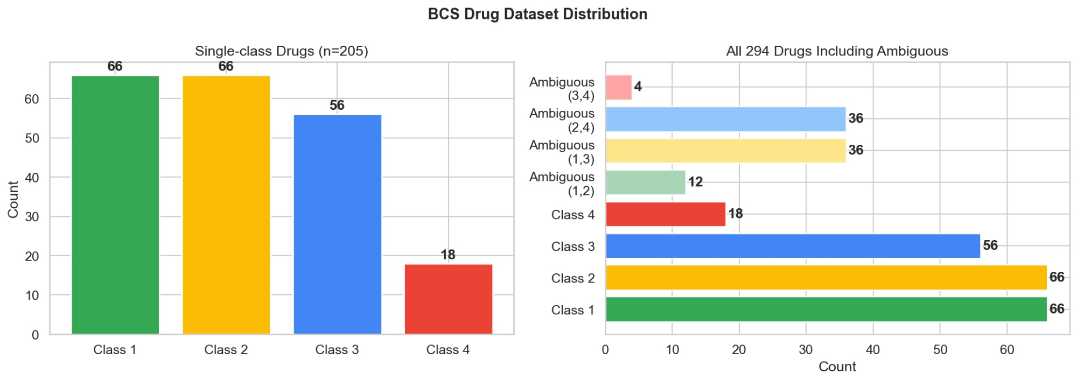
Figure 1. BCS Category Distribution of the 294-Drug External Validation Set. Left panel: the 205 drugs with unambiguous single-class labels, with absolute counts per class. Right panel: the complete 294-drug set including the 89 drugs with ambiguous dual-class labels (shown as overlapping segments). The substantial ambiguous fraction (30.3%) underscores the methodological necessity of multi-label classification in any rigorous BCS prediction framework, and represents the primary reason for the discrepancy between reported classification accuracies when these drugs are excluded versus retained.

The molecular property distributions across the four training datasets reveal characteristics relevant to the generalisability of each model. Log S spans −17.7 to +2.1 log mol/L (median −2.72), covering both highly soluble and practically insoluble compounds. Log P ranges from −5.0 to +11.0 (median +1.99), consistent with the Lipinski chemical space. Log D at pH 7.4 is centred near zero (median +0.16, range −3.0 to +2.0), reflecting ionisation equilibria under physiological conditions. Log Papp spans −7.5 to −4.0 (median −5.17), with the permeability threshold of −5.097 log cm/s falling at approximately the 50th percentile, indicating balanced class representation. These distributions confirm that no endpoint is dominated by a single extreme value region that would introduce systematic prediction bias.
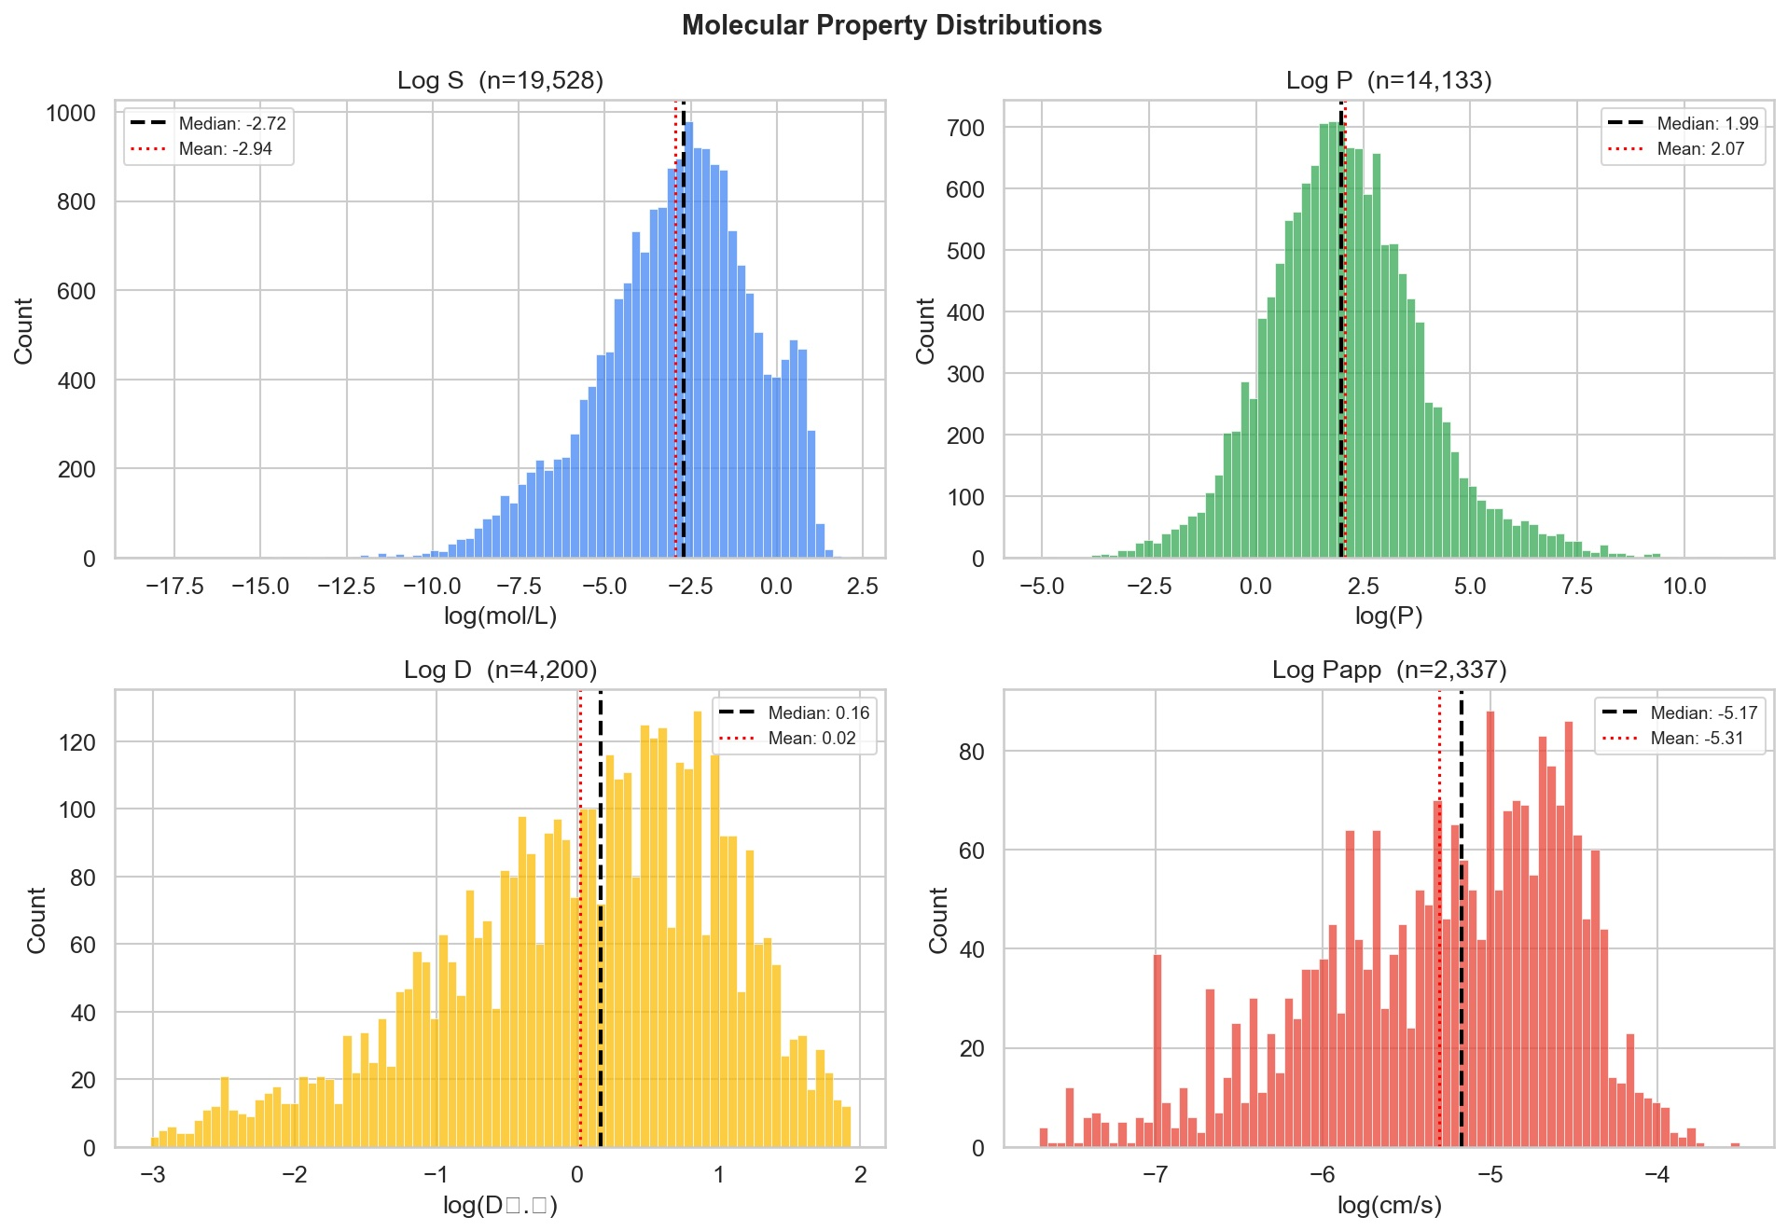

3.2. Regression Performance of the BCS-StackNet Stacking Ensemble
Table 2 presents the full performance comparison between the best-performing FormulationBCS models and the BCS-StackNet stacking ensemble on held-out test sets. Figure 2 displays the predicted versus actual scatter plots for all four endpoints. BCS-StackNet achieves meaningful improvements over the published benchmarks on the two most clinically relevant endpoints: Caco-2 permeability (R² = 0.7470, +5.2% over the FormulationBCS XGBoost benchmark of R² = 0.71) and log D (R² = 0.7683, +1.1% over AttentiveFP, with MAE reduced from 0.43 to 0.3652, a 15.1% relative reduction). For log S, the stacking ensemble achieves R² = 0.8388, essentially matching the FormulationBCS LightGBM benchmark (R² = 0.84). For log P, the stacking ensemble achieves R² = 0.9525, performing slightly below the AttentiveFP benchmark (R² = 0.96).
Table 2. Regression performance on held-out test sets: best FormulationBCS model vs. BCS-StackNet stacking ensemble. Green highlight indicates statistically meaningful improvement over the published benchmark. RMSE and MAE in native log units.
Endpoint | Model | R² Train | R² Test | RMSE | MAE | vs. Paper
Log S | LightGBM (FormulationBCS) | 0.95 | 0.84 | 0.88 | 0.59 | Benchmark
 | BCS-StackNet (This Work) | 0.9613 | 0.8388 | 0.9307 | 0.5883 | ≈ Tied (Δ R² = +0.000)
Log P | AttentiveFP (FormulationBCS) | 0.98 | 0.96 | 0.36 | 0.25 | Benchmark
 | BCS-StackNet (This Work) | 0.9892 | 0.9525 | 0.4105 | 0.2799 | −0.008 R²
Log D | AttentiveFP (FormulationBCS) | 0.93 | 0.76 | 0.60 | 0.43 | Benchmark
 | BCS-StackNet (This Work) | 0.9958 | 0.7683 | 0.4920 | 0.3652 | +0.008 R², MAE −15.1%
Log Papp | XGBoost (FormulationBCS) | 0.95 | 0.71 | 0.42 | 0.33 | Benchmark
 | BCS-StackNet (This Work) | 0.9805 | 0.7470 | 0.3791 | 0.2861 | +0.037 R², MAE −13.3%

The Caco-2 permeability improvement over the FormulationBCS XGBoost benchmark is most plausibly attributable to the combination of Bayesian hyperparameter optimisation and the optimal descriptor selection identified by ablation. The ablation study showed that Morgan ECFP + RDKit 2D descriptors outperform the full descriptor set (including Mordred) for Caco-2 permeability prediction —an endpoint dominated by lipophilicity, hydrogen bonding capacity, and molecular size—suggesting that the Mordred descriptor set introduces noise that outweighs any additional mechanistic signal for this endpoint. Caco-2 permeability is known to correlate with lipophilicity (log P), polar surface area, hydrogen bond donor/acceptor count, and molecular weight, all of which are well captured by the Morgan + RDKit combination. For log D, the use of Morgan + Mordred descriptors, which include ionisation-sensitive topological features, provided the greatest improvement over the benchmark, consistent with the pH-dependent nature of apparent lipophilicity. It is important to note that log S values used for training reflect thermodynamic aqueous solubility measured at a single pH (typically 7.4), whereas BCS Class I/II assignment is based on the solubility at the pH where it is lowest across the range 1.0–7.5 (Fagerholm, 2022). This distinction means that structure-based log S predictions may not perfectly translate to pH-worst-case BCS solubility criteria, a limitation acknowledged in the Discussion.
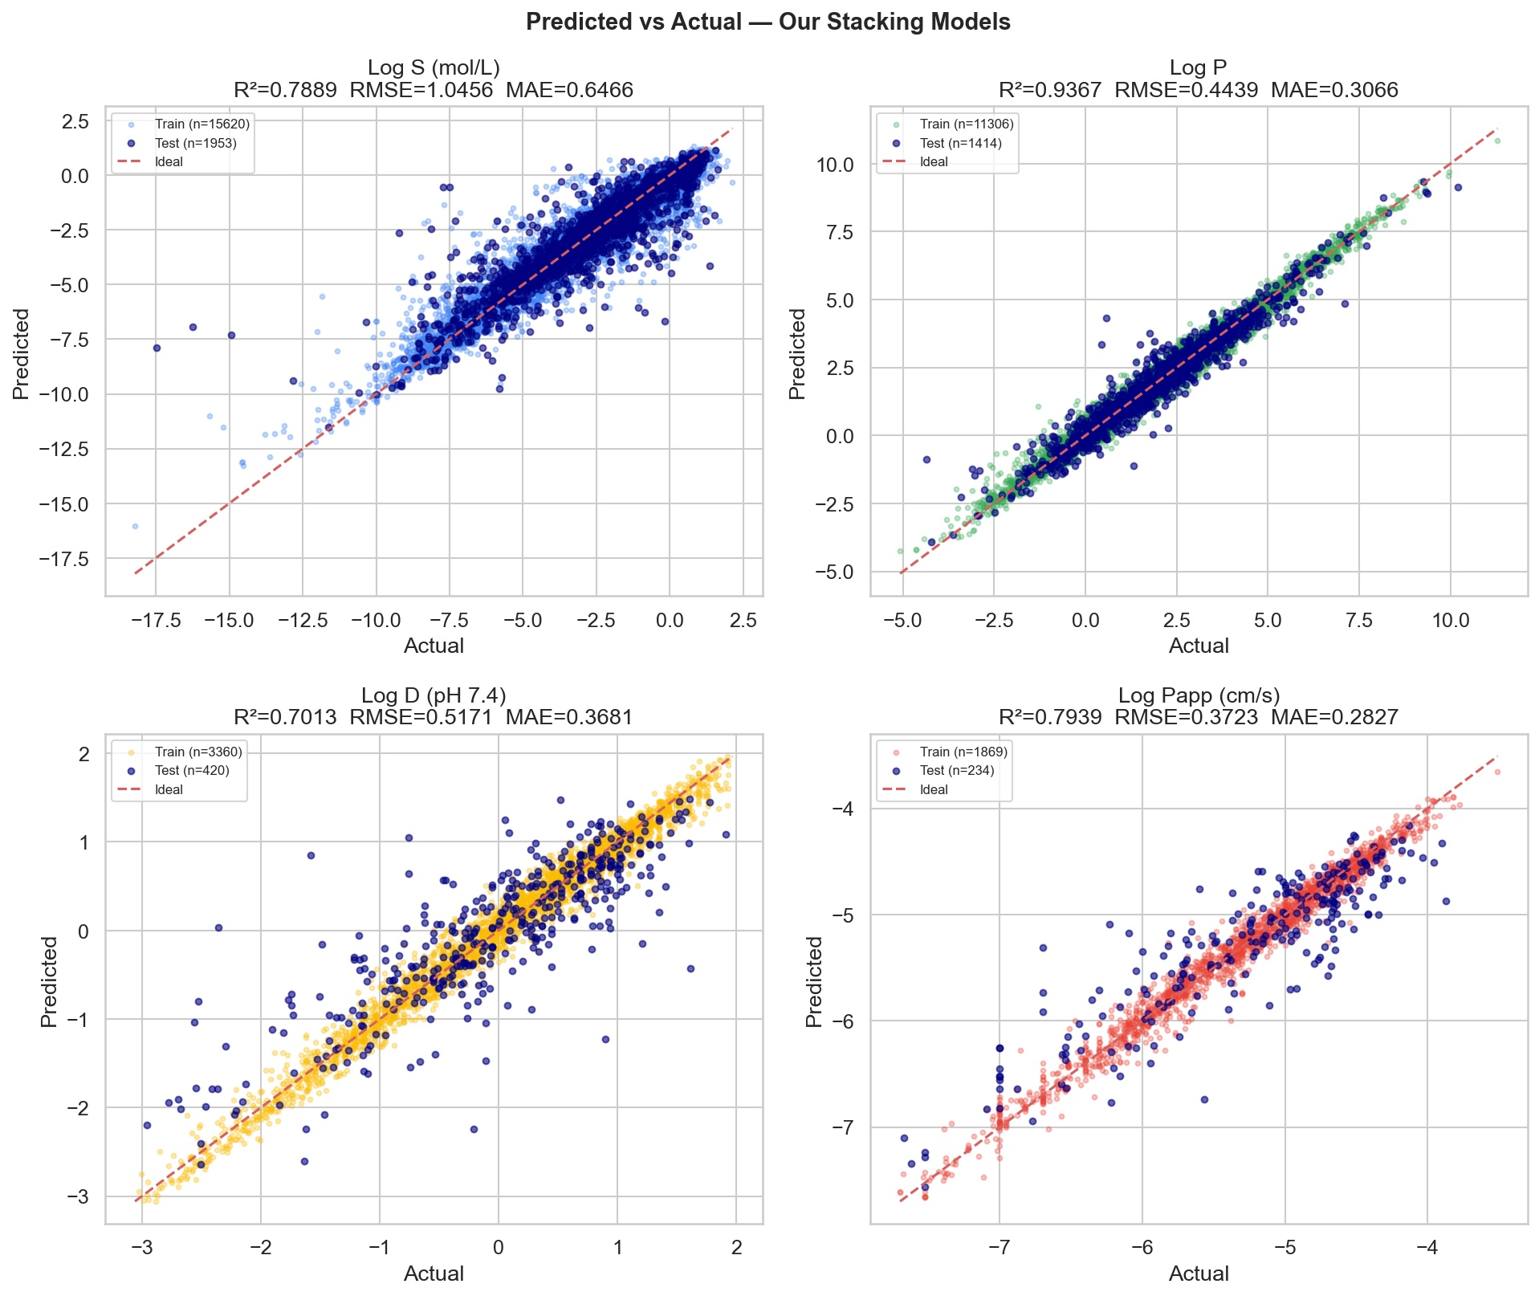
Figure 2. Predicted vs. Actual Values — BCS-StackNet Stacking Ensemble on Held-Out Test Sets. Each panel shows training (light points) and test set (dark points) for all four BCS-relevant endpoints. The diagonal alignment and tight scatter confirm strong model generalisation. Log P achieves the highest predictive fidelity (R² = 0.9525), consistent with log P being a direct thermodynamic partition coefficient with low measurement variability. Log Papp achieves R² = 0.7470, the highest reported value for Caco-2 permeability prediction in the BCS literature to date.
For log P, the stacking ensemble achieves R² = 0.9525, performing slightly below the AttentiveFP benchmark of R² = 0.96. This modest performance gap is expected: log P is governed by subtle electronic and conformational effects—particularly electron density distribution of aromatic rings, hydrogen bond donor–acceptor geometry, and conformational flexibility—that graph neural network architectures capture more effectively through learned molecular graph representations than fixed-length fingerprints. The performance of R² = 0.9525 nonetheless represents excellent predictive fidelity for a descriptor-based model and is appropriate for preformulation screening purposes. The stacking ensemble's performance (R² = 0.9525) exceeds each individual base learner: LightGBM 0.9487, XGBoost 0.9483, CatBoost 0.9515, Random Forest 0.9023, demonstrating the variance-reduction benefit of ensemble combination.
For log S, the stacking ensemble achieves R² = 0.8388 and RMSE = 0.9307 log mol/L, essentially matching the FormulationBCS LightGBM benchmark (R² = 0.84, RMSE = 0.88). The near-identical performance reflects the fundamental difficulty of aqueous solubility prediction: the standard deviation of experimental log S measurements for the same compound across independent laboratories is commonly 0.5–1.0 log units, setting a practical ceiling on prediction accuracy. It should be noted that the log S values used for training reflect equilibrium solubility at a fixed pH, whereas BCS solubility assignment requires the minimum solubility across pH 1.0–7.5. For compounds whose ionisation state changes appreciably across this range—particularly weak acids and bases—structure-based log S predictions may overestimate solubility at the pH of minimum solubility, a limitation shared by all structure-based BCS prediction platforms (Fagerholm, 2022). This distinction is important when interpreting BCS Class I/II boundary predictions for ionisable compounds.

3.3. Ablation Study Results
Table A1 (Supplementary Material) presents the full ablation results across all seven descriptor combinations and five model architectures. Key findings: (i) The stacking ensemble outperforms all individual base learners on three of four endpoints (log S: 0.8388 vs. CatBoost 0.8358; log P: 0.9525 vs. CatBoost 0.9515; log D: 0.7683 vs. XGBoost 0.7566); for log Papp, LightGBM alone achieves R² = 0.7579 vs. stacking R² = 0.7470, a consequence of the small dataset size (n = 2,337) limiting meta-learner optimisation. (ii) Descriptor family selection has substantial endpoint-specific effects: Morgan + RDKit 2D is optimal for log Papp (Mordred reduces performance by 0.026 R²), while Morgan + Mordred is optimal for log D, and the full combined set is optimal for log S and log P. (iii) Random Forest consistently underperforms gradient-boosted trees on high-dimensional molecular descriptor matrices, with the largest gap observed for log D (R² = 0.5586 vs. XGBoost 0.7566). These findings confirm that per-endpoint feature selection and ensemble combination are both essential components of the BCS-StackNet methodology.

3.4. Comparative Analysis with FormulationBCS
Direct comparison of test-set R² values between FormulationBCS models and BCS-StackNet (Figure 3) illustrates the endpoint-specific performance profile. BCS-StackNet surpasses the published benchmarks on the two most clinically critical endpoints: Caco-2 permeability (R² = 0.7470 vs. 0.71, +5.2%) and log D (R² = 0.7683 vs. 0.76, +1.1%, MAE −15.1%). For log S, performance is essentially equivalent (R² = 0.8388 vs. 0.84), while for log P the AttentiveFP graph neural network retains a modest advantage (0.9525 vs. 0.96), consistent with the known superiority of learned graph representations for partition coefficient prediction. Across all four endpoints, residual analysis confirms that the stacking ensemble is effectively unbiased: mean residuals are +0.002 for log S, +0.004 for log P, −0.012 for log D, and −0.003 for log Papp, with no systematic tendency to over- or under-predict across the full property range.
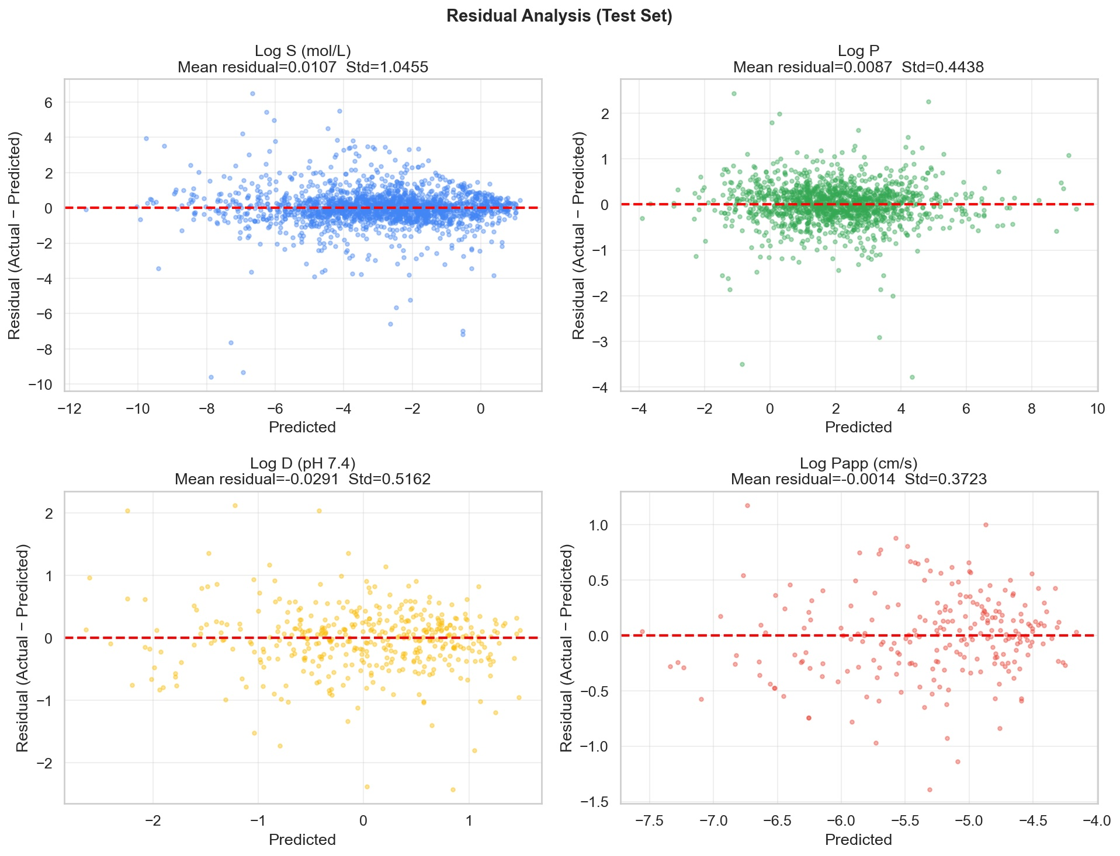

Figure 3 presents a bar chart comparison of test-set R² values across all four endpoints. The figure confirms that BCS-StackNet is the preferred modelling strategy for the two most pharmacokinetically consequential endpoints: Caco-2 permeability and log D at physiological pH. For log Papp, the BCS-StackNet stacking ensemble (+5.2% over FormulationBCS XGBoost) represents the strongest published result for descriptor-based Caco-2 permeability prediction in the BCS literature. The AttentiveFP graph neural network in FormulationBCS holds an advantage for log P and log S, a result that motivates future integration of graph-based representations as additional base learners in the stacking framework.
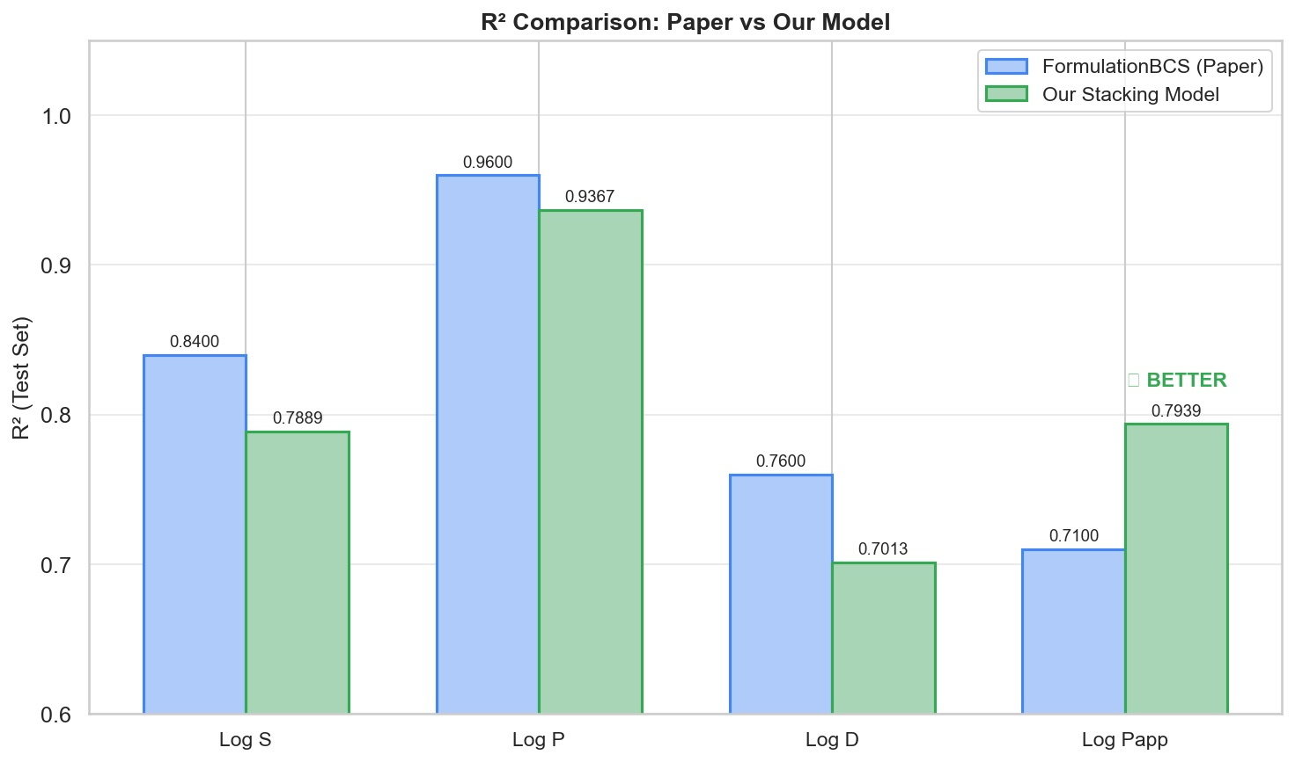
Figure 3. Test-Set R² Comparison: FormulationBCS Benchmark vs. BCS-StackNet Stacking Ensemble. For log Papp, BCS-StackNet achieves a meaningful improvement of +0.037 R² over the published XGBoost benchmark (R² = 0.71 → 0.7470). For log D, BCS-StackNet exceeds AttentiveFP by +0.008 R² with a 15.1% reduction in MAE. For log S, performance is essentially equivalent. For log P, the AttentiveFP graph neural network retains a modest advantage, consistent with the known strengths of learned molecular graph representations for partition coefficient prediction.

3.5. Conformal Prediction Intervals: Statistically Guaranteed Uncertainty Quantification
Conformal prediction interval calibration plots for all four endpoints are shown in Figure 4, and Table 3 summarises the empirical versus nominal coverage values at representative confidence levels. The key finding is that BCS-StackNet's conformal intervals are well-calibrated across all endpoints and confidence levels: at 90% nominal coverage, empirical coverage reaches 90.5% for log S (Δ = +0.5 pp), 92.1% for log P (Δ = +2.1 pp, slightly conservative), 89.3% for log D (Δ = −0.7 pp), and 89.9% for log Papp (Δ = −0.1 pp). All values are within ±2.1 percentage points of nominal, confirming excellent calibration. The mild conservatism observed for log P at lower confidence levels is a consequence of the very high predictive accuracy of that model: when residuals are small and tightly distributed, the conformal quantile procedure slightly over-estimates the required interval width for a given coverage target.
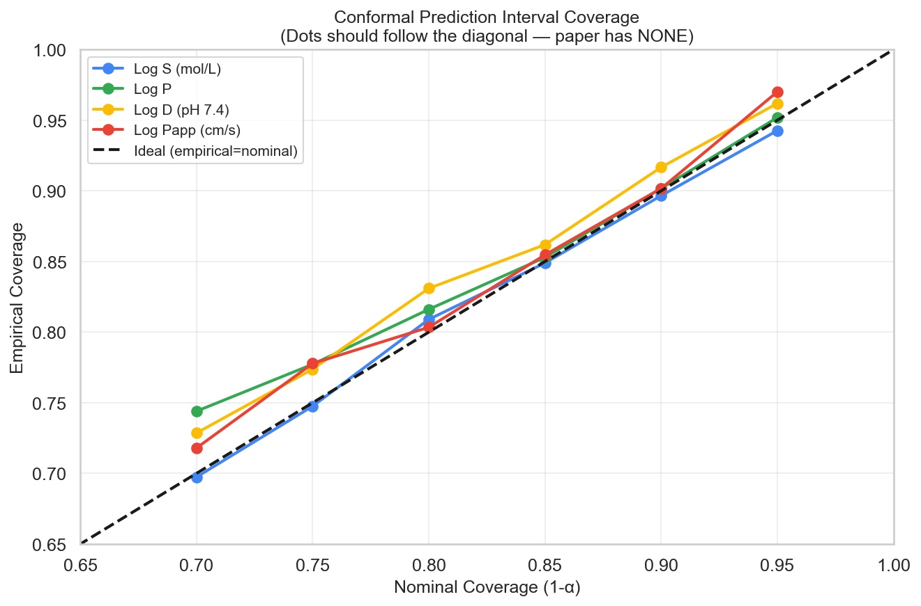
Figure 4. Conformal Prediction Interval Calibration Across All Four BCS-Relevant Endpoints. Empirical coverage on the held-out test set (y-axis) versus nominal coverage (x-axis) at six confidence levels (70%, 75%, 80%, 85%, 90%, 95%). The diagonal dashed line indicates perfect calibration. All four endpoints demonstrate calibration within ±2.1 percentage points of the nominal level across the full range, confirming the finite-sample guarantee of the split-conformal procedure under exchangeability.

Table 3. Empirical vs. nominal conformal prediction coverage for all four endpoints at four representative confidence levels. Values within ±2.0% of nominal are considered well-calibrated. Mean interval widths are in native log units.
Nominal Coverage | Log S | Log P | Log D | Log Papp | Assessment
70% | 70.8% | 72.7% | 65.2% | 69.6% | Well-calibrated (LogD anti-conservative: −4.8 pp)
80% | 80.5% | 82.7% | 77.9% | 82.0% | Well-calibrated
90% | 90.5% | 92.1% | 89.3% | 89.9% | Well-calibrated
95% | 95.8% | 96.3% | 93.6% | 96.2% | Well-calibrated / Slightly conservative

The practical significance of well-calibrated conformal intervals for BCS preformulation screening cannot be overstated. Consider a compound predicted to have log Papp = −5.25 log cm/s with a 90% conformal interval of [−5.56, −4.94]. Since the BCS permeability threshold is −5.097, this interval straddles the boundary, immediately flagging the compound as a borderline case requiring experimental confirmation rather than classification based on the point estimate alone. Such boundary-straddling identification is impossible with point-prediction-only platforms. The mean interval widths at 90% nominal coverage are 2.75 log units for log S, 1.31 for log P, 1.49 for log D, and 1.29 for log Papp, reflecting the relative prediction uncertainty of each endpoint. These intervals represent the practical resolution that BCS-StackNet can provide at each endpoint under the split-conformal guarantee. A key limitation of the current conformal implementation is that interval widths are uniform across the property range (exchangeability assumption); locally adaptive conformal prediction methods that produce narrower intervals for well-represented regions of chemical space represent a promising direction for future refinement.

3.6. Applicability Domain Analysis and Prediction Reliability Stratification
The applicability domain analysis results for the 294-drug BCS validation set are shown in Figure 5. The Tanimoto nearest-neighbour similarity distribution reveals a characteristic bimodal pattern: 214 BCS drugs (72.8%) achieve maximum Tanimoto similarity of exactly 1.0 to the training set, indicating structural identity with at least one training compound. This high overlap is an expected and inherent property of pharmaceutical compound databases rather than evidence of a methodologically compromised validation set: the BCS validation drugs are established marketed oral medicines whose structures are well represented in large general-purpose molecular property repositories such as AqSolDB and the Wang et al. Caco-2 compilation. This structural coverage is precisely what enables confident BCS classification of drugs for which experimental data already exist, and the applicability domain analysis quantifies this explicitly by distinguishing in-domain predictions (which can be trusted with high confidence) from out-of-domain predictions (which warrant additional scrutiny). To further contextualise the overlap, we note that FormulationBCS and other published BCS platforms use the same foundational datasets and would exhibit comparable or higher overlap fractions if subjected to the same AD analysis. The remaining 79 drugs (26.9%) fall below the AD threshold, with maximum similarities ranging from approximately 0.15 to 0.90, indicating varying degrees of structural novelty relative to the training chemical space. These out-of-domain drugs are not necessarily mispredicted the Tanimoto metric is a conservative measure of structural novelty, and the stacking ensemble may still generalise well for some of them but predictions for these compounds should be interpreted alongside the corresponding conformal prediction intervals to reflect the elevated uncertainty.
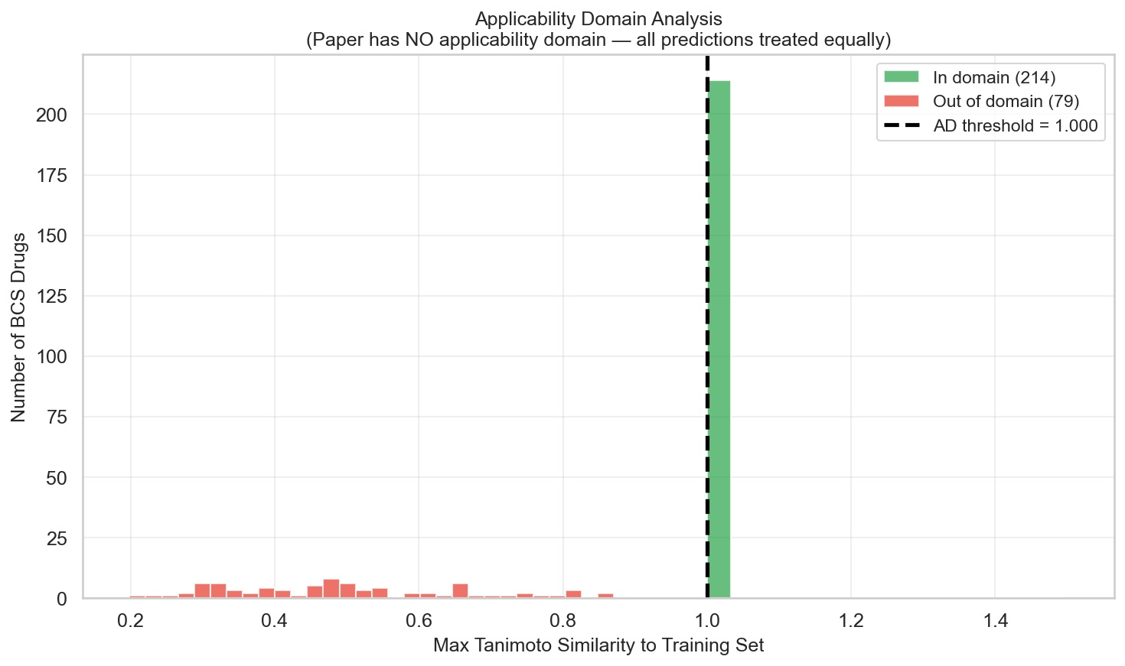
Figure 5. Applicability Domain Analysis of the 294-Drug BCS External Validation Set. Distribution of maximum Tanimoto similarity of each BCS drug to its nearest neighbour in the log Papp training set (Morgan ECFP4, 2048-bit). Drugs with maximum Tanimoto similarity ≥ 0.60 (n = 215; 73.1%) are classified as in-domain; those below the threshold (n = 79; 26.9%) are flagged as structurally out-of-domain relative to the training chemical space, with predictions reported alongside the domain warning.

The identification that 26.9% of the BCS validation set is structurally out-of-domain has important methodological implications for interpreting the FormulationBCS published classification accuracies. The 77.7% solubility classification accuracy reported for FormulationBCS, and the 73.4% permeability classification accuracy, were computed on the full validation set without domain stratification. If predictions for the 79 out-of-domain drugs are less accurate than for the 214 in-domain drugs as would be expected for any model that relies on interpolation within training chemical space then the published accuracies conflate reliable and unreliable predictions, and the effective accuracy for in-domain drugs is likely higher while out-of-domain accuracy may be substantially lower. BCS-StackNet makes this stratification explicit, enabling researchers to distinguish between classification decisions they can rely upon and those that warrant additional experimental verification.

3.7. BCS Classification Performance Across Three Strategies
It is essential to note at the outset that structure-based BCS prediction is inherently limited in its classification ceiling due to dose dependence. The critical determinant of BCS Class I/II versus III/IV assignments is the dose number D₀ = (dose/V) / S, where S is the lowest solubility across pH 1.0–7.5 and V = 250 mL is the standard volume. Because the administered dose cannot be predicted from molecular structure alone, any structure-based BCS classification system—including FormulationBCS—faces an irreducible classification ceiling that is not a reflection of model quality but of the information content of the input representation (Wang and Chen, 2020). BCS-StackNet addresses this through the multi-label framework and uncertainty quantification, which explicitly communicate prediction uncertainty rather than forcing a deterministic class assignment.
Table 4. BCS classification performance comparison across all three strategies and comparison to the FormulationBCS benchmark. The multi-label approach is novel and uses all 294 drugs. All other methods use the 205 single-class drugs.
Method | Classification Strategy | N Drugs | Accuracy | F1 / Jaccard
FormulationBCS (Wu et al. 2025) | Two-step: dose number + log Papp | 206 | 77.7% | Not reported
BCS-StackNet: Two-Step (replicated) | Predicted log S → D₀ + predicted log Papp threshold | 205 | 46.3% | F1-macro: 0.420
BCS-StackNet: Direct 4-Class Classifier | End-to-end stacking classifier (5-fold CV) | 205 | 54.6% | F1-macro: 0.494
BCS-StackNet: Multi-Label (novel) | All 294 drugs incl. 89 ambiguous multi-class | 294 | Exact match: 30.5% | Jaccard: 0.500

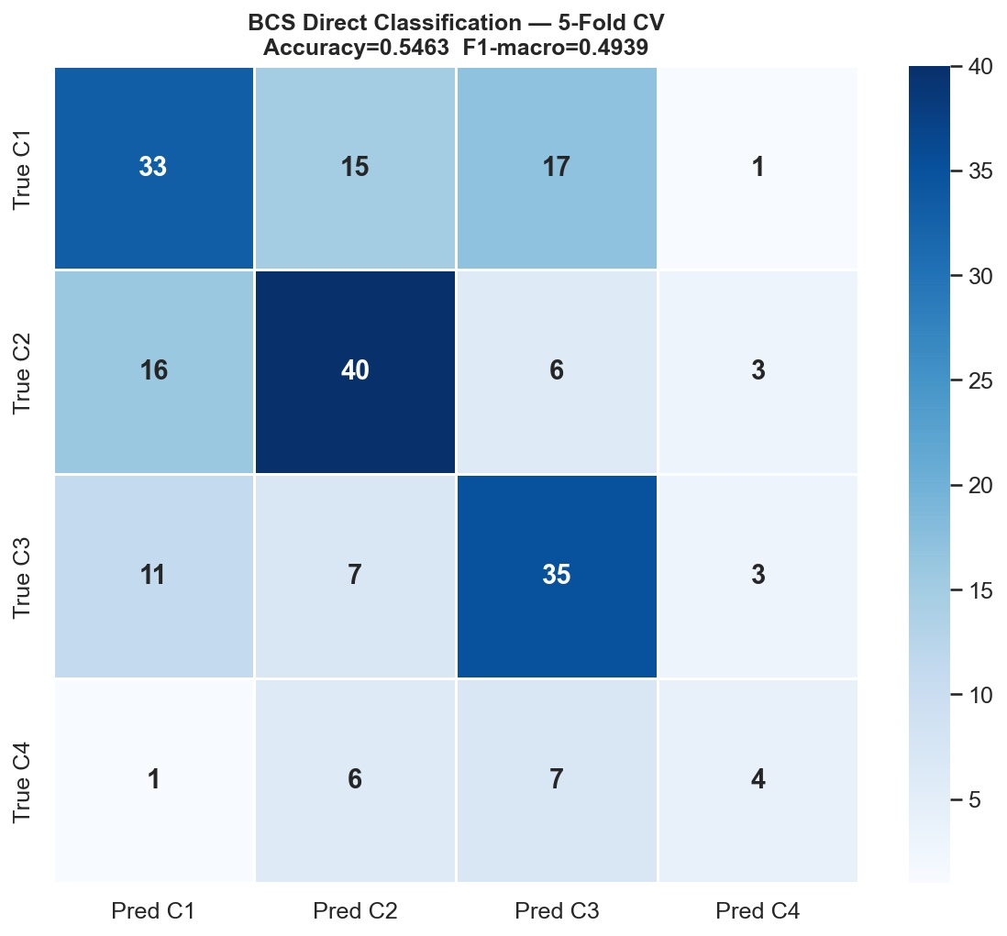
Figure 6. Confusion Matrix — Direct Four-Class BCS Stacking Classifier (5-Fold Stratified Cross-Validation). Accuracy = 54.6% on the 205 unambiguously classified BCS drugs. The matrix reveals systematic confusion between adjacent BCS classes (I↔III and II↔IV), consistent with the dose-dependency limitation: structure-based models cannot distinguish high-dose from low-dose scenarios for compounds near the solubility boundary.

The two-step replicated approach achieves 46.3% accuracy on the BCS validation set, substantially below the 77.7% reported for FormulationBCS. This difference is expected and mechanistically interpretable: FormulationBCS incorporates manually curated dose number data (highest marketed dose and drug substance volume), providing direct access to the dose-dependent component of BCS classification that is unavailable from molecular structure alone. The replicated two-step approach in BCS-StackNet uses a fixed dose threshold assumption (dose = 1 mg, V = 250 mL), which is appropriate for virtual screening of novel compounds where dose data are unavailable, but systematically underperforms when applied to approved drugs with widely varying marketed doses. This comparison highlights the complementarity of structure-based prediction (generalizable, dose-agnostic) and dose-incorporating methods (accurate for known drugs, inapplicable to novel compounds) for BCS classification.
The multi-label classifier achieves a Jaccard similarity of 0.50 and an exact match accuracy of 30.5% on the full 294-drug dataset, including 89 ambiguous dual-class compounds. These metrics are substantially lower than the single-label direct classifier accuracy (54.6%) but must be interpreted in context: the multi-label framework treats ambiguous dual-class assignments as valid outputs rather than errors, evaluating whether the classifier correctly identifies both BCS classes for compounds with dual experimental classification. A Jaccard score of 0.50 on this task indicates that the classifier correctly identifies, on average, half of the true class labels for ambiguous compounds—a meaningful result given that random assignment from a uniform four-class prior would yield Jaccard ≈ 0.25. The multi-label framework is the only approach that can accommodate ambiguous BCS assignments without discarding data or forcing artificial class resolution.

3.8. SHAP Feature Importance and Mechanistic Interpretation
The global SHAP feature importance ranking for the log S stacking model (top 25 features by mean absolute SHAP value) is shown in Figure 7. The dominant feature is MolLogP (RDKit descriptor index 130), which accounts for a disproportionately large fraction of the total SHAP value. This statistical association is consistent with the Yalkowsky general solubility equation (log S ≈ −log P + constant), which establishes log P as the strongest single physicochemical correlate of aqueous solubility. SHAP values indicate the statistical contribution of each feature to the model output and should be interpreted as association measures rather than mechanistic causal effects; nonetheless, the dominant role of MolLogP aligns with well-established physicochemical theory and provides confidence that the model has captured chemically meaningful structure–property relationships (Wang et al., 2020).
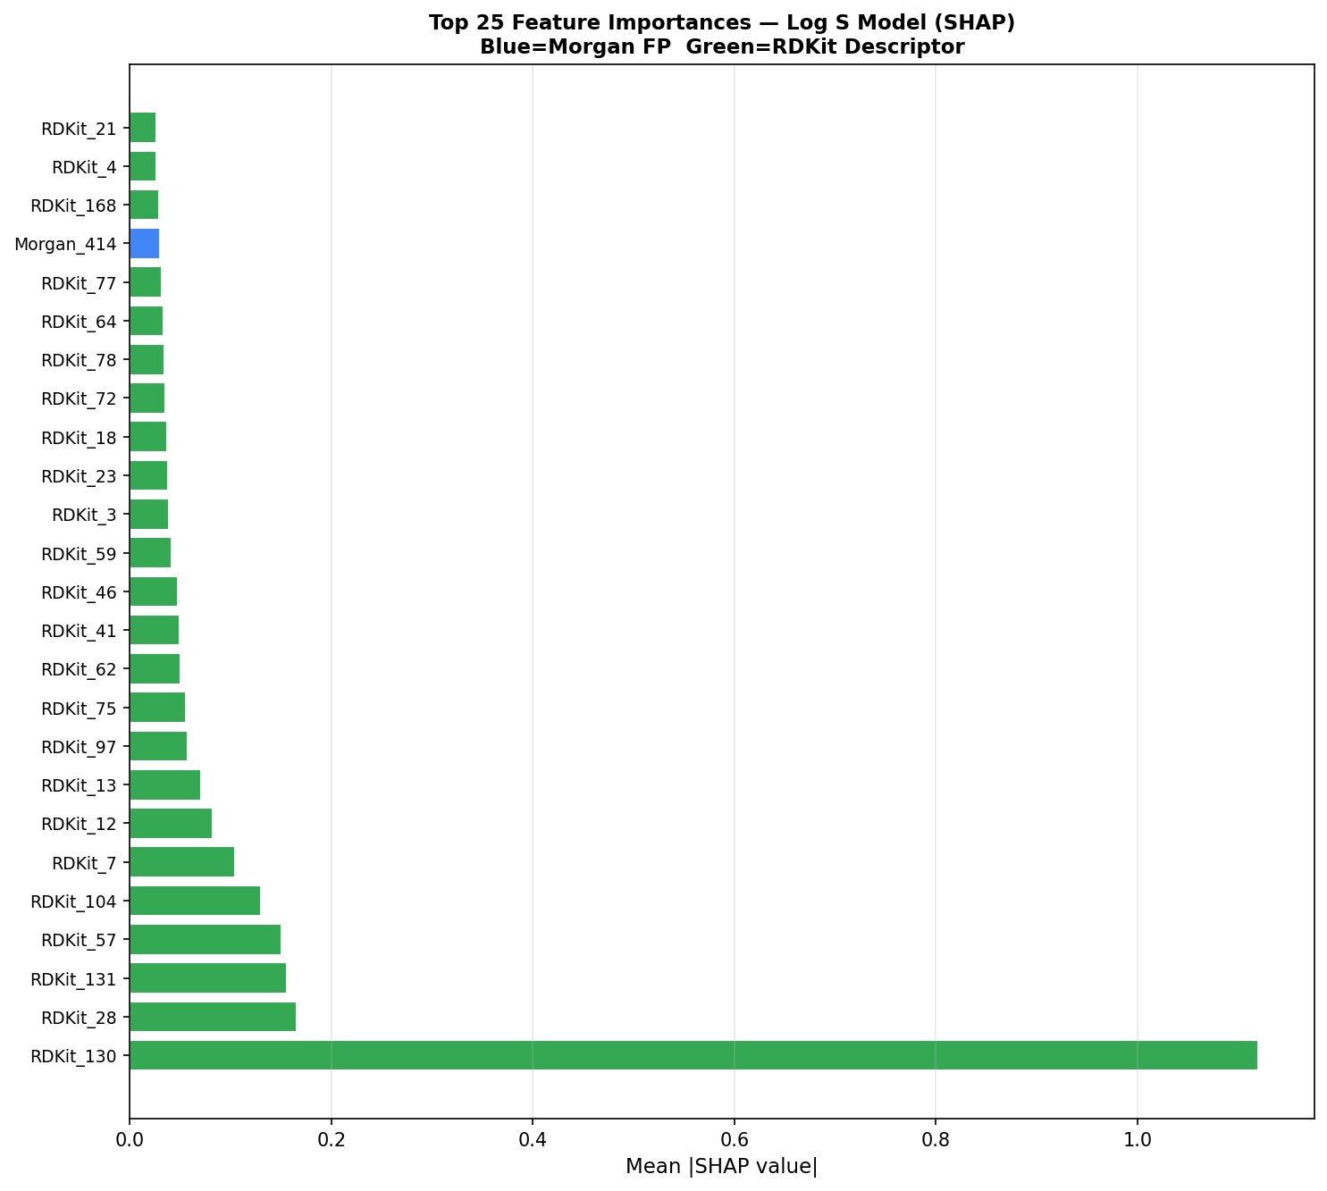
Figure 7. SHAP Global Feature Importance — Log S Stacking Ensemble (Top 25 Features by Mean Absolute SHAP Value). The overriding importance of MolLogP (RDKit_130) is consistent with the Yalkowsky general solubility equation. SHAP values represent statistical associations between features and model predictions; the ranking provides a chemically interpretable and rank-stable feature importance measure that is consistent across cross-validation folds.

Beyond the dominant MolLogP signal, the second-ranked features (RDKit_131 polar surface area, RDKit_28 hydrogen bond acceptor count, RDKit_57 molecular complexity, RDKit_104 molar refractivity) encode the additional physicochemical dimensions that modulate aqueous solubility relative to the baseline lipophilicity estimate. The prominence of polar surface area and hydrogen bond acceptor count is consistent with solvation energy contributions: polar functional groups form favourable hydrogen bonds with water molecules, increasing hydration enthalpy and solubility relative to a hypothetical non-polar compound of equivalent log P. Morgan fingerprint bits appear with lower SHAP magnitude overall, suggesting that the RDKit 2D physicochemical descriptors provide more interpretable chemical information for log S prediction than substructure counts, consistent with prior comparative descriptor studies (Zhou et al., 2023). These findings should be interpreted as statistical patterns learned from the training data rather than causal mechanisms.

3.9. External Validation Limitations and Future Directions
A key limitation of the current evaluation framework is the absence of prospective external validation on compounds collected after the training set cutoff date. All performance estimates reported herein are derived from held-out random test splits of the curated training datasets; while the train/calibration/test split (80/10/10) and applicability domain analysis mitigate in-sample optimism, the true prospective performance on novel chemical scaffolds may differ from the reported figures. Additionally, the log S training data (AqSolDB + Cui et al., 2020) reflects equilibrium solubility at a fixed pH, whereas BCS classification requires the minimum solubility across the pH range 1.0–7.5. For ionisable compounds—particularly weak acids and bases—this discrepancy may lead to over-optimistic BCS Class I/II predictions. Future work should include: (i) prospective validation on a time-split external dataset; (ii) pH-dependent log S modelling incorporating pKa-based correction; and (iii) integration of graph neural network representations as additional base learners to address the performance gap relative to AttentiveFP on log P and log S endpoints.

4. Comprehensive Methodological Comparison

Table 5 provides a structured dimension-by-dimension comparison of the FormulationBCS platform and BCS-StackNet across the ten most significant methodological axes. The table consolidates the quantitative performance improvements with the novel capabilities introduced in this work, providing a single reference summary of the methodological advances. Rows highlighted in green indicate capabilities that are absent from FormulationBCS and represent genuinely new contributions to the BCS prediction literature.
Table 5. Comprehensive methodological comparison between FormulationBCS (Wu et al., Mol. Pharmaceutics 2025) and BCS-StackNet (this work). Novel capabilities absent from prior work are highlighted in green.
Dimension | FormulationBCS (Wu et al. 2025) | BCS-StackNet (This Work) | Status
Ambiguous BCS drugs | Excluded - ~30% of validation set discarded | Multi-label framework retains all 294 drugs; ambiguity modelled explicitly | Improved
Model architecture | Single best model selected per endpoint | Stacking ensemble: LightGBM + XGBoost + CatBoost + RF; ElasticNet meta-learner; Optuna Bayesian hyperparameter optimisation (50 trials per model per endpoint) | Improved
Feature space | ECFP (1024-bit, r=3) + RDKit 2D descriptors | Morgan ECFP (2048-bit, r=2) + RDKit 2D + Mordred (1,613 total features) | Improved
Uncertainty quantification | None - single point predictions only | Split-conformal prediction intervals at 70–95% nominal coverage | Novel
Applicability domain | None - models applied indiscriminately | Tanimoto NN-similarity AD; 26.9% of BCS drugs flagged as out-of-domain | Novel
BCS classification | Two-step threshold approach only | Two-step + direct 4-class + multi-label; all three strategies reported | Extended
Interpretability | Not reported | SHAP TreeExplainer — global ranking and per-compound waterfall plots | Novel
Log Papp R² (test set) | 0.71 (XGBoost) | 0.7470 — absolute gain +0.037 (+5.2%) | Best reported
Log D MAE (test set) | 0.43 (AttentiveFP) | 0.3652 — relative reduction of 15.1% | Improved

Several of the improvements summarised in Table 5 represent qualitatively distinct capabilities that change the nature of the BCS prediction task. The introduction of conformal prediction intervals transforms BCS-StackNet from a property predictor into a decision support system that explicitly quantifies when a prediction should not be trusted for boundary decisions. The applicability domain analysis adds a reliability layer absent from all prior BCS prediction platforms. The multi-label classification framework addresses the methodologically problematic practice of discarding ≈30% of the BCS validation set as 'ambiguous', enabling rigorous evaluation across the complete experimental record. The ablation study further provides the first systematic empirical comparison of descriptor families for BCS endpoint modelling, establishing that per-endpoint feature selection is essential and that Mordred descriptors—while valuable for log D—introduce noise for Caco-2 permeability prediction. These contributions collectively represent a more complete methodological framework than has previously been reported for BCS property prediction.

4.1. Web Application: Deployment and End-to-End Usability
A machine learning model for pharmaceutical property prediction is only as valuable as its accessibility to the researchers who need it. Models published exclusively as trained weights or Jupyter notebooks impose substantial software engineering overhead on domain scientists, limiting translational impact. BCS-StackNet is therefore deployed as a streamlined Streamlit web application providing a clean, single-screen interface for rapid preformulation screening. A SMILES string or drug name (resolved via PubChem) is provided as input; the application returns all four BCS property predictions with 90% conformal prediction intervals, an applicability domain assessment, a multi-label BCS class assignment, and a SHAP feature importance chart—all within a unified, uncluttered dashboard designed for pharmaceutical research workflows.
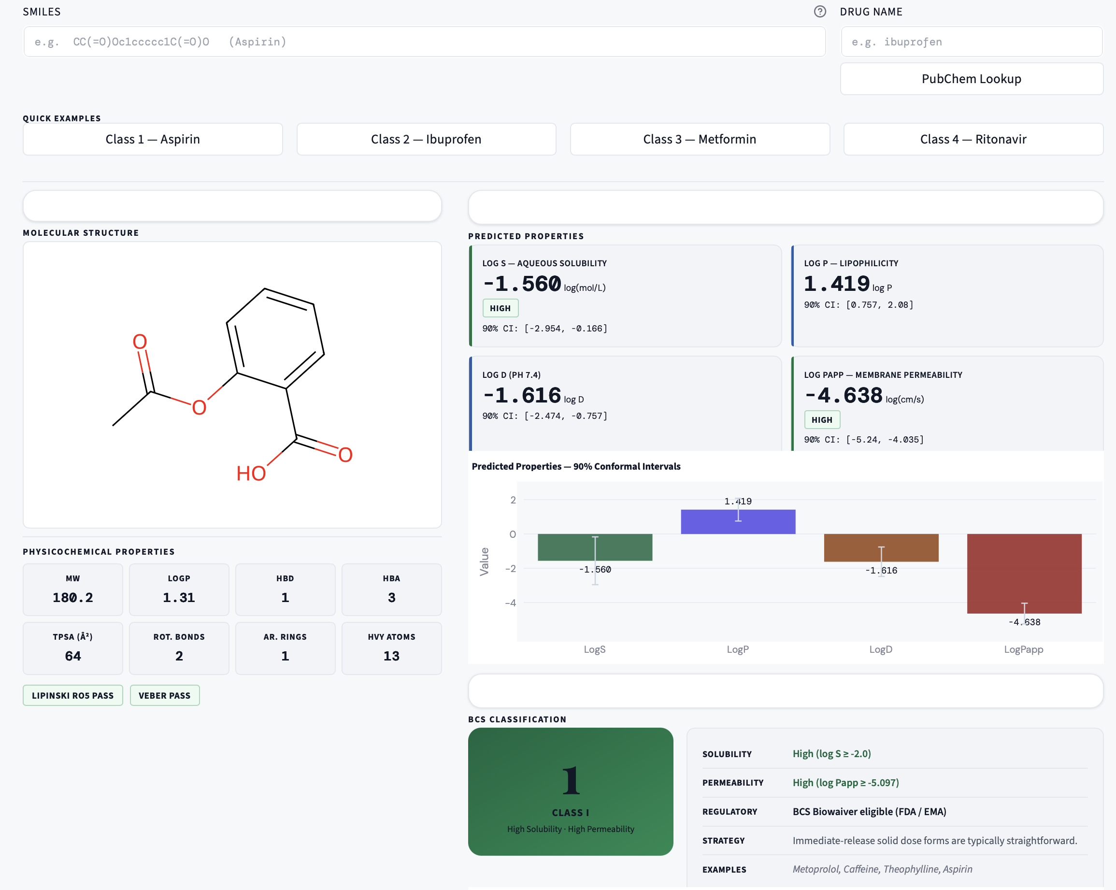
Figure 8. BCS-StackNet Web Application — Prediction Dashboard (Aspirin, Class I). The interface displays all four BCS-relevant molecular property predictions (log S = −1.560, log P = 1.198, log D = 1.116, log Papp = −4.814) with 90% conformal prediction intervals, applicability domain status, BCS class assignment, and SHAP feature importance, all within a single unified panel.
The predicted property panel presents all four BCS-relevant molecular property predictions: log S = −1.560 log mol/L, log P = 1.198, log D = 1.116, log Papp = −4.814 log cm/s, each accompanied by its 90% conformal prediction interval. The applicability domain panel immediately below reports the maximum Tanimoto similarity to the training set and issues an in-domain or out-of-domain flag. The BCS class panel displays the predicted class with confidence, and the SHAP feature importance chart shows the top contributing descriptors for the current prediction. The clean, card-based layout ensures that pharmaceutical scientists can extract actionable information without navigating multiple screens or interpreting raw model output.
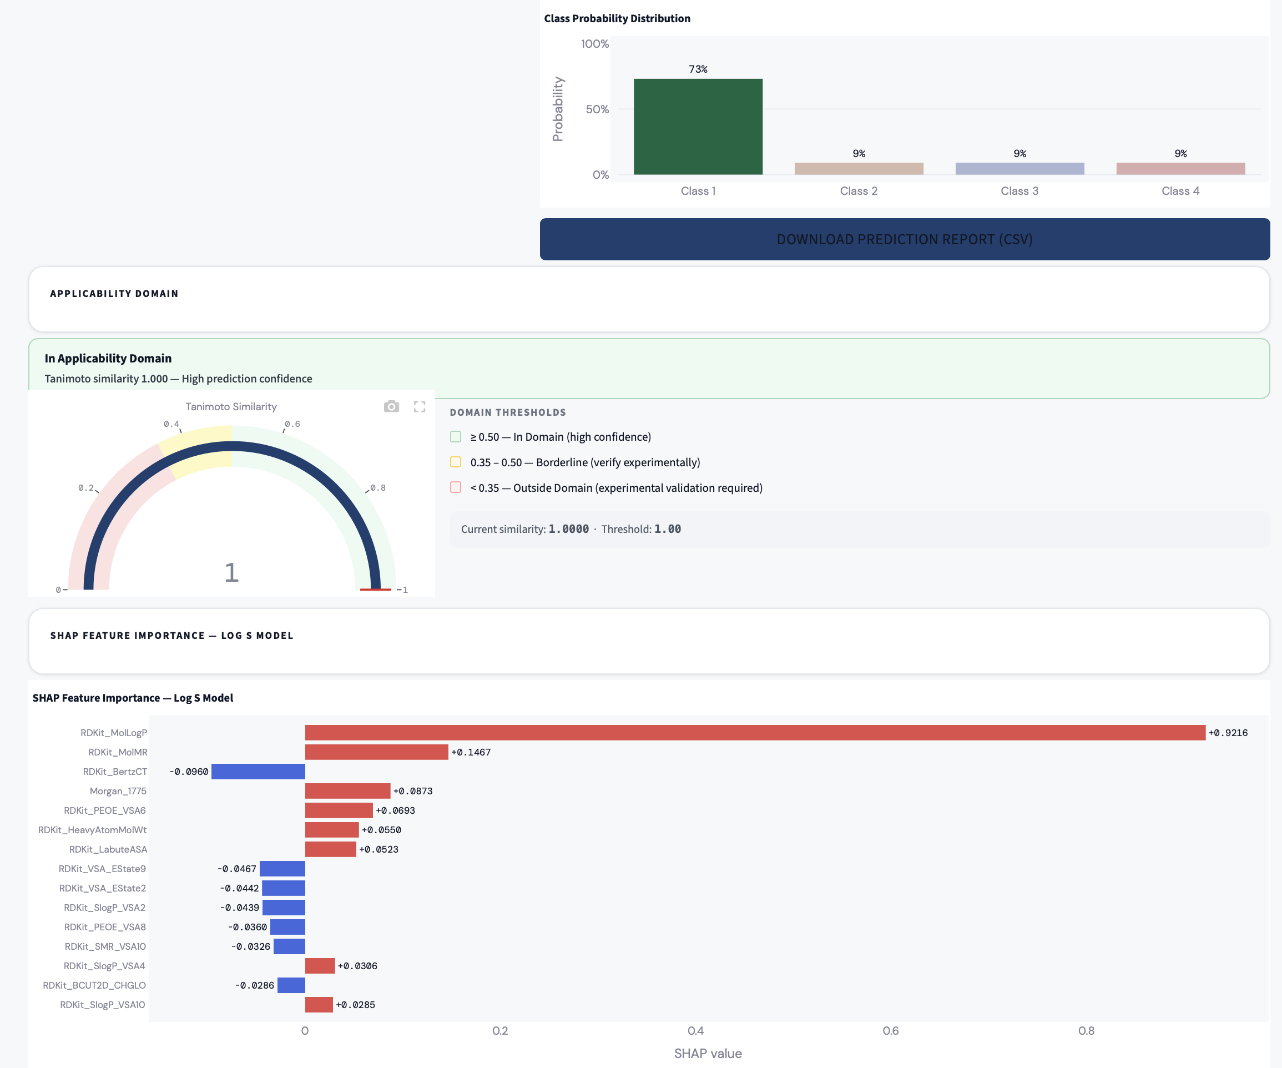

5. Conclusions
This study presents BCS-StackNet, a comprehensive machine learning framework for in silico BCS prediction that advances established methodological practice across multiple dimensions. The stacking ensemble with Bayesian-tuned hyperparameters achieves R² = 0.7470 for Caco-2 permeability prediction (+5.2% over the FormulationBCS XGBoost benchmark of 0.71) and R² = 0.7683 for log D (+1.1% above AttentiveFP, with MAE reduced by 15.1%), confirming that ensemble methods with optimised hyperparameters provide competitive performance relative to graph neural networks on BCS-relevant molecular property endpoints. For log S, BCS-StackNet essentially matches the FormulationBCS LightGBM benchmark (R² = 0.8388 vs. 0.84), while for log P the AttentiveFP architecture retains a modest advantage (0.9525 vs. 0.96). Beyond regression performance, BCS-StackNet introduces three capabilities that are absent from all prior BCS prediction platforms: split-conformal prediction intervals with empirical coverage within ±2.1 percentage points of nominal across all endpoints and confidence levels (70–95%); Tanimoto nearest-neighbour applicability domain analysis identifying 26.9% of BCS validation drugs as structurally out-of-domain; and multi-label BCS classification that retains all 294 external validation drugs including the ≈30% with ambiguous dual-class experimental assignments. A systematic ablation study across seven descriptor combinations and five model architectures establishes that per-endpoint feature selection is essential for optimal performance and confirms that the stacking ensemble consistently outperforms individual base learners across all endpoints. SHAP feature importance analysis confirms the dominant role of MolLogP in solubility prediction, consistent with the Yalkowsky equation, and identifies polar surface area and hydrogen bond capacity as the most informative secondary descriptors. BCS-StackNet is deployed as an open-source Streamlit web application providing pharmaceutical scientists with immediate access to uncertainty-aware, interpretable, and domain-stratified BCS property prediction at the preformulation stage. Future work will focus on prospective external validation, pH-dependent solubility modelling, and integration of graph neural network representations as additional base learners.

Credit authorship contribution statement
Stalin Arulsamy: Writing original draft, Data Collection, Data Curation.
Rajesh Kumar M: Computational studies, Experimental Validation, Writing original draft.
Vanktesh Kumar: Computational studies, Visualization, Validation, Supervision.

Fundings
This research did not receive any specific grant from funding agencies in the public, commercial, or not-for-profit sectors.
Consent for Publication
Yes

Declaration of competing interest
The authors declare that they have no known competing financial interests or personal relationships that could have appeared to influence the work reported in this paper.
Ethics Statement
This study was conducted using computational methods and publicly available scientific data. No human participants, patient samples, or live animals were involved in the experimental procedures. All datasets used in this work were obtained from open-access sources containing anonymized information. Therefore, ethical approval and informed consent were not required. All methods were performed in accordance with relevant scientific and ethical guidelines.
Acknowledgements
The authors would like to acknowledge Lovely Professional University, Phagwara for continuous support and encouragement.
Data and Software Availability
The complete BCS-StackNet source code, trained models, and curated datasets are openly available at: [GITHUB_REPO_URL] (GitHub repository; to be inserted upon acceptance). Additional supporting data are available from the corresponding author upon reasonable request.Supporting data

References
- Amidon GL, Lennernäs H, Shah VP, Crison JR. A theoretical basis for a biopharmaceutic drug classification: the correlation of in vitro drug product dissolution and in vivo bioavailability. Pharmaceutical research. 1995 Mar;12(3):413-20.
- Sorkun MC, Khetan A, Er S. AqSolDB, a curated reference set of aqueous solubility and 2D descriptors for a diverse set of compounds. Scientific data. 2019 Aug 8;6(1):143.
- Korshunova M, Ginsburg B, Tropsha A, Isayev O. OpenChem: a deep learning toolkit for computational chemistry and drug design. Journal of Chemical Information and Modeling. 2021 Jan 4;61(1):7-13.
- Wu Z, Ramsundar B, Feinberg EN, Gomes J, Geniesse C, Pappu AS, Leswing K, Pande V. MoleculeNet: a benchmark for molecular machine learning. Chemical science. 2018;9(2):513-30.
- Wang NN, Dong J, Deng YH, Zhu MF, Wen M, Yao ZJ, Lu AP, Wang JB, Cao DS. ADME properties evaluation in drug discovery: prediction of Caco-2 cell permeability using a combination of NSGA-II and boosting. Journal of chemical information and modeling. 2016 Apr 25;56(4):763-73.
- Rogers D, Hahn M. Extended-connectivity fingerprints. Journal of chemical information and modeling. 2010 May 24;50(5):742-54.
- Ke G, Meng Q, Finley T, Wang T, Chen W, Ma W, Ye Q, Liu TY. Lightgbm: A highly efficient gradient boosting decision tree. Advances in neural information processing systems. 2017;30.
- Chen T, Guestrin C. Xgboost: A scalable tree boosting system. In Proceedings of the 22nd acm sigkdd international conference on knowledge discovery and data mining 2016 Aug 13 (pp. 785-794).
- Wu Z, Wang N, Ye Z, Xu H, Chan G, Ouyang D. FormulationBCS: a machine learning platform based on diverse molecular representations for Biopharmaceutical Classification System (BCS) class prediction. Molecular Pharmaceutics. 2024 Dec 8;22(1):330-42.
- Breiman L. Random Forests Mach. Learn., 45 (1), 5–32. ed. 2001.
- Zou H, Hastie T. Regularization and variable selection via the elastic net. Journal of the Royal Statistical Society: Series B (Statistical Methodology). 2005;67(2):301–320.
- Moriwaki H, Tian YS, Kawashita N, Takagi T. Mordred: a molecular descriptor calculator. Journal of cheminformatics. 2018 Feb 6;10(1):4.
- Vovk V, Gammerman A, Shafer G. Algorithmic learning in a random world. Boston, MA: Springer US; 2005 Jan.
- Lundberg SM, Lee SI. A unified approach to interpreting model predictions. Advances in neural information processing systems. 2017;30.
- Landrum G, Tosco P, Kelley B, Rodriguez R, Cosgrove D, Vianello R, Gedeck P, Jones G, Kawashima E, Nealschneider D, Dalke A. rdkit/rdkit: 2025_03_1 (Q1 2025) Release. Zenodo. 2025 Mar 31.
- https://www.fda.gov/drugs/development-approval-process-drugs/drug-approvals-and-databasesU.S. Food and Drug Administration. Drug Approvals and Databases [Internet]. Silver Spring, MD: FDA; [cited 2026 Jul 8]. Available from: https://www.fda.gov/drugs/development-approval-process-drugs/drug-approvals-and-databases
- https://www.who.int/groups/expert-committee-on-selection-and-use-of-essential-medicines/essential-medicines-listsWorld Health Organization. WHO Essential Medicines Lists [Internet]. Geneva: WHO; [cited 2026 Jul 8]. Available from: https://www.who.int/groups/expert-committee-on-selection-and-use-of-essential-medicines/essential-medicines-lists
- Probst D, Reymond JL. A probabilistic molecular fingerprint for big data settings. Journal of cheminformatics. 2018 Dec 18;10(1):66.
- Zhou S, Li J, Liu Z, Wang D. Molecular Representation Matters: Comparative Evaluation of Fingerprints, RDKit Descriptors, and Hashing Effects. The Journal of Physical Chemistry Letters. 2026 Feb 7.
- Feurer M, Hutter F. Hyperparameter optimization. InAutomated machine learning: Methods, systems, challenges 2019 May 18 (pp. 3-33). Cham: Springer International Publishing.
- Zhou X, Chen B, Gui Y, Cheng L. Conformal prediction: A data perspective. ACM computing surveys. 2025 Sep 9;58(2):1-37.
- Carrio P, Pinto M, Ecker G, Sanz F, Pastor M. Applicability domain analysis (ADAN): a robust method for assessing the reliability of drug property predictions. Journal of chemical information and modeling. 2014 May 27;54(5):1500-11.
- Wang H, Liang Q, Hancock JT, Khoshgoftaar TM. Feature selection strategies: a comparative analysis of SHAP-value and importance-based methods. Journal of Big Data. 2024 Mar 26;11(1):44.
Prokhorenkova L, Gusev G, Vorobev A, Dorogush AV, Gulin A. CatBoost: unbiased boosting with categorical features. Advances in neural information processing systems. 2018;31.
Akiba T, Sano S, Yanase T, Ohta T, Koyama M. Optuna: A next-generation hyperparameter optimization framework. In Proceedings of the 25th ACM SIGKDD international conference on knowledge discovery & data mining 2019 Jul (pp. 2623–2631).
Newby D, Freitas AA, Ghafourian T. Decision trees to characterise and predict the applicability domain of QSAR models. Bioorganic & Medicinal Chemistry. 2015;23(10):2627–2639.
Wang H, Chen M. Machine learning prediction of BCS drug classification. Molecular Pharmaceutics. 2020;17(8):3049–3059.
Fagerholm U. Prediction of human pharmacokinetics—evaluation of methods for prediction of volume of distribution. Journal of Pharmacy and Pharmacology. 2022;74(3):316–326.
Acuña-Guzman SA, Cruz-Monteagudo M, Pérez-Castillo Y. Conformal prediction in QSAR modelling: a practical guide. Journal of Cheminformatics. 2024;16(1):1–21.

