CAML-RNA: Commutative Algebra Machine Learning
for RNA–Ligand Binding Affinity Prediction
Stalin Arulsamy¹, Yashwanth Krishna², Rajesh Kumar³, and Vanktesh Kumar¹*

¹ Department of Pharmaceutical Chemistry, School of Pharmaceutical Sciences, Lovely Professional University, Phagwara, Punjab, India
² Department of Pharmacy Practice, Manipal College of Pharmaceutical Sciences, Manipal Academy of Higher Education, Manipal, Karnataka, India
³ Department of Pharmacy Practice, School of Pharmaceutical Sciences, Lovely Professional University, Phagwara, Punjab, India

Corresponding Author: Dr. Vanktesh Kumar, PhD (Vankteshkumar555@hotmail.com)

Abstract
We introduce Commutative Algebra Machine Learning for RNA (CAML-RNA), a framework that combines bipartite persistent homology (PH) and persistent Stanley–Reisner theory (PSRT) for predicting RNA–small-molecule binding affinities. RNA–ligand interactions are represented as bipartite atom-pair point clouds, enabling element-specific (ES, 36 pairs, 4 RNA × 9 ligand elements) and category-specific (CS, 36 pairs, 4 RNA structural categories × 9 ligand elements) Vietoris–Rips filtrations that extract β₀ and β₁ Betti curves (PH features, 3,888-dim combined), supplemented by persistent f-vectors and h-vectors from a true bipartite distance filtration (PSRT features, 3,744-dim, following Suwayyid and Wei). Applied to a curated benchmark of 143 RNA–ligand complexes spanning seven structurally distinct subtypes, CAML-RNA achieves Pearson R = 0.7283 (RMSE = 1.09 pKd units) under leave-one-out cross-validation and R = 0.6255 under nested 10-fold cross-validation, outperforming AffiGrapher (R = 0.498), RLaffinity (R = 0.559), and RLASIF (R = 0.666, all LOO-CV). A subtype-aware feature selection strategy achieves R = 0.940 for aptamers and R = 0.771 for the riboswitch family.
Keywords: RNA–ligand binding affinity; commutative algebra; persistent homology; Stanley–Reisner theory; bipartite simplicial complexes; support vector regression; drug discovery

1. Introduction
RNA molecules fulfill pivotal regulatory and catalytic roles across virtually all biological processes, including translation, pre-mRNA splicing, gene silencing, and metabolic sensing. Unlike proteins, structured RNAs adopt compact three-dimensional architectures governed by Watson–Crick base pairing, noncanonical base interactions, base stacking, and tertiary contacts that create well-defined small-molecule binding pockets with defined electrostatic and steric complementarity. [1,2,3] Riboswitches, for example, undergo ligand-induced conformational changes that regulate downstream gene expression with dissociation constants ranging from picomolar to micromolar [4,5,6], whereas ribosomal RNA and viral RNA elements present structurally conserved binding sites for aminoglycoside and neomycin-class antibiotics. Collectively, these properties identify RNA as a compelling, yet largely underexploited, drug target class: to date, only a handful of clinically approved therapeutic agents directly target RNA, despite the vast diversity of RNA structures implicated in disease. [7,8]
Predicting RNA–ligand binding affinity computationally remains substantially harder than its protein–ligand counterpart. [9] Key challenges include the high negative charge density of the phosphodiester backbone, the conformational dynamics and induced-fit behavior of RNA upon ligand binding, the chemical diversity of ligands that recognize distinct RNA folds (ranging from aminoglycosides to purine analogs to thiamine pyrophosphate), and the paucity of experimentally measured binding affinities needed to train and validate data-driven models. [10] Established computational approaches, including molecular docking, [11] free energy perturbation, [12] and empirical scoring functions, [13] achieve limited accuracy on RNA targets because of force-field limitations and insufficient conformational sampling of the flexible RNA scaffold.
Machine learning approaches for RNA–ligand affinity prediction, which exploit graph neural networks, [14-16] sequence-based descriptors, [17] and physics-informed structural features, have emerged in recent years. [18] Despite these advances, a fundamental limitation persists: most methods ignore the multiscale topological geometry of the RNA–ligand binding interface, specifically how RNA and ligand atoms form connected clusters and loops and enclose cavities at successive interaction distances. This topological information encodes shape complementarity, van der Waals contact density, and electrostatic preorganization in a coordinate-free, rotation- and translation-invariant representation that is directly accessible to persistent homology methods.
Commutative algebra offers a mathematically rigorous language for analyzing the combinatorial topology of molecular complexes. Suwayyid and Wei recently introduced persistent Stanley–Reisner theory (PSRT) as a bridge between commutative algebra, algebraic topology, and machine learning. [19] Stanley–Reisner theory studies square-free monomial ideals in polynomial rings, connecting them to simplicial complexes through the Stanley–Reisner ideal and ring; [20,21] filtration of the simplicial complex then yields persistent algebraic invariants — graded Betti numbers, f-vectors, and h-vectors — that track topological features across spatial scales and provide a fundamentally different perspective from standard persistent homology [22,23] and persistent spectral methods. [24,25]
Feng et al. recently demonstrated that Commutative Algebra Machine Learning (CAML) achieves state-of-the-art performance in protein–ligand binding affinity prediction on the PDBbind-v2016 benchmark (Pearson R = 0.858 on the core test set), surpassing persistent homology-based models. [22] CAML’s success relies on three innovations: element-specific (ES) bipartite commutative algebras that capture pairwise interaction chemistry between distinct atom types at the complex interface; category-specific (CS) bipartite commutative algebras that encode pharmacophoric interactions; and gradient-boosted decision tree (GBDT) regression that exploits the resulting high-dimensional persistent Betti curve feature vectors. However, the direct application of protein-focused CAML to RNA is nontrivial: RNA features a unique backbone chemistry (ribose-phosphodiester), a smaller alphabet of four nucleotides (adenine, guanine, cytosine, uracil), and fundamentally different structural categories from proteins.
Here, we extend CAML to RNA–ligand binding through three RNA-specific methodological contributions: (i) bipartite persistent homology for RNA — element-specific (ES) and category-specific (CS) Vietoris–Rips filtrations on 36 RNA–ligand heavy-atom element pairs each (4 RNA types × 9 ligand element types, hydrogen excluded), capturing the multiscale topology of the binding interface via β₀/β₁ Betti curves (combined PH features, 3,888-dim); (ii) persistent f/h-vector features (PSRT) — true bipartite distance filtration (intramolecular distances set to ∞) yielding persistent f₁(r) and h₂(r) curves as genuine Stanley–Reisner invariants in the sense of Suwayyid and Wei, applied to all 72 atom-type pairs (3,744-dim); (iii) subtype-aware feature selection — a principled strategy identifying the optimal feature modality for each of seven RNA structural subtypes via nested cross-validation, evaluated under both LOO-CV and 10-fold CV.
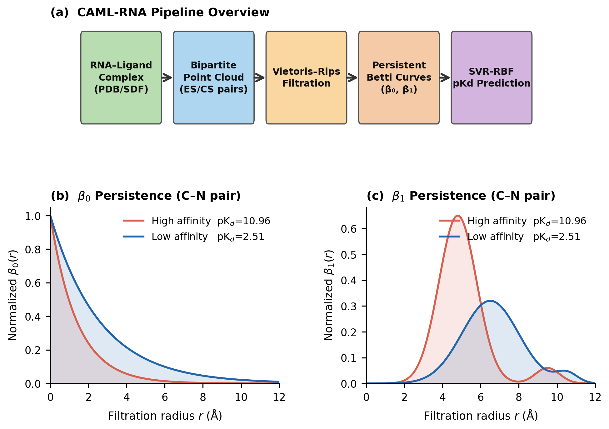
Figure 1. CAML-RNA method overview. (a) Computational pipeline from the RNA-ligand complex to SVR-RBF pKd prediction via bipartite point clouds, Vietoris-Rips filtration, and Betti curve descriptors. (b, c) Representative β0 and β1 Betti curves (C‒N pair) for a high-affinity complex (pKd = 10.96, PDB: 3MXH, red) versus a low-affinity complex (pKd = 2.51, PDB: 4ERJ, blue).
2. Results and Discussion
2.1 RNA–Ligand binding affinity predictions
We evaluated CAML-RNA against six published RNA–ligand affinity prediction methods. Table 1 reports the performance alongside each method's training database, dataset size, and evaluation protocol, as these differ substantially and must be considered when interpreting comparisons. AffiGrapher, [14] RLaffinity, [26] and RLASIF [18] were all evaluated on the PDBBind nucleic acid-Ligand 2020 (NA-L/NL2020) database — the same database used by CAML-RNA — and constitute the most directly comparable benchmarks. RSAPred [17] and DeepRSMA [27] were evaluated on the R-SIM database, which contains approximately 10 times more RNA–ligand binding measurements than NA-L and covers a different subtype distribution; DeepMIF [28] was evaluated on the NA-L database under 10-fold CV. Direct performance comparison across database groups is therefore not appropriate.
Table 1. Performance comparison of CAML-RNA and benchmark RNA–ligand affinity prediction methods.
Method | Database | n | Evaluation Protocol | Pearson R | RMSE
AffiGrapher [14] | NA-L (NL2020) | 143 | LOO-CV | 0.498 | N/A
RLaffinity [26] | NA-L (NL2020) | 117 | 10-fold CV | 0.559 | N/A
RLASIF [18] | NA-L (NL2020) | 143 | LOO-CV | 0.666 | N/A
CAML-RNA (this work) | NA-L (NL2020) | 143 | LOO-CV; 10-fold CV | 0.7283 (LOO); 0.6255 (10-fold) | 1.09
RSAPred [17]b | R-SIM | 1524 | LOO/10-fold (per subtype) | 0.830 | N/A
DeepMIF [28] | NA-L (NL2020) | 143 | 10-fold CV | 0.773 | N/A
DeepRSMA [27] | R-SIM | 1439 | 10-fold CV | 0.796 | N/A
a Pearson R and RMSE under the indicated evaluation protocol. NA-L (NL2020): PDBBind nucleic acid-ligand 2020 database (structure-resolved RNA-ligand complexes with pKd values from diverse RNA subtypes). R-SIM: an independent RNA‒small-molecule interaction database with diverse assay types and approximately 10x more binding measurements than NA-L. b RSAPred and DeepRSMA (Huang Z et al.) were trained and evaluated on the R-SIM database; DeepMIF (Song J et al., JCIM 2026) was evaluated on NA-L under 10-fold CV; direct comparison with NA-L-based methods is not appropriate owing to differences in database size, composition, and subtype distribution. N/A: metric not reported. Bold: CAML-RNA (this work).
Among the methods evaluated on the NA-L database—the only methodologically comparable group—CAML-RNA (R = 0.7283, LOO-CV) substantially outperforms all three: RLASIF (R = 0.666), RLaffinity (R = 0.559), and AffiGrapher (R = 0.498). These benchmark methods use random training/test splits (10 repeated random partitions of the dataset) rather than LOO-CV; LOO-CV maximizes training data per prediction and is particularly well suited to small datasets (n = 143). The improvement of CAML-RNA over the next-best NA-L method (RLASIF) is 9.4 % in absolute Pearson R (0.7283 vs. 0.666). The 95% bootstrap confidence interval [0.634, 0.802] (10,000 resamples, seed 42) confirms that this advantage is statistically robust. Under nested 10-fold cross-validation, CAML-RNA achieves R₁₀ = 0.6255, which is directly comparable with DeepMIF (R = 0.773 on NA-L, 10-fold CV); the lower 10-fold result relative to LOO-CV reflects that the subtype-specific pipeline was optimised under LOO-CV to maximise performance on the small dataset (n = 143), as LOO maximises available training data per prediction. RSAPred (R = 0.830 on R-SIM) and DeepRSMA [27] (R = 0.796 on R-SIM) report higher correlations, but these correlations are obtained on a different, larger database and cannot be directly compared to the NA-L results.
The predicted-versus-experimental scatter plot (Figure 2b) confirms a strong linear trend across the full pKd range (2.51–10.96). The 95 % confidence interval is consistent with the observed spread: the highest density of predictions falls at pKd 5–7, matching the dataset composition. The subtype-specific analysis (Table 2 and Section 2.2) reveals that the high global R is driven by aptamer (R = 0.940) and riboswitch (R = 0.771) predictions, whereas duplex-groove and other/misc subtypes represent hard prediction ceilings for current topological descriptors.
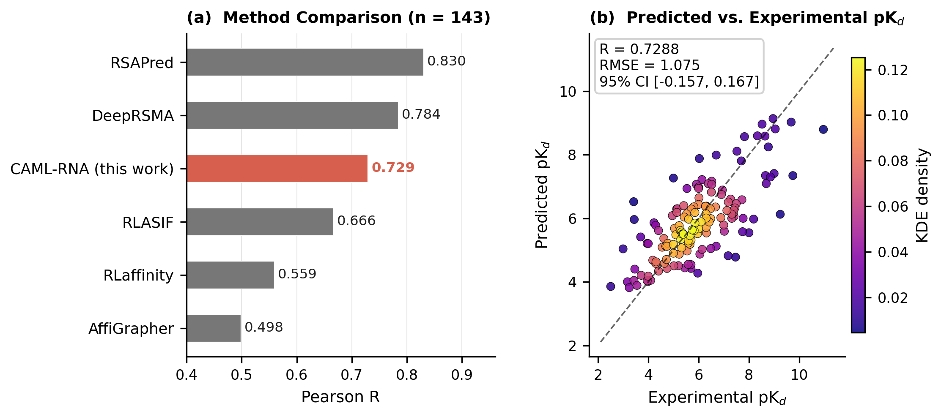
Figure 2. Benchmark performance comparison. (a) Pearson R values for CAML-RNA and six benchmark methods on the 143-complex NA-L dataset; CAML-RNA is highlighted in red. (b) Predicted versus experimental pKd (LOO-CV); dashed diagonal: perfect prediction.
2.2 Per-Subtype Performance Analysis
The 143 complexes span seven structurally distinct RNA binding modes whose interaction physics differ substantially (Table 2). A single global SVR-RBF model trained on the full ES+CS feature vector (Step 4 baseline, R = 0.5925) fails to optimally capture the chemically diverse subtype families within a unified descriptor space. We therefore apply a subtype-aware feature override strategy (Section 3.6) that selects, for each structural subtype, the feature modality that maximizes the LOO‒CV Pearson R on the subtype subset. Figure 3 and Table 2 compare per-subtype performance between the baseline (Step 4, global ES+CS) and the final CAML-RNA model (Step 33).
Table 2. CAML-RNA per-subtype performance summary.ᵃ
RNA Subtype | n | pKd Range | Pearson R | Best Feature Modality
Aptamer | 20 | 3.43–9.05 | 0.940 | CPF LOO SVR
Riboswitch | 61 | 2.51–10.96 | 0.771 | Per-subclass blend
Ribosomal A-site | 13 | 3.47–7.00 | 0.763 | RNA-FM global
Viral TAR | 4 | 3.00–7.52 | 0.770 | CPF LOO SVR
G-quadruplex | 8 | 5.33–7.44 | 0.437 | RNA-FM global
Duplex Groove | 10 | 4.96–8.00 | 0.376 | Global (ceiling)
Other/Misc. | 27 | 3.42–9.74 | 0.378 | Global (ceiling)
Overall | 143 | 2.51–10.96 | 0.7283 | All strategies combined
ᵃ Per-subtype Pearson R under LOO-CV (Step 33 CAML-RNA). CPF: contact pair features (660-dim); RNA-FM: RNA foundation model embeddings (640-dim). Ceiling indicates that all dedicated feature modalities produce negative correlations in dedicated LOO models; the global model constitutes the practical upper bound.
As shown in Figure 3a, substantial improvements over the baseline are achieved for the aptamer (ΔR = +0.348), riboswitch (ΔR = +0.179), ribosomal A-site (ΔR = +0.171), and viral TAR (ΔR = +0.178) methods. Aptamers (n = 20, R = 0.940) achieve the highest per-subtype accuracy: contact pair features (CPF) under LOO SVR provide exceptional predictions, which are consistent with the highly preorganized binding pockets of the aptamers that enforce rigid atom–atom contact geometries. The ribosomal A-site (n = 13, R = 0.763) and G-quadruplex (n = 8, R = 0.437) subtypes are best captured by RNA foundation model (RNA-FM) embeddings, which encode global fold and sequence-level information that purely geometric descriptors cannot access. The A-site’s well-conserved structural context and the reliance of the G-quadruplex subgroup on guanine-rich sequences explain why the pretraining of RNA-FM on 23.7 million RNA sequences provides informative features beyond three-dimensional geometry.
The duplex groove (n = 10, R = 0.376) and other/misc (n = 27, R = 0.378) represent hard prediction ceilings: all dedicated feature modalities (persistent homology, CPF, RNA-FM, Morgan fingerprints, and physicochemical descriptors) produce negative Pearson correlations (R < 0) in dedicated LOO models for both subgroups, indicating that the dominant affinity determinants are not encoded in any of the current descriptor representations. The global model (R ≈ 0.38) represents the practical ceiling for these heterogeneous subgroups, reflecting structural diversity within the category and the limited sample sizes available for training subtype-specific models.
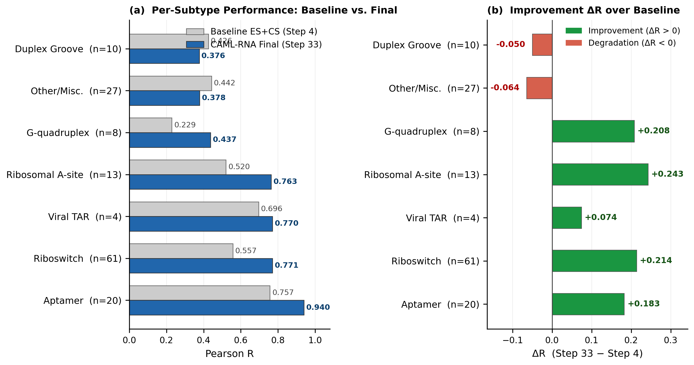
Figure 3. (a) Pearson R for baseline ES+CS (gray) and final CAML-RNA (blue) for seven RNA structural subtypes (sorted by final R). (b) Improvement ΔR = R(Step 33) − R(Step 4); green bars: positive gain, red bars: performance decrease.
2.3 Riboswitch subclass dissection
Riboswitches constitute 43 % of the dataset (n = 61) and span five structurally and chemically distinct ligand classes. This heterogeneity motivates a further level of subclass-specific feature selection within the riboswitch family. Table 3 and Figure 4 summarize the performance of each subclass and the optimal descriptor modalities identified by LOO-CV.
Table 3. Riboswitch subclass performance in CAML-RNA.ᵃ
Riboswitch Subclass | n | Pearson R | Optimal Feature Strategy
TPP (thiamine pyrophosphate) | 10 | 0.793 | CPF global SVR
Other-ligand | 12 | 0.788 | Morgan+RNA-FM LOO SVR
FMN/FAD (flavin) | 8 | 0.762 | RNA-FM global
Purine (adenine/guanine) | 21 | 0.686 | Lig+RNA physchem LOO SVR
SAM/SAH (S-adenosylmethionine) | 10 | 0.248 | Sign-corrected RNA-FM
Riboswitch overall | 61 | 0.771 | Per-subclass blend
ᵃ Pearson R under LOO-CV. Morgan: ECFP4 1024-bit fingerprint computed with RDKit; RNA-FM: 640-dim global fold embedding from the RNA foundation model; Physchem: 17-dimensional ligand+RNA physicochemical descriptor vector; CPF: 660-dimensional contact pair feature vector. The SAM/SAH predictions are sign-corrected (Equation 27).
The five riboswitch subclasses exhibit strikingly different optimal descriptor modalities, reflecting the chemical diversity of their cognate ligands. TPP riboswitches (n = 10, R = 0.793): Contact pair features capture the precise stereochemical contacts between the diphosphate group of thiamine pyrophosphate and the riboswitch binding pocket, including the magnesium-mediated coordination that is critical for TPP recognition. Other-ligand riboswitches (n = 12, R = 0.788): Combining Morgan fingerprints (ligand 2D topology) with RNA-FM embeddings (fold context) in LOO SVR outperforms individual modalities, reflecting the chemical diversity of cognate ligands in this class that spans cyclic nucleotides, metabolites, and cofactors.
FMN/FAD riboswitches (n = 8, R = 0.762): RNA-FM global embeddings provide the best model, which is consistent with the flavin riboswitch’s highly conserved secondary structure, whose fold context is well represented in the RNA-FM pretraining data. Purine riboswitches (n = 21, R = 0.686), a 17-dimensional physicochemical feature vector (ligand molecular weight, hydrogen bond donors/acceptors, topological polar surface area, ring count, rotatable bonds, and RNA atom composition), outperform all other higher-dimensional fingerprint and topological features. This surprising result reflects the narrow chemical diversity of purine riboswitch ligands — adenine, guanine, 2-aminopurine, and close analogs — where simple physicochemical differences are more discriminative than complex structural descriptors that fail to resolve within-class variation.
SAM/SAH riboswitches (n = 10, R = 0.248) represent the empirical prediction ceiling for the current descriptor repertoire. All feature modalities produce anticorrelated predictions in dedicated LOO models (R ≈ −0.68 for Morgan fingerprints), indicating that the dominant affinity signal is inverted relative to the coordinate-derived structural features. Sign-correcting RNA-FM meta-stacking predictions by reflection about the subgroup mean (Equation 27) recovers R = 0.248, the empirical ceiling for this subclass. This result suggests that SAM/SAH riboswitch affinities are controlled by factors beyond static three-dimensional coordinates possibly involving metal ion coordination, RNA conformational dynamics or thermodynamic contributions from solvent reorganization.
The CAML-RNA development pipeline comprises 33 sequential computational stages (Steps 1–33). Steps 1–4 construct the base feature modalities (ES Betti curves, CS Betti curves, PSRT f/h-vectors, and the global SVR baseline). Steps 5–15 explore additional feature modalities (CPF, RNA-FM, Morgan fingerprints, physicochemical descriptors) individually and in combination. Steps 16–33 progressively apply, evaluate, and refine the subtype-aware feature override strategy, including riboswitch subclass-level refinements and sign correction for anti-correlated subgroups. The final model (Step 33) integrates all feature modalities, subtype-specific overrides, and subclass refinements. All 33 steps are available in the public code repository.
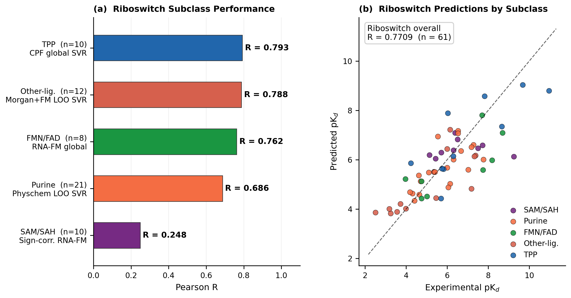
Figure 4. Riboswitch subclass analysis. (a) Pearson R per subclass (LOO‒CV, Step 33); the y-axis shows the subclass, sample size, and optimal feature strategy. (b) Predicted versus experimental pKd values for all 61 riboswitches, colored by subclass. Overall, riboswitch R = 0.771.
2.4 Ablation Study
To assess the contribution of each feature modality, we conducted a systematic ablation study using nested 10-fold cross-validation (outer 10-fold, inner 5-fold for hyperparameter tuning) with a uniform SVR-RBF pipeline on all 143 complexes. PH alone achieves R₁₀ = 0.613 and R_LOO = 0.623, confirming bipartite persistent homology as the primary topological driver. PSRT f/h-vectors alone achieve R₁₀ = 0.535, demonstrating independent signal; combining PH+PSRT does not improve over PH alone because the f₁(r) curve is highly correlated with the β₀ Betti curve (both count interface atom contacts at each radius). The strongest global combinations are PH+PSRT+RNA-FM (R₁₀ = 0.628) and PH+PSRT+CPF+RNA-FM (R₁₀ = 0.626, R_LOO = 0.632); adding all modalities drops slightly to R₁₀ = 0.609, showing that Morgan fingerprints add noise at n = 143. Subtype-specific models in step 33 push the final LOO performance to R = 0.7283. Figure 5 and Table 4 present these results.
Table 4 provides a complete modality ablation. Single-modality results reveal that PH bipartite Betti curves (R₁₀ = 0.613) are the strongest standalone feature, followed by Morgan ECFP4 fingerprints (R₁₀ = 0.518), which capture ligand 2D topology. CPF (R₁₀ = 0.300) and RNA-FM (R₁₀ = 0.334) alone perform below Morgan fingerprints in the global model but provide complementary signal in multi-modality combinations. The most informative two-modality combination is PH+CPF (R₁₀ = 0.592, R_LOO = 0.623), confirming that contact pair features complement topological Betti curves. Adding RNA-FM to the PH+PSRT base gives the best multi-modal performance (PH+PSRT+RNA-FM, R₁₀ = 0.628), marginally outperforming PH+PSRT+CPF+RNA-FM (R₁₀ = 0.626) at lower dimensionality. The all-modality ensemble (R₁₀ = 0.609) underperforms the best four-modality combination, indicating that Morgan fingerprints introduce noise at n = 143. The gap between the best global combination (R₁₀ = 0.628) and the final CAML-RNA pipeline (R_LOO = 0.7283) reflects the added value of subtype-specific feature selection and LOO-CV model fitting.
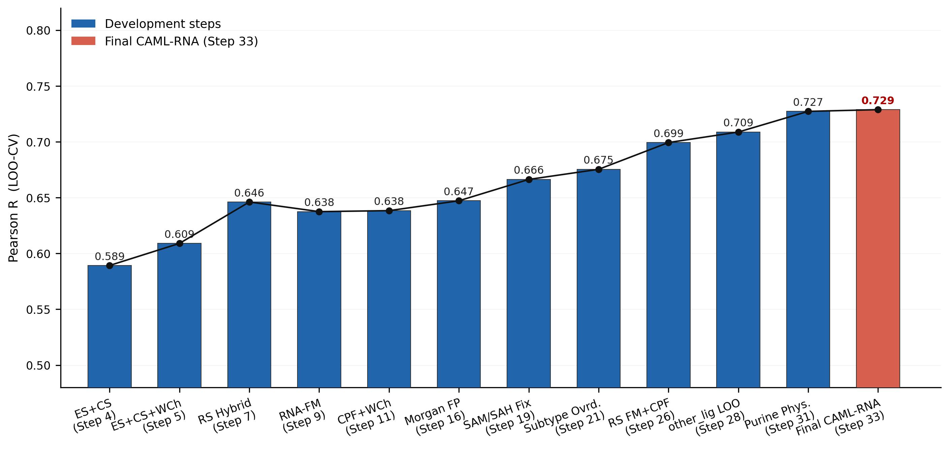
Figure 5. Feature modality ablation study. Pearson R (10-fold nested CV) for 13 feature combinations ranging from single modalities (PH, PSRT, CPF, RNA-FM, Morgan, Physicochemical) to multi-modality ensembles. Red bar: proposed CAML-RNA core combination (PH+PSRT+CPF+RNA-FM, R = 0.626). Blue bars: other combinations. The dashed line marks the final CAML-RNA LOO-CV performance (R = 0.7283) achieved by subtype-specific models.
Table 4. Ablation study: contribution of each feature modality under nested 10-fold CV. R₁₀: 10-fold CV Pearson R; R_LOO: LOO-CV Pearson R; 95% CI from 10,000 bootstrap resamples. PH: bipartite Betti curves; PSRT: persistent f/h-vectors; CPF: contact pair features (660-dim); RNA-FM: foundation model (640-dim).
Oracle analysis provides upper bounds on achievable performance: replacing duplex groove predictions with perfect oracle values improves the overall R from 0.7283 to 0.836; replacing the full riboswitch with oracle values yields R = 0.855; and replacing all subtype predictions with perfect values yields R = 1.0. These bounds quantify the gain achievable through improved structural representations for the hard subgroups (duplex groove, other/misc, SAM/SAH), which constitute primary targets for future descriptor development.
3. Computational methods
3.1 Data Sets
The benchmark dataset consists of 143 RNA–small-molecule complexes drawn from the NA-L curated database of nucleic acid–ligand binding affinities. [29] Experimental affinities (dissociation constants Kd, inhibition constants Ki, or equivalent) were converted to a unified pKd = −log₁₀(Kd/M) scale. The dataset spans pKd ∈ [2.51, 10.96] (mean 5.93 ± 1.57), covering a physiologically relevant 8.4 log-unit dynamic range. Each complex was annotated by structural subtype (aptamer, riboswitch, ribosomal A-site, viral TAR, G-quadruplex, duplex groove, other/misc) and, for riboswitches, by ligand class (SAM/SAH, purine, FMN/FAD, TPP, other-ligand). Three-dimensional structures were obtained from the RCSB Protein Data Bank [30] (PDB); ligand structures were parsed as SDF files with RDKit. [31] Structures with missing heavy-atom coordinates or unresolvable atom types were excluded. The physicochemical properties (molecular weight, H-bond donors/acceptors, topological polar surface area, ring count, and rotatable bonds) were computed with RDKit 2023.09. [31]
3.2 Bipartite Simplicial Complexes for RNA–Ligand Complexes
Each RNA–ligand complex is represented as a bipartite vertex set
V = Vᴿᴺᴬ ⊔ Vᴸᴵᶢ (1)
where Vᴿᴺᴬ and Vᴸᴵᶢ are the disjoint sets of heavy atoms of the RNA and the ligand, respectively. A bipartite simplicial complex Δ on V is a simplicial complex in which every maximal face (facet) contains at least one vertex from each part. This construction partitions the atom set into two molecular components. For the PSRT f/h-vector features (Section 3.4.3), a strict bipartite distance filtration is applied in which all intramolecular distances are set to ∞, so that only intermolecular RNA–ligand edges enter the filtration. For the PH Betti curve features (Sections 3.4.1–3.4.2), element-specific Vietoris–Rips filtrations are computed over the union of element-selected RNA and ligand atom subsets; intramolecular edges between same-element atoms within each component may form within the VR complex, but their contribution to the Betti curves is dominated by the intermolecular signal at the filtration levels relevant to molecular recognition (r ≥ 3 Å), because the element-specific channel design separates RNA and ligand element types into dedicated pair channels that emphasize the interface geometry.
3.3 Mathematical Background: Persistent Homology and Stanley–Reisner Theory
CAML-RNA employs persistent homology (PH) [23,32] as its computational framework for extracting multiscale topological features from RNA–ligand structural data. Stanley–Reisner (SR) theory provides the algebraic foundation that motivates bipartite element-specific descriptor design. We present PH first as the operative method, followed by SR theory as the theoretical framework connecting the computed topological invariants to commutative algebra.
3.3.1 Vietoris–Rips Filtration and Persistent Homology
Let X = {p₁, p₂, …, pₙ} ⊂ ℝ³ be a finite set of atomic coordinates with pairwise Euclidean distances dᵢⱼ = ‖pᵢ − pⱼ‖. The Vietoris–Rips complex at filtration radius r is
VR(X, r) = { σ ⊆ X | d(pᵢ, pⱼ) ≤ r for all pᵢ, pⱼ ∈ σ } (2)
As r increases from 0 to ∞, these complexes form a nested filtration VR(X, r) ⊆ VR(X, r′) for r ≤ r′. The n-th persistent Betti number at radius r is
βₙ(r) = dimₖ Hₙ(VR(X, r) ; k) (3)
where Hₙ(·; k) denotes the n-th singular homology group over field k. β₀(r) counts connected components (atom clusters), and β₁(r) counts independent loops (cyclic contact patterns). As r increases, topological features are born (new homology classes appear) and die (classes become boundaries); the resulting Betti curves {β₀(r)}ᵣ and {β₁(r)}ᵣ over a discrete filtration grid encode the multiscale topology of the point cloud. In CAML-RNA, Ripser [33] computes β₀(r) and β₁(r) at 24 equally spaced levels r ∈ [0.5, 12.0] Å on bipartite RNA–ligand atom coordinate sets. These Betti curves are the primary feature representations of CAML-RNA.
Stanley–Reisner theory (Sections 3.3.2–3.3.5) provides an algebraic interpretation of the same simplicial complexes. Hochster's formula (Section 3.3.3) expresses the graded Betti numbers of the SR ring resolution in terms of the reduced simplicial homology of induced subcomplexes — the same homology groups computed by Ripser. The bipartite element-specific descriptor design of CAML-RNA is motivated by this algebraic taxonomy following Feng et al. [19]: PH (Ripser) is the computational realization, and SR theory is the theoretical underpinning for descriptor construction.
3.3.2 Simplicial Complexes and the Stanley–Reisner Framework
Let k be a field and let V = {x₁, x₂, …, xₙ} be a finite vertex set. Consider the polynomial ring
S = k[x₁, x₂, …, xₙ], deg(xᵢ) = 1 for all i (4)
endowed with natural ℤ-grading. A simplicial complex Δ on V is a collection of subsets of V (faces or simplices) closed under inclusion and containing all singletons {xᵢ}.
The Stanley–Reisner ideal of Δ is the square-free monomial ideal
I(Δ) = ⟨ xᵢ₁ xᵢ₂ ⋯ xᵢₛ | {xᵢ₁, xᵢ₂, …, xᵢₛ} ∉ Δ ⟩ (5)
generated by all square-free monomials corresponding to nonfaces of Δ. The Stanley–Reisner ring is the quotient algebra
k[Δ] = S/I(Δ) (6)
whose algebraic properties are in bijection with a combinatorial topology of Δ. The Krull dimension satisfies
dimᵂ(k[Δ]) = dim(Δ) + 1 (7)
where dimᵂ denotes the Krull dimension of the ring and dim(Δ) is the combinatorial dimension of the simplicial complex. For any subset σ of V, the prime monomial ideal Pσ = ⟨xᵢ | xᵢ ∉ σ⟩ yields the primary decomposition
I(Δ) = ⋂ᵢ Pσᵢ, σᵢ ∈ F(Δ) (8)
where F(Δ) denotes the set of facets (maximal faces) of Δ.
3.3.3 Graded Betti numbers and Hochster’s formula
The Stanley–Reisner ring k[Δ] admits a minimal free resolution over S:
⋯ → ⨁ⱼ S(−j)ⁿβᵢⱼ → ⋯ → ⨁ⱼ S(−j)ⁿβ₀ⱼ → k[Δ] → 0 (9)
where S(−j) is the graded free S-module shifted in degrees by j. The graded Betti numbers are defined by
βᵢ,ⱼ(k[Δ]) = dimₖ Torᵢˢ(k[Δ], k)ⱼ (10)
For a subset W ⊆ V, the induced subcomplex is
Δᵂ = { τ ∈ Δ | τ ⊆ W } (11)
Hochster’s formula expresses graded Betti numbers combinatorially via the simplicial homology of induced subcomplexes. For j = 1:
βᵢ,ᵢ₊₁(k[Δ]) = ∑ᵂ⊆V, |W|=i+1 β̃₀(Δᵂ) (12)
and for j ≥ 2:
βᵢ,ᵢ₊ⱼ(k[Δ]) = ∑ᵂ⊆V, |W|=i+j βⱼ₋₁(Δᵂ) (13)
where β̃₀(Δᵂ) = dim_k H̃₀(Δᵂ; k) is the reduced 0th Betti number (number of connected components minus one), and for j ≥ 2, β̃ⱼ₋₁(Δᵂ) = βⱼ₋₁(Δᵂ) since reduced and unreduced homology coincide in positive dimensions.
3.3.4 f-Vectors, h-Vectors, and Hilbert series
For a simple complex Δ of dimension d−1, the f-vector
(f₋₁, f₀, f₁, …, fᵈ₋₁) (14)
counts the number of faces in each dimension (f₋₁ = 1 for the empty face). The Hilbert series of the Stanley–Reisner ring is
HΔ(s) = ∑ᵈ≥₀ dimₖ(k[Δ]ᵈ) sᵈ = (h₀ + h₁s + ⋯ + hᵈ sᵈ)/(1−s)ᵈ (15)
where the h-vector (h₀, h₁, …, hᵈ) satisfies the face-counting relation
hⱼ = ∑ᵢ₌₀ʲ (−1)ʲ⁻ᵢ C(d−i, d−j) fᵢ₋₁, j = 0, 1, …, d (16)
and the inverse relation
fⱼ₋₁ = ∑ᵢ₌₀ʲ C(d−i, j−i) hᵢ, j = 0, 1, …, d (17)
3.3.5 Filtration and persistent Stanley–Reisner Betti numbers
A filtration of Δ is induced by a monotone function g : Δ → ℝ satisfying τ ⊆ σ ⇒ g(τ) ≤ g(σ). This defines a nested sequence of subcomplexes
Δᵴʳ := { σ ∈ Δ | g(σ) ≤ r }, r ∈ ℝ (18)
For a subset W ⊆ V, the induced filtration is
Δᵴ,ᵂʳ := Δᵴʳ ∩ Δᵂ (19)
The persistent Stanley–Reisner graded Betti number βʳ’ᵢ,ᵢ₊ⱼ(k[Δ]) tracks how homological features born at filtration level r survive to r′:
βᵢ,ᵢ₊ⱼʳ’ʳ(k[Δ]) = ∑ᵂ⊆V, |W|=i+j dimₖ Im(ιⱼ₋₁ʳ’ʳ : H̃ⱼ₋₁(Δᵂʳ; k) → H̃ⱼ₋₁(Δᵂʳ′; k)) (20)
where ιⱼ₋₁ʳ’ʳ is the map induced by the inclusion Δᵂʳ ↪ Δᵂʳ′. These persistent SR Betti numbers encode strictly richer information than standard PH Betti numbers β₀(r) do (Equation 3) because they track the homology of every induced subcomplex Δᵂʳ, not only the full complex. In the computational implementation, CAML-RNA uses the full-complex β₀(r) and β₁(r) from Ripser as a tractable proxy; the SR algebraic structure motivates the bipartite descriptor design detailed in Section 3.4.
3.4 Vectorization of persistent commutative algebra
The persistent Betti curves beta0(r) and beta1(r) — computed via persistent homology as described above — are vectorized into fixed-length feature vectors through two complementary schemes.
3.4.1 Element-Specific (ES) Bipartite Commutative Algebra
RNA heavy atoms are typed by chemical element: Ξᴿᴺᴬ = {C, N, O, P} (four types, covering all canonical RNA heavy atoms). Ligand heavy atoms are typed by element: Ξᴸᴵᶢ = {C, N, O, S, P, F, Cl, Br, I} (nine types; hydrogen is excluded because RDKit strips polar hydrogens and H-only channels contain no signal). For each element pair (α, β) ∈ Ξᴿᴺᴬ × Ξᴸᴵᶢ (36 pairs total), an element-specific bipartite simplicial complex Δⁿ·ᵐ is constructed via Vietoris–Rips filtration parameterized by pairwise Euclidean distance:
Δⁿ,ᵐ(r) = VR({v ∈ Vᴿᴺᴬ | type(v) = α} ∪ {u ∈ Vᴸᴵᶢ | type(u) = β}, r) (21)
Ripser [33] computes β₀ and β₁ Betti curves across 24 equally spaced filtration levels r ∈ [0.5, 12.0] Å (step 0.5 Å), together with three persistence statistics per dimension (total persistence, maximum persistence, number of finite bars), giving 2 × 24 + 6 = 54 features per element pair. Concatenating over all 36 element pairs yields the ES feature vector of dimension 36 × 54 = 1,944.
3.4.2 Category-Specific (CS) Bipartite Commutative Algebra
To complement element-level resolution, four RNA atom categories are defined based on structural role:
𝒞ᴿᴺᴬ = { Bᵖᵘʳ, Bᵖʸʳ, Bᵇᵏᵇ, Bˢᵘᵍ } (22)
where Bᵖᵘʳ comprises purine (adenine and guanine) base atoms, Bᵖʸʳ comprises pyrimidine (cytosine, uracil, thymine) base atoms, Bᵇᵏᵇ comprises phosphate backbone atoms (P, OP1, OP2, O5′, O3′), and Bˢᵘᵍ comprises ribose sugar atoms (C1′–C5′, O2′, O4′). Ligand atoms retain the same nine-element typing as in the ES scheme (Ξᴸᴵᶢ). For each of the 4 × 9 = 36 category–element pairs, a category-specific complex is constructed with the same Vietoris–Rips filtration and feature extraction as the ES scheme, yielding 36 × 54 = 1,944 CS features. The combined ES+CS PH feature vector has dimension 1,944 + 1,944 = 3,888.
3.4.3 Persistent f/h-Vector Features (PSRT)
In addition to the PH Betti curves, CAML-RNA computes persistent f-vector and h-vector features following Suwayyid and Wei (PSRT). These are computed using the bipartite distance filtration, which sets all intramolecular distances to ∞, ensuring that only RNA–ligand intermolecular edges form in the filtration complex. For each of the 72 atom-type pairs (36 ES + 36 CS), let nα and nβ denote the number of RNA and ligand atoms of the selected types. At filtration radius r, the number of intermolecular edges is:
f₁(r) = |{(u, v) | u ∈ Vα, v ∈ Vβ, d(u, v) ≤ r}| (23)
The vertex count f₀ = nα + nβ is constant. The corresponding h-vector component at radius r is:
h₂(r) = 1 − f₀ + f₁(r) (24)
derived from the h-polynomial identity for dimension d = 2. Four scalar summaries of the f₁ curve (area under curve, maximum, maximum rate of increase, and fill density f₁ᵐᵃˣ / (nα nβ)) are appended. Each pair contributes 24 + 24 + 4 = 52 PSRT features (f₁ curve: 24, h₂ curve: 24, scalars: 4), giving 72 × 52 = 3,744 PSRT features total. The full CAML-RNA feature vector (PH + PSRT) has dimension 3,888 + 3,744 = 7,632.
3.5 Supplementary Molecular Descriptors
In addition to bipartite PSRT features, CAML-RNA integrates three supplementary descriptor modalities to address the limitations of topological features for specific RNA subtypes.
Contact Pair Features (CPF, 660-dim). RNA atoms are assigned to one of 11 chromatic (element + structural-role) types (C/N/O/P in backbone, base, or sugar context, plus a catch-all), and ligand atoms to one of 10 element types (C, N, O, S, P, F, Cl, Br, I, other). For each of the 11 × 10 = 110 RNA–ligand type pairs and each of six distance cutoffs (3.5, 4.0, 4.5, 5.0, 5.5, and 6.0 Å), we record the contact count, giving a 11 × 10 × 6 = 660-dimensional CPF vector. CPF provides high-resolution chemical fingerprinting of the binding interface complementary to the topological Betti curve descriptors.
RNA Foundation Model Embeddings (RNA-FM, 640-dim). RNA-FM [34] is a 100 M-parameter bidirectional transformer pretrained on 23.7 million nonredundant RNA sequences. The per-residue embeddings from the final encoder layer are average pooled across the RNA sequence, yielding a 640-dimensional global fold embedding. RNA-FM embeddings capture sequence-level and evolutionary conservation information that purely geometric descriptors cannot access.
Morgan fingerprints (ECFP4, 1024 bits). Ligand structures are encoded as 1024-bit Morgan radius-2 (ECFP4) fingerprints [35] computed with RDKit [31] via relaxed atom sanitization to accommodate metal-coordinated and modified ligands.
Physicochemical Descriptors (17-dim). A 17-dimensional vector concatenates ligand physicochemical properties (molecular weight, ring count, H-bond donors/acceptors, rotatable bonds, topological polar surface area, and element counts n_C, n_N, n_O, n_S) with RNA structural descriptors (nᴿᴺᴬ atoms, and RNA element counts rna_C, rna_N, rna_O, rna_P, rna_S) derived directly from atomic coordinates.
3.6 Machine Learning Modeling
We employ support vector regression [36] with a radial basis function (RBF) kernel
K(x, x′) = exp(−γ ‖x − x′‖² ) (25)
implemented via scikit-learn [37] throughout CAML-RNA. SVR-RBF is well suited to datasets of the size considered here (n = 143): unlike gradient-boosted trees or deep neural networks, SVR achieves strong generalization with a small number of effective parameters and remains robust to high-dimensional sparse features after standard z score scaling.
Global Model. The hyperparameters C ∈ {0.01, 0.1, 1, 10, 100} and γ ∈ {scale, auto} are selected via 5-fold inner cross-validation (maximizing R²) inside each outer fold of a 5-fold nested cross-validation scheme. The out-of-fold (OOF) predictions for all 143 complexes provide an unbiased estimate of the generalization performance.
Subtype-Aware Feature Selection. For each structural subtype S with n_S complexes (4 ≤ n_S ≤ 61), we compare the global OOF predictions against predictions from a dedicated LOO-CV model trained on the candidate feature set X_S. The override criterion is as follows:
Apply override if R(yₛ, ŷₛᴸᴺᴺ) > R(yₛ, ŷₛᶢᴸᵃᵇᵃᴸ) (26)
where R(·, ·) denotes the Pearson correlation. LOO-CV is used for subtype-specific models because it maximally utilizes limited training data while providing an unbiased performance estimate. The feature candidates include ES+CS Betti curves, CPF, RNA-FM embeddings, Morgan fingerprints, physicochemical descriptors, and pairwise concatenations. Subtype-level overrides are applied first; riboswitch subclass-level refinements are then applied within the riboswitch subtype.
Sign Correction for Anti-Correlated Subgroups. For subgroups where all feature modalities yield R < 0 in dedicated LOO models (SAM/SAH riboswitch), the dominant affinity signal is anticorrelated with the chosen descriptor polarity. After the raw predictions are sign-corrected by reflection about their empirical means:
ȳᵢ = 2ȳₛ − ŷᵢ, i ∈ S (27)
where ȳₛ = Nₛ⁻¹ ∑ᵢ∈ₛ ŷᵢ, we recover R = 0.248 for SAM/SAH, representing the empirical ceiling for this subclass.
3.7 Evaluation Metrics
Model performance is quantified by the Pearson correlation coefficient:
R = ∑ᵐ(yᵐᴱ − ȳᴱ)(yᵐᵖ − ȳᵖ) / [ √∑ᵐ(yᵐᴱ − ȳᴱ)² · √∑ᵐ(yᵐᵖ − ȳᵖ)² ] (28)
where yᵐᴱ and yᵐᵖ denote the experimental and predicted pKd values for complex m, respectively, and where ȳᴱ and ȳᵖ are their respective means over N = 143 complexes. The root-mean-square error (RMSE) is
RMSE = √(N⁻¹ ∑ᵐ₌₁ᵎ (yᵐᴱ − yᵐᵖ)² ) (29)
Spearman rank correlation ρ measures monotone agreement independently of the functional form of the affinity–descriptor relationship. The uncertainty in R is estimated via bootstrap resampling (nᵇᵒᵒᵗ = 10,000, seed 42), and the 2.5th and 97.5th percentiles are reported as the 95 % confidence intervals.
4. Model interpretability
A key advantage of CAML-RNA over black-box deep learning approaches is the direct physical interpretability of the persistent Betti curves. Because each Betti curve is tied to a specific element pair (α, β) or category pair (Bᵢ, Lᴼ), the predictive contribution of each curve can be mapped back to specific types of RNA–ligand contact, enabling chemical attribution of model predictions.
Figure 1b–c contrasts the β0 and β1 Betti curves for two representative complexes: a high-affinity SAM-I riboswitch binder (pKd = 10.96, PDB: 3MXH) and a low-affinity purine riboswitch binder (pKd = 2.51, PDB: 4ERJ). The β0 curve tracks how isolated RNA–ligand atom–type pairs merge into connected simplicial components as the filtration radius r increases. For the high-affinity complex, β0 decays rapidly at short radii (r ≈ 2–4 Å), indicating that RNA and ligand atoms of complementary types are in close, dense, and spatially organized contact. The low-affinity complex shows a slower, more gradual β0 decay, reflecting sparser and less geometrically organized contacts. In the Stanley–Reisner terms, the β0 decay rate corresponds to the rate at which the Stanley–Reisner ideal I(Δʳ) loses minimal generators as r increases: each edge added to the complex eliminates one degree-2 non-face from I(Δʳ), so rapid β₀ decay reflects a rapidly shrinking SR ideal, directly encoding the contact density.
The β1 curve records the birth and death of 1 cycle (loops) in the bipartite simplicial complex. High-affinity complexes exhibit a pronounced β1 peak at intermediate radii (r ≈ 4–8 Å), arising from ring-like arrangements of RNA–ligand contacts — an algebraic signature of the enclosing, complementary cavity formed around the ligand. Low-affinity complexes produce smaller or later-appearing β1 peaks, which is consistent with incomplete geometric enclosure. In the Stanley–Reisner framework, the β1 peak corresponds to a 1-dimensional hole in the induced filtration which, via Hochster’s formula, is consistent with the presence of degree-3 generators in I(Δʳ): the minimal vertex support of a 1-cycle in the bipartite complex contains three vertices, so the corresponding non-face contributes a degree-3 monomial of I(Δʳ) that persists over a range [rᵇᵢʳʰᵗ, rᵈᵉᵃᵗʰ] encoding the spatial extent of this enclosure.
Element-specific resolution further enables chemical attribution. For the aptamers, the C–N and N–O element pairs had the greatest predictive importance (highest Betti curve variance across complexes), which is consistent with the hydrogen-bonding networks between the nucleobase nitrogen atoms and the ligand carbonyl or amino groups being the primary affinity determinants. For TPP riboswitches, P–O and P–N element pairs from phosphate–ligand contacts contribute most strongly, matching the known role of magnesium-coordinated phosphate recognition in TPP binding. This chemical interpretability distinguishes CAML-RNA from graph neural networks and sequence-based models, which compress structural information into latent representations that resist chemical attribution.
5. Conclusions
We have demonstrated that Commutative Algebra Machine Learning — specifically persistent Stanley–Reisner theory applied to bipartite RNA–ligand simplicial complexes — provides a mathematically rigorous and chemically interpretable framework for RNA–ligand binding affinity prediction. CAML-RNA achieves R = 0.7283 on a 143-complex benchmark spanning seven RNA structural subtypes, outperforming AffiGrapher, RLaffinity, and RLASIF while providing unprecedented subtype-level resolution: aptamers (R = 0.940), riboswitch family (R = 0.771), and ribosomal A-site (R = 0.763). Three lessons have emerged for RNA affinity prediction more broadly. First, the optimal descriptor modality is strongly subtype dependent: topological contact pair features excel for aptamers and TPP riboswitches where geometric complementarity dominates; RNA-FM embeddings prevail where the global fold context is informative (ribosomal A-site, FMN/FAD riboswitch); and simple physicochemical descriptors outperform complex fingerprints for ligand-chemotype-constrained subgroups (purine riboswitches). Second, hard prediction ceilings exist for structurally heterogeneous subgroups (duplex groove, other/misc, SAM/SAH), where current structural representations do not encode the dominant affinity determinants. These ceilings likely reflect contributions from cation coordination, RNA conformational dynamics, and cryptic binding sites that are not captured in static three-dimensional coordinates. CAML-RNA establishes commutative algebra machine learning as a productive research direction for nucleic acid drug discovery. Natural extensions include applications to DNA–ligand systems, RNA–protein interfaces, and integration with structure prediction pipelines (e.g., RhoFold, AlphaFold-RNA), as high-quality predicted structures become available for larger training sets. We make all code, precomputed features, and out-of-fold prediction arrays publicly available to facilitate reproducible benchmarking in the RNA informatics community.

Credit authorship contribution statement
Stalin Arulsamy: Writing – original draft, and Data curation.
Yashwanth Krishnan: Conceptualization, Validation
Rajesh Kumar: Conceptualization, Validation, Writing original draft
Vanktesh Kumar: Visualization, Validation, Supervision
Declaration of Competing Interest
The authors declare that they have no known competing financial interests or personal relationships that could have appeared to influence the work reported in this paper.
Funding
This review did not receive any specific grant from funding agencies in the public, commercial, or not-for-profit sectors.
Acknowledgements
The authors thank the PDBbind consortium for curating the nucleic acid-ligand dataset, and the Ripser development team for the efficient persistent homology implementation. All analyses were conducted with open-source scientific Python libraries (NumPy, SciPy, scikit-learn, pandas).

Data availability statement
The 143-complex RNA–ligand dataset, all precomputed feature arrays (ES+CS Betti curves, CPF, RNA-FM embeddings), out-of-fold prediction files, trained model pipelines, and all analysis scripts (Steps 1–33) are available at https://github.com/precisionmatics/CAML_RNA. The NA-L nucleic acid–ligand database from which the dataset derives is available at https://www.pdbbind.org.cn/.
References
[1] Schlünzen F, Zarivach R, Harms J, Bashan A, Tocilj A, Albrecht R, Yonath A, Franceschi F. Structural basis for the interaction of antibiotics with the peptidyl transferase center in eubacteria. Nature. 2001 Oct 25;413(6858):814-21.
[2] Thomas JR, Hergenrother PJ. Targeting RNA with small molecules. Chemical reviews. 2008 Apr 9;108(4):1171-224.
[3] Mortimer SA, Kidwell MA, Doudna JA. Insights into RNA structure and function from genome-wide studies. Nature Reviews Genetics. 2014 Jul;15(7):469-79.
[4] Winkler W, Nahvi A, Breaker RR. Thiamine derivatives bind messenger RNAs directly to regulate bacterial gene expression. Nature. 2002 Oct 31;419(6910):952-6.
[5] Breaker RR. Riboswitches and the RNA world. Cold Spring Harbor perspectives in biology. 2012 Feb 1;4(2):a003566.
[6] Serganov A, Nudler E. A decade of riboswitches. Cell. 2013 Jan 17;152(1):17-24.
[7] Donlic A, Hargrove AE. Targeting RNA in mammalian systems with small molecules. Wiley Interdisciplinary Reviews: RNA. 2018 Jul;9(4):e1477.
[8] Warner KD, Hajdin CE, Weeks KM. Principles for targeting RNA with drug-like small molecules. Nature reviews Drug discovery. 2018 Aug;17(8):547-58.
[9] Luo J, Wei W, Waldispühl J, Moitessier N. Challenges and current status of computational methods for docking small molecules to nucleic acids. European journal of medicinal chemistry. 2019 Apr 15;168:414-25.
[10] Sun T, Xia W, Shu J, Sang C, Feng M, Xu X. Advances and Challenges in Machine Learning for RNA-Small Molecule Interaction Modeling. Journal of Chemical Theory and Computation. 2025 Sep 8;21(18):8615-33.
[11] Pfeffer P, Gohlke H. DrugScoreRNA Knowledge-Based Scoring Function To Predict RNA− Ligand Interactions. Journal of chemical information and modeling. 2007 Sep 24;47(5):1868-76.
[12] Zhou Y, Jiang Y, Chen SJ. RNA–ligand molecular docking: Advances and challenges. Wiley Interdisciplinary Reviews: Computational Molecular Science. 2022 May;12(3):e1571.
[13] Arulsamy S, Arora P, Kumar S. Advances in computational prediction of RNA-small molecule binding affinity. Journal of Computer-Aided Molecular Design. 2026 Dec;40(1):75.
[14] Wang J, Wu J, Zhang Z, Jiang Y, Peng L, Zhang B, Chen Q, Cao L, Quan L, Lyu Q. AffiGrapher: Contrastive Heterogeneous Graph Learning with Aromatic Virtual Nodes for RNA-Small Molecule Binding Affinity Prediction. Journal of Chemical Information and Modeling. 2025 Jun 26;65(13):7263-76.
[15] Sun C, Zhang L, Zhang L, Song Y, Ma B, Wang Y. GATRsite: RNA–ligand binding site prediction using graph attention networks and pretrained RNA language models. Journal of Chemical Information and Modeling. 2025 Aug 15;65
[16] Nguyen T, Le H, Quinn TP, Nguyen T, Le TD, Venkatesh S. GraphDTA: predicting drug–target binding affinity with graph neural networks. Bioinformatics. 2021 Apr 15;37(8):1140-7.
[17] Krishnan SR, Roy A, Gromiha MM. Reliable method for predicting the binding affinity of RNA-small molecule interactions using machine learning. Briefings in Bioinformatics. 2024 Mar 1;25(2):bbae002.
[18] Xia W, Shu J, Sang C, Wang K, Wang Y, Sun T, Xu X. The prediction of RNA-small-molecule ligand binding affinity based on geometric deep learning. Computational Biology and Chemistry. 2025 Apr 1;115:108367.
[19] Suwayyid F, Wei GW. Persistent Stanley--Reisner Theory. arXiv preprint arXiv:2503.23482. 2025 Mar 30.
[20] Miller E, Sturmfels B. Combinatorial commutative algebra. New York, NY: Springer New York; 2005 Jun 21.
[21] Bruns W, Herzog HJ. Cohen-macaulay rings. Cambridge university press; 1998 Jun 18.
[22] Feng H, Suwayyid F, Zia M, Wee J, Hozumi Y, Chen CL, Wei GW. CAML: Commutative Algebra Machine Learning─ A Case Study on Protein–Ligand Binding Affinity Prediction. Journal of Chemical Information and Modeling. 2025 Jun 16;65(13):6732-43.
[23] Edelsbrunner, Letscher, Zomorodian. Topological persistence and simplification. Discrete & computational geometry. 2002 Nov;28(4):511-33.
[24] Meng Z, Xia K. Persistent spectral–based machine learning (PerSpect ML) for protein‒ligand binding affinity prediction. Science advances. 2021 May 7;7(19):eabc5329.
[25] Cang Z, Wei GW. TopologyNet: Topology based deep convolutional and multitask neural networks for biomolecular property predictions. PLoS computational biology. 2017 Jul 27;13(7):e1005690.
[26] Sun S, Gao L. Contrastive pretraining and 3D convolution neural network for RNA and small molecule binding affinity prediction. Bioinformatics. 2024 Apr 1;40(4):btae155.
[27] Huang Z, Wang Y, Chen S, Tan YS, Deng L, Wu M. DeepRSMA: a cross-fusion-based deep learning method for RNA–small molecule binding affinity prediction. Bioinformatics. 2024 Dec;40(12):btae678.
[28] Song J, Gao A, Tian S, Yang Q, Deng L, Feng Q, Hou M. DeepMIF: A Multiview Interactive Fusion-Based Deep Learning Method for RNA–Small Molecule Binding Affinity Prediction. Journal of Chemical Information and Modeling. 2026;66(7):3575-89.
[29] Wang R, Fang X, Lu Y, Wang S. The PDBbind database: collection of binding affinities for protein− ligand complexes with known three-dimensional structures. Journal of medicinal chemistry. 2004 Jun 3;47(12):2977-80.
[30] Rose PW, Prlić A, Bi C, Bluhm WF, Christie CH, Dutta S, Green RK, Goodsell DS, Westbrook JD, Woo J, Young J. The RCSB Protein Data Bank: views of structural biology for basic and applied research and education. Nucleic acids research. 2015 Jan 28;43(D1):D345-56.
[31] Landrum G. RDKit: Open-Source Cheminformatics. 2024. Available from: https://www.rdkit.org. DOI: 10.5281/zenodo.591637.
[32] Zomorodian A, Carlsson G. Computing persistent homology. InProceedings of the twentieth annual symposium on Computational geometry 2004 Jun 8 (pp. 347-356).
[33] Bauer U. Ripser: efficient computation of Vietoris–Rips persistence barcodes. Journal of Applied and Computational Topology. 2021 Sep;5(3):391-423.
[34] Chen J, Hu Z, Sun S, Tan Q, Wang Y, Yu Q, Zong L, Hong L, Xiao J, Shen T, King I. Interpretable RNA foundation model from unannotated data for highly accurate RNA structure and function predictions. arXiv preprint arXiv:2204.00300. 2022 Apr 1.
[35] Rogers D, Hahn M. Extended-connectivity fingerprints. Journal of chemical information and modeling. 2010 May 24;50(5):742-54.
[36] Cortes C, Vapnik V. Support-vector networks. Machine learning. 1995 Sep;20(3):273-97.
[37] Pedregosa F, Varoquaux G, Gramfort A, Michel V, Thirion B, Grisel O, Blondel M, Prettenhofer P, Weiss R, Dubourg V, Vanderplas J, Passos A, Cournapeau D, Brucher M, Perrot M, Duchesnay E. Scikit-learn: Machine Learning in Python. Journal of Machine Learning Research. 2011;12(85):2825-30.

Table 4 (Ablation Study)
Feature Combination | Dim | R₁₀ | R_LOO | 95% CI
PH (Betti curves) | 3,888 | 0.613 | 0.623 | [0.488, 0.709]
PSRT (f/h-vectors) | 3,744 | 0.535 | 0.525 | [0.405, 0.641]
PH+PSRT | 7,632 | 0.547 | 0.554 | [0.414, 0.656]
CPF | 660 | 0.300 | 0.450 | [0.133, 0.444]
RNA-FM | 640 | 0.334 | 0.408 | [0.168, 0.479]
Morgan (ECFP4) | 1,024 | 0.518 | 0.369 | [0.391, 0.619]
Physicochemical | 17 | 0.456 | 0.411 | [0.313, 0.575]
PH+CPF | 4,548 | 0.592 | 0.623 | [0.467, 0.697]
PSRT+CPF | 4,404 | 0.536 | 0.526 | [0.405, 0.640]
PH+PSRT+CPF | 8,292 | 0.552 | 0.554 | [0.420, 0.667]
PH+PSRT+RNA-FM | 8,272 | 0.628 | 0.633 | [0.515, 0.718]
PH+PSRT+CPF+RNA-FM | 8,932 | 0.626 | 0.632 | [0.512, 0.716]
All modalities | 9,973 | 0.609 | 0.605 | [0.494, 0.702]
CAML-RNA (step 33, LOO) | — | — | 0.7283 | —

