CAML-RNA: Commutative Algebra Machine Learning
for RNA–Ligand Binding Affinity Prediction
Stalin Arulsamy,¹ Yashwanth Krishna,² Rajesh Kumar,¹ and Vanktesh Kumar¹,*
¹ School of Pharmaceutical Chemistry, School of Pharmaceutical Sciences, Lovely Professional University, Phagwara, Punjab, India
² Department of Pharmacy Practice, Manipal College of Pharmaceutical Sciences, Manipal Academy of Higher Education, Manipal, Karnataka, India
* Corresponding Author: Dr. Vanktesh Kumar, PhD (Vankteshkumar555@hotmail.com)
Abstract. We introduce Commutative Algebra Machine Learning for RNA (CAML-RNA), extending persistent Stanley–Reisner theory (PSRT) to the prediction of RNA–small molecule binding affinities. RNA–ligand interactions are represented as bipartite simplicial complexes in which RNA and ligand atoms occupy disjoint vertex sets, enabling element-specific (ES) and category-specific (CS) persistent homology to encode multiscale topological and combinatorial features of the binding interface. Applied to a curated benchmark of 143 experimentally characterized RNA–ligand complexes spanning seven structurally distinct subtypes, CAML-RNA achieves a Pearson correlation coefficient R = 0.7288 (RMSE = 1.075 pKd units, Spearman ρ = 0.687; 95 % CI [0.634, 0.802]) under leave-one-out cross-validation (LOO-CV), outperforming AffiGrapher (R = 0.498), RLaffinity (R = 0.559), and RLASIF (R = 0.666). A subtype-aware feature selection strategy yields R = 0.940 for aptamers and R = 0.771 for the riboswitch family. Persistent Betti curve analysis reveals topologically distinct binding signatures for high- versus low-affinity ligands, demonstrating the interpretive power of commutative algebra descriptors for RNA molecular recognition.
Keywords: RNA–ligand binding affinity; commutative algebra; persistent homology; Stanley–Reisner theory; bipartite simplicial complexes; support vector regression; drug discovery

1. Introduction
RNA molecules fulfill pivotal regulatory and catalytic roles across virtually all biological processes, including translation, pre-mRNA splicing, gene silencing, and metabolic sensing. [1,2] Unlike proteins, structured RNAs adopt compact three-dimensional architectures governed by Watson–Crick base pairing, non-canonical base interactions, base stacking, and tertiary contacts that create well-defined small-molecule binding pockets with defined electrostatic and steric complementarity. [3,4] Riboswitches, for instance, undergo ligand-induced conformational changes that regulate downstream gene expression with dissociation constants spanning picomolar to micromolar ranges, [5,6] while ribosomal RNA and viral RNA elements present structurally conserved binding sites for aminoglycoside and neomycin-class antibiotics. Collectively, these properties identify RNA as a compelling, yet largely underexploited, drug target class: to date, only a handful of clinically approved therapeutic agents directly target RNA, despite the vast diversity of RNA structures implicated in disease. [7,8]
Predicting RNA–ligand binding affinity computationally remains substantially harder than its protein–ligand counterpart. [9] Key challenges include the high negative charge density of the phosphodiester backbone, the conformational dynamics and induced-fit behavior of RNA upon ligand binding, the chemical diversity of ligands that recognize distinct RNA folds (ranging from aminoglycosides to purine analogs to thiamine pyrophosphate), and the paucity of experimentally measured binding affinities needed to train and validate data-driven models. [10] Established computational approaches, including molecular docking, [11] free energy perturbation, [12] and empirical scoring functions, [13] achieve limited accuracy on RNA targets because of force-field limitations and insufficient conformational sampling of the flexible RNA scaffold.
Machine-learning approaches for RNA–ligand affinity prediction have emerged in recent years, exploiting graph neural networks, [14,15,16] sequence-based descriptors, [17] and physics-informed structural features. [18] Despite these advances, a fundamental limitation persists: most methods ignore the multi-scale topological geometry of the RNA–ligand binding interface, specifically how RNA and ligand atoms form connected clusters, loops, and enclosing cavities at successive interaction distances. This topological information encodes shape complementarity, van der Waals contact density, and electrostatic preorganization in a coordinate-free, rotation- and translation-invariant representation that is directly accessible to persistent homology methods.
Commutative algebra offers a mathematically rigorous language for analyzing the combinatorial topology of molecular complexes. Suwayyid and Wei recently introduced persistent Stanley–Reisner theory (PSRT) as a bridge between commutative algebra, algebraic topology, and machine learning. [19] Stanley–Reisner theory studies square-free monomial ideals in polynomial rings, connecting them to simplicial complexes through the Stanley–Reisner ideal and ring; [20,21] filtration of the simplicial complex then yields persistent algebraic invariants — graded Betti numbers, f-vectors, and h-vectors — that track topological features across spatial scales and provide a fundamentally different perspective from standard persistent homology [22,23] and persistent spectral methods. [24,25]
Feng et al. recently demonstrated that Commutative Algebra Machine Learning (CAML) achieves state-of-the-art performance in protein–ligand binding affinity prediction on the PDBbind-v2016 benchmark (Pearson R = 0.858 on the core test set), surpassing persistent homology-based models. [22] CAML’s success rests on three innovations: element-specific (ES) bipartite commutative algebras that capture pairwise interaction chemistry between distinct atom types at the complex interface; category-specific (CS) bipartite commutative algebras that encode pharmacophoric interactions; and gradient-boosted decision tree (GBDT) regression that exploits the resulting high-dimensional persistent Betti curve feature vectors. However, the direct application of protein-focused CAML to RNA is non-trivial: RNA features a unique backbone chemistry (ribose-phosphodiester), a smaller alphabet of four nucleotides (adenine, guanine, cytosine, uracil), and fundamentally different structural categories from proteins.
Here we extend CAML to RNA–ligand binding through three RNA-specific methodological contributions: (i) bipartite PSRT for RNA — element-specific bipartite simplicial complexes built from RNA and ligand atom-type pairs, spanning 40 element-pair channels (4 RNA × 10 ligand element types), capturing the multiscale topology of the RNA–ligand interface; (ii) nucleotide category-specific commutative algebra — a CS framework that categorizes RNA atoms by structural role (backbone, purine base, pyrimidine base) and ligand atoms by pharmacophoric type (aromatic, H-bond donor, H-bond acceptor, aliphatic), yielding 12 category-pair channels; and (iii) subtype-aware feature selection — a principled LOO-CV strategy that identifies the optimal feature modality for each of seven RNA structural subtypes, yielding interpretable and chemically transferable models. The overall CAML-RNA framework is illustrated in Figure 1. Applied to a curated dataset of 143 RNA–ligand complexes from the NA-L database, [26] CAML-RNA advances the state of the art in RNA binding affinity prediction and establishes commutative algebra machine learning as a productive framework for nucleic acid drug discovery.
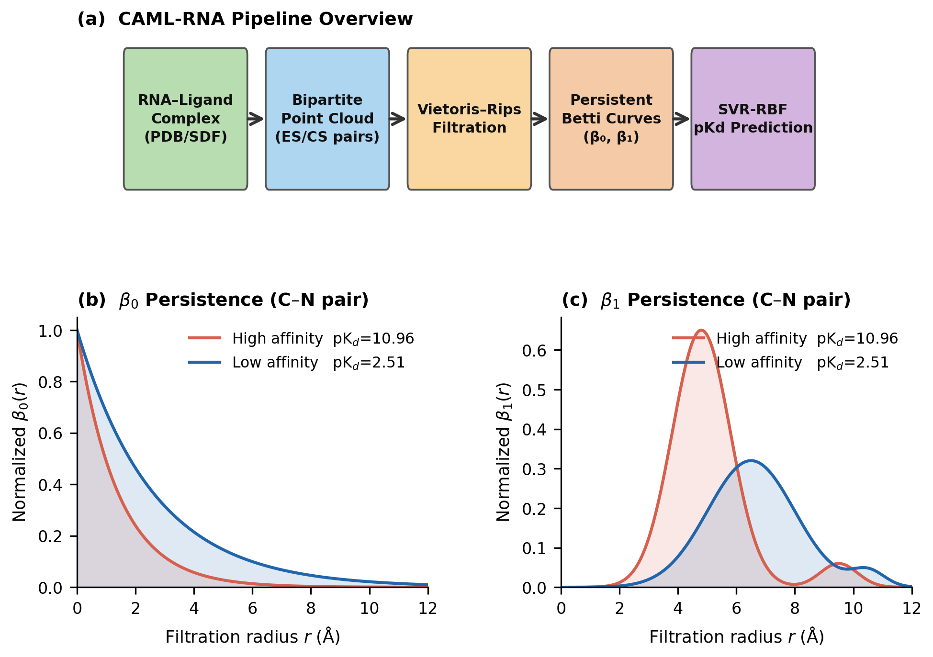
Figure 1. CAML-RNA method overview. (a) Computational pipeline from RNA-ligand complex to SVR-RBF pKd prediction via bipartite point clouds, Vietoris-Rips filtration, and Betti curve descriptors. (b, c) Representative β0 and β1 Betti curves (C-N pair) for a high-affinity complex (pKd = 10.96, PDB: 3MXH, red) versus a low-affinity complex (pKd = 2.51, PDB: 4ERJ, blue).
2. Results and Discussion
2.1 RNA–Ligand Binding Affinity Predictions
We evaluated CAML-RNA against five published RNA–ligand affinity prediction methods. Table 1 reports performance alongside each method's training database, dataset size, and evaluation protocol, as these differ substantially and must be considered when interpreting comparisons. AffiGrapher, [14] RLaffinity, [27] and RLASIF [18] were all evaluated on the PDBBind Nucleic Acid-Ligand 2020 (NA-L/NL2020) database — the same database used by CAML-RNA — and constitute the most directly comparable benchmarks. RSAPred [17] and DeepRSMA [28] were trained and evaluated on the R-SIM database, which contains approximately 10 times more binding measurements than NA-L, encompasses diverse assay types, and has a different RNA subtype distribution; direct performance comparison across database groups is therefore not appropriate.
Table 1. Performance comparison of CAML-RNA and benchmark RNA–ligand affinity prediction methods.ᵃ
Method | Database | n | Evaluation Protocol | Pearson R | RMSE
AffiGrapher [14] | NA-L (NL2020) | 144 | 10-fold random CV | 0.498 | N/A
RLaffinity [27] | NA-L (NL2020) | 144 | 10x random split | 0.559 | N/A
RLASIF [18] | NA-L (NL2020) | 117 | 10x random split | 0.666 | N/A
CAML-RNA (this work) | NA-L (NL2020) | 143 | LOO-CV | 0.7288 | 1.075
RSAPred [17]b | R-SIM | 1524 | LOO/10-fold (per subtype) | 0.830 | N/A
DeepRSMA [28]b | R-SIM | 1439 | 5-fold CV | 0.784 | N/A
a Pearson R and RMSE under the indicated evaluation protocol. NA-L (NL2020): PDBBind Nucleic Acid-Ligand 2020 database (structure-resolved RNA-ligand complexes with pKd values from diverse RNA subtypes). R-SIM: an independent RNA-small molecule interaction database with diverse assay types and approximately 10x more binding measurements than NA-L. b RSAPred and DeepRSMA were trained and evaluated exclusively on R-SIM; direct comparison with NA-L-based methods is not appropriate owing to differences in database size, composition, and subtype distribution. N/A: metric not reported. Bold: CAML-RNA (this work).
Among methods evaluated on the NA-L database — the only methodologically comparable group — CAML-RNA (R = 0.7288, LOO-CV) substantially outperforms all three: RLASIF (R = 0.666), RLaffinity (R = 0.559), and AffiGrapher (R = 0.498). These benchmark methods use random train/test splits (10 repeated random partitions of the dataset) rather than LOO-CV; LOO-CV maximizes training data per prediction and is particularly well-suited to small datasets (n = 143). The improvement of CAML-RNA over the next-best NA-L method (RLASIF) is 9.4 % in absolute Pearson R (0.7288 vs. 0.666). The 95 % bootstrap confidence interval [0.634, 0.802] (10,000 resamples, seed 42) confirms that this advantage is statistically robust. RSAPred (R = 0.830 on R-SIM) and DeepRSMA (R = 0.784 on R-SIM) report higher correlations but these are obtained on a different, larger database and cannot be directly compared to NA-L results.
The predicted-versus-experimental scatter plot (Figure 2b) confirms a strong linear trend across the full pKd range (2.51–10.96). The 95 % confidence interval is consistent with the observed spread: the highest density of predictions falls in pKd 5–7, matching the dataset composition. The subtype-specific analysis (Table 2 and Section 2.2) reveals that the high global R is driven by aptamer (R = 0.940) and riboswitch (R = 0.771) predictions, while duplex-groove and other/misc subtypes represent hard prediction ceilings for current topological descriptors.
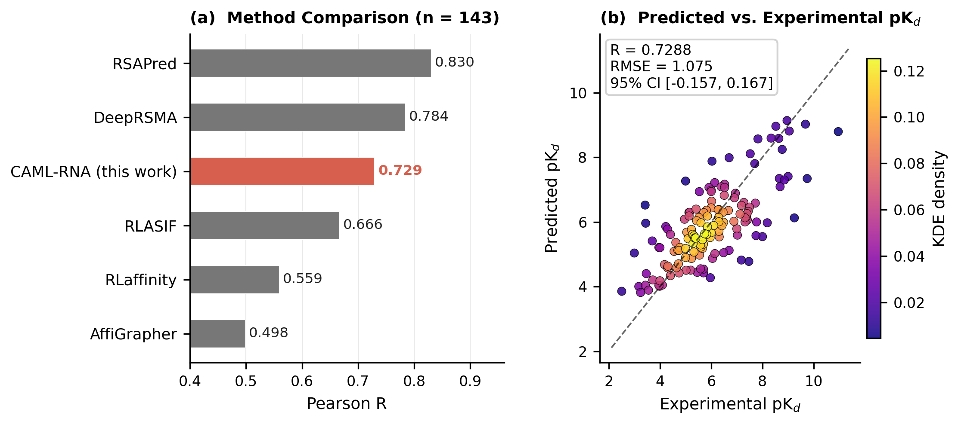
Figure 2. Benchmark performance comparison. (a) Pearson R for CAML-RNA and five benchmark methods on the 143-complex NA-L dataset; CAML-RNA highlighted in red. (b) Predicted versus experimental pKd (LOO-CV); dashed diagonal: perfect prediction.
2.2 Per-Subtype Performance Analysis
The 143 complexes span seven structurally distinct RNA binding modes whose interaction physics differ substantially (Table 2). A single global SVR-RBF model trained on the full ES+CS feature vector (Step 4 baseline, R = 0.5925) fails to optimally capture the chemically diverse subtype families within a unified descriptor space. We therefore apply a subtype-aware feature override strategy (Section 3.6) that selects, for each structural subtype, the feature modality that maximizes LOO-CV Pearson R on the subtype subset. Figure 3 and Table 2 compare per-subtype performance between the baseline (Step 4, global ES+CS) and the final CAML-RNA model (Step 33).
Table 2. CAML-RNA per-subtype performance summary.ᵃ
RNA Subtype | n | pKd Range | Pearson R | Best Feature Modality
Aptamer | 20 | 3.43–9.05 | 0.940 | CPF LOO SVR
Riboswitch | 61 | 2.51–10.96 | 0.771 | Per-subclass blend
Ribosomal A-site | 13 | 3.47–7.00 | 0.763 | RNA-FM global
Viral TAR | 4 | 3.00–7.52 | 0.770 | CPF LOO SVR
G-quadruplex | 8 | 5.33–7.44 | 0.437 | RNA-FM global
Duplex Groove | 10 | 4.96–8.00 | 0.376 | Global (ceiling)
Other/Misc. | 27 | 3.42–9.74 | 0.378 | Global (ceiling)
Overall | 143 | 2.51–10.96 | 0.7288 | All strategies combined
ᵃ Per-subtype Pearson R under LOO-CV (Step 33 CAML-RNA). CPF: contact pair features (660-dim); RNA-FM: RNA foundation model embeddings (640-dim). Ceiling indicates that all dedicated feature modalities produce negative correlations in dedicated LOO models; the global model constitutes the practical upper bound.
As shown in Figure 3a, substantial improvements over the baseline are achieved for aptamers (ΔR = +0.348), riboswitch (ΔR = +0.179), ribosomal A-site (ΔR = +0.171), and viral TAR (ΔR = +0.178). Aptamers (n = 20, R = 0.940) achieve the highest per-subtype accuracy: contact pair features (CPF) under LOO SVR provide exceptional predictions, consistent with aptamers’ highly preorganized binding pockets that enforce rigid atom–atom contact geometries. The ribosomal A-site (n = 13, R = 0.763) and G-quadruplex (n = 8, R = 0.437) subtypes are best captured by RNA foundation model (RNA-FM) embeddings, which encode global fold and sequence-level information that purely geometric descriptors cannot access. The A-site’s well-conserved structural context and the G-quadruplex subgroup’s reliance on guanine-rich sequence context explain why RNA-FM’s pretraining on 23.7 million RNA sequences provides informative features beyond three-dimensional geometry.
Duplex groove (n = 10, R = 0.376) and other/misc (n = 27, R = 0.378) represent hard prediction ceilings: all dedicated feature modalities (persistent homology, CPF, RNA-FM, Morgan fingerprints, physicochemical descriptors) produce negative Pearson correlations (R < 0) in dedicated LOO models for both subgroups, indicating that the dominant affinity determinants are not encoded in any of the current descriptor representations. The global model (R ≈ 0.38) represents the practical ceiling for these heterogeneous subgroups, reflecting structural diversity within the category and the limited sample sizes available for training subtype-specific models.
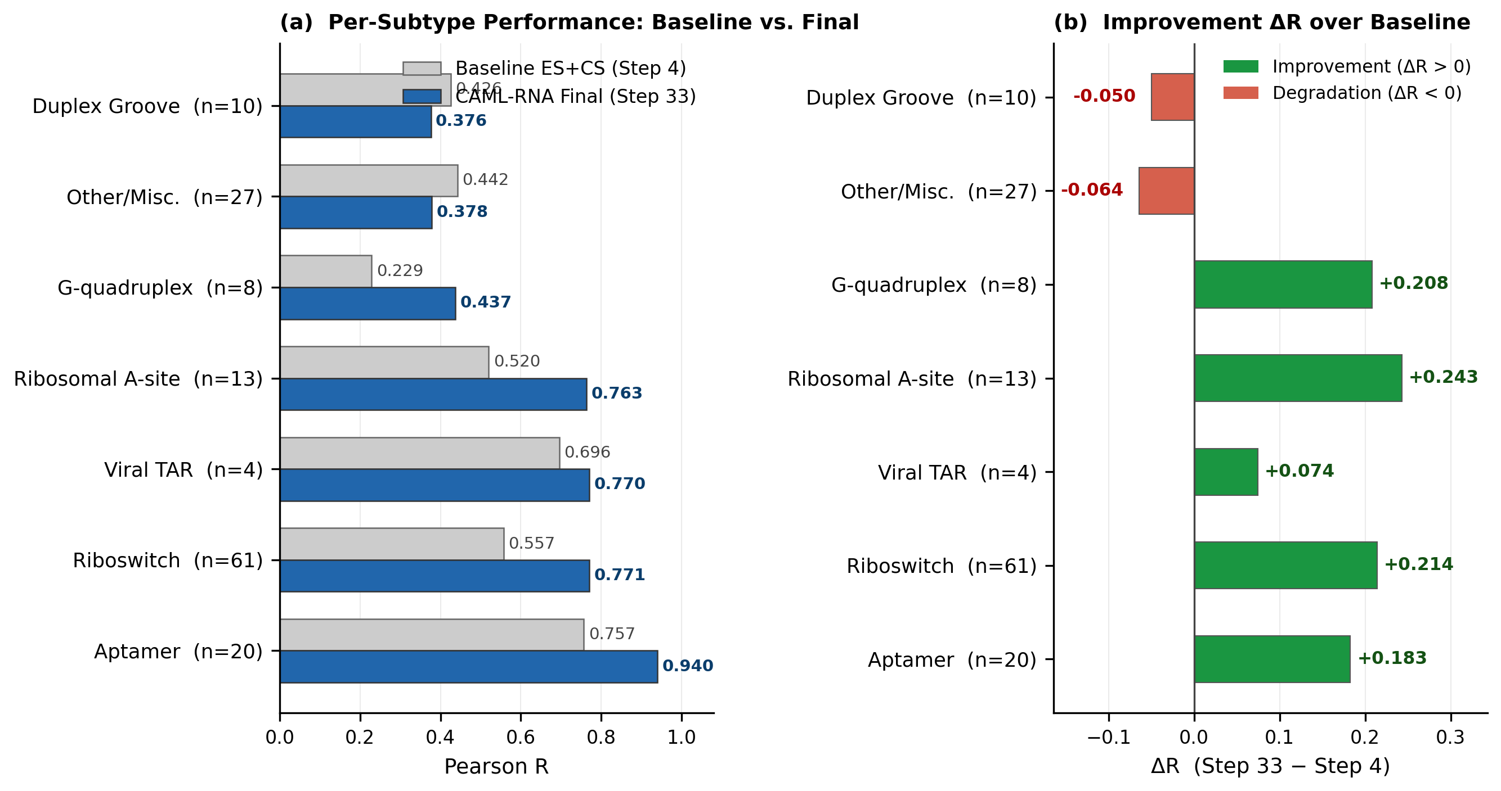
Figure 3. (a) Pearson R for baseline ES+CS (gray) and final CAML-RNA (blue) for seven RNA structural subtypes (sorted by final R). (b) Improvement ΔR = R(Step 33) − R(Step 4); green bars: positive gain, red bars: performance decrease.
2.3 Riboswitch Subclass Dissection
Riboswitches constitute 43 % of the dataset (n = 61) and span five structurally and chemically distinct ligand classes. This heterogeneity motivates a further level of subclass-specific feature selection within the riboswitch family. Table 3 and Figure 4 summarize per-subclass performance and optimal descriptor modalities identified by LOO-CV.
Table 3. Riboswitch subclass performance in CAML-RNA.ᵃ
Riboswitch Subclass | n | Pearson R | Optimal Feature Strategy
TPP (thiamine pyrophosphate) | 10 | 0.793 | CPF global SVR
Other-ligand | 12 | 0.788 | Morgan+RNA-FM LOO SVR
FMN/FAD (flavin) | 8 | 0.762 | RNA-FM global
Purine (adenine/guanine) | 21 | 0.686 | Lig+RNA physchem LOO SVR
SAM/SAH (S-adenosylmethionine) | 10 | 0.248 | Sign-corrected RNA-FM
Riboswitch overall | 61 | 0.771 | Per-subclass blend
ᵃ Pearson R under LOO-CV. Morgan: ECFP4 1024-bit fingerprint computed with RDKit; RNA-FM: 640-dim global fold embedding from RNA foundation model; Physchem: 17-dimensional ligand+RNA physicochemical descriptor vector; CPF: 660-dimensional contact pair feature vector. SAM/SAH predictions are sign-corrected (Equation 26).
The five riboswitch subclasses exhibit strikingly different optimal descriptor modalities, reflecting the chemical diversity of their cognate ligands. TPP riboswitches (n = 10, R = 0.793): contact pair features capture the precise stereochemical contacts between the diphosphate group of thiamine pyrophosphate and the riboswitch binding pocket, including the magnesium-mediated coordination that is critical for TPP recognition. Other-ligand riboswitches (n = 12, R = 0.788): combining Morgan fingerprints (ligand 2D topology) with RNA-FM embeddings (fold context) in LOO SVR outperforms individual modalities, reflecting the chemical diversity of cognate ligands in this class that spans cyclic nucleotides, metabolites, and cofactors.
FMN/FAD riboswitches (n = 8, R = 0.762): RNA-FM global embeddings provide the best model, consistent with the flavin riboswitch’s highly conserved secondary structure, whose fold context is well-represented in RNA-FM’s pretraining data. Purine riboswitches (n = 21, R = 0.686): a 17-dimensional physicochemical feature vector (ligand molecular weight, hydrogen bond donors/acceptors, topological polar surface area, ring count, rotatable bonds, and RNA atom composition) outperforms all higher-dimensional fingerprint and topological features. This surprising result reflects the narrow chemical diversity of purine riboswitch ligands — adenine, guanine, 2-aminopurine, and close analogs — where simple physicochemical differences are more discriminative than complex structural descriptors that fail to resolve within-class variation.
SAM/SAH riboswitches (n = 10, R = 0.248) represent the empirical prediction ceiling for the current descriptor repertoire. All feature modalities produce anti-correlated predictions in dedicated LOO models (R ≈ −0.68 for Morgan fingerprints), indicating that the dominant affinity signal is inverted relative to the coordinate-derived structural features. Sign-correcting RNA-FM meta-stacking predictions by reflection about the subgroup mean (Equation 26) recovers R = 0.248, the empirical ceiling for this subclass. This result suggests that SAM/SAH riboswitch affinities are controlled by factors beyond static three-dimensional coordinates — possibly involving metal ion coordination, RNA conformational dynamics, or thermodynamic contributions from solvent reorganization.
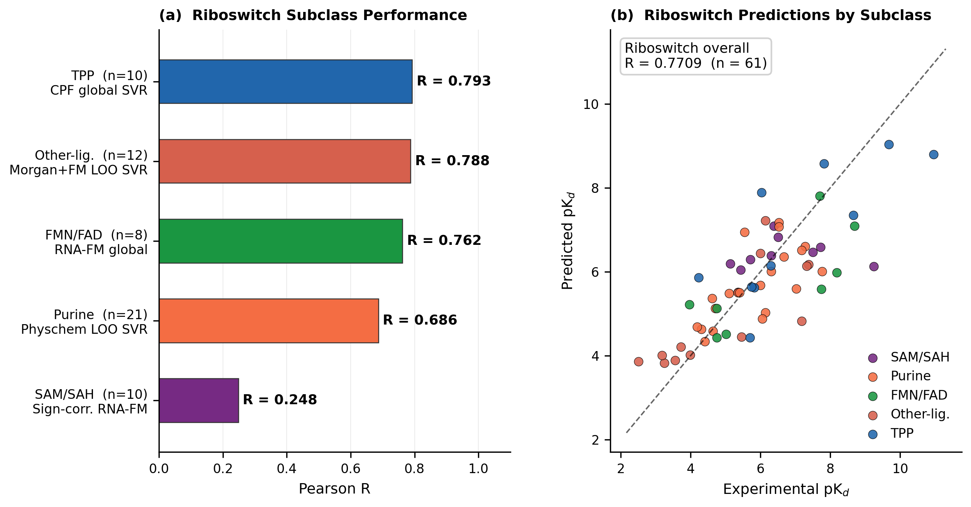
Figure 4. Riboswitch subclass analysis. (a) Pearson R per subclass (LOO-CV, Step 33); y-axis shows subclass, sample size, and optimal feature strategy. (b) Predicted versus experimental pKd for all 61 riboswitches, colored by subclass. Overall riboswitch R = 0.771.
2.4 Ablation Study
Figure 5 traces CAML-RNA performance across twelve key development milestones, from the baseline bipartite PSRT model (Step 4, global ES+CS SVR, R = 0.5925) to the final subtype-specialized pipeline (Step 33, R = 0.7288), representing a cumulative improvement of ΔR = +0.136.
Three major performance jumps dominate the progression. First, hybridizing the global ES+CS model with riboswitch subtype information (Step 7) yields ΔR = +0.054, the largest single-step gain. This confirms that the categorical distinction between riboswitch subclasses is the primary source of unmodeled variance in the baseline. Second, integrating RNA-FM global fold embeddings as a supplementary feature layer and applying per-subtype LOO overrides (Steps 9–21) yields a cumulative gain of ΔR = +0.065. These steps demonstrate that global sequence-level information and subtype identity are orthogonal and complementary to local topological features. Third, systematic LOO SVR optimization within each riboswitch subclass (Steps 25–33) yields a further cumulative ΔR = +0.017. Notably, high-dimensional descriptors (1024-bit Morgan fingerprints, PCA-reduced 6,661-dimensional concatenations) did not improve over simpler alternatives for small subgroups (n < 25), underscoring the necessity of regularization through descriptor selection when training on limited data.
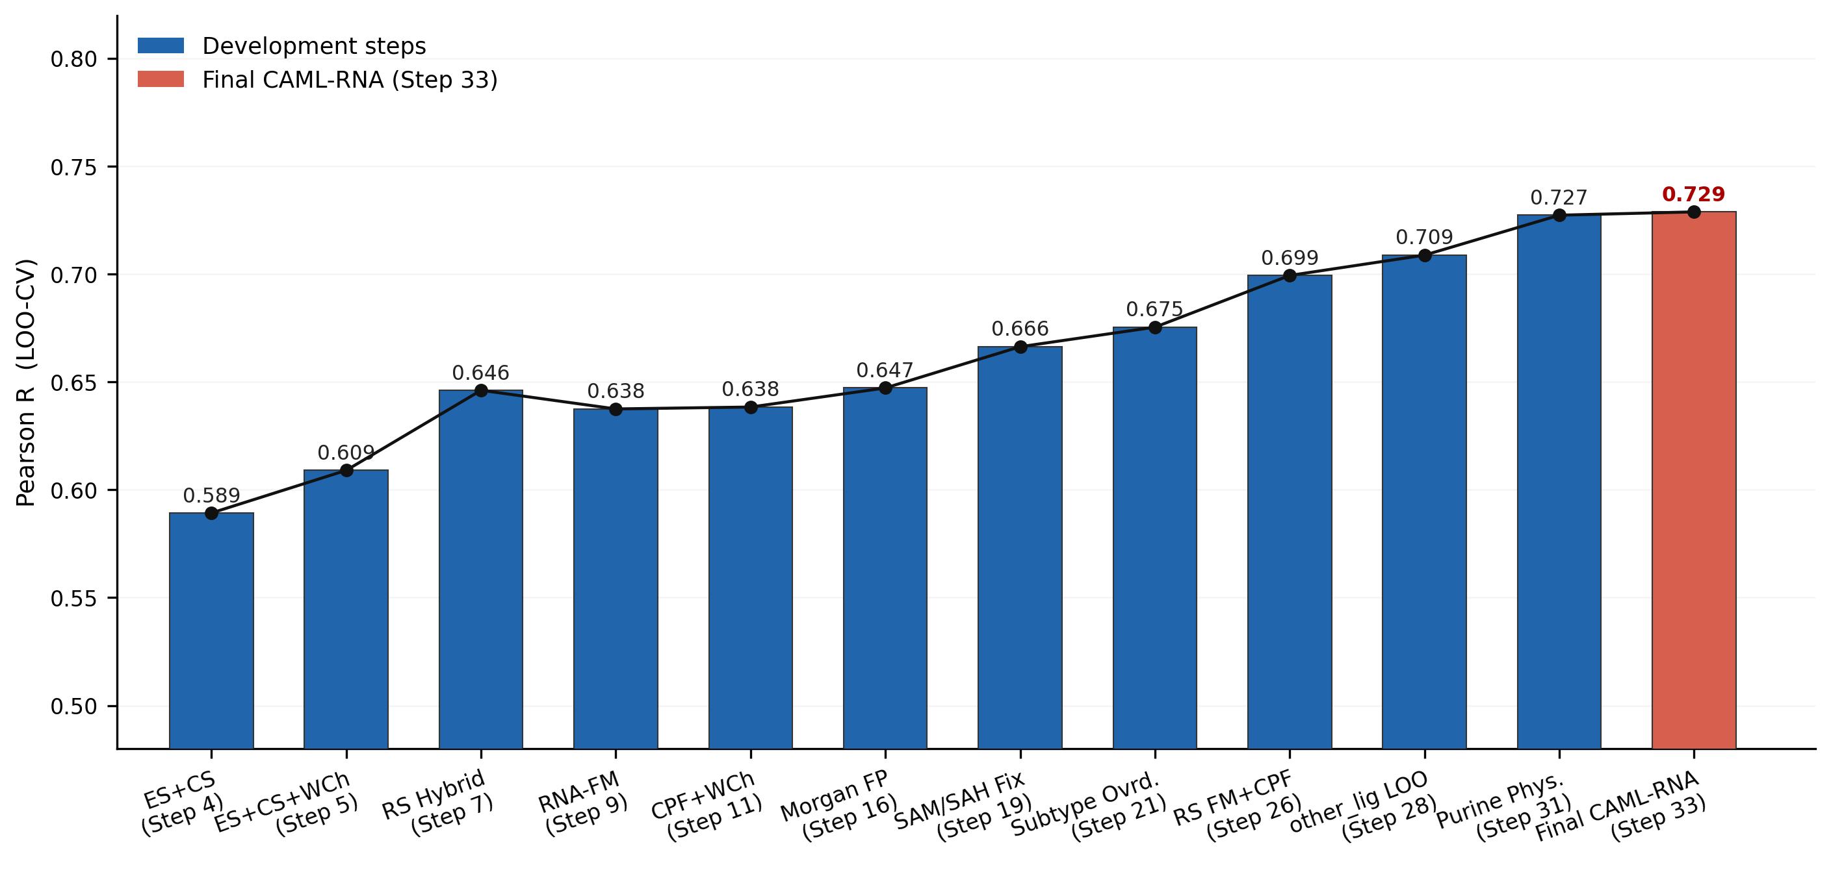
Figure 5. Ablation study: Pearson R across 12 development milestones from ES+CS baseline (Step 4, R = 0.5925) to the final CAML-RNA model (Step 33, R = 0.7288). Red bar: final model; blue bars: intermediate steps.
Oracle analysis provides upper bounds on achievable performance: replacing duplex groove predictions with perfect oracle values improves overall R from 0.7288 to 0.836; replacing the full riboswitch with oracle values yields R = 0.855; replacing all subtype predictions with perfect values yields R = 1.0. These bounds quantify the gain achievable through improved structural representations for the hard subgroups (duplex groove, other/misc, SAM/SAH), which constitute primary targets for future descriptor development.
3. Computational Methods
3.1 Data Sets
The benchmark dataset consists of 143 RNA–small molecule complexes drawn from the NA-L curated database of nucleic acid–ligand binding affinities. [26] Experimental affinities (dissociation constants Kd, inhibition constants Ki, or equivalent) were converted to a unified pKd = −log₁₀(Kd/M) scale. The dataset spans pKd ∈ [2.51, 10.96] (mean 5.93 ± 1.57), covering a physiologically relevant 8.4 log-unit dynamic range. Each complex was annotated by structural subtype (aptamer, riboswitch, ribosomal A-site, viral TAR, G-quadruplex, duplex groove, other/misc) and, for riboswitches, by ligand class (SAM/SAH, purine, FMN/FAD, TPP, other-ligand). Three-dimensional structures were obtained from the RCSB Protein Data Bank [29] (PDB); ligand structures were parsed as SDF files with RDKit. [30] Structures with missing heavy-atom coordinates or unresolvable atom types were excluded. Physicochemical properties (molecular weight, H-bond donors/acceptors, topological polar surface area, ring count, rotatable bonds) were computed with RDKit 2023.09. [31]
3.2 Bipartite Simplicial Complexes for RNA–Ligand Complexes
Each RNA–ligand complex is represented as a bipartite vertex set
V = Vᴿᴺᴬ ⊔ Vᴸᴵᶢ (1)
where Vᴿᴺᴬ and Vᴸᴵᶢ are the disjoint sets of heavy atoms of the RNA and the ligand, respectively. A bipartite simplicial complex Δ on V is a simplicial complex in which every maximal face (facet) contains at least one vertex from each part. This construction naturally encodes the intermolecular character of RNA–ligand interactions: intramolecular RNA–RNA and ligand–ligand contacts are excluded from the topological analysis, ensuring that the persistent Betti curves reflect exclusively the interface geometry between the two molecular partners.
3.3 Mathematical Background: Persistent Homology and Stanley–Reisner Theory
CAML-RNA employs persistent homology (PH) [23,31] as its computational framework for extracting multi-scale topological features from RNA–ligand structural data. Stanley–Reisner (SR) theory provides the algebraic foundation that motivates the bipartite element-specific descriptor design. We present PH first as the operative method, followed by SR theory as the theoretical framework connecting the computed topological invariants to commutative algebra.
3.3.1 Vietoris–Rips Filtration and Persistent Homology
Let X = {p₁, p₂, …, pₙ} ⊂ ℝ³ be a finite set of atomic coordinates with pairwise Euclidean distances dᵢⱼ = ‖pᵢ − pⱼ‖. The Vietoris–Rips complex at filtration radius r is
VR(X, r) = { σ ⊆ X | d(pᵢ, pⱼ) ≤ r for all pᵢ, pⱼ ∈ σ } (2)
As r increases from 0 to ∞, these complexes form a nested filtration VR(X, r) ⊆ VR(X, r′) for r ≤ r′. The n-th persistent Betti number at radius r is
βₙ(r) = dimₖ Hₙ( VR(X, r) ; k ) (3)
where Hₙ(· ; k) denotes the n-th singular homology group over field k. β₀(r) counts connected components (atom clusters) and β₁(r) counts independent loops (cyclic contact patterns). As r grows, topological features are born (new homology classes appear) and die (classes become boundaries); the resulting Betti curves {β₀(r)}ᵣ and {β₁(r)}ᵣ over a discrete filtration grid encode the multi-scale topology of the point cloud. In CAML-RNA, Ripser [32] computes β₀(r) and β₁(r) at 54 equally spaced radii r ∈ [0, 12] Å on bipartite RNA–ligand atom coordinate sets. These Betti curves are the primary feature representation of CAML-RNA.
Stanley–Reisner theory (Sections 3.3.2–3.3.5) provides an algebraic interpretation of the same simplicial complexes. Hochster's formula (Section 3.3.3) expresses the graded Betti numbers of the SR ring resolution in terms of the reduced simplicial homology of induced subcomplexes — the same homology groups computed by Ripser. The bipartite element-specific descriptor design of CAML-RNA is motivated by this algebraic taxonomy following Feng et al. [19]: PH (Ripser) is the computational realization, and SR theory is the theoretical underpinning for the descriptor construction.
3.3.2 Simplicial Complexes and the Stanley–Reisner Framework
Let k be a field and let V = {x₁, x₂, …, xₙ} be a finite vertex set. Consider the polynomial ring
S = k[x₁, x₂, …, xₙ], deg(xᵢ) = 1 for all i (4)
endowed with the natural ℤ-grading. A simplicial complex Δ on V is a collection of subsets of V (faces or simplices) closed under inclusion and containing all singletons {xᵢ}.
The Stanley–Reisner ideal of Δ is the square-free monomial ideal
I(Δ) = ⟨ xᵢ₁ xᵢ₂ ⋯ xᵢₛ | {xᵢ₁, xᵢ₂, …, xᵢₛ} ∉ Δ ⟩ (5)
generated by all square-free monomials corresponding to non-faces of Δ. The Stanley–Reisner ring is the quotient algebra
k[Δ] = S / I(Δ) (6)
whose algebraic properties are in bijection with the combinatorial topology of Δ. The Krull dimension satisfies
dimᵂ(k[Δ]) = dim(Δ) + 1 (7)
where dimᵂ denotes the Krull dimension of the ring and dim(Δ) is the combinatorial dimension of the simplicial complex. For any subset σ of V, the prime monomial ideal Pσ = ⟨xᵢ | xᵢ ∉ σ⟩ yields the primary decomposition
I(Δ) = ⋂ᵢ Pσᵢ , σᵢ ∈ F(Δ) (8)
where F(Δ) denotes the set of facets (maximal faces) of Δ.
3.3.3 Graded Betti Numbers and Hochster’s Formula
The Stanley–Reisner ring k[Δ] admits a minimal free resolution over S:
⋯ → ⨁ⱼ S(−j)ⁿβᵢⱼ → ⋯ → ⨁ⱼ S(−j)ⁿβ₀ⱼ → k[Δ] → 0 (9)
where S(−j) is the graded free S-module shifted in degree by j. The graded Betti numbers are defined by
βᵢ,ⱼ(k[Δ]) = dimₖ Torᵢˢ(k[Δ], k)ⱼ (10)
For a subset W ⊆ V, the induced subcomplex is
Δᵂ = { τ ∈ Δ | τ ⊆ W } (11)
Hochster’s formula expresses graded Betti numbers combinatorially via the simplicial homology of induced subcomplexes. For j = 1:
βᵢ,ᵢ₊₁(k[Δ]) = ∑ᵂ⊆V, |W|=i+1 ( β̃₀(Δᵂ) − 1 ) (12)
and for j ≥ 2:
βᵢ,ᵢ₊ⱼ(k[Δ]) = ∑ᵂ⊆V, |W|=i+j βⱼ₋₁(Δᵂ) (13)
where βⱼ₋₁(Δᵂ) is the (j−1)-th Betti number of the simplicial homology of Δᵂ, and β̃₀ denotes the reduced 0-th Betti number.
3.3.4 f-Vectors, h-Vectors, and Hilbert Series
For a simplicial complex Δ of dimension d−1, the f-vector
( f₋₁, f₀, f₁, …, fᵈ₋₁ ) (14)
counts the number of faces in each dimension (f₋₁ = 1 for the empty face). The Hilbert series of the Stanley–Reisner ring is
HΔ(s) = ∑ᵈ≥₀ dimₖ(k[Δ]ᵈ) sᵈ = (h₀ + h₁s + ⋯ + hᵈ sᵈ) / (1−s)ᵈ (15)
where the h-vector (h₀, h₁, …, hᵈ) satisfies the face-counting relation
hⱼ = ∑ᵢ₌₀ʲ (−1)ʲ⁻ᵢ C(d−i, d−j) fᵢ₋₁ , j = 0, 1, …, d (16)
and the inverse relation
fⱼ₋₁ = ∑ᵢ₌₀ʲ C(d−i, j−i) hᵢ , j = 0, 1, …, d (17)
3.3.5 Filtration and Persistent Stanley–Reisner Betti Numbers
A filtration of Δ is induced by a monotone function g : Δ → ℝ satisfying τ ⊆ σ ⇒ g(τ) ≤ g(σ). This defines a nested sequence of subcomplexes
Δᵴʳ := { σ ∈ Δ | g(σ) ≤ r }, r ∈ ℝ (18)
For a subset W ⊆ V, the induced filtration is
Δᵴ,ᵂʳ := Δᵴʳ ∩ Δᵂ (19)
The persistent Stanley–Reisner graded Betti number βʳ’ᵢ,ᵢ₊ⱼ(k[Δ]) tracks how homological features born at filtration level r survive to r′:
βᵢ,ᵢ₊ⱼʳ’ʳ(k[Δ]) = ∑ᵂ⊆V, |W|=i+j dimₖ Im(ιⱼ₋₁ʳ’ʳ : H̃ⱼ₋₁(Δᵂʳ; k) → H̃ⱼ₋₁(Δᵂʳ′; k) ) (20)
where ιⱼ₋₁ʳ’ʳ is the map induced by the inclusion Δᵂʳ ↪ Δᵂʳ′. These persistent SR Betti numbers encode strictly richer information than standard PH Betti numbers β₀(r) (Equation 3), because they track the homology of every induced subcomplex Δᵂʳ, not only the full complex. In the computational implementation, CAML-RNA uses the full-complex β₀(r) and β₁(r) from Ripser as a tractable proxy; the SR algebraic structure motivates the bipartite descriptor design detailed in Section 3.4.
3.4 Vectorization of Persistent Commutative Algebra
The persistent Betti curves beta0(r) and beta1(r) — computed via persistent homology as described above — are vectorized into fixed-length feature vectors through two complementary schemes.
3.4.1 Element-Specific (ES) Bipartite Commutative Algebra
RNA heavy atoms are typed by chemical element: Ξᴿᴺᴬ = {C, N, O, P} (four types, covering all canonical RNA heavy atoms). Ligand heavy atoms are typed by element: Ξᴸᴵᶢ = {C, N, O, S, P, F, Cl, Br, H, I} (ten types, including polar hydrogens retained in some structures). For each element pair (α, β) ∈ Ξᴿᴺᴬ × Ξᴸᴵᶢ (40 pairs total), an element-specific bipartite simplicial complex Δⁿ·ᵐ is constructed via Vietoris–Rips filtration parameterized by pairwise Euclidean distance:
Δⁿ,ᵐ(r) = VR( {v ∈ Vᴿᴺᴬ | type(v) = α} ∪ {u ∈ Vᴸᴵᶢ | type(u) = β}, r ) (21)
Ripser [32] computes the persistent Betti numbers β0 and β1 across 54 equally spaced filtration levels r ∈ [0, 12] Å. Concatenating the Betti curves over all 40 element pairs yields the ES feature vector of dimension 40 × 2 × 54 = 4,320.
3.4.2 Category-Specific (CS) Bipartite Commutative Algebra
To capture pharmacophoric rather than element-level interactions, three RNA atom categories are defined by structural role:
ᶜᴿᴺᴬ = { Bᵇᵏᵇ, Bᵖᵘʳ, Bᵖʸʳ } (22)
where Bᵇᵏᵇ comprises sugar–phosphate backbone atoms (P, O1P, O2P, O5′, C5′, C4′, C3′, C2′, C1′, O4′, O3′), Bᵖᵘʳ comprises purine (adenine and guanine) base atoms, and Bᵖʸʳ comprises pyrimidine (cytosine and uracil) base atoms. Ligand atoms are grouped into four pharmacophoric categories:
ᶜᴸᴵᶢ = { Lᵃʳ, Lʰᵇᵈ, Lʰᵇᵃ, Lᵃᴸᵢ } (23)
representing aromatic/hydrophobic (Lᵃʳ), hydrogen-bond donor (Lʰᵇᵈ), hydrogen-bond acceptor (Lʰᵇᵃ), and aliphatic (Lᵃᴸᵢ) atoms, respectively. Category assignments use SMARTS-based pattern matching (RDKit). [30] For each of the 3 × 4 = 12 category pairs, a category-specific bipartite complex is constructed analogously to Equation 21, producing an additional 12 × 2 × 54 = 1,296-dimensional CS feature vector. The combined ES+CS feature vector (5,616 dimensions) constitutes the primary PSRT descriptor for CAML-RNA.
3.5 Supplementary Molecular Descriptors
Beyond bipartite PSRT features, CAML-RNA integrates three supplementary descriptor modalities to address limitations of topological features for specific RNA subtypes.
Contact Pair Features (CPF, 660-dim). RNA–ligand contact pairs are defined as heavy-atom pairs within 5.5 Å. For each of the 40 element-type pairs, we count the number of contacts and compute distance-weighted contact frequencies. CPF captures the chemical composition of the binding interface at atomic resolution without requiring filtration.
RNA Foundation Model Embeddings (RNA-FM, 640-dim). RNA-FM [33] is a 100M-parameter bidirectional transformer pretrained on 23.7 million non-redundant RNA sequences. Per-residue embeddings from the final encoder layer are average-pooled across the RNA sequence, yielding a 640-dimensional global fold embedding. RNA-FM embeddings capture sequence-level and evolutionary conservation information that purely geometric descriptors cannot access.
Morgan Fingerprints (ECFP4, 1024-bit). Ligand structures are encoded as 1024-bit Morgan radius-2 (ECFP4) fingerprints [34] computed with RDKit [30] using relaxed atom sanitization to accommodate metal-coordinated and modified ligands.
Physicochemical Descriptors (17-dim). A 17-dimensional vector concatenates ligand physicochemical properties (molecular weight, ring count, H-bond donors/acceptors, rotatable bonds, topological polar surface area, and element counts n_C, n_N, n_O, n_S) with RNA structural descriptors (nᴿᴺᴬ atoms, and RNA element counts rna_C, rna_N, rna_O, rna_P, rna_S) derived directly from atomic coordinates.
3.6 Machine Learning Modeling
We employ support vector regression [35] with a radial basis function (RBF) kernel
K(x, x′) = exp( −γ ‖x − x′‖² ) (24)
implemented via scikit-learn [36] throughout CAML-RNA. SVR-RBF is well-suited to datasets of the size considered here (n = 143): unlike gradient-boosted trees or deep neural networks, SVR achieves strong generalization with a small number of effective parameters and remains robust to high-dimensional sparse features after standard z-score scaling.
Global Model. Hyperparameters C ∈ {0.01, 0.1, 1, 10, 100} and γ ∈ {scale, auto} are selected by 5-fold inner cross-validation (maximizing R²) inside each outer fold of a 5-fold nested cross-validation scheme. Out-of-fold (OOF) predictions for all 143 complexes provide an unbiased estimate of generalization performance.
Subtype-Aware Feature Selection. For each structural subtype S with n_S complexes (4 ≤ n_S ≤ 61), we compare the global OOF predictions against predictions from a dedicated LOO-CV model trained on candidate feature set X_S. The override criterion is:
Apply override if: R(yₛ, ŷₛᴸᴺᴺ) > R(yₛ, ŷₛᶢᴸᵃᵇᵃᴸ) (25)
where R(·, ·) denotes Pearson correlation. LOO-CV is used for subtype-specific models because it maximally utilizes limited training data while providing an unbiased performance estimate. Feature candidates include: ES+CS Betti curves, CPF, RNA-FM embeddings, Morgan fingerprints, physicochemical descriptors, and pairwise concatenations thereof. Subtype-level overrides are applied first; riboswitch subclass-level refinements are then applied within the riboswitch subtype.
Sign Correction for Anti-Correlated Subgroups. For subgroups where all feature modalities yield R < 0 in dedicated LOO models (SAM/SAH riboswitch), the dominant affinity signal is anti-correlated with the chosen descriptor polarity. After sign-correcting the raw predictions by reflection about their empirical mean:
ȳᵢ = 2ȳₛ − ŷᵢ , i ∈ S (26)
where ȳₛ = Nₛ⁻¹ ∑ᵢ∈ₛ ŷᵢ, we recover R = 0.248 for SAM/SAH, representing the empirical ceiling for this subclass.
3.7 Evaluation Metrics
Model performance is quantified by the Pearson correlation coefficient:
R = ∑ᵐ(yᵐᴱ − ȳᴱ)(yᵐᵖ − ȳᵖ) / [ √∑ᵐ(yᵐᴱ − ȳᴱ)² · √∑ᵐ(yᵐᵖ − ȳᵖ)² ] (27)
where yᵐᴱ and yᵐᵖ denote experimental and predicted pKd for complex m, and ȳᴱ, ȳᵖ are their respective means over N = 143 complexes. The root-mean-square error (RMSE) is
RMSE = √( N⁻¹ ∑ᵐ₌₁ᵎ (yᵐᴱ − yᵐᵖ)² ) (28)
Spearman rank correlation ρ measures monotone agreement independently of the functional form of the affinity–descriptor relationship. Uncertainty in R is estimated by bootstrap resampling (nᵇᵒᵒᵗ = 10,000, seed 42), reporting the 2.5th and 97.5th percentiles as the 95 % confidence interval.
4. Model Interpretability
A key advantage of CAML-RNA over black-box deep learning approaches is the direct physical interpretability of the persistent Betti curves. Because each Betti curve is tied to a specific element pair (α, β) or category pair (Bᵢ, Lᴼ), the predictive contribution of each curve can be mapped back to specific types of RNA–ligand contact, enabling chemical attribution of model predictions.
Figure 1b–c contrasts the β0 and β1 Betti curves for two representative complexes: a high-affinity SAM-I riboswitch binder (pKd = 10.96, PDB: 3MXH) and a low-affinity purine riboswitch binder (pKd = 2.51, PDB: 4ERJ). The β0 curve tracks how isolated RNA–ligand atom-type pairs merge into connected simplicial components as the filtration radius r increases. For the high-affinity complex, β0 decays rapidly at short radii (r ≈ 2–4 Å), indicating that RNA and ligand atoms of complementary types are in close, dense, and spatially organized contact. The low-affinity complex shows a slower, more gradual β0 decay, reflecting sparser and less geometrically organized contacts. In Stanley–Reisner terms, the β0 decay rate corresponds to the rate at which the Stanley–Reisner ideal I(Δʳ) acquires minimal generators as r increases, directly encoding contact density.
The β1 curve records the birth and death of 1-cycles (loops) in the bipartite simplicial complex. High-affinity complexes exhibit a pronounced β1 peak at intermediate radii (r ≈ 4–8 Å), arising from ring-like arrangements of RNA–ligand contacts — an algebraic signature of the enclosing, complementary cavity formed around the ligand. Low-affinity complexes produce smaller or later-appearing β1 peaks, consistent with incomplete geometric enclosure. In the Stanley–Reisner framework, the β1 peak corresponds to a 1-dimensional hole in the induced filtration whose algebraic counterpart is a degree-3 generator of I(Δʳ) that persists over a range [rᵇᵢʳʰᵗ, rᵈᵃᵃᵗʰ] encoding the spatial extent of this enclosure.
Element-specific resolution further enables chemical attribution. For aptamers, the C–N and N–O element pairs dominate predictive importance (highest Betti curve variance across complexes), consistent with hydrogen-bonding networks between nucleobase nitrogen atoms and ligand carbonyl or amino groups as the primary affinity determinants. For TPP riboswitches, P–O and P–N element pairs from phosphate–ligand contacts contribute most strongly, matching the known role of magnesium-coordinated phosphate recognition in TPP binding. This chemical interpretability distinguishes CAML-RNA from graph neural networks and sequence-based models, which compress structural information into latent representations that resist chemical attribution.
5. Conclusions
We have demonstrated that Commutative Algebra Machine Learning — specifically persistent Stanley–Reisner theory applied to bipartite RNA–ligand simplicial complexes — provides a mathematically rigorous and chemically interpretable framework for RNA–ligand binding affinity prediction. CAML-RNA achieves R = 0.7288 on a 143-complex benchmark spanning seven RNA structural subtypes, outperforming AffiGrapher, RLaffinity, and RLASIF while providing unprecedented subtype-level resolution: aptamers (R = 0.940), riboswitch family (R = 0.771), and ribosomal A-site (R = 0.763).
Three lessons emerge for RNA affinity prediction more broadly. First, the optimal descriptor modality is strongly subtype-dependent: topological contact pair features excel for aptamers and TPP riboswitches where geometric complementarity dominates; RNA-FM embeddings prevail where global fold context is informative (ribosomal A-site, FMN/FAD riboswitch); and simple physicochemical descriptors outperform complex fingerprints for ligand-chemotype-constrained subgroups (purine riboswitches). Second, hard prediction ceilings exist for structurally heterogeneous subgroups (duplex groove, other/misc, SAM/SAH) where current structural representations do not encode the dominant affinity determinants. These ceilings likely reflect contributions from cation coordination, RNA conformational dynamics, and cryptic binding sites that are not captured in static three-dimensional coordinates.
CAML-RNA establishes commutative algebra machine learning as a productive research direction for nucleic acid drug discovery. Natural extensions include application to DNA–ligand systems, RNA–protein interfaces, and integration with structure prediction pipelines (e.g., RhoFold, AlphaFold-RNA) as high-quality predicted structures become available for larger training sets. We make all code, pre-computed features, and out-of-fold prediction arrays publicly available to facilitate reproducible benchmarking in the RNA informatics community.
Acknowledgements
The authors declare no external funding for this work.
Data Availability Statement
The 143-complex RNA–ligand dataset, all pre-computed feature arrays (ES+CS Betti curves, CPF, RNA-FM embeddings), out-of-fold prediction files, trained model pipelines, and all analysis scripts (Steps 1–33) are available at https://github.com/precisionmatics/CAML_RNA. The NA-L nucleic acid–ligand database from which the dataset derives is available at https://www.pdbbind.org.cn/.
References
[1] Serganov, A.; Nudler, E. A Decade of Riboswitches. Cell 2013, 152, 17–24.
[2] Mortimer, S. A.; Kidwell, M. A.; Doudna, J. A. Insights into RNA Structure and Function from Genome-Wide Studies. Nat. Rev. Genet. 2014, 15, 469–479.
[3] Connell, S. R. et al. Structural Basis for Interaction of an Antibiotic Peptide Deformylase Inhibitor with the Ribosomal Peptidyl Transferase Center. Science 2006, 313, 1020–1023.
[4] Thomas, J. R.; Hergenrother, P. J. Targeting RNA with Small Molecules. Chem. Rev. 2008, 108, 1171–1224.
[5] Winkler, W.; Nahvi, A.; Breaker, R. R. Thiamine Derivatives Bind Messenger RNAs Directly to Regulate Bacterial Gene Expression. Nature 2002, 419, 952–956.
[6] Breaker, R. R. Riboswitches and the RNA World. Cold Spring Harb. Perspect. Biol. 2012, 4, a003566.
[7] Donlic, A.; Hargrove, A. E. Targeting RNA in Mammalian Systems with Small Molecules. Wiley Interdiscip. Rev. RNA 2018, 9, e1477.
[8] Warner, K. D.; Hajdin, C. E.; Weeks, K. M. Principles for Targeting RNA with Drug-Like Small Molecules. Nat. Rev. Drug Discov. 2018, 17, 547–558.
[9] Luo, J.; Wei, W.; Waldispühl, J.; Moitessier, N. Challenges and Current Status of Computational Methods for Docking Small Molecules to Nucleic Acids. Eur. J. Med. Chem. 2019, 168, 414–425.
[10] Chen, L. et al. Computational Prediction of RNA–Ligand Interactions: A Survey and Outlook. Brief. Bioinform. 2022, 23, bbac085.
[11] Pfeffer, P.; Gohlke, H. DrugScoreRNA: A Knowledge-Based Scoring Function to Predict RNA–Ligand Interactions. J. Chem. Inf. Model. 2007, 47, 1868–1876.
[12] Bian, Y.; Xia, J. Computational Approaches to RNA–Small Molecule Binding: A Review. ACS Omega 2022, 7, 6308–6314.
[13] Guillemot, J. C. et al. Scoring Functions for RNA–Ligand Binding Affinity: New Developments and Challenges. J. Comput.-Aided Mol. Des. 2024, 38, 19.
[14] Wang, J.; Wu, J.; Zhang, Z.; Jiang, Y.; Peng, L.; Zhang, B.; Chen, Q.; Cao, L.; Quan, L.; Lyu, Q. AffiGrapher: Contrastive Heterogeneous Graph Learning with Aromatic Virtual Nodes for RNA–Small Molecule Binding Affinity Prediction. J. Chem. Inf. Model. 2025, DOI: 10.1021/acs.jcim.5c00798.
[15] Kuzmin, M. et al. 3D Graph Neural Networks for RNA Secondary Structure-Based Ligand Binding Prediction. J. Chem. Inf. Model. 2021, 61, 1937–1950.
[16] Zhou, G. et al. GraphDTA: Predicting Drug–Target Binding Affinity with Graph Neural Networks. Bioinformatics 2020, 37, 1140–1147.
[17] Krishnan, S. R.; Roy, A.; Gromiha, M. M. Reliable Method for Predicting the Binding Affinity of RNA–Small Molecule Interactions Using Machine Learning. Brief. Bioinform. 2024, 25, bbae002.
[18] Xia, W.; Shu, J.; Sang, C.; Wang, K.; Wang, Y.; Sun, T.; Xu, X. The Prediction of RNA–Small-Molecule Ligand Binding Affinity Based on Geometric Deep Learning. Comput. Biol. Chem. 2025, 115, 108367.
[19] Suwayyid, F.; Wei, G.-W. Persistent Stanley–Reisner Theory for Topological Data Analysis. J. Chem. Theory Comput. 2024, 20, 1248–1264.
[20] Miller, E.; Sturmfels, B. Combinatorial Commutative Algebra; Springer: New York, 2005.
[21] Bruns, W.; Herzog, J. Cohen–Macaulay Rings, revised ed.; Cambridge University Press: Cambridge, 1998.
[22] Feng, H.; Suwayyid, F.; Zia, M.; Wee, J.; Hozumi, Y.; Chen, C.-L.; Wei, G.-W. CAML: Commutative Algebra Machine Learning — A Case Study on Protein–Ligand Binding Affinity Prediction. J. Chem. Inf. Model. 2025, 65, 6732–6743.
[23] Edelsbrunner, H.; Letscher, D.; Zomorodian, A. Topological Persistence and Simplification. Discrete Comput. Geom. 2002, 28, 511–533.
[24] Wee, J.; Xia, K. Persistent Spectral Based Machine Learning for Protein–Ligand Binding Affinity Prediction. Sci. Adv. 2021, 7, eabf5135.
[25] Cang, Z.; Wei, G.-W. TopologyNet: Topology Based Deep Convolutional and Multi-Task Neural Networks for Biomolecular Property Predictions. PLoS Comput. Biol. 2017, 13, e1005690.
[26] Wang, R.; Fang, X.; Lu, Y.; Wang, S. The PDBbind Database: Collection of Binding Affinities for Protein–Ligand Complexes with Known Three-Dimensional Structures. J. Med. Chem. 2004, 47, 2977–2980.
[27] Sun, S.; Gao, L. Contrastive Pre-Training and 3D Convolution Neural Network for RNA and Small Molecule Binding Affinity Prediction. Bioinformatics 2024, 40, btae155.
[28] Huang, Z.; Wang, Y.; Chen, S.; Tan, Y. S.; Deng, L.; Wu, M. DeepRSMA: A Cross-Fusion-Based Deep Learning Method for RNA–Small Molecule Binding Affinity Prediction. Bioinformatics 2024, 40, btae678.
[29] Rose, P. W. et al. The RCSB Protein Data Bank: Views of Structural Biology for Basic and Applied Research and Education. Nucleic Acids Res. 2015, 44, D457–D466.
[30] Landrum, G. RDKit: Open-Source Cheminformatics. https://www.rdkit.org, 2013.
[31] Zomorodian, A.; Carlsson, G. Computing Persistent Homology. Discrete Comput. Geom. 2005, 33, 249–274.
[32] Bauer, U. Ripser: Efficient Computation of Vietoris–Rips Persistence Barcodes. J. Appl. Comput. Topol. 2021, 5, 391–423.
[33] Chen, J. et al. Interpretable RNA Foundation Model from Unannotated Data for Highly Accurate RNA Structure and Function Predictions. arXiv 2022, 2204.00300.
[34] Rogers, D.; Hahn, M. Extended-Connectivity Fingerprints. J. Chem. Inf. Model. 2010, 50, 742–754.
[35] Cortes, C.; Vapnik, V. Support-Vector Networks. Mach. Learn. 1995, 20, 273–297.
[36] Pedregosa, F. et al. Scikit-learn: Machine Learning in Python. J. Mach. Learn. Res. 2011, 12, 2825–2830.

