# The Tablet Config Tool

Please note: tabletconfig.exe is a *dealer only* tool.   
Releasing this tool to customers could allow circumvention   
of licensing and result in loss of sales.   
   
Please note: The versions of both T3C and T3C installed by   
TabletConfig may not be the most recent versions.   
Always do an online update after installing to insure you   
have the latest software.

**TabletConfig.exe** is setup software that allows a dealer to install both T3RRA Cutta (T3C) and T3RRA Design (T3D) on a customers computer. Additionally, TabletConfig can make certain changes to a windows based computer in order to facilitate easier use of T3C.

TabletConfig should always be run directly from a thumb drive plugged into a customers computer. It should never be copied to a customers hard drive and allowed to remain on the customers computer. To run TabletConfig navigate to the "Installer" folder on the thumb drive and double click the TabletConfig.exe file

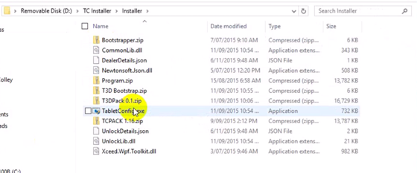

(depending on your settings, the '.exe' extension may not show)

After you have successfully started TableConfig you will see a screen like below: 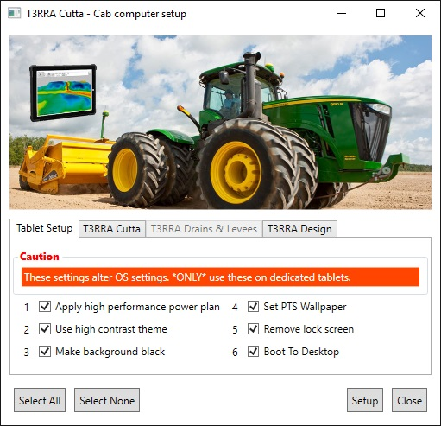

*IMPORTANT: operations on each tab are installed independently. Pressing the* ***Setup*** *button will caused all* ***checked*** *operations to run but* ***ONLY*** *on the current tab. You do not need to worry about the check status of any operations on other tabs.*

#### Tablet Setup tab

ONLY use this tab if you are installing on a tablet destined for in-cab use!! Performing these setup operations on your desktop or laptop computer will result in unhappiness all round. Manual settings changes will need to be performed to restore certain features and this is tedious and painful.

Features on this tab can be run on any tablet destined to run T3C in the cab of the computer. These are convenience settings that allow quicker startup, better viewing, and stop the tablet from automatically sleeping to conserve power.

#### T3RRA Cutta tab

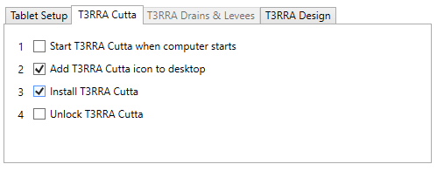

The first 3 checkboxes should be checked when installing on an in-cab tablet. This will install a 'demo' version of T3C and will cause the program to start automatically when the tablet boots up. In order to unlock the tablet for either a 'Dealer Demo' or a permanent sale you should check the the 4th checkbox *(installing and unlocking can be performed independently or together)*

##### Unlocking

An internet connection must be present when unlocking a tablet in order for the unlock code to be verified and/or the timed demo details to be recorded and monitored.

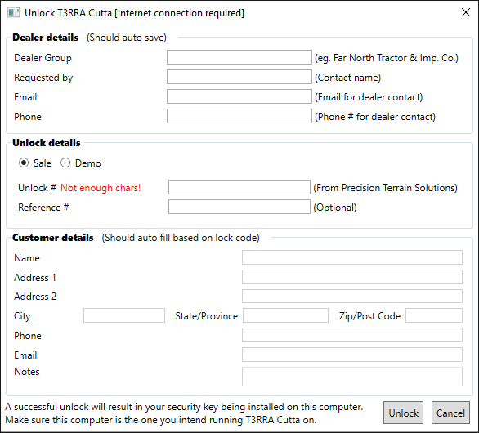

It is important to fill in all details when unlocking a tablet for either demo or sale. This is important for both your records and ours. Dealer details will be saved on the thumb drive and will not need to be entered on any but the first unlock.

When doing an unlock for a sale there is no need to enter the customer details as these will be auto filled based on the unlock code.

When doing an unlock for demonstration purposes you may set the start and end dates for the demo. The maximum allowable period is 5 days.

#### T3RRA Design tab

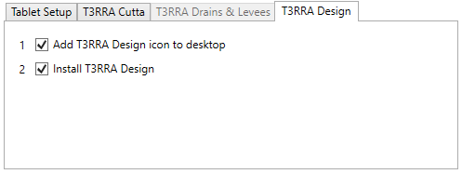

Both checkboxes should be left checked and then press **Setup**.

**Trouble shooting:** If you have problems with TabletConfig check the following:

1. Make sure you computer has the latest .NET runtimes installed
2. Make sure you have an internet connection
3. Install all available Windows updates