For the stochastic compartmental model: for each country/region we have the following equations (we will write down the stochastic version which we solve below).

$$\frac{dS_{i}}{dt}=-λ_{i}S_{i}+w_{i}R_{i}$$

$$\frac{dI_{i}}{dt}=λ_{i}S_{i}-γ_{i}I_{i}$$

$$\frac{dR_{i}}{dt}=γ_{i}I_{i}-w_{i}R_{i}$$

where the force of infection I is given by:

$$λ_{i}=β_{i}\sum_{j}{m_{ij}\frac{I_{j}}{N_{i}}}$$

note that we have *Ni* in the denominator above which means that we have made an implicit assumption that transmission takes place in population *i*, presumably resulting from the movement of an infectious individual from population *j*. We could have made the other assumption: that transmission is due to individual from population *i* travelling to population *j* and picking up the infection during this travel time. This will require putting *N*j in the denominator above.

The recovery rate, i, can be different (or the same for all countries/regions). The rate that immunity wanes is *wi* and I have set it to four years.

The coefficients, *mij*, measure the strength of interaction between populations and we will assume that is has an off-set power-law dependence on the distance between the centroids of the populations (*rij*):

The power determines the mixing between the populations and sd is the distance (in km) below which the kernel function is saturated. We can decide not to have an off-set and we can start with =-4. The matrix will be normalized by ensuring that the sum over rows equals 1. By looking at the median value of our distance matrix we can set the distance sd. Below is a plot of mij with =-2 (blue),-4 (red) and -6 (green) and sd=5km, seems that we may even want to set it to a smaller number (2km like in the Mills/Riley paper?)

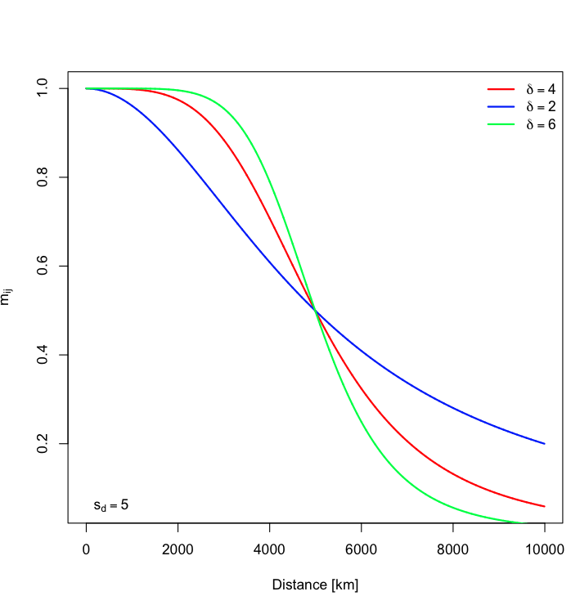

We will be solving the stochastic version of the three equations for Si, Ii and Ri

where we will calculate the probability of population *i* to be infected as:

$$p_{i}^{inf}=1-exp\left(-λ_{i}∙Δt\right)$$

(see above for the definition of i), the probability of this population to recover as:

$$p_{i}^{rec}=1-exp\left(-Δt{∙γ}_{i}\right)$$

and the probability to lose immunity as:

with t being the time step. Using these two probabilities we can calculate the number of infected/recovered for each country as:

$$N_{i,S,t}^{inf}=rbinom\left(1,S_{i},p_{i}^{inf}\right)$$

$$N_{i,I,t}^{rec}=rbinom\left(1,I_{i},p_{i}^{rec}\right)$$

$$N_{i,I,t}^{lst}=rbinom\left(1,R_{i},p_{i}^{lst}\right)$$

I am using the term ‘country’ in a loose way here. It can mean country/state/region/county etc.