🍽
Food Ordering System
Microservices Architecture with Spring Boot, ActiveMQ, Camunda BPMN & React
AI Implementation Report
Documenting an AI-assisted, full-stack microservices build

Objective
The objective of this project is to design and implement a full-stack, event-driven food ordering platform that mirrors the core experience of commercial apps like Zomato or Swiggy, while showcasing enterprise backend patterns commonly expected in a Java microservices role: service decomposition, asynchronous messaging, workflow orchestration, and a clean customer-facing UI.
Specifically, the system aims to:
- Decompose the ordering workflow into independently deployable microservices (Order, Kitchen, Payment, Delivery).
- Use ActiveMQ (JMS) to decouple order placement from kitchen preparation and delivery dispatch.
- Model the order lifecycle as a business process using Camunda BPMN for auditable, visual workflow orchestration.
- Persist each service's data independently in MySQL, respecting microservice data ownership.
- Present a single, customer-facing React interface that hides internal services (Kitchen, Delivery) the customer should never interact with directly.
- Package the entire system as one Maven multi-module reactor so it can be built and run with a single command.

Technology Stack

Backend
Layer | Technology
Language | Java 17
Framework | Spring Boot 3.2.5
Data Access | Spring Data JPA (Hibernate)
Database | MySQL 8
Messaging | ActiveMQ (JMS)
Workflow Engine | Camunda BPMN 7.20 (embedded, Spring Boot starter)
Build Tool | Maven (multi-module reactor)
API Style | REST (JSON over HTTP)

Frontend
Layer | Technology
Library | React 18
Build Tool | Vite
Routing | React Router v6
HTTP Client | Axios
Styling | Bootstrap 5

Integration
Layer | Technology
Gateway | Spring Boot proxy (single entry point, port 8090)
Static Hosting | React production build served as Spring Boot static resources

Architecture Diagram
High-level request flow, from the customer's browser down to each backend service:
Layer | Component | Responsibility
Client | Browser (React SPA) | Customer-facing UI: Home → Menu → Order → Payment → Success → History
Gateway | api-gateway (port 8090) | Serves the compiled React app; proxies /api/** to the correct backend service
Service | order-service (8081) | Order CRUD, order status, Camunda process owner
Service | payment-service (8080) | Payment processing (mocked gateway, card data masked)
Service (internal) | kitchen-service (8082) | Consumes orders from ActiveMQ, simulates preparation
Service (internal) | delivery-service (8083) | Consumes ready orders, simulates delivery, marks order delivered
Messaging | ActiveMQ (61616) | kitchen.queue and delivery.queue — decouples services
Data | MySQL (3306) | One schema per service: order_db, payment_db, kitchen_db, delivery_db

Textual flow diagram:
Customer → React UI → api-gateway → order-service (POST /orders) order-service → Camunda process instance started → ActiveMQ (kitchen.queue) kitchen-service ← kitchen.queue | kitchen-service → order-service (status callback: PREPARING → READY) kitchen-service → ActiveMQ (delivery.queue) → delivery-service delivery-service → order-service (status callback: OUT_FOR_DELIVERY → DELIVERED) Meanwhile: React UI → api-gateway → payment-service (POST /payment/pay)

Modules
Module | Port | Purpose
common | — | Shared DTOs (OrderDTO, PaymentDTO, KitchenOrderDTO, DeliveryDTO) used by every service so REST and JMS payloads stay consistent
order-service | 8081 | Order CRUD, order status endpoint, publishes to kitchen.queue, embeds Camunda BPMN process for the order lifecycle
kitchen-service | 8082 | Listens on kitchen.queue, simulates food preparation, calls back to order-service to update status, forwards to delivery.queue
payment-service | 8080 | Records payments against an order (mock gateway); masks card numbers before persisting
delivery-service | 8083 | Listens on delivery.queue, assigns a delivery agent, simulates delivery, calls back to order-service on completion
api-gateway | 8090 | Single public entry point; serves the compiled React build and proxies API calls to the right service
frontend | — | React source; built via frontend-maven-plugin as part of the Maven reactor, output consumed by api-gateway

Working Flow

Customer-facing flow
- Home — landing page, "Order Now" call to action
- Menu — fixed menu (Pizza, Burger, Fried Rice, Biryani) with prices
- Order — customer enters name, quantity, address; submitting POSTs to order-service
- Payment — order total shown; card details captured (mocked, masked before storage); POSTs to payment-service
- Success — confirms payment, shows order ID, "Preparing your food..."
- History — polls order-service for all orders and their live status

Background flow (invisible to the customer)
- order-service saves the order (status = PENDING) and publishes it to kitchen.queue
- kitchen-service consumes the message, sets status = PREPARING, simulates cooking time
- kitchen-service marks the order READY and forwards it to delivery.queue
- delivery-service consumes the message, assigns a delivery agent, sets status = OUT_FOR_DELIVERY
- After a simulated delivery window, delivery-service marks the order DELIVERED
- Each of these transitions is written back to order-service via a status callback, so the History page always reflects the true state

Database Design
Each microservice owns its own schema — no service reaches into another service's database directly.

order_db.orders
Column | Type | Notes
id | BIGINT (PK, auto) | Order identifier
customer_name | VARCHAR
food_item | VARCHAR
quantity | INT
price | DOUBLE | Unit price
address | VARCHAR
status | VARCHAR | PENDING → PREPARING → READY → OUT_FOR_DELIVERY → DELIVERED

payment_db.payments
Column | Type | Notes
id | BIGINT (PK, auto)
order_id | BIGINT | References order-service's order
amount | DOUBLE
card_number | VARCHAR | Stored masked: **** **** **** 1234
expiry | VARCHAR
status | VARCHAR | PAID / FAILED

kitchen_db.kitchen_orders
Column | Type | Notes
id | BIGINT (PK, auto)
order_id | BIGINT | References order-service's order
customer_name | VARCHAR
food_item | VARCHAR
quantity | INT
status | VARCHAR | PENDING / PREPARING / READY

delivery_db.deliveries
Column | Type | Notes
id | BIGINT (PK, auto)
order_id | BIGINT | References order-service's order
address | VARCHAR
delivery_boy | VARCHAR | Randomly assigned
expected_time | VARCHAR | e.g. "30 mins"
status | VARCHAR | ASSIGNED / OUT_FOR_DELIVERY / DELIVERED

API Details

Order Service — http://localhost:8081
Method | Endpoint | Description
POST | /orders | Create a new order; publishes to kitchen.queue
GET | /orders | List all orders (used by History page)
GET | /orders/{id} | Fetch a single order
PUT | /orders/{id}/status | Internal callback used by kitchen/delivery services to update status

Payment Service — http://localhost:8080
Method | Endpoint | Description
POST | /payment/pay | Process a mock payment for an order
GET | /payment | List all recorded payments

Kitchen Service — http://localhost:8082 (internal)
Method | Endpoint | Description
GET | /kitchen | Ops/debug visibility into current kitchen queue — not called by the customer UI

Delivery Service — http://localhost:8083 (internal)
No customer-facing endpoints. Consumes delivery.queue only and calls back to order-service.

Gateway — http://localhost:8090
Serves the compiled React app at "/" and proxies "/api/orders/**" and "/api/payment/**" to the respective services, giving the customer a single origin to talk to.

Frontend
The frontend is a single-page React application built with Vite and styled with Bootstrap 5. It intentionally exposes only the pages a real customer would use — Kitchen and Delivery remain backend-only services that the customer never sees or calls directly.
Page | Route | Purpose
Home | / | Landing page with "Order Now" call to action
Menu | /menu | Browse fixed menu items and prices
Order | /order | Enter customer details, quantity, and address
Payment | /payment | Enter card details and confirm payment
Success | /success | Confirmation screen with order ID
History | /history | Live order status, polled from order-service

State is passed between pages via React Router's location state (selected item → order → payment total → order ID), avoiding any dependency on browser storage.

Screenshots
Once the system is running locally (see README), capture and insert screenshots of each screen below. Recommended set:
- Home page
- Menu page with all four items
- Order form filled out
- Payment page
- Success page showing order ID
- History page showing status progressing from Preparing → Out for Delivery → Delivered

Figure 1: Home Page
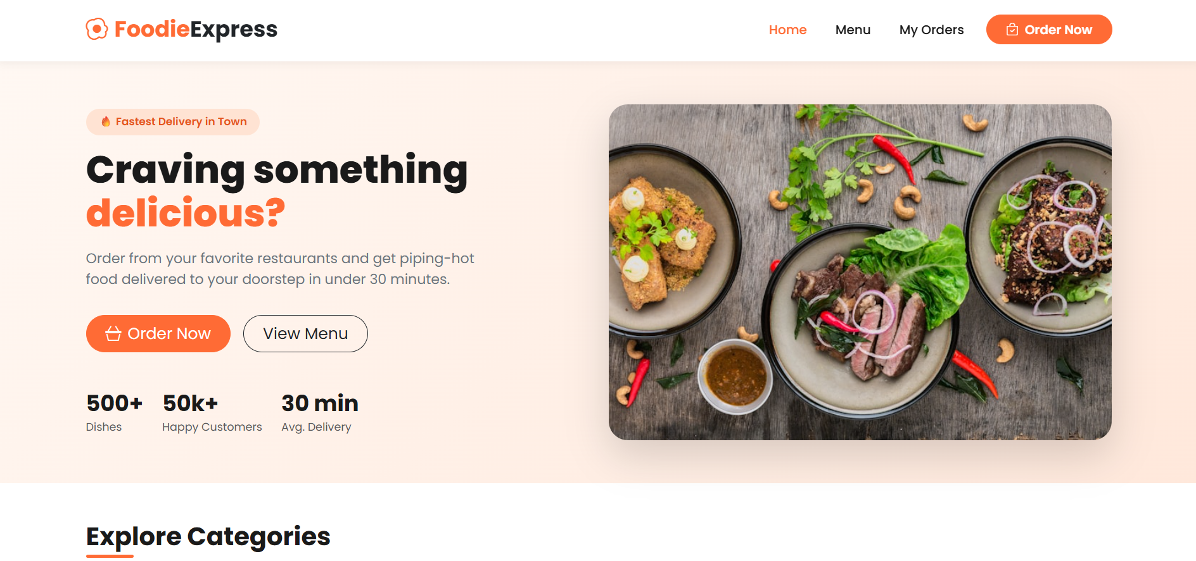
Figure 2: Menu Page
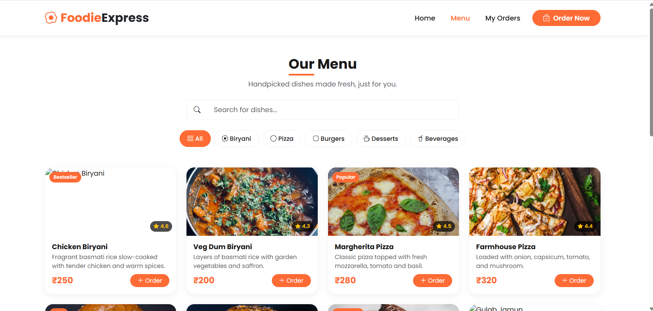
Figure 3: Order Page

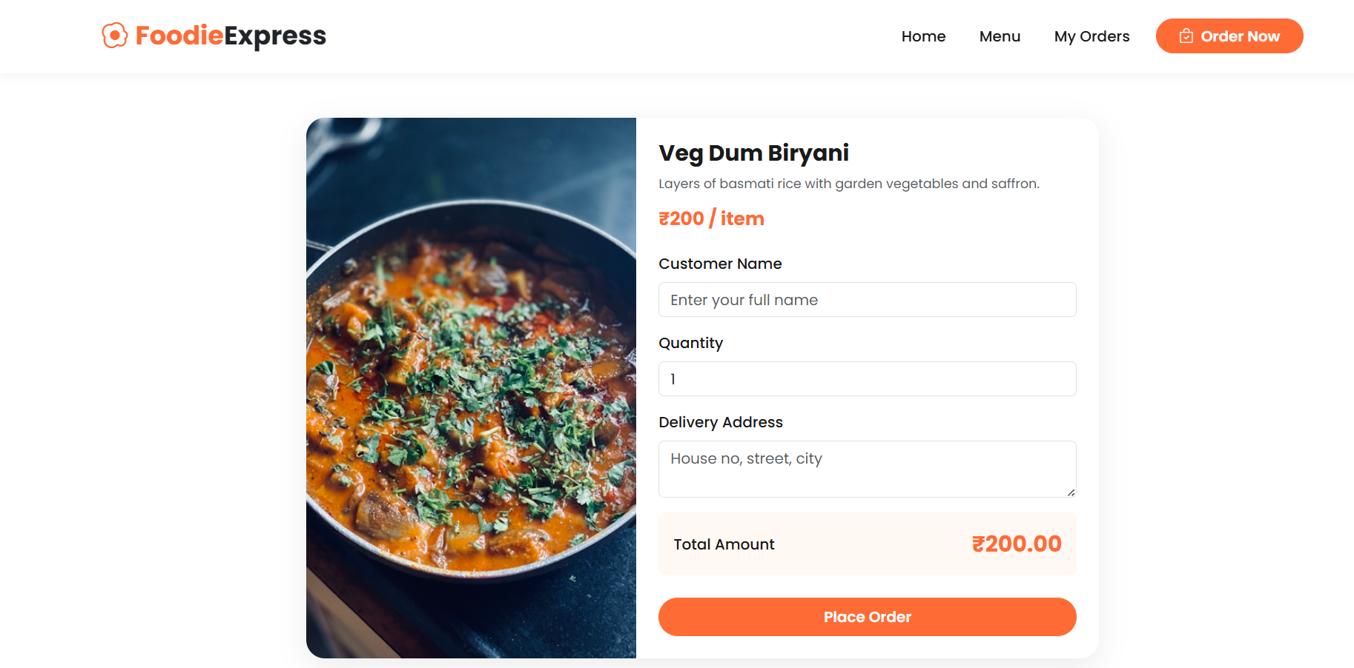

Figure 4: Payment Page

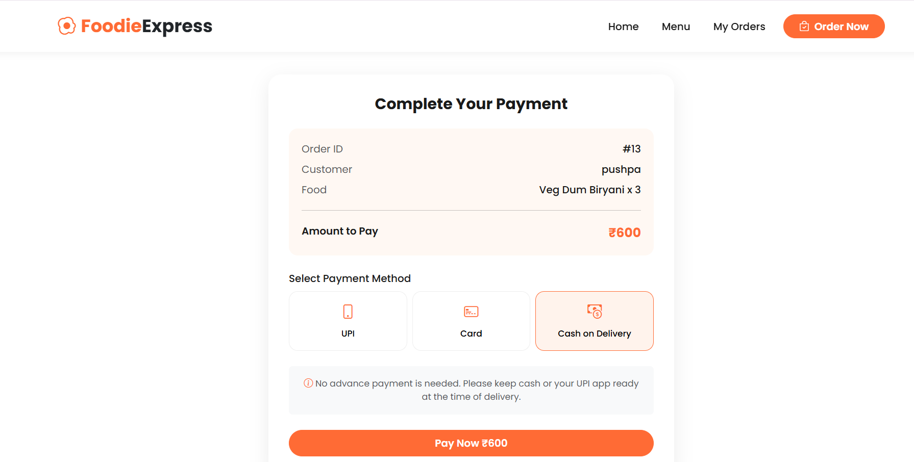

Figure 5: Success Page
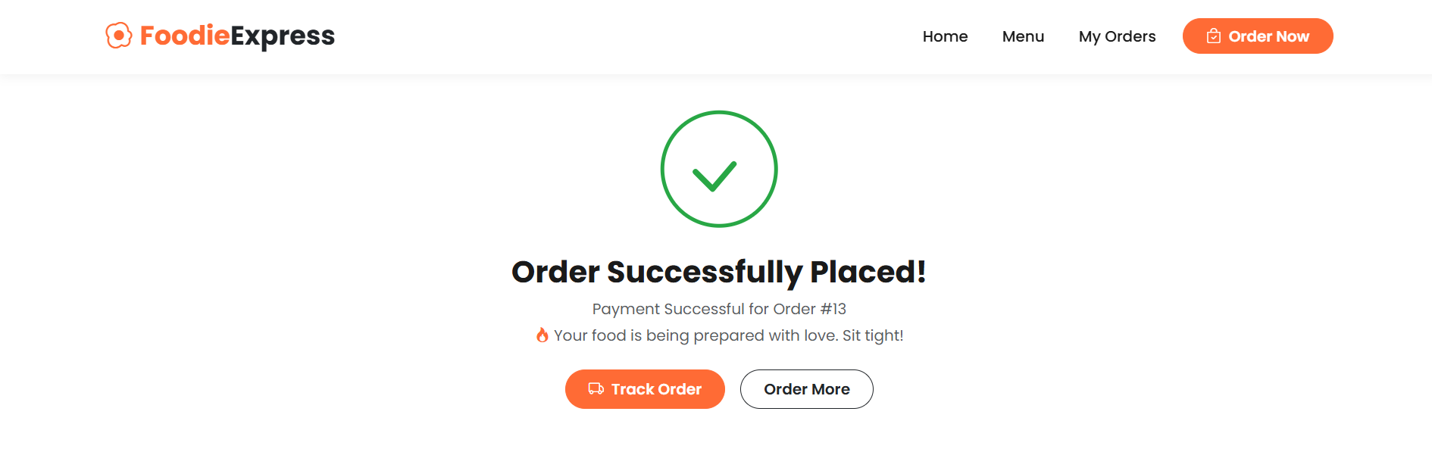

[ Insert screenshot here — Figure 6: Order History Page ]
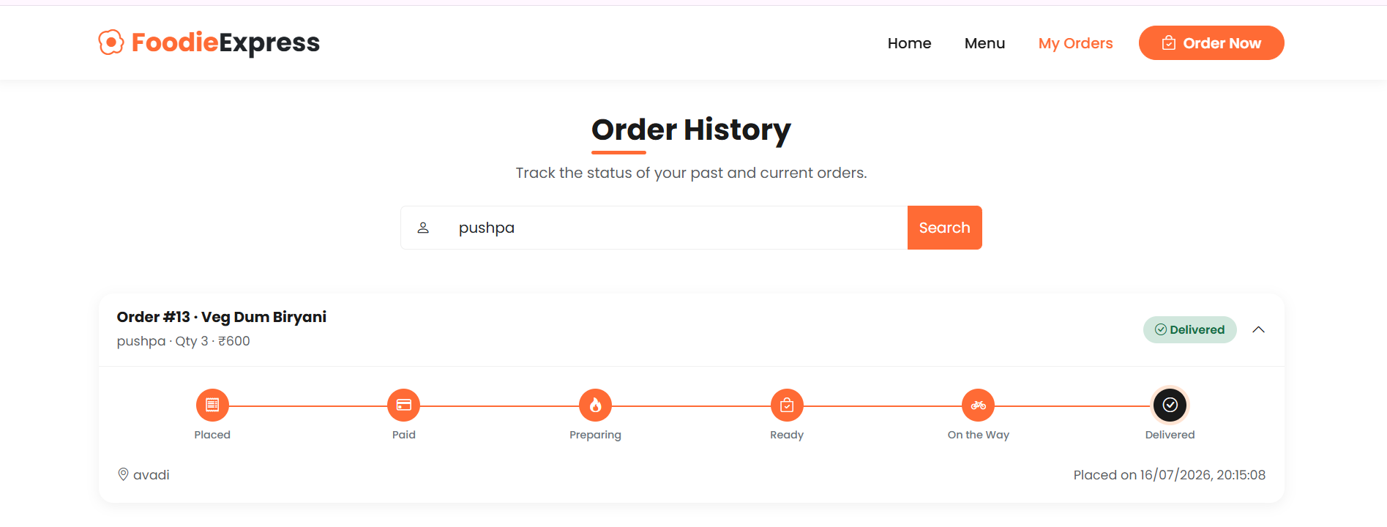

Testing

Manual end-to-end test
- Start MySQL and ActiveMQ, then start all five backend services followed by api-gateway
- Open http://localhost:8090, place an order through the full flow (Menu → Order → Payment → Success)
- Confirm the order appears in History as PENDING, then watch it progress automatically to PREPARING, READY, OUT_FOR_DELIVERY, and DELIVERED

API-level testing
- Use Postman/curl to POST directly to /orders and /payment/pay and verify responses and status codes
- Verify GET /orders/{id} reflects each status transition as background processing completes

Messaging verification
- Use the ActiveMQ web console (http://localhost:8161) to confirm messages arrive on kitchen.queue and delivery.queue and are consumed (not stuck pending)

Suggested automated tests (future work)
- Unit tests for each service layer using JUnit 5 and Mockito
- Integration tests with @SpringBootTest and an embedded ActiveMQ broker
- Camunda process tests using camunda-bpm-assert to verify the BPMN flow reaches expected end states

Future Enhancements
- Replace direct REST status callbacks with a dedicated order-events queue for full event-driven consistency
- Add authentication/authorization (Spring Security + JWT) for customer accounts
- Integrate a real payment gateway (Razorpay/Stripe) instead of the mocked payment flow
- Add a live order-tracking view using WebSockets instead of polling History
- Containerize each service with Docker and orchestrate with Docker Compose or Kubernetes
- Add centralized logging/tracing (ELK stack or Zipkin) across all five services
- Expand the Camunda process with compensation flows for order cancellation and refunds
- Add automated CI (GitHub Actions) running the full Maven reactor build and test suite on every push

Conclusion
This project demonstrates a realistic, decoupled microservices architecture for a food ordering platform: independent services for Order, Kitchen, Payment, and Delivery, coordinated through ActiveMQ messaging and a Camunda BPMN-modeled order lifecycle, all fronted by a single customer-facing React application. The Maven multi-module structure allows the entire system — backend services and frontend — to be built and reasoned about as one project, while still preserving clear service boundaries and independent data ownership. The result is a working, end-to-end demonstration of the patterns most relevant to a Java microservices role: service decomposition, asynchronous processing, workflow orchestration, and clean separation between customer-facing and internal services.

