#handling of ipv4 as well as ipv6 addresses
#Script is modified from the sciptes provide by Brendan Gregg as a par of the bcc library
#probes attatched to the wrong functions. these probes activate when connections tcp are established
#In your program, `kprobe__tcp_v4_connect` and `kretprobe__tcp_v4_connect` are not packet-in and packet-out functions. They are kernel probes that are triggered when the `tcp_v4_connect` function is called and returns in the kernel, respectively. The `tcp_v4_connect` function is part of the TCP stack in the Linux kernel and is called when a TCP connection is being established, not for each packet sent or received.
#For incoming packets, we might want to attach a kprobe to the `tcp_v4_do_rcv` function, which is called when a TCP packet is received. For outgoing packets, you might want to attach a kprobe to the `tcp_transmit_skb` function, which is called when a TCP packet is sent.
#problem with source and destination addresses- like source is always same while destination is diifferent. should be opposite
#okay so source is actually my address? wlp0s20f3 is my interface. but why? isn't this about incoming packets? have to check
# it says that to check what the matter is and why this is happening we should print out the source and destination ports.
##If the source port is a high-numbered ephemeral port and the destination port is a well-known port (e.g., 80 for HTTP or 443 for HTTPS), then the packets are likely outgoing packets from your machine. If the source port is a well-known port and the destination port is a high-numbered ephemeral port, then the packets are likely incoming packets to your machine.
# bit messed up. i am pretty confused right now. like sport and port are super random, probably because it is capturing all recieving packets instead of just connected tcp connections.
#i think dport and sport meaning are lining up with the rcv function but ofc i cant see any popoular ports in the listing. bit weird.
# i think sport and sport are being shown correctly
# chatgpt says that sourceip will be mostly the ip of the machine on which the bpf program is running
#im gonna try to modify this according to the suggestion given by chatgpt which is in the program changed_stack.py where i attatch the probe to a different function in the tcp stack
#still still still getting the same thing. this is annoying. gonna leave it now and just focus on other stuff. tysm.
#i think maybe ip_rcv function probing will give me all sorts of traffic instead of just tcp packets gonna try that now.
#nooo it is fully coming 0.0.0.0. like all source and destination ips
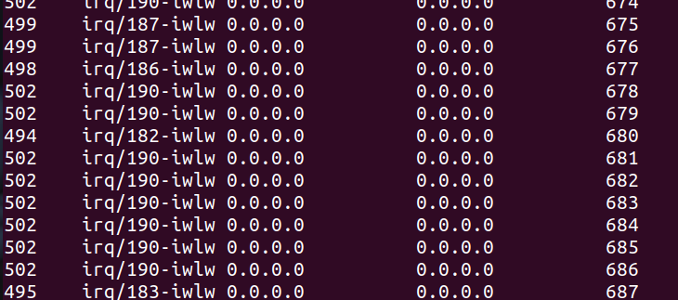
#so i was able to attatch the probe to ip/-rcv abd capture the packet details at the topmost layer, but ofc the packets were from and destined to places all over the world, so maybe kind of usesless, i have to see about filtering these.
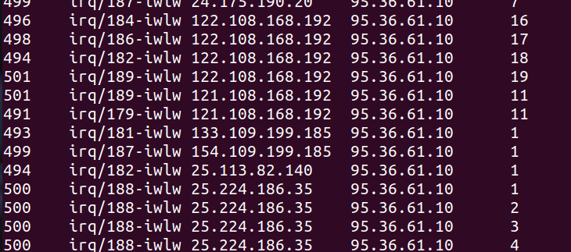
#SAying we can dynamically change if the destination ip can match any of the network interface ips. we can either enter the ips manually or we can do it dynamically.
#trying to do it dynamically ofc. but errors are coming.
#what do i want exactly? all network traffic? or just the network traffic intended for me? confirm and think about this. Check with the dataset.

