Word-to-md
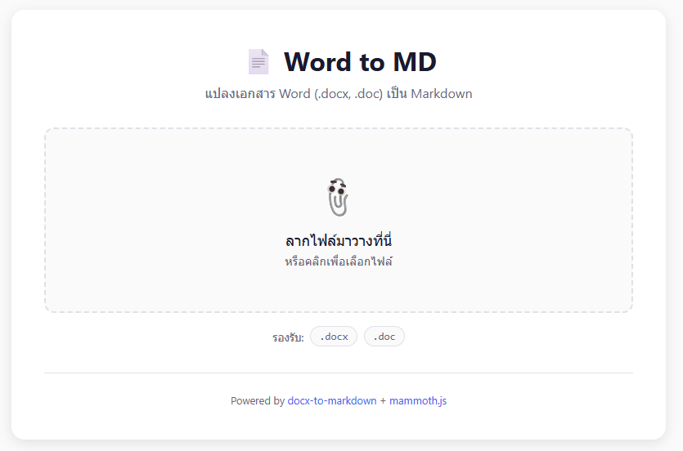

Test document
Topic | Detail | Rate
#1 - Happy | My emotion | 50
#2 – Proud | My thought | 60
#3 - Thinking | My task | 70

