Lab – 01 - Monday, March – 16 [ 2 Lab programmes for the Day]
Experiment 1: Creating First Hello World Servlet using Eclipse
Aim
To create and run a Hello World Servlet using Eclipse IDE and Apache Tomcat Server.
Software Requirements
- JDK 21
- Eclipse IDE 2025 (Enterprise / Web Developer edition)
- Apache Tomcat Server
- Web Browser (Chrome / Firefox)
Steps to Create Hello World Servlet in Eclipse
Step 1: Start Eclipse IDE
- Open Eclipse IDE 2025.
- Select a Workspace location.
- Click Launch.

Step 2: Create a Dynamic Web Project
- Click File → New → Dynamic Web Project.
- Enter the Project Name as HelloServletApp
- Select Target Runtime → Apache Tomcat Server.
- Keep default settings.
- Click Finish.

Step 3: Project Structure Created by Eclipse
After creating the project, Eclipse generates the following structure:
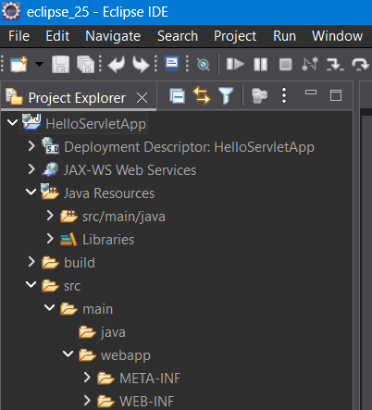

Step 4: Create a Servlet Class
- Right click the project - HelloServletApp
- Select New → Servlet.
- Enter the following details:
Field | Value
Package Name - | com.example
Class Name - | HelloServlet
- Click Next
- Keep default URL mapping:
/HelloServlet
- Click Finish.
Eclipse automatically creates the servlet file:
HelloServlet.java
⚠ Important:
Servlet programs must always be saved with .java extension.
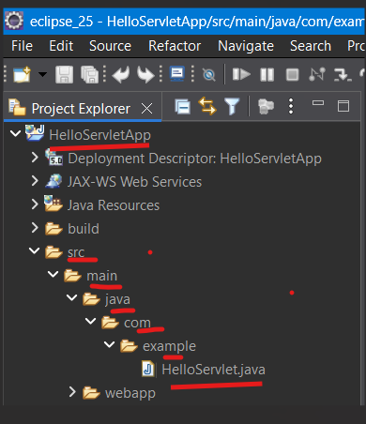
Step 5: Double click on the servlet “HelloServlet.java“ add the below Servlet Code in the file under doGet method
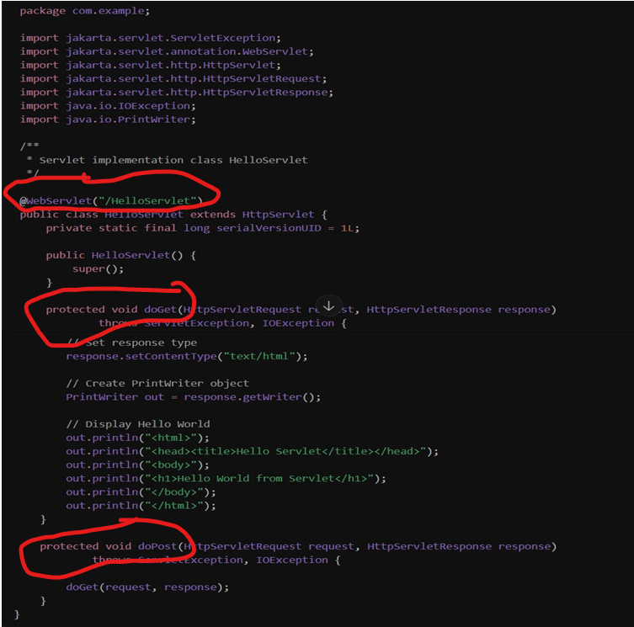
Type this content in HelloServlet.java under the get method as above diagram
// Set response type
response.setContentType("text/html");
// Create PrintWriter object
PrintWriter out = response.getWriter();
// Display Hello World
out.println("<html>");
out.println("<head><title>Hello Servlet</title></head>");
out.println("<body>");
out.println("<h1>Hello World from Servlet</h1>");
out.println("</body>");
out.println("</html>");

Step 6: Run the Project on Server
- Right click the project - HelloServletApp
- Select Run As → Run on Server.
- Choose Apache Tomcat Server.
- Click Finish.
Tomcat server will start automatically.

Step 7: Access the Servlet in Browser
Initially, below url will be opened and HTTP Status 404 – Not Found
Will be shown
http://localhost:8089/HelloServletApp/
This means the servlet is available at:
http://localhost:8089/HelloServletApp/HelloServlet
Tomcat will only run the servlet when that exact URL is requested.
So you must manually add:
/HelloServlet (which is ur Class name)
So add HelloServlet to the url
http://localhost:8089/HelloServletApp/HelloServlet

Expected Output
The browser displays:
Hello World from Servlet
NOTE – By default Web container will not open a servlet page at first as servlet is for backend/Logic, by default Web container will open only html/jsp (Frontend) page kept in “webapp” folder in Eclipse

Experiment 2: Creating First Jsp page and link it to “HelloServlet” servlet
Step 1 —
- Right click the webapp Folder under the project HelloServletApp
- Select New → jsp File , file structure as below
Create a file – index.jsp
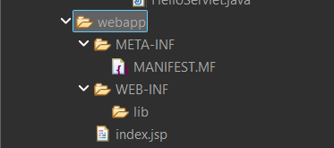

Step 2 - Type the below content in index.jsp
<%@ page language="java" contentType="text/html; charset=UTF-8"
pageEncoding="UTF-8"%>
<%@ page import="java.util.Date" %>
<!DOCTYPE html>
<html>
<head>
<meta charset="UTF-8">
<title>Insert title here</title>
<style>
.container{
background: white;
padding: 40px;
width: 420px;
margin: auto;
border-radius: 12px;
box-shadow: 0px 6px 15px rgba(0,0,0,0.2);
}
body{
font-family: Arial, Helvetica, sans-serif;
background: linear-gradient(to right, #4facfe, #00f2fe);
display: flex;
justify-content: center;
align-items: center;
height: 100vh;
margin: 0;
}
</style>
</head>
<body>
<div class="container">
<h1>Hello World from JSP</h1>
<p>This page is generated using <b>JSP</b>.</p>
<p>Click the button below to run the <b>Hello Servlet</b>.</p>

<a href="HelloServlet">Run Hello Servlet</a>
<p>
Current Date/Time is - <%= new Date() %>
</p>
</div>
</body>
</html>

Step 3: Run the index.jsp file on Browser
- Right click the project - HelloServletApp
- Select Run As → Run on Server.
- Choose Apache Tomcat Server.
- Click Finish.
Tomcat server will open the index.jsp file in browser

Result
In today’s lab we successfully created and executed a Servlet and a JSP file using the Eclipse IDE and Apache Tomcat Server.

