Department of Computer Science and Engineering



*CGC College of Engineering*

*Landran -Mohali, 140307*

**PROJECT REPORT**

**ON**

TUTORIALS WEBSITE



Submitted By: Submitted To:

**Preekshit Dahiya and Yashwani Mr. Shivam Thakur.**

**2019214 2019256 Trainer**

# ACKNOWLEDGEMENT:

We want to express a deep sense of gratitude for all those people who have supported me to accomplish our training project. First, We would like to thank the management of **“** **CHANDIGRH GROUP OF COLLEGEs , LANDRAN ”** who has given me the opportunity to accomplish our training for partial fulfillment of the requirement for the degree of Bachelors of Technology to I K Gujral Punjab Technical University .

Secondly, we would like to thank our parents and friends who have directly or indirectly helped us in finalizing this project within a limited time frame.

We are thankful to Solitaire Infosys Pvt. Ltd. for providing me the relevant training and certification.

Preekshit Dahiya Yashwani

2019214 2019256

B.Tech CSE B.Tech CSE

4th semester 4th semester

Group E1 Group E2

**CERTIFICATE:**

This is to certify that the work embodied in this Project Report entitled “ ***ExamPreparations.Com*** ” being submitted by “***PREEKSHIT DAHIYA***” Roll number***:“ 2019214*** ” ,and “***YASHWANI***” roll number:” ***2019256*** ”of 4th Semester for partial fulfillment of the requirement for the degree of “ *Bachelor of Technology* ” disciplined in “ *CGC LANDRAN* ” during the academic session Jan-June 2022 is a record of bonafide piece of work, carried out by student under my supervision and guidance in the “ *Department of Computer Science & Engineering* ”, CGC LANDRAN.

Approved and Guided by:

……………….

Mr. Shivam Thakur

Trainer

Solitaire Infosys Pvt. Ltd

**DECLARATION:**

We, student of **Bachelor of Technology** in **Computer Science & Engineering, 4th Semester , session: Jan – June 2022, CGC LANDRAN**, hereby declare that the work presented in this Project Report entitled “ **ExamPreparations.com** ” is the outcome of our own work, is bonafide and correct to the best of my knowledge and this work has been carried out taking care of Engineering Ethics. The work presented does not infringe any patented work and has not been submitted to any other university or anywhere else for the award of any degree or any professional diploma.

Students details and Signature:

…………………. ………………

Preekshit Dahiya Yashwani

2019214 2019256

B.Tech CSE B.Tech CSE

4th semester 4th semester

Group E1 Group E2

Approved & Guided By:

…………………….

Mr. Shivam Thakur

Trainer

Solitaire Infosys Pvt. Ltd

**INDEX**

|  |  |  |
| --- | --- | --- |
| S.NO. | CONTENTS | PAGE NO. |
| 1. | TITLE AND OBJECTIVE. | 6. |
| 2. | INTRODUCTION OF THE PROJECT. | 7. |
| 3. | FEATURES AND  SCOPE OF THE PROJECT. | 8. |
| 4. | TECHNOLOGY USED. | 9-11. |
| 5. | HARDWARE AND SOFTWARE SPECIFICATIONS. | 12. |
| 6. | CODING AND OUTPUT. | 13-26. |
| 7. | INNOVATIONS IN PROJECT. | 27. |
| 8. | CONCLUSION. | 27. |
| 9. | REFERENCES. | 28. |

**TITLE:**

**Tutorials website titled as**

**ExamPreparations.com**

**OBJECTIVE:**

This project is made with the objective to provide the tutorials for each subject of each semester in I K Gujral Punjab technical University. With this system students can easily learn and get study material from this website according to their subjects

**INTRODUCTION:**

ExamPreparations.com is a website that can be used to provide tutorials to students of I K Gujral Punjab Technical University.

This system contains tutorials of different subject which make it easy for students to get the study material for their examinations.

This system also provides exciting events like ideathon, code like ninja, expert talks etc.

Further it also gives the forms to contact and join us.

This software is built to eliminate and in some cases reduce the hardships faced by the students in getting study material for their exam preparations. Moreover, this system can be updated according to the need of students and syllabus of university.

**FEATURES and SCOPE of the PROJECT:**

The main features of this project are as follows:

->Simple and one click navigation menu.

-> Five sections home page -navbar, tutorials, events, contact form,

footer.

-> Forms to contact and join us.

The scope of this project is as follows:

* Can give study assistance for exam preparations
* Provide Study material according to subjects
* Specially designed for I K Gujral Punjab Technical University students
* Easy and compatible to use.
* User friendly interface.

**TECHNOLOGY USED:**

REACT JS

In this project, react js is used to develop user-interface. React Js features like importing and exporting files, routing etc. To design the ui of this project, further CSS concepts are used.

WHAT IS REACT JS?

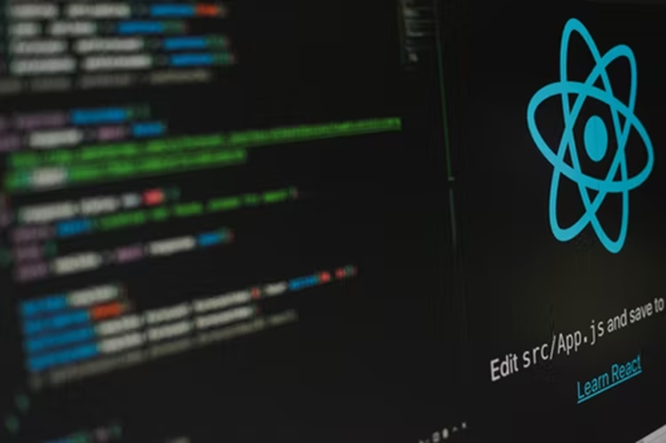

React (also known as React.js or React JS) is a free and open-source front-end JavaScript library for building user interfaces based on UI components. It is maintained by Meta (formerly Facebook) and a community of individual developers and companies. React can be used as a base in the development of single-page, mobile, or server-rendered applications with frameworks like Next.js. However, React is only concerned with state management and rendering that state to the DOM, so creating React applications usually requires the use of additional libraries for routing, as well as certain client-side functionality.

Features:

->Declarative

React adheres to the declarative programming paradigm. Developers design views for each state of an application, and React updates and renders components when data changes. This is in contrast with imperative programming.

->Components

React code is made of entities called components. These components are reusable and must be formed in the SRC folder following the Pascal Case as its naming convention (capitalize camel case). Components can be rendered to a particular element in the DOM using the React DOM library. When rendering a component, one can pass the values between components through "props".

->Virtual DOM

Another notable feature is the use of a virtual Document Object Model, or virtual DOM. React creates an in-memory data-structure cache, computes the resulting differences, and then updates the browser's displayed DOM efficiently. This process is called reconciliation. This allows the programmer to write code as if the entire page is rendered on each change, while the React libraries only render subcomponents that actually change. This selective rendering provides a major performance boost. It saves the effort of recalculating the CSS style, layout for the page and rendering for the entire page.

->JSX

JSX, or JavaScript Syntax Extension, is an extension to the JavaScript language syntax. Similar in appearance to HTML, JSX provides a way to structure component rendering using syntax familiar to many developers. React components are typically written using JSX; although they do not have to be (components may also be written in pure JavaScript). JSX is similar to another extension syntax created by Facebook for PHP called XHP.

WHAT IS NPM?

NPM (originally short for Node Package Manager) is a package manager for the JavaScript programming language maintained by NPM, Inc. NPM is the default package manager for the JavaScript runtime environment Node.js. It consists of a command line client, also called NPM, and an online database of public and paid-for private packages, called the NPM registry. The registry is accessed via the client, and the available packages can be browsed and searched via the NPM website. The package manager and the registry are managed by NPM, Inc.

NPM is included as a recommended feature in the Node.js installer. NPM consists of a command line client that interacts with a remote registry. It allows users to consume and distribute JavaScript modules that are available in the registry. Packages in the registry are in CommonJS format and include a metadata file in JSON format. Over 1.3 million packages are available in the main npm registry. The registry does not have any vetting process for submission, which means that packages found there can potentially be low quality, insecure, or malicious. Instead, npm relies on user reports to take down packages if they violate policies by being low quality, insecure, or malicious. NPM exposes statistics including number of downloads and number of depending packages to assist developers in judging the quality of packages.

In npm version 6, the audit feature was introduced to help developers identify and fix security vulnerabilities in installed packages. The source of security vulnerabilities were taken from reports found on the Node Security Platform (NSP) and has been integrated with npm since npm's acquisition of NSP.

**HARDWARE AND SOFTWARE SPECIFICATIONS:**

**Hardware:**

**->**Processor: 10th Gen Intel core i5.

**->**Processor speed: 2.42GHz.

**->**Windows 10 or above.

**->**RAM: 2.00GB or above.

**->**System type: 64-bit operating system.

**->**Internet connection: any type.

**Software:**

**->** Browser: Google Chrome.

**->**Operating system: Run in every OS.

**->** Front End: React JS.

**->** Back End: Not Used.

**->** IDE used: Visual Studio Code.

**->**Runs project on: NPM (Node Package Manager) package manager

for the Node JavaScript platform.

**CODING AND OUTPUT:**

Index.js:

import React from 'react';

import ReactDOM from 'react-dom/client';

import './index.css';

import App from './App';

import reportWebVitals from './reportWebVitals';

import { Router } from 'react-router-dom';

const root = ReactDOM.createRoot(document.getElementById('root'));

root.render(

  <React.StrictMode>

    <App />

  </React.StrictMode>

);

// If you want to start measuring performance in your app, pass a function

// to log results (for example: reportWebVitals(console.log))

// or send to an analytics endpoint. Learn more: https://bit.ly/CRA-vitals

reportWebVitals();

App.js:

import React from 'react';

import Home from './pages/home';

import Navbar from './pages/navbar';

import Join from './pages/join_us';

import Tutorials from './pages/tutorials';

import Events from './pages/events';

import About from './pages/about_us';

import Contact from './pages/contact_us';

import Footer from './pages/footer';

import {BrowserRouter as Router,Routes,Route} from 'react-router-dom';

function App() {

   return (

   <>

        <Router>

        <Navbar/>

         <Routes>

            <Route path="/" element={<Home/>}/>

            <Route path="/tutorials" element={<Tutorials/>}/>

            <Route path="/events" element={<Events/>}/>

            <Route path="/contact" element={<Contact/>}/>

            <Route path="/about" element={<About/>}/>

             <Route path="/join" element={<Join/>}/>

            </Routes>

            <Footer/>

        </Router>

   </>

   )

}

export default App;

navbar.js:

import React from 'react';

import Join from './join_us';

import {Outlet,NavLink} from 'react-router-dom';

const Navbar=()=> {

    return(

        <>

          <nav id="navbar">

            <div id="logo">

                <img src="./images/logo.png" alt="ExamPreparations.com"/>

            </div>

            <ul>

                 <li class="item"><NavLink to="/">Home</NavLink></li>

                 <li class="item"><NavLink to="/tutorials">Tutorials</NavLink></li>

                 <li class="item"><NavLink to="/events">Events</NavLink></li>

                 <li class="item"><NavLink to="/contact">Contact us</NavLink></li>

                 <li class="item"><NavLink to="/about">About us</NavLink></li>

            </ul>

        </nav>

        <section id="Home">

            <h1>ExamPreparations</h1>

            <p>WELCOME TO EXAM PREPATIONS</p>

            <NavLink to="/join"><button>JOIN US</button></NavLink>

        </section>

        <Outlet/>

        </>

        )

}

export default Navbar;

home.js:

import React from 'react';

import { NavLink, Outlet } from 'react-router-dom';

const Home=()=> {

   return(<>

     <div>

<section>

    <h1 id="tutorialheading">Tutorials</h1>

<section id="Tutorials">

    <div class="box">

    <img src="./images/os.jpg" alt="OperatingSystem"/>

    <h2>OPERATING SYSTEM</h2>

    </div>

    <div class="box">

    <img src="./images/opps.jpg" alt="ObjectOrientedProgramming"/>

    <h2>OBJECT ORIENTED PROGRAMMING</h2>

    </div>

    <div class="box">

    <img src="./images/dsa.jpg" alt="DataStructure"/>

    <h2>DATA STRUCTURE</h2>

    </div>

</section>

<nav id="tutorialnav">

    <NavLink to="/tutorials"><button><h3>see all</h3></button></NavLink>

    </nav>

</section>

<section>

    <h1 id="eventsheading">Events</h1>

    <section id="Events">

    <div class="box">

    <img src="./images/codelikeninja.jpg" alt="CodeLikeNinja"/>

    <h2>CODE LIKE NINJA</h2>

    </div>

    <div class="box">

    <img src="./images/experttalk.jpg" alt="ExpertTalk"/>

    <h2>EXPERT TALK</h2>

    </div>

    <div class="box">

    <img src="./images/ideathon.jpg" alt="Ideathon"/>

    <h2>IDEATHON</h2>

    </div>

    </section>

<nav id="eventsnav">

        <NavLink to="/events"><button><h3>see all</h3></button></NavLink>

    </nav>

</section>

<section id="contact">

    <h1>CONTACT US</h1>

    <div id="contact_box">

        <fieldset>

            <form>

            <div class="form-group">

                <label for="name">Name:</label>

                <input type="text" name="name" id="name" placeholder="Enter your Name"/>

            </div>

            <div class="form-group">

                <label for="email">Email:</label>

                <input type="text" name="name" id="name" placeholder="Enter your Email"/>

            </div>

            <div class="form-group">

                <label for="phone">Phone:</label>

                <input type="text" name="name" id="name" placeholder="Enter your Phone"/>

            </div>

            <div class="form-group">

                <label for="message">Message:</label>

                <textarea name="message" id="message" cols="20" rows="5"></textarea>

            </div>

        </form>

        </fieldset>

    </div>

</section>

     </div>

     <Outlet/>

     </>

    );

}

export default Home;

tutorials.js:

import React from 'react';

 const Tutorials=()=>{

    return(

<div>

    <h1 id="tutorials_heading">Tutorials</h1>

        <section id="tutorials">

         <div class="box">

         <img src="./images/os.jpg" alt="OperatingSystem"/>

         <h2>OPERATING SYSTEM</h2>

         </div>

         <div class="box">

         <img src="./images/opps.jpg" alt="ObjectOrientedProgramming"/>

         <h2>OBJECT ORIENTED PROGRAMMING</h2>

         </div>

         <div class="box">

         <img src="./images/dsa.jpg" alt="DataStructure"/>

         <h2>DATA STRUCTURE</h2>

         </div>

    </section>

    <section id="tutorials">

         <div class="box">

         <img src="./images/ai.jpg" alt="ArtificialIntelligence"/>

         <h2>ARTIFICIAL INTELLIGENCE</h2>

         </div>

         <div class="box">

         <img src="./images/coa.jpg" alt="ComputerOrganizationAndArchitecture"/>

         <h2>COMPUTER ARCHITECTURE</h2>

         </div>

         <div class="box">

         <img src="./images/daa.jpg" alt="DesignAndAnalysisOfAlgorithms"/>

         <h2>DESIGN and ANALYSIS OF ALGORITHMS</h2>

         </div>

    </section>

    <section id="tutorials">

         <div class="box">

         <img src="./images/evs.jpg" alt="EnvironmentalStudies"/>

         <h2>ENVIRONMENTAL STUDIES</h2>

         </div>

         <div class="box">

         <img src="./images/cyber security.jpg" alt="CyberSecurity"/>

         <h2>CYBER SECURITY</h2>

         </div>

         <div class="box">

         <img src="./images/html.jpg" alt="WebTechnologies"/>

         <h2>WEB TECHNOLOGIES</h2>

         </div>

    </section>

    <section id="tutorials">

         <div class="box">

         <img src="./images/java.jpg" alt="Java"/>

         <h2>JAVA</h2>

         </div>

         <div class="box">

         <img src="./images/pps.jpg" alt="ProgrammingForProblemSolving"/>

         <h2>PPS</h2>

         </div>

         <div class="box">

         <img src="./images/uhv.jpg" alt="UniversalHumanValues"/>

         <h2>UNIVERSAL HUMAN VALUES</h2>

         </div>

    </section>

    <section id="tutorials">

         <div class="box">

         <img src="./images/cn.jpg" alt="ComputerNetworks"/>

         <h2>COMPUTER NETWORKS</h2>

         </div>

         <div class="box">

         <img src="./images/dbms.jpg" alt="DatabaseManagementSystem"/>

         <h2>DATABASE MANAGEMENT SYSTEM</h2>

         </div>

         <div class="box">

         <img src="./images/se.jpg" alt="SoftwareEngineering"/>

         <h2>SOFTWARE ENGINEERING</h2>

         </div>

    </section>

</div>

    );

 }

 export default Tutorials;

events.js:

import React from 'react';

 const Events=()=>{

    return(

    <div>

    <h1 id="events_heading">Events</h1>

         <section id="Events">

         <div class="box">

         <img src="./images/codelikeninja.jpg" alt="CodeLikeNinja"/>

         <h2>CODE LIKE NINJA</h2>

         </div>

         <div class="box">

         <img src="./images/experttalk.jpg" alt="ExpertTalk"/>

         <h2>EXPERT TALK</h2>

         </div>

         <div class="box">

         <img src="./images/ideathon.jpg" alt="Ideathon"/>

         <h2>IDEATHON</h2>

         </div>

         </section>

         <section id="Events">

         <div class="box">

         <img src="./images/hackathon.jpg" alt="Hackathon"/>

         <h2>HACKATHON</h2>

         </div>

         <div class="box">

         <img src="./images/webinar.jpg" alt="Webinar"/>

         <h2>WEBINAR</h2>

         </div>

         <div class="box">

         <img src="./images/workshop.jpg" alt="Workshops"/>

         <h2>WORKSHOPS</h2>

         </div>

         </section>

    </div>

    )

}

export default Events;

contact_us.js:

import React from 'react';

const Contact=()=>{

    return(

    <div id="contact">

        <div>

    <h1 id="Contact_heading">Contact Us</h1>

    </div>

    <br/>

<div id="contact_box">

        <fieldset>

            <form>

            <div class="form-group">

                <label for="name">Name:</label>

                <input type="text" name="name" id="name" placeholder="Enter your Name"/>

            </div>

            <div class="form-group">

                <label for="email">Email:</label>

                <input type="text" name="name" id="name" placeholder="Enter your Email"/>

            </div>

            <div class="form-group">

                <label for="phone">Phone:</label>

                <input type="text" name="name" id="name" placeholder="Enter your Phone"/>

            </div>

            <div class="form-group">

                <label for="message">Message:</label>

                <textarea name="message" id="message" cols="20" rows="10"></textarea>

            </div>

        </form>

        <div id="button_box">

        <button  id="button" type="submit">SUBMIT</button>

        </div>

        </fieldset>

    </div>

</div>

    )

}

export default Contact;

about_us.js:

import React from 'react';

const About=()=>{

   return( <div>

        <h1 id="about_us_heading">About ExamPreparations</h1>

       <section id="about_us">

      </section>

       <div id="About">

         <p>Hi, first of all, thanks for visiting this page. This page is all about Exampreparations.com. Read more for exciting things .</p>

         <p><b>Success is all about taking new initiatives. I started developing ExamPreparation in the year 2022.</b>  </p> At the moment, I was providing training on Java. Meanwhile, I thought, why not to spread my knowledge to the world. So I started developing ExamPreparation on Java using the Struts 2 framework. At that time, struts 2 was the leading web framework. I told one of my students to convert the Java programs into the HTML files. He converted all the files, I added some description about the page and put it on the website.<br/>

            After that, I added Spring and Hibernate and later I too many technologies. In 2013, I left the Job and set up a small business in Ghaziabad, and I hired some employees on content and training both. In 2 years, ExamPreparation grew up from 1 to 10 employees. In 2015, I shifted my office location, Ghaziabad to Noida. In 4 years, I have achieved many things and learned a lot; and now the team size is 100+. So we are growing day by day. Our motto is to have 1000+ employees. Here, 70 employees are in content development and rest in Management, Development, Training and Digital Marketing.<br/>

           <b>Why I started the ExamPreparation:</b> <br/>

           If you try to help others, God will help you surely. A student from another teacher came to me and said, Sir I asked for the slide (PPT) from the Sir (Don't want to mention any name) to my sir and he scolded me. I told him not to worry, we are nothing; we haven't made Java, we are just delivering the things in a better way, since I don't use any PPT, I will put all my notes on the web, you people can learn from there. It was just to help the students. I was unaware of any kind of business.<br/>

           <b>Why ExamPreparation Name:</b><br/>

           I searched a lot of good names on the web, but all were registered. Since I was providing training in Mohan Nagar, Ghaziabad (Delhi/NCR), there was a tpoint which was very famous. So I just added tpoint with Java and checked on the net if it is registered or not. Thankfully, It was not registered. So, I registered this domain. In my opinion, name doesn't matter too much, work matters a lot. I thought, if I could work better to the existing site, it will be famous one day. And, thank God, now all the software professionals and students know about it.<br/>

           <b>Future Aspect:</b><br/>

           I always think: "It's just a beginning". I have to achieve more. I have the option to sell my website in 50 crores. But, I don't bound myself in 50 or 100 crores. I want to see my growth endless. It's not my dream to touch the sky, I want to go beyond the sky. Finally, I would like to say, It's just the beginning.<br/>

           <b>Belief in God:</b><br/>

           I have a strong belief in the existence of God. I think we are made of energy. One day, we will lose our energy (Aatma in Hindi), and it will go to the God again (Parmatma in Hindi).<br/>

           <b>About Success:</b><br/>

            Everybody has different thoughts on Success. What are the key points to get successful? Luck! May be but not all the time. There are a lot of factors that makes a person successful: positive thinking nature, your goal: you must know what do you have to do in life, decision-making ability, your working nature in setback and failures, time management: what are you doing now and what will you do in future, ready to take risks, and innovative ideas.<br/>

           <b>Being ideal defines your success.</b><br/>

      </div>

    </div>

   )

}

export default About;

join_us.js:

import React from 'react';

const Join=()=>{

    return(

    <div id="join">

        <div>

    <h1 id="join_heading">JOIN US</h1>

    </div>

    <br/>

<div id="join_box">

        <fieldset>

            <form>

            <div class="form-group">

                <label for="name">Name:</label>

                <input type="text" name="name" id="name" placeholder="Enter your Name"/>

            </div>

            <div class="form-group">

                <label for="email">Email:</label>

                <input type="text" name="name" id="name" placeholder="Enter your Email"/>

            </div>

            <div class="form-group">

                <label for="phone">Phone:</label>

                <input type="text" name="name" id="name" placeholder="Enter your Phone"/>

            </div>

            <div class="form-group">

                <label for="Education">Education:</label>

                <input type="text" name="name" id="name" placeholder="Enter your Education qualifications"/>

            </div>

            <div class="form-group">

                <label for="message">Reason:</label>

                <textarea name="message" id="message" placeholder="Enter why you want to join us?" cols="20" rows="10"></textarea>

            </div>

        </form>

        <div id="button_box">

        <button  id="button" type="submit">SUBMIT</button>

        </div>

        </fieldset>

    </div>

</div>

    )

}

export default Join;

footer.js:

import React from 'react';

import { Outlet,NavLink } from 'react-router-dom';

const Footer=()=> {

    return(

<footer>

    <div id="row">

      <div class="col">

        <img src="project/logo.png" alt="ExamPreparation.com" id="logo"/>

        <h2>ExamPreparations.com</h2>

        <p>Contact For More Details and Feedback<br/>

         Copyright &copy;My ExamPreparations.com.<br/>

        All rights reserved!</p>

      </div>

      <div class="col">

        <h2>Address:</h2>

        <p>CGC College of Engineering<br/>

           Landran,Mohali<br/>

           Punjab,140307<br/>

           India

        </p>

        <p id="email">preekshitdahiyasaini@gmail.com</p>

        <h3>+91-8218882128</h3>

      </div>

      <div class="col">

        <h2>Links:</h2>

        <ul>

                 <li class="links"><NavLink to="/">Home</NavLink></li>

                 <li class="links"><NavLink to="/tutorials">Tutorials</NavLink></li>

                 <li class="links"><NavLink to="/events">Events</NavLink></li>

                 <li class="links"><NavLink to="/contact">Contact us</NavLink></li>

                 <li class="links"><NavLink to="/about">About us</NavLink></li>

        </ul>

      </div>

      <div class="col">

        <h2>Newsletter:</h2>

        <form id="footer_form">

            <img id="envelope" src="./images/envelope.png"/>

            <input type="email" placeholder="Enter your email-id"/>

            <button type="submit"><img id="arrow" src="./images/arrow.jpg"/></button>

        </form>

      </div>

    </div>

    <Outlet/>

</footer>

    );

}

export default Footer;

Home page:

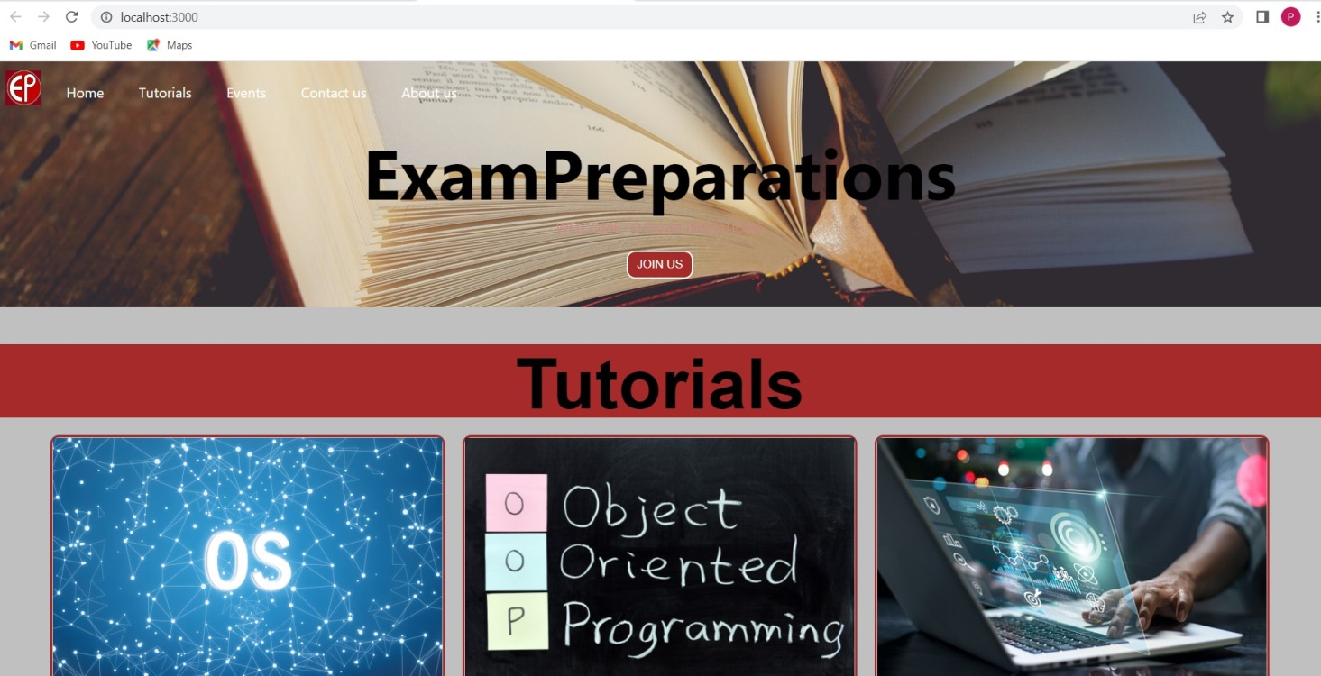

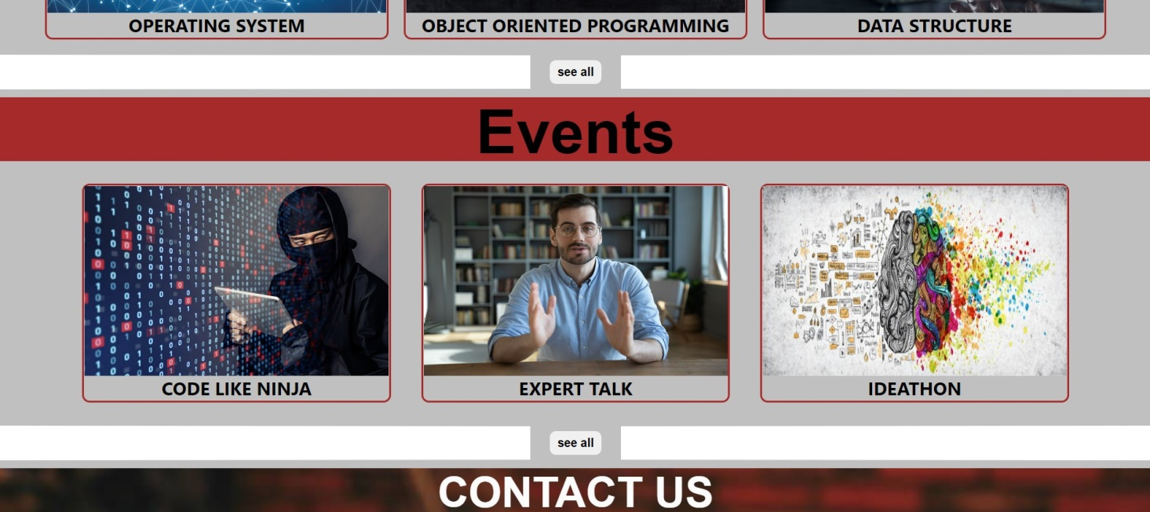





**INNOVATIONS IN PROJECT:**

.

Following are the new innovations that can be added in this system to make it more effective:

* We can make website more lucrative
* We can provide video assistance as well

.

* Also we sort the tutorials according to courses and departments.

**CONCLUSION:**

ExamPreparations.com is the tutorials website which is both simple and user friendly. It is especially designed in accordance with PTU syllabus. With this website students can easily get study material for their exams.

**REFERENCES:**

Project learning: Solitaire Infosys.

Images: Unsplash and Istock.

Writing Material: Wikipedia.