Department of Computer Science and Engineering

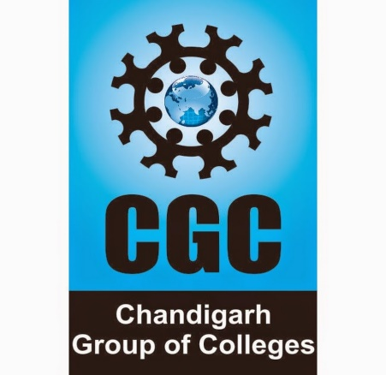

*CGC College of Engineering*

*Landran -Mohali, 140307*

**PROJECT SYNOPSIS**

**ON**

TUTORIALS WEBSITE



Submitted By: Submitted To:

**Preekshit Dahiya and Yashwani Mr Shivam Thakur.**

**2019214 2019256 Trainer**

**INDEX**

|  |  |  |
| --- | --- | --- |
| S.NO. | CONTENTS | PAGE NO. |
| 1. | TITLE AND OBJECTIVE. | 3. |
| 2. | INTRODUCTION OF THE PROJECT. | 4. |
| 3. | FEASIBILITY STUDY. | 5. |
| 4. | FEATURES AND  SCOPE OF THE PROJECT. | 6. |
| 5. | TECHNOLOGY USED. | 7. |
| 6. | HARDWARE AND SOFTWARE SPECIFICATIONS. | 8. |
| 7. | INNOVATIONS IN PROJECT. | 9. |
| 8. | CONCLUSION. | 9. |
| 9. | REFERENCES. | 10. |

**TITLE:**

**Tutorials website titled as**

**ExamPreparations.com**

**OBJECTIVE:**

This project is made with the objective to provide the tutorials for each subject of each semester in I K Gujral Punjab technical University. With this system students can easily learn and get study material from this website according to their subjects

**INTRODUCTION:**

ExamPreparations.com is a website that can be used to provide tutorials to students of I K Gujral Punjab Technical University.

This system contains tutorials of different subject which make it easy for students to get the study material for their examinations.

This system also provides exciting events like ideathon, code like ninja, expert talks etc.

Further it also gives the forms to contact and join us.

This software is built to eliminate and in some cases reduce the hardships faced by the students in getting study material for their exam preparations. Moreover, this system can be updated according to the need of students and syllabus of university.

**FEASIBILITY STUDY:**

**FEATURES and SCOPE of the PROJECT:**

The main features of this project are as follows:

->Simple and one click navigation menu.

-> Five sections home page -navbar, tutorials, events, contact form,

footer.

-> Forms to contact and join us.

The scope of this project is as follows:

* Can give study assistance for exam preparations
* Provide Study material according to subjects
* Specially designed for I K Gujral Punjab Technical University students
* Easy and compatible to use.
* User friendly interface.

**TECHNOLOGY USED:**

REACT JS

In this project, react js which is a free and open-source front-end JavaScript library is used to develop user-interface. React Js features like importing and exporting files, routing etc. To design the ui of this project, further CSS concepts are used.

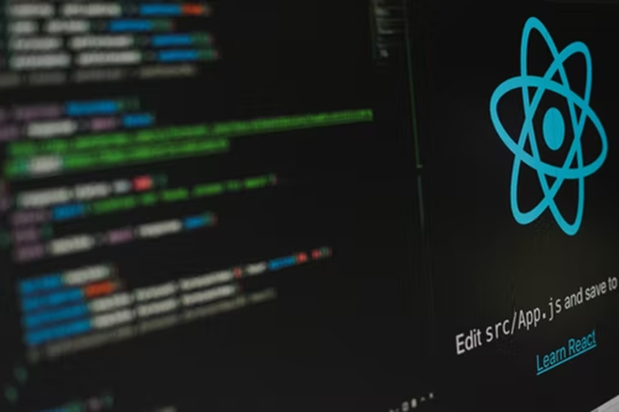

**HARDWARE AND SOFTWARE SPECIFICATIONS:**

**Hardware:**

**->**Processor: 10th Gen Intel core i5.

**->**Processor speed: 2.42GHz.

**->**Windows 10 or above.

**->**RAM: 2.00GB or above.

**->**System type: 64-bit operating system.

**->**Internet connection: any type.

**Software:**

**->** Browser: Google Chrome.

**->**Operating system: Run in every OS.

**->** Front End: React JS.

**->** Back End: Not Used.

**->** IDE used: Visual Studio Code.

**->**Runs project on: NPM (Node Package Manager) package manager

for the Node JavaScript platform.

**INNOVATIONS IN PROJECT:**

.

Following are the new innovations that can be added in this system to make it more effective:

* We can make website more lucrative
* We can provide video assistance as well

.

* Also we sort the tutorials according to courses and departments.

**CONCLUSION:**

ExamPreparations.com is the tutorials website which is both simple and user friendly. It is especially designed in accordance with PTU syllabus. With this website students can easily get study material for their exams.

**REFERENCES:**

Project learning: Solitaire Infosys.

Images: Unsplash and Istock.

Material: Wikkipedia.