tCompile – used to compile la basic programs

tCompile -cf T24.properties <routine name>.b

The syntax for using tCompile is-

**tCompile [-options] [dirName] filelist**

There are three options available–cf,-f,-h

-cf is used to specify a configuration file for the compilation

-f specifies a list of files to compile

-h is used to get help on the command.

tCompile D:\TAFJWORSKSHOP\T24\LOCAL.BP -It will compiles all the basic programs in the folder.

tRun – execute the compiled programs

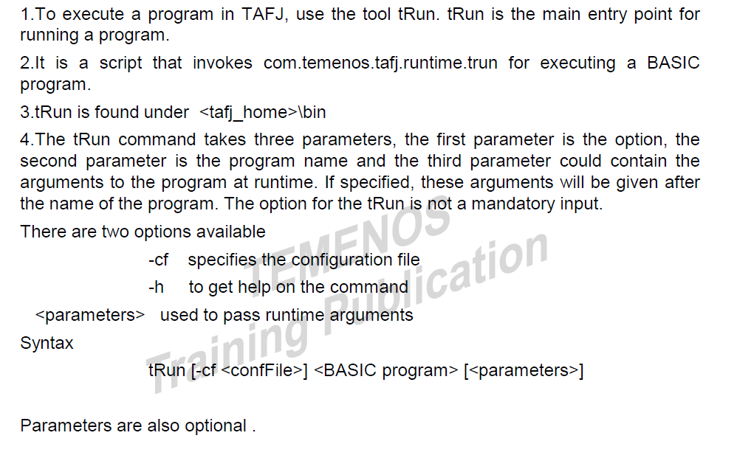

TAFJ tools:

tDiag – Displays the environment settings for tafj project like jdiag

tShow – Displays the compilation details like jshow

tShowCheck – Displays compilation status for a set of basic routines.



C:/>tShowCheck -s D:\T24_BP -p D:\T24_Precompiled\R10GA.jar -r d:\Report

tCrypt – encrypt the password

tFindDevice – get info abt the system printers.

TAFJ Disttribution Tools:

tComponentSplitter – Used to componentisation of class files.

tIntegrate – Compile all the basic files to create jar file for all classes and a jar file for all inserts

tMerge – Merge precompiled jar files with patch jar.

tPackager



1st syntax- encrypts all the class files.

2nd syntax – packages all the class files into jar file specified in the path

3rd syntax – encrypts all the class files and also packaging the class into jar.

If you got the below error while packaging in encrypt mode. Then you have to change the below

‘**temn.tafj.runtime.custom.classloader=jencryptloader’**.



We should know what is tComponentSplitter, tIntegrate

tRun.bat START.TSM or tRun.bat START.TSM -DEBUG to start the TSM

tRun.bat Tsa 2 for start it in single agent.

Multiple area conf in TAFJ

