A Real Time and Interactive Dashboard in Tourism Industry

Design Document

By

Junyu Zhou 592115508

Yawei Li 592115518

Department of Software Engineering,

College of Arts, Media and Technology,

ChiangMai University

Project Advisor



Table of Contents

Table of Contents 2

1. Document History 3

2. Introduction 5

2.1 purpose 5

2.2 Intended Audience and Reading Suggestions 5

2.3 Project Scope 6

2.4 Acronyms 6

3. System Architecture 7

4. Detail Design (UML Diagram) 8

4.1 Development Diagram 8

4.2 ER Diagram 9

4.3 Sequence Diagram 10

5. User Interface Design 11

5.1 Web Application UI 11

W-UI01-Login 11

W-UI02-View Summary & W-UI03-Logout 12

# 1. Document History

|  |  |  |  |  |  |
| --- | --- | --- | --- | --- | --- |
| History | Status | Date | Viewable | Editable | Responsible |
| Project-DesignDocument_v1.docx  Create:  - Document History  - Introduction  - System Architecture  - Detail Design  - User Interface Design | Draft | 17, July 2019 | ZJY, LYW,  AJP | ZJY, LYW | ZJY,  LYW |
| Project-DesignDocument_v2.docx  Modify: | Final | 7, Aug 2019 | ZJY, LYW,  AJP | ZJY, LYW | ZJY,  LYW |
| - Detail Design  - User Interface Design |  |  |  |  |  |

ZJY = Junyu Zhou

LYW = Yawei Li

AJP = Dr. Pree Thiengburanathum

# 2. Introduction

## 2.1 purpose

The purpose of the software design document (SDD) is to design the detailed structure of the system according with the software requirement specification (SRS). It intended to help stakeholders in the project understands the detailed design of the system using class diagrams, sequence diagrams, and user interface designs.

## 2.2 Intended Audience and Reading Suggestions

**2.2.1 Intended Audience**

This software requirement specification will benefit to audiences as followed:

**Development Team**

The software requirement specification will help everyone in developer team has the same understanding or overall scope of the project.

The software requirement specification will help the developer to verify and validate the software product that match with the requirements in this document or not.

The software requirement specification will help developers to develop project more efficiency.

The software requirement specification will be required when some changing occur. Developer will know where get effect and know where to change.

**User**

The software requirement specification will help the user to know the process of the software product.

User can check that the requirements in software requirement specification match with their requirement or not.

The software requirement specification can help the user to discuss with developers easier.

## 2.3 Project Scope

A real time and interactive dashboard in tourism industry is a web-based application. It is for decision maker to do the easy statistics of mess data in a real time way. For decision maker to manage and keep tracks all the data.

## 2.4 Acronyms

SRS = Software Requirement Specification SDD Software Design Document  
UI = User Interface

DD = Development Diagram

# 3. System Architecture

The system consists of clients and server. For the client, there is a part, the web application. The web application that used by users will send and receive data from web-server in JSON format. The server itself store and retrieve data from the database.

We are using pusher components, which could transfer the data two-way duplex.

# 4. Detail Design (UML Diagram)

## 4.1 Development Diagram

## 4.3 Sequence Diagram

# 5. User Interface Design

## Web Application UI

## W-UI01-Login

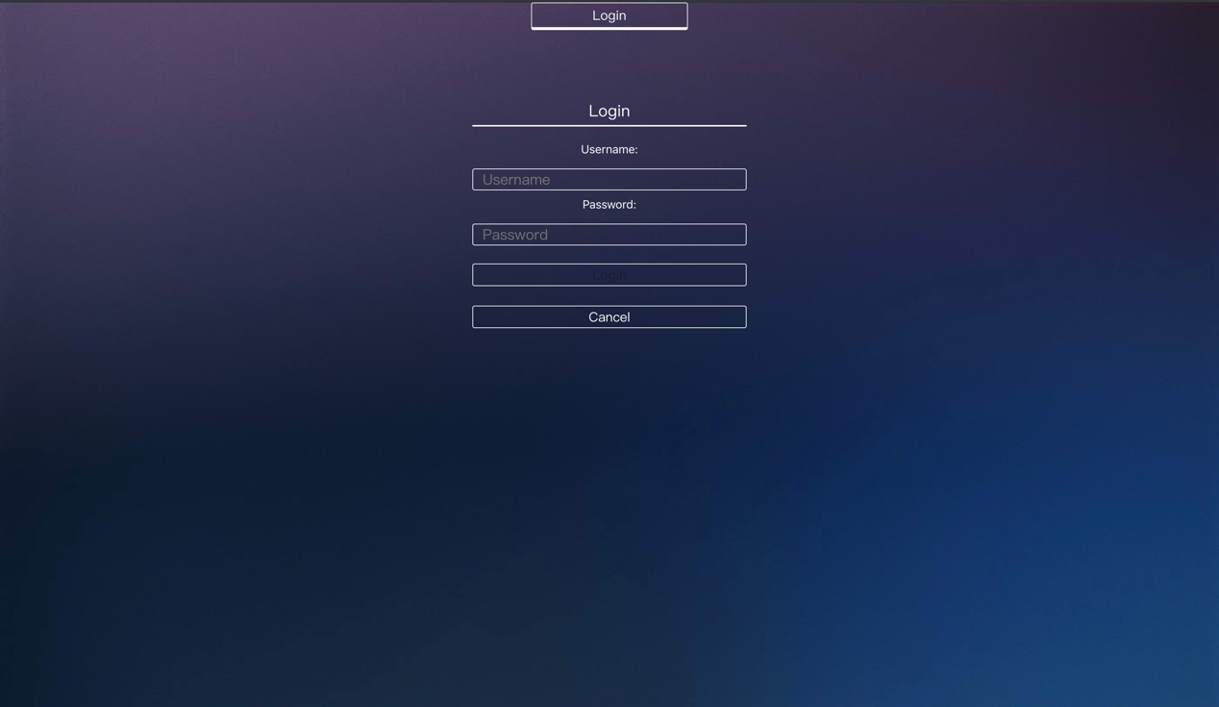

This page is using for decision maker to login to dashboard, it consists of:

1. Text flied used for input username and password.
2. “Login” button for login to dashboard.
3. “Cancel” button for going to previous page.

## W-UI02-View Summary & W-UI03-Logout

This page displays data visualization summaries after decision maker login successful, it consist of:

1. “Summary” button for showing all data visualization summaries which have:

1.1 All the summary sparkline chart

1.2 Positive comments rate line chart

1.3 Word frequency bar chart

1.4 Number of comments bar chart

* 1. Types of comments stacked column chart

1. “Word-Cloud” button for showing the word cloud.
2. “Heatmap” button for showing the heatmap.
3. “Logout” button for decision maker to logout from dashboard.