PROJECT CHARTER
NegotiateIQ
An Agentic AI Procurement Negotiation Tool
Preet Patel | M.S. Engineering Management | USC 2026

1. The Problem
Procurement teams spend a significant amount of time on repetitive, low-value negotiation work. Every week, buyers manually review supplier data, think through what lever to pull, decide on a tone, and write outreach emails from scratch. For a team managing hundreds of suppliers, this is exhausting and inconsistent.

The core tension in procurement:
Buyers have the most impact when they are focused on strategic supplier relationships. But the majority of their time gets consumed by transactional tasks that are repetitive, rule-driven, and honestly, automatable.

NegotiateIQ was built to fix that.

2. Two Worlds of Procurement
Not all supplier relationships are the same. Before building anything, I mapped the problem space into two distinct categories, because they require very different approaches.

 | Transactional Procurement | Strategic Procurement
Supplier Tier | B and C tier (routine, replaceable) | A tier (critical, relationship-driven)
Spend Level | Low to mid spend per supplier | High spend, often sole-source
Decision Type | Repetitive, rule-based, price-sensitive | Complex, strategic, relationship-sensitive
Human Role | Minimal oversight needed | Full buyer involvement required
NegotiateIQ Role | Automates outreach and drafts messages | Flags for human review and escalates

NegotiateIQ focuses entirely on the transactional tier. The goal is not to replace the buyer, but to free them up. When the repetitive B and C tier work is automated, buyers can spend their energy where it actually matters: on the strategic relationships that drive the biggest business outcomes.

3. The Solution
NegotiateIQ is an agentic AI procurement tool I conceptualized and built from scratch. The idea came from a gap I noticed in how procurement teams actually spend their time. The pipeline works in six stages and is designed around a core principle of bounded autonomy: the system acts independently on routine decisions, and escalates anything that requires human judgment.

End-to-End Pipeline
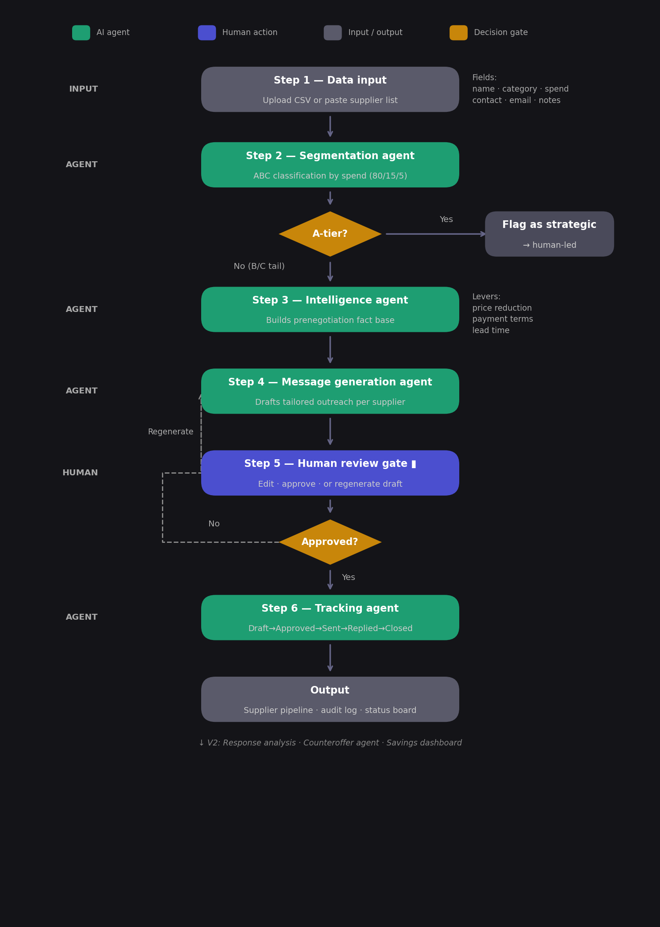

How Each Agent Works
- Intelligence Agent: For every B and C tier supplier, the agent analyzes spend, category, country, sole-source status, and the last negotiation date. It identifies the single best negotiation lever (price reduction, payment terms, or lead time) and recommends a negotiation tone from a defined matrix. No generic advice.
- Message Generation Agent: Using the intelligence output, this agent drafts a personalized outreach email. It applies a tone matrix based on supplier risk profile and writes in plain language, under 200 words, without jargon or templates that sound robotic.
- Human Review Layer: Every message requires buyer approval before anything is sent. The buyer can approve, request a revision with a reason, or escalate. This is where bounded autonomy matters most.
- Tracking Agent: Monitors pipeline health across all active negotiations. Surfaces KPIs like messages sent, replies received, estimated savings, and stale negotiations that need follow-up.

4. Project Objectives
- Reduce the time buyers spend on repetitive negotiation prep for transactional suppliers
- Improve consistency of supplier outreach across the team
- Surface data-driven savings opportunities that might otherwise be missed
- Keep humans in control of every message that leaves the building
- Demonstrate a practical, deployable application of agentic AI in a real supply chain context

5. Scope

In Scope
- Supplier data ingestion via CSV upload with a downloadable template
- Automatic ABC tier classification for all uploaded suppliers
- AI-powered pre-negotiation intelligence for B and C tier suppliers
- Automated negotiation email drafting with tone and lever logic
- Human approval workflow with revision and escalation options
- Pipeline tracking dashboard with negotiation KPIs

Out of Scope (for now)
- Direct email sending integration (currently draft and approve only)
- CRM or ERP integration
- A tier strategic supplier management

6. Tech Stack
Layer | Technology
Frontend | Python, Streamlit
AI / LLM | Anthropic Claude API, Groq (Llama 3), etc.
Agent Pipeline | Custom multi-agent architecture (Python)
Data Processing | Pandas, CSV
Deployment | Streamlit Cloud
Reporting | Plotly, PDF export via fpdf2

7. Current Status
Status: Scope Phase

The core pipeline architecture is in place and the overall flow is working end-to-end. I am currently in the scope phase, mapping out what each agent needs to do in more detail before going deeper into development.

Right now I am working through the scope of each agent, figuring out what data each one needs, how the models should be structured, and what the decision logic looks like in practice. This phase is about making sure the foundation is solid before building further.

NegotiateIQ | Preet Patel | USC 2026 | preetcpa@usc.edu

