ReactJS Installation
Before installing ReactJS, make sure these are installed on your system:
• Node.js
• npm (comes with Node.js)
Node js website : https://nodejs.org/en/download
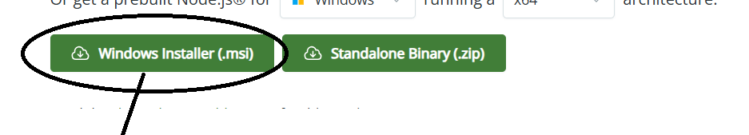
After goto Drive and get path
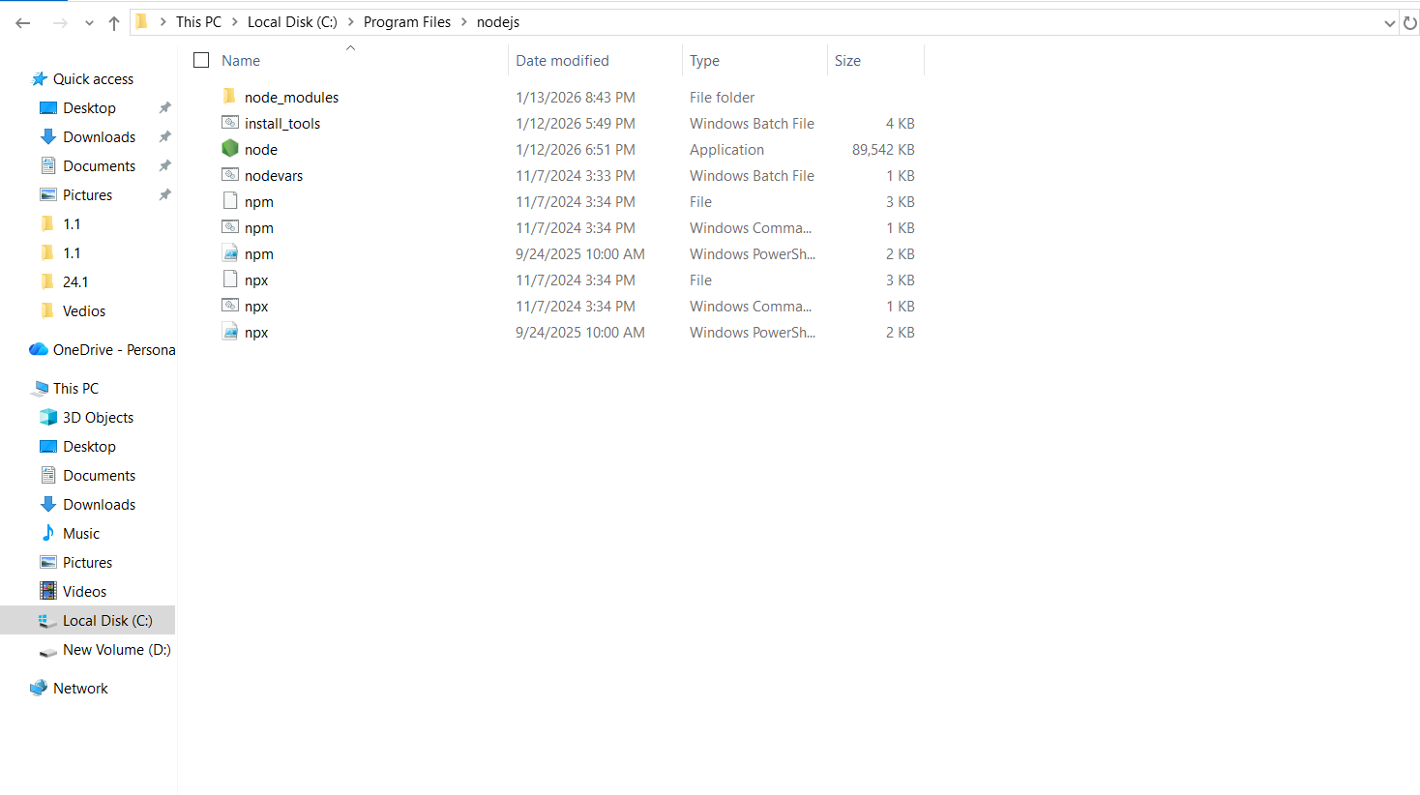
Then take the path
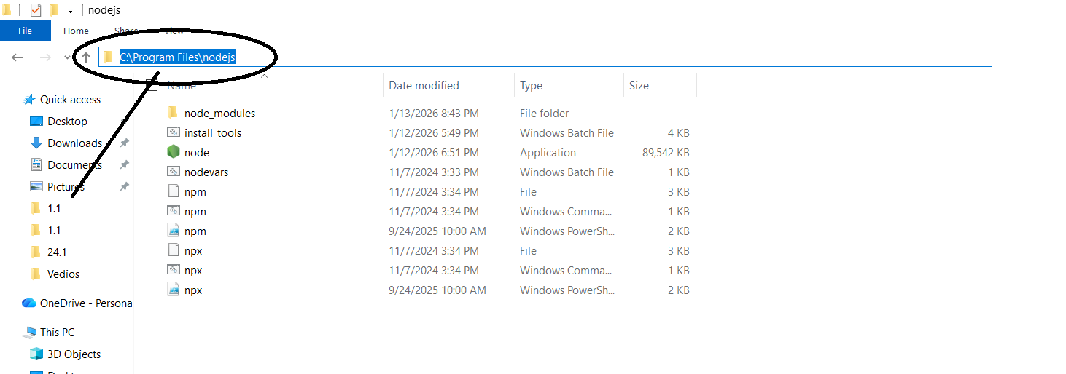
Then add this path in (edit the system environment variables)
Open window
Type : edit the system environment variables
Select this one
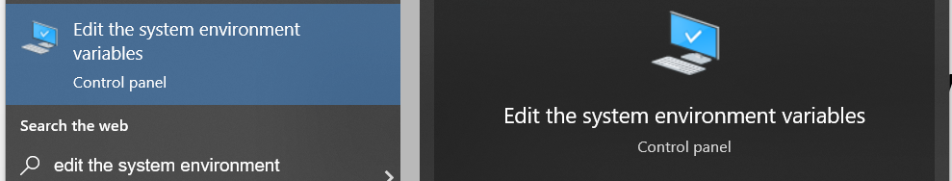
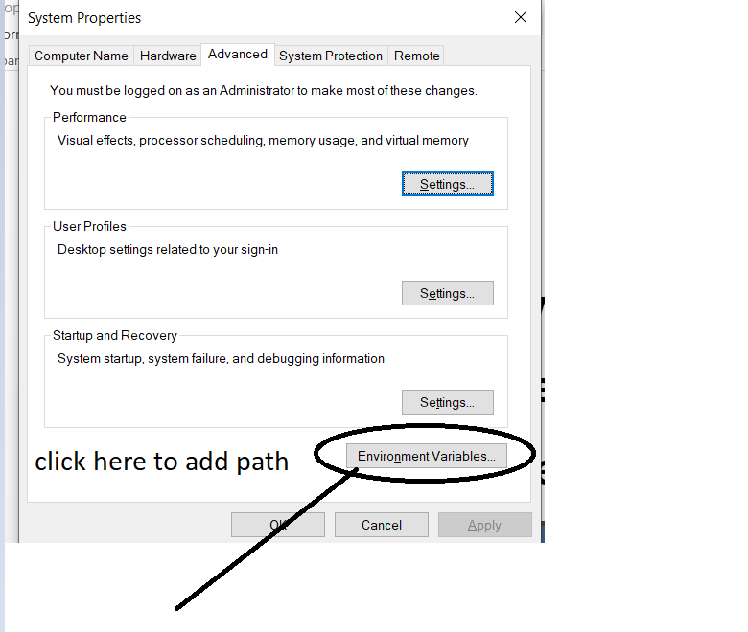
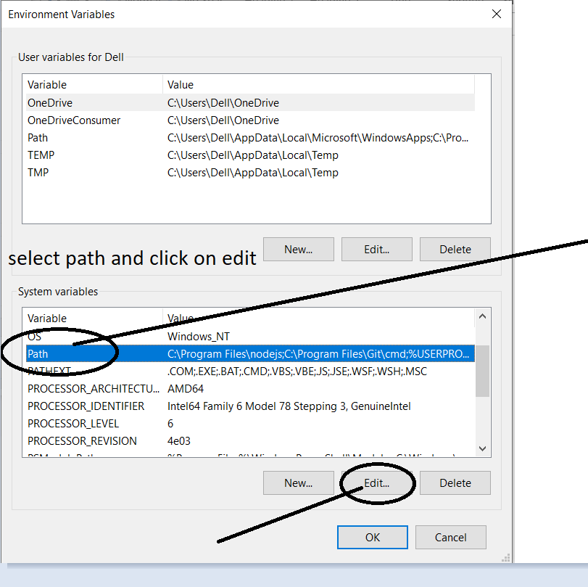
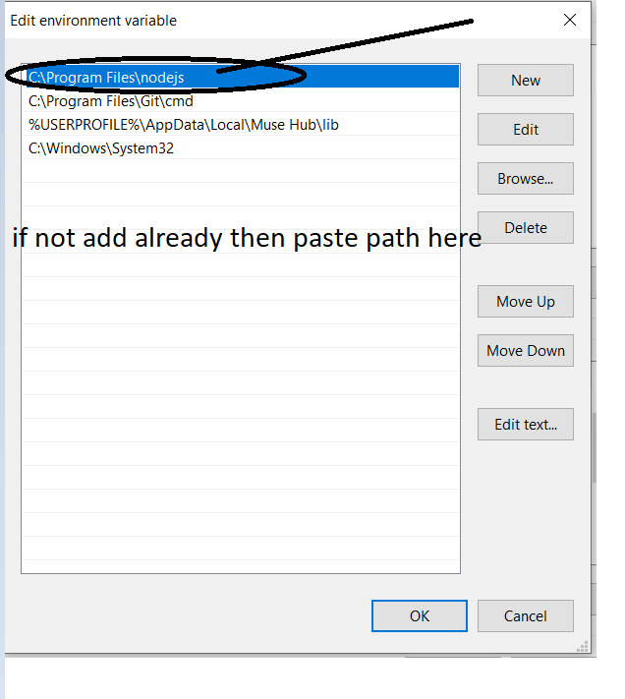

2. Create a React Project
npx create-react-app my-app
Move into project folder: cd my-react-app
Install dependencies: npm install
Start development server: npm run dev

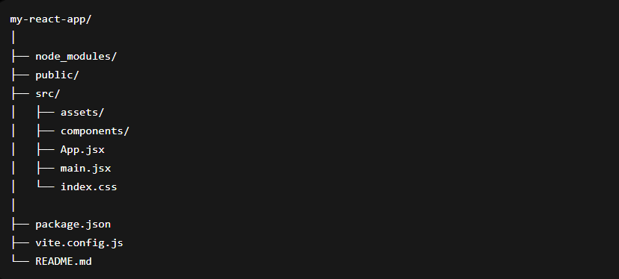
Important Folders and Their Uses
- node_modules/

Use:
- Stores all installed packages and dependencies.
- Automatically created after npm install.

Example:
Contains React library, Vite packages, etc.

public/

Use:
- Stores static files.
- Files here are directly accessible by browser.

Examples:
- Images
- Icons
- favicon
- Static JSON files
- src/

Use:
- Main working directory of React application.
- Contains all components and application logic.
This is the most important folder.

main.jsx

Use:
- Entry point of React app.
- Connects React app to HTML page.
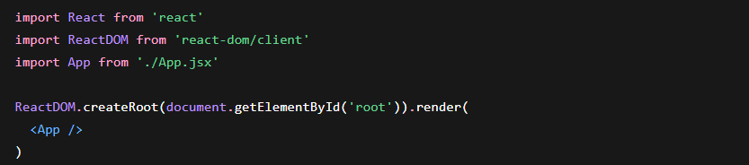

App.jsx

Use:
- Main component of application.
- Used to design UI and call other components.
