What are Hooks in React JS?
Hooks are special functions in React that let you use state, lifecycle features, and other React features inside functional components.
Before Hooks, state and lifecycle methods were mainly used in class components. React introduced Hooks in React 16.8 so functional components could do the same things more easily.

Why use Hooks?
- Manage state in functional components.
- Handle side effects (API calls, timers, etc.).
- Improve code reusability.
- Make code cleaner and easier to understand.
1. useState Hook
useState is used to store and update data (state) in a component.
Example: Counter
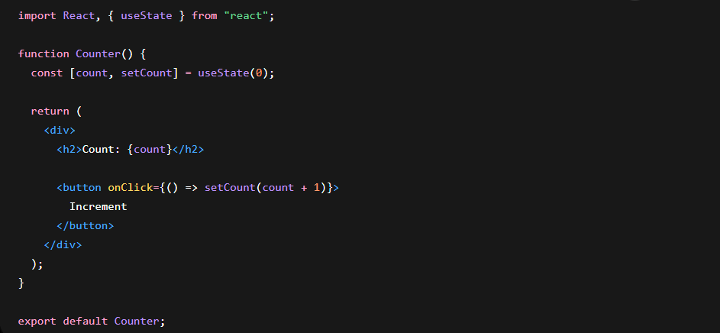
How it works
• count → current value
• setCount() → updates value
• 0 → initial value

2. useEffect Hook
Used for:
- API calls
- Timers
- DOM updates
- Side effects
Example
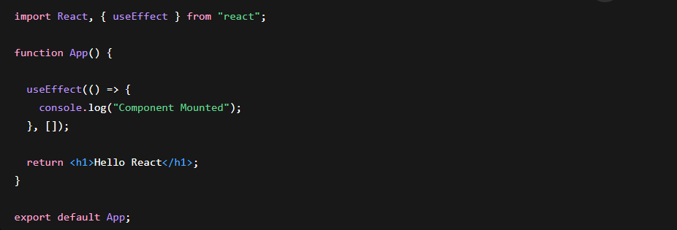
Dependency Array
Run once
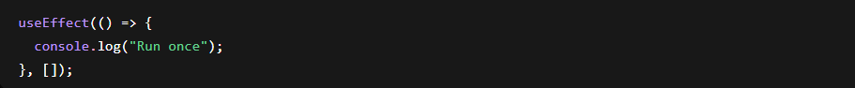
Run every render
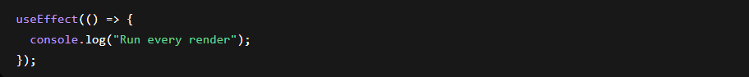
Run when count changes

React Function Component Lifecycle
A Lifecycle means the different stages a component goes through from creation to removal.
Just like a human has stages (Birth → Growth → Death), a React component also has stages:
• Mounting → Component is created and added to the screen.
• Updating → Component re-renders when state or props change.
• Unmounting → Component is removed from the screen.
In Class Components, React provides lifecycle methods such as:
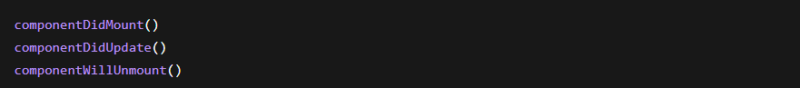
But in Function Components, these lifecycle methods are handled using the useEffect Hook.
1. Mounting Phase
Mounting occurs when a component is rendered for the first time and added to the DOM.
Common use cases:
- Fetch API data
- Display welcome messages
- Start timers
- Initialize libraries
In Function Components, mounting is handled by:
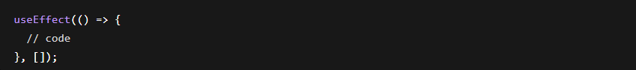
The empty dependency array [] tells React to run the code only once after the first render.
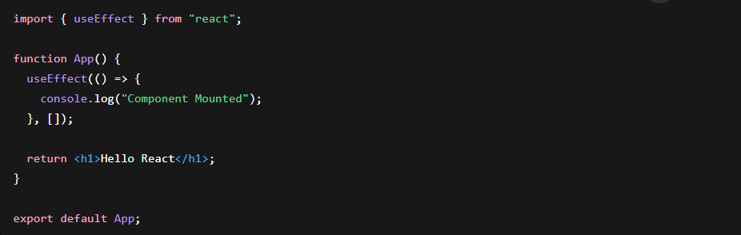
2. Updating Phase
Updating occurs whenever:
- State changes
- Props change
React re-renders the component and updates the UI.
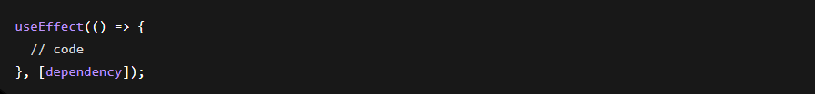
The effect runs whenever the dependency changes.
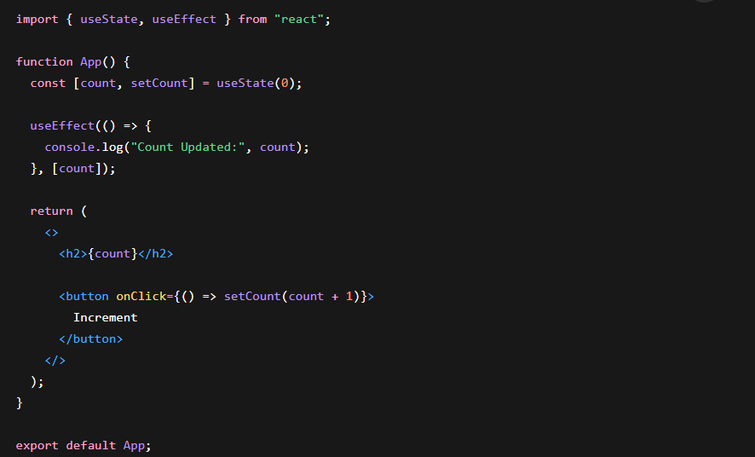
Runs every time count changes.
3. Unmounting Phase
Unmounting occurs when a component is removed from the DOM.
Common use cases:
- Clear timers
- Remove event listeners
- Cancel API requests
- Cleanup resources
In Function Components, React uses a cleanup function.
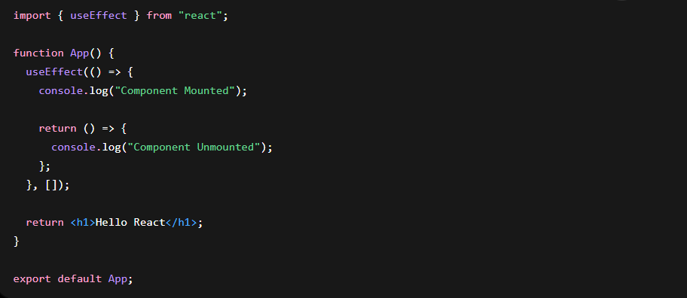

3. useContext Hook
Used to share data without passing props manually through multiple components.
Create Context
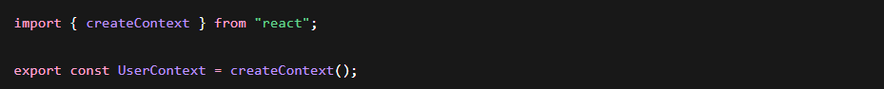
Provide Data
Consume Data
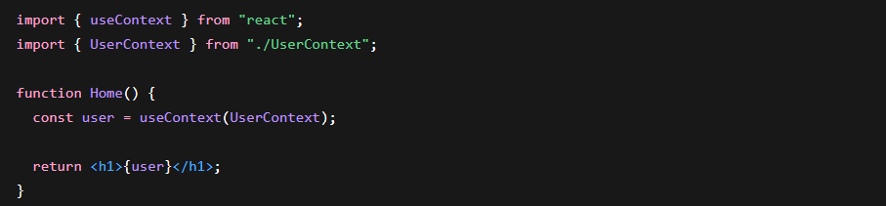
4. useRef Hook
Used to:
- Access DOM elements
- Store values without re-rendering
Example
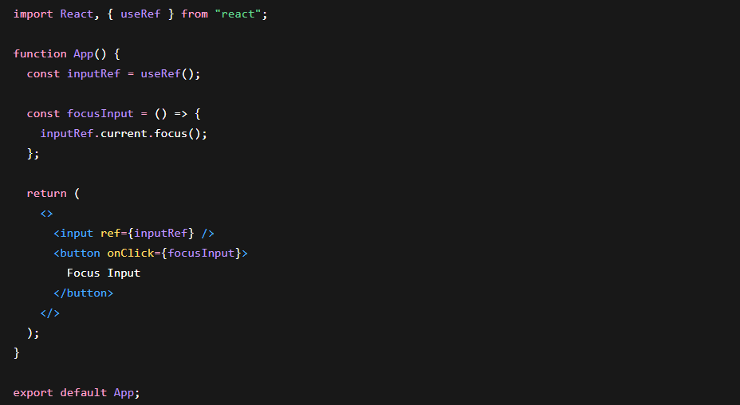

Custom Hook
You can create your own hook.
Example
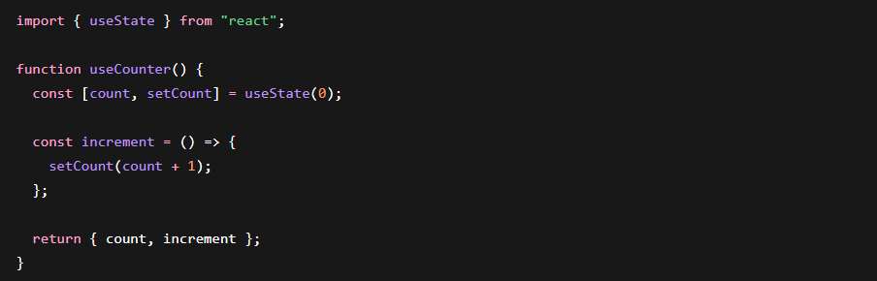
Use Custom Hook
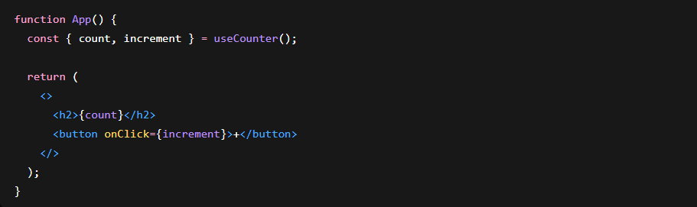
Most Important Hooks for Interviews
