**Data Validation**

* Used to control what a user can fill in a cell.
* Can decide what type of values can be entered.
* Data validation helps users type in only valid data.
* If an invalid data is entered, an error message will be displayed.

The figure below shows an excel sheet with a bunch of questions.

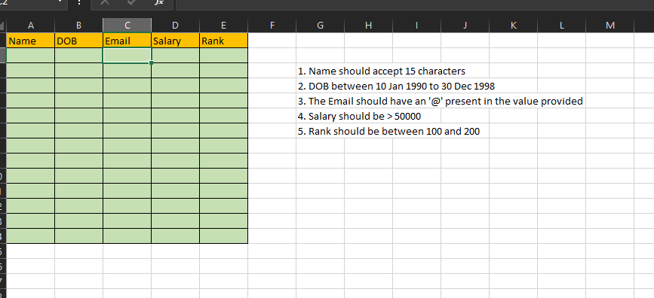

For question 1, first select the cells under the Name header where we want the data validated. For that, we can go to Data > data validation which will open a window like shown below,

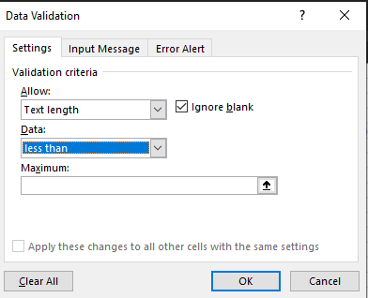

Like we can see in the Settings tab, allow ‘text length; data ‘less than’; maximum ‘15’.

For question 2, we follow the same procedure. The following image shows how to do it.

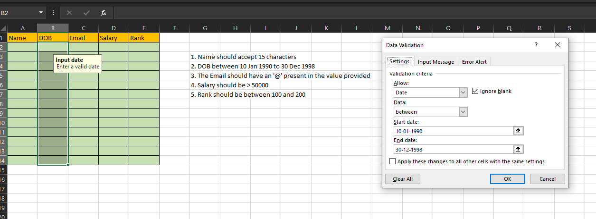

Question 3,

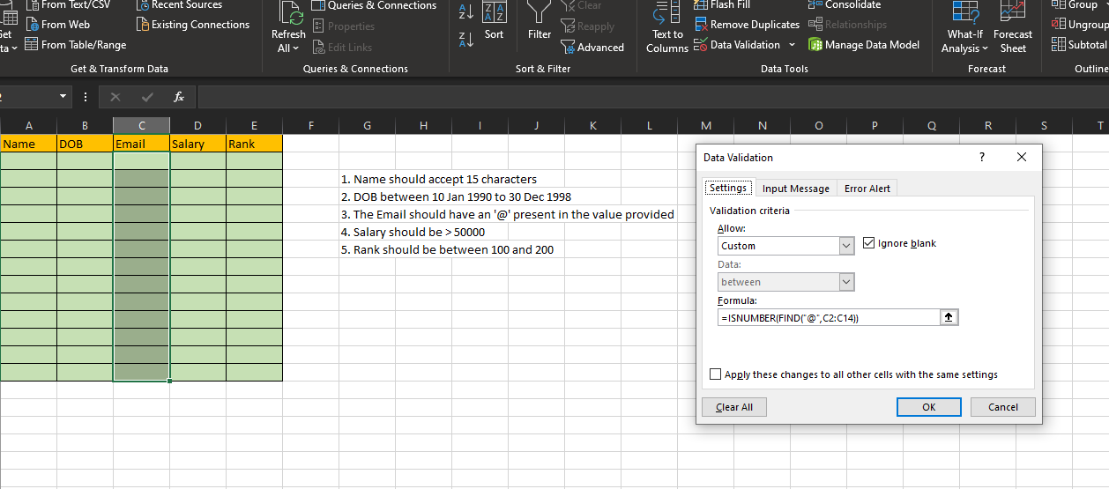



Question 4,

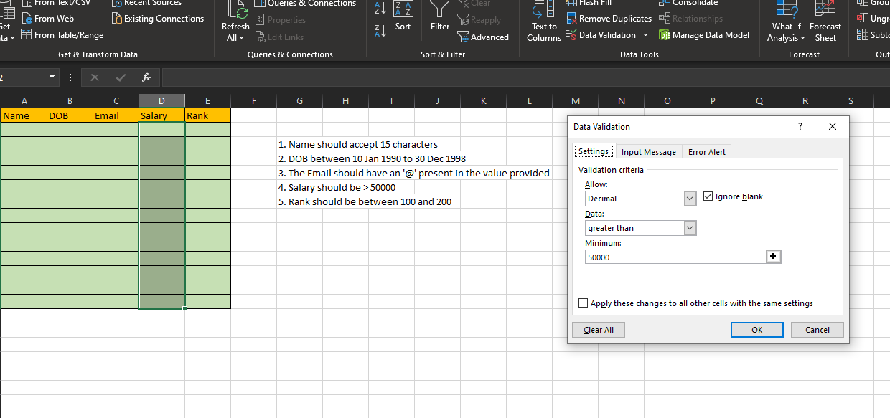

Question 5,

