**Sort and filter**

The picture below shows how I have filtered the dataset from the latest date to the oldest.

The steps involved were: Copy the header part of the dataset/data frame (date listed, area etc) and click on Sort and filter under the Home section. Then, we can select the drop-down menu and select the option from newest to oldest.

What I have done here is that I have copied the data frame into a separate space. We can do that by going to the **Data > Advanced > Copy to another location**

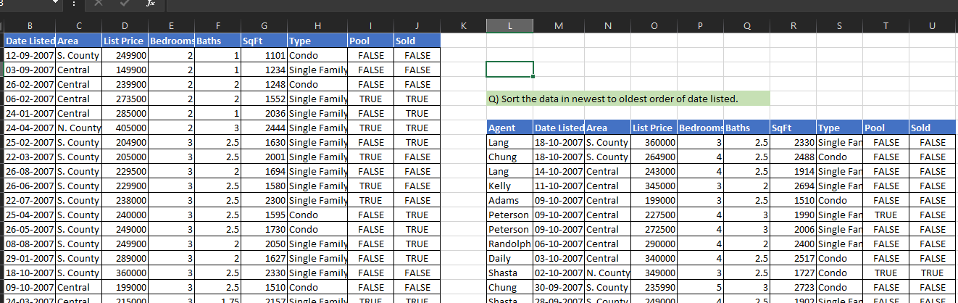

In the following picture, I have sorted the data in ascending order of Area and descending order of Agent name.

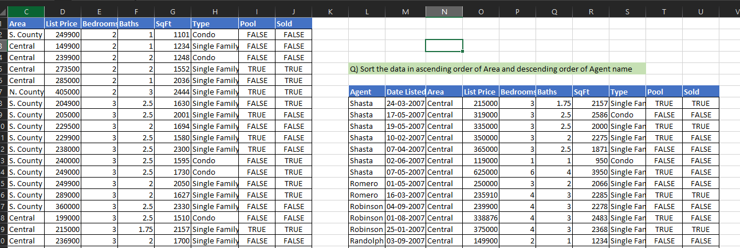

In the picture below, I have sorted the area in the order: S. County, Central and N. County

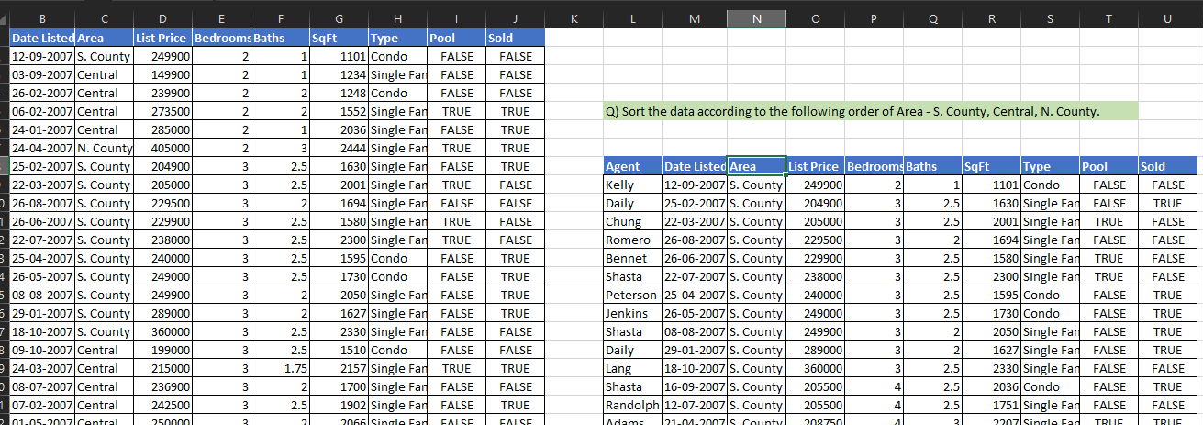

To do the sorting, we choose the column > sort > custom sort and then use custom order for the desired order and click OK.

