Node 1:(Chat Trigger)

Click on +(Add a trigger) button to create the flow

Click on chat on search box then select chat--->On new Chat event

Click on testchat or close the chat window (you will see chat trigger is created on flow page)

Node 2:(AI Agent)

Click on +(Add a trigger) button

Click on chat on search box then select AI Agent

Double click on AI Agent and Select source for prompt as the option Connected Chat Trigger Node

select system message and paste the prompt given in the "Test Case Generator -ICEPOT-Prompt" file

Node 3:

Under AI Agent you can find '+' symbol to add the model component .Click on + and add Groq Chat Model

Parameters -->Credentials to connect with --Click the create new credential-->Add the Api key and click save .

Choose the model like llama-3.3-70b-versatile ., etc

Node 4:(Fallback model)

Double click on AI Agent and Toggle on Enable Fallback Model now you will find fallback option under AI Agent

Click on + and add Groq Chat Model

Parameters -->Credentials to connect with --Click the create new credential-->Add the Api key and click save .

Choose the model like llama-3.3-70b-versatile ., etc

Double click on Chat Trigger component and under options click Add field option and select Allow file uploads then enable the Allow File Uploads then you will find attachment option in chat window

Node 5:
Under AI Agent you can find '+' symbol to add the memory .Click on + and add Simple Memory

Open Chat and give the userstory in chat window

Start generating the testcases with memory and fallback models

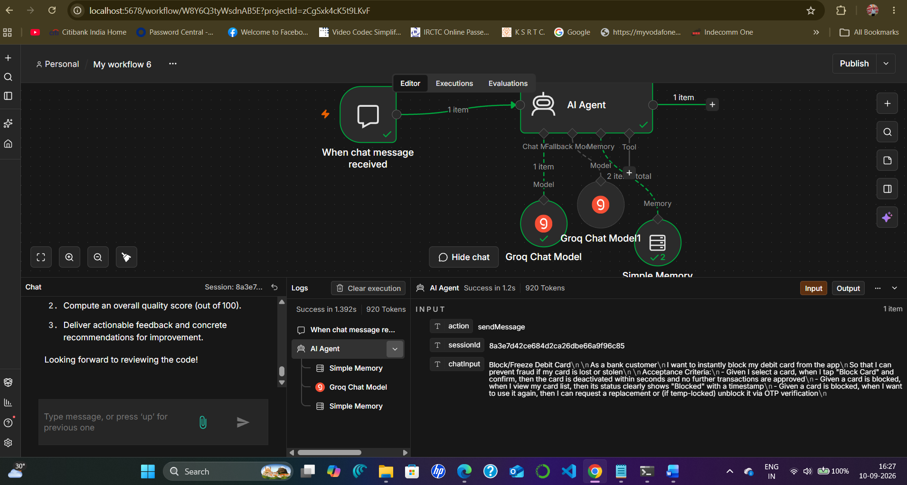

Steps to Create GitHub code reviewer agent :

Original URL : https://github.com/testleaftrainings/Sel_May_2026/blob/main/Week5/Day2/LearnDragAndDrop.java

Changed URL : https://raw.githubusercontent.com/testleaftrainings/Sel_May_2026/main/Week5/Day2/LearnDragAndDrop.java

Component 1:

Add the initial trigger component On Form Submission

Double click and open the component

Fill or choose the below options
Authentication --None
Form Title --AI GitHub Code Reviewer

Form Description---Enter a GitHub Repository or File URL. The AI will review the source code and generate a detailed code review report.

Click Add Form Element

Label-GitHub File URL
Element Type- Text Input
Select the placeholder and update the GitHub URL

On Respond When---"Choose Form is submitted"

Component 2:

Add HTTP Request

Double click and open the component

Method should be Get

Under URL option paste the Changed GitHub URL

Authentication should be none

Component 3:

Add Basic LLM Chain

Double click and open the component

Source for Prompt (User Message) as Define Below from dropdown

On Prompt (User Message)--Mouse hover and select expression

Add the prompt (Prompt Template file) in the placeholder provided on prompt(user message)

Component 4:Groq Model

Under Basic LLM Chain you can find '+' symbol to add the model component .Click on + and add Groq Chat Model

Double click and open the component

Parameters -->Credentials to connect with --Click the create new credential-->Add the Api key and click save .

Choose the model like llama-3.3-70b-versatile ., etc

Component 5:Send an Email

Before setup the component you need to have a setup your gmail account with password:

Password is key created from google account to connect (not a normal password which is used by users)

Steps to create the password for gmail setup

https://myaccount.google.com/security

enable 2-Step Verification If it's not already enabled.

After enabling 2-Step Verification, search for App passwords or open the below link

https://myaccount.google.com/apppasswords

Enter App Name as "n8n" and app password will be created .Make a note of it

Now go back and open the flow & Double click and open the component (Send an Email)

Under parameters

Credential to connect with Click new credentials

Enter user--Your mail id
Password --Key created from google account just now
Host--smtp.gmail.com

Make sure Port should be 465 and SSL/TLS should be enabled
Click Save button

Operation --->Send

Enter the from and to emails

Subject :Userstory Review

Email format--Text

Text ---{{ $json.text }}

Component 5:Convert to File and select Convert to HTML

Double click and open the component
Operation -->Convert to HTML

