**Objective:**

1. Create a popularity based recommender system at a genre level. User will input a genre (g), minimum ratings threshold (t) for a movie and no. of recommendations(N) for which it should be recommended top N movies which are most popular within that genre (g) ordered by ratings in descending order where each movie has at least (t) reviews.

Example: Mid Program Project

© B r a i n 4 c e E d u c a t i o n S o l u t i o n s P v t . L t d Page 2

Input:

Genre (g) : Comedy

Minimum reviews threshold (t) : 100

Num recommendations (N) : 5

Output:

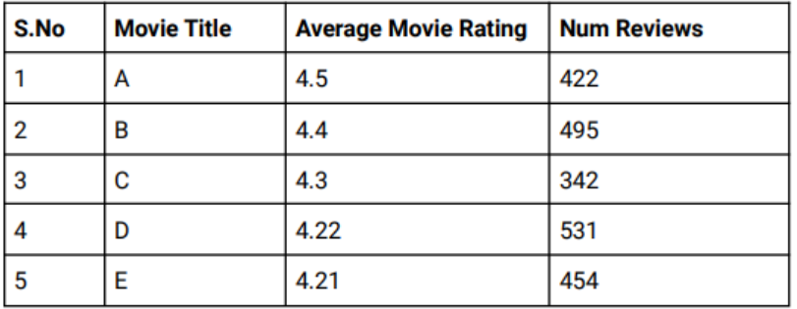

1. Create a content based recommender system which recommends top N movies

based on similar movie(m) genres.

Example:

Input:

Movie Title (t) : Toy Story

Num recommendations (N) : 5

Output:

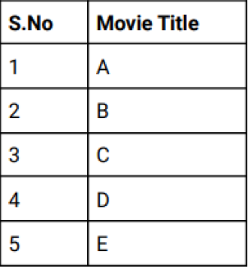

1. Create a collaborative based recommender system which recommends top N

movies based on “K” similar users for a target user “u”

Example:

Input:

UserID : 1

Num recommendations(N) : 5

Threshold for similar users (k): 100

Output:

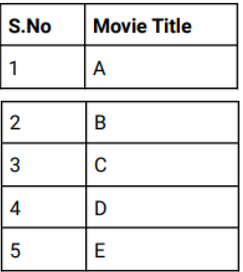

Data Description:

The data consists of 105339 ratings applied over 10329 movies. The average rating is

3.5 and minimum and maximum rating is 0.5 and 5 respectively. There are 668 users

who have given their ratings for 149532 movies.

There are two data files which are provided:

Movies.csv

* movieId: ID assigned to a movie
* title: Title of a movie
* genres: pipe separated list of movie genres.

Ratings.csv

* userId: ID assigned to a user
* movieId: ID assigned to a movie
* rating: rating by a user to a movie
* Timestamp: time at which the rating was provided.

Steps and Tasks

1. Import libraries and load dataset.
2. Exploratory Data Analysis including:

Understanding of distribution of the features available

Finding unique users and movies

Average rating and Total movies at genre level.

Unique genres considered.

3. Design the 3 different types of recommendation modules as mentioned in

4.Additional/Optional: Create a GUI interface using Python libraries (ipywidgets

etc.) to play around with the recommendation modules.