Hospital Data Analysis Project
Project Overview
This project analyzes healthcare data from the HCDataSet (Kaggle) to identify key performance indicators and trends in hospital operations. The analysis focuses on readmission rates, length of stay, emergency department throughput, mortality rates, ambulatory visits, and blood pressure control metrics.
1.Hospital Readmission Rate Analysis
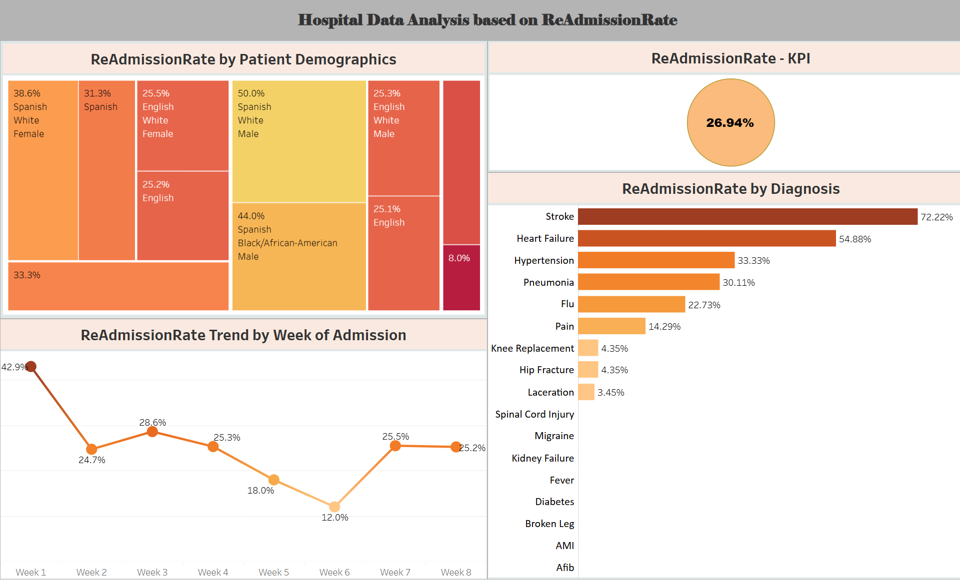
Key Findings:
- Overall Readmission Rate: 26.94%
- Highest Risk Diagnosis: Stroke patients show the highest readmission rate at 72.22%, followed by Heart Failure at 54.88%
- Weekly Trend Analysis: Readmission rates peaked in Week 1 at 42.9% and dropped to the lowest point of 12.0% in Week 6
Demographic Insights:
- Spanish-speaking White males showed a 50% readmission rate
- Spanish-speaking Black/African-American males demonstrated a 44% readmission rate
- Spanish-speaking White females had a 38.6% readmission rate
Business Impact:
This analysis helps identify high-risk patient populations requiring targeted intervention programs to reduce hospital readmissions and improve patient outcomes.

2.Length of Stay (LOS) Analysis
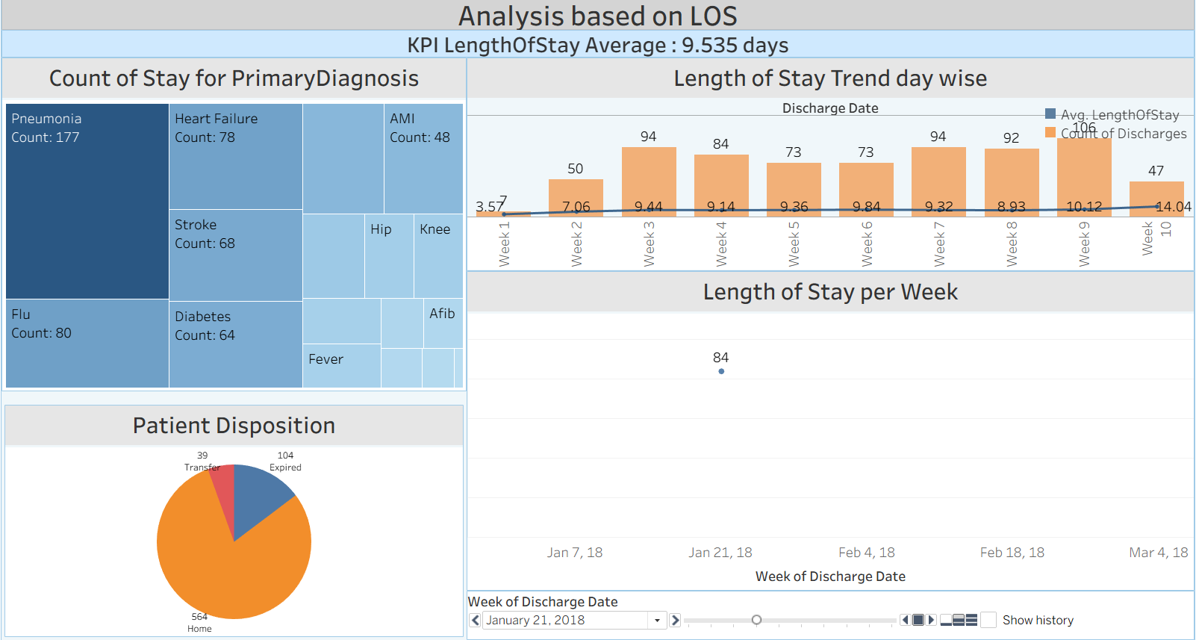
Key Metrics:
- Average Length of Stay: 9.535 days
- Primary Diagnoses Distribution:
  - Pneumonia: 177 cases
  - Heart Failure: 78 cases
  - Flu: 80 cases
  - Stroke: 68 cases
  - AMI: 48 cases
Weekly Trends:
- Peak discharge count occurred in Week 3 (94 patients) and Week 9 (106 patients)
- Average LOS ranged from 3.57 days (Week 1) to 14.04 days (Week 10)
- Week 3 showed the highest average LOS at 9.44 days with 94 discharges
Patient Disposition:
- Home Discharge: 564 patients (majority)
- Expired: 104 patients
- Transfer: 39 patients
Insights:
The analysis reveals patterns in patient flow and resource utilization, enabling better bed management and discharge planning.

3. Emergency Department (ED) Throughput Analysis
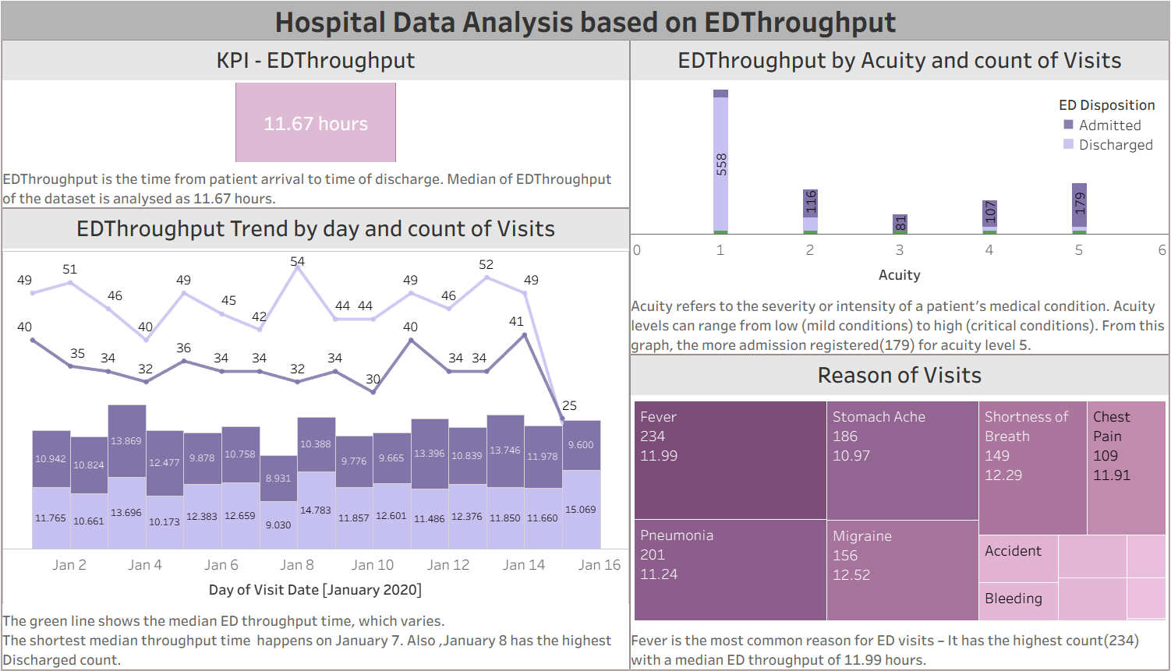
Key Performance Indicators:
- Median ED Throughput Time: 11.67 hours
- Total ED Visits: Approximately 1,200+ visits analyzed
Daily Trends (January 2020):
- Shortest Throughput: January 7 with optimal patient flow
- Highest Discharge Volume: January 8 (despite longer throughput times)
- Variable throughput times ranging from 8.9 to 14.8 hours
Visit Acuity Analysis:
- Acuity Level 5: Highest admission count (179 patients) - critical conditions
- Acuity levels range from 1 (mild) to 5 (critical)
- Higher acuity levels correlate with increased admission rates
Top Reasons for ED Visits:
- Fever: 234 visits (median throughput: 11.99 hours)
- Stomach Ache: 186 visits (median throughput: 10.97 hours)
- Pneumonia: 201 visits (median throughput: 11.24 hours)
- Shortness of Breath: 149 visits (median throughput: 12.29 hours)
- Chest Pain: 109 visits (median throughput: 11.91 hours)
Disposition Patterns:
The ED disposition shows a balance between admitted and discharged patients, with variations based on acuity levels and visit reasons.
4. Mortality Rate Analysis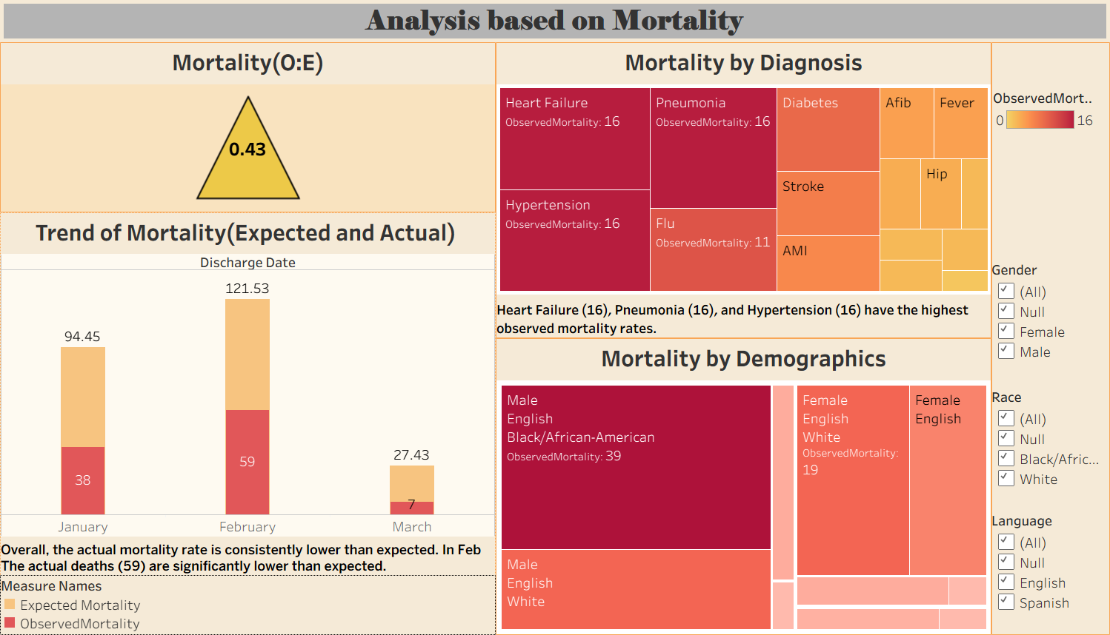
Key Findings:
- Overall Mortality Rate (O:E Ratio): 0.43
  - Actual mortality is consistently lower than expected, indicating quality care delivery
Monthly Mortality Trends:
- January: 38 observed vs 94.45 expected deaths
- February: 59 observed vs 121.53 expected deaths (highest actual count)
- March: 7 observed vs 27.43 expected deaths
Insight: The hospital is performing significantly better than expected mortality benchmarks, particularly in February where actual deaths were lower despite being the highest observed count.
Mortality by Diagnosis:
Highest Observed Mortality:
- Heart Failure: 16 deaths
- Pneumonia: 16 deaths
- Hypertension: 16 deaths
- Flu: 11 deaths
Demographic Analysis:
- Highest Mortality Group: Male, English-speaking, Black/African-American patients (39 deaths)
- Second Highest: Female, English-speaking, White patients (19 deaths)
- Gender and language appear to influence mortality outcomes, requiring further investigation

5. Ambulatory Visits Analysis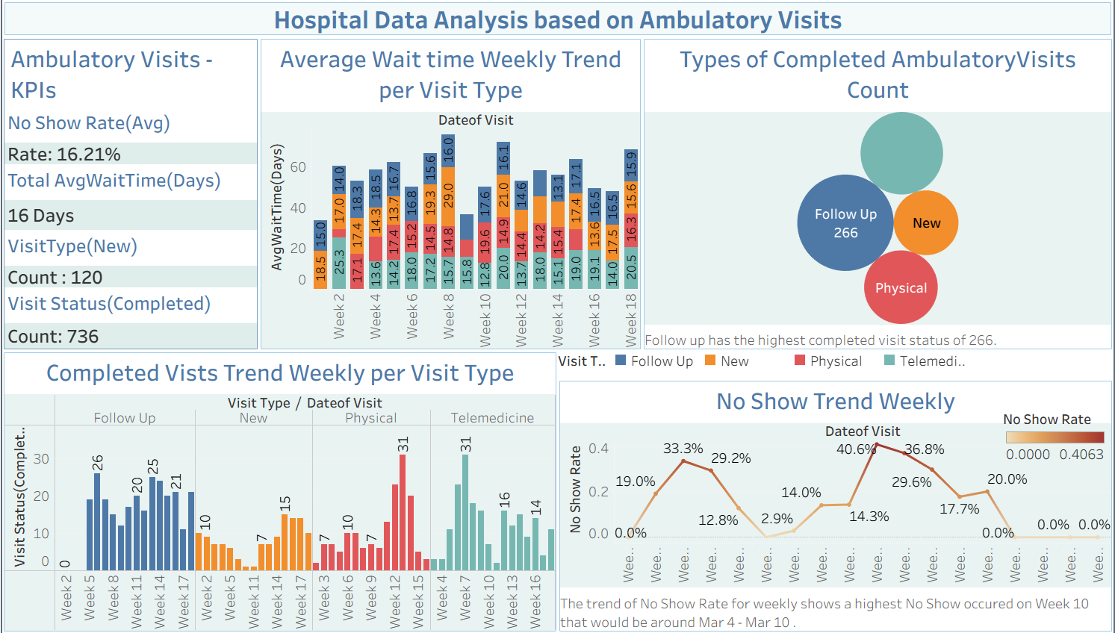
Key Performance Indicators:
- No Show Rate: 16.21% (average)
- Average Wait Time: 16 days
- New Visit Count: 120 patients
- Completed Visit Status: 736 visits
Visit Type Distribution:
- Follow Up: 266 completed visits (highest)
- New Visits: 120 patients
- Physical Exams: Significant volume
- Telemedicine: Growing utilization
Weekly Trends:
Average Wait Time by Visit Type:
- Consistent wait times ranging from 30-70 days across different visit types
- Week 9 showed the highest combined wait time at 70+ days
- Follow-up visits showed the most consistent completion rates
No Show Trends:
- Peak No Show Rate: Week 10 at 40.6%
- Lowest No Show Rate: Week 6 at 2.9%
- Average fluctuation suggests need for appointment reminder systems
- The trend indicates a correlation between longer wait times and higher no-show rates
Completed Visits Weekly Trend:
- Physical visits peaked in Week 15 (31 visits)
- Follow-up visits remained consistently high across weeks
- Telemedicine visits showed steady adoption in later weeks

