**Project Documentation**

**FITFLEX: YOUR PERSONAL FITNESS COMPANION**

**1. Introduction:**

**Project Titl**e: Fitness – Your Personal Fitness Companion

**Team ID**: NM2025TMID37641

**Team Leader**: Preetha.D & preethadavid1029@gmail.com ]

**Team Members: Monika S &** [**monikaajith04@gmail.com**](mailto:monikaajith04@gmail.com)

**Team Members: Priyadharshini E &** [**vanithapriya36@gmail.com**](mailto:vanithapriya36@gmail.com)**]**

**Team Members: Vasantharani P &** [**krishnaraj052@gmail.com**](mailto:krishnaraj052@gmail.com)

**Team Members: Sivaranjini R &** [**sivaranjinirajendran35@gmail.com**](mailto:sivaranjinirajendran35@gmail.com)**]**

**2. Project Overview**

Purpose:

Fitness is a personal fitness companion app designed to help users track workouts, monitor diet plans, log progress, and stay motivated through personalized recommendations and analytics.

Features:

* + User registration & login
  + Personalized workout plans
  + Meal and calorie tracking
  + Progress tracking (weight, BMI, workout stats)

Notifications & reminders

Social/community features (optional future add-on)

Admin dashboard for managing content and users

3**. Architecture:**

Frontend: React.js with Bootstrap and Material UI

Backend: Node.js and Express.js for server logic and APIs

Database: MongoDB for storing user profiles, workouts, meals, progress logs

Authentication: JWT for secure login and protected routes

**4. Setup Instructions**

Prerequisites:

* Node.js
* MongoDB
* Git
* React.js
* Express.js
* Mongoose
* Visual Studio Code

Installation Steps:

# Clone the repository

git clone <repo-url>

# Install client dependencies

cd client

npm install

# Install server dependencies

cd ../server

npm install

**5. Folder Structure**

Fitness-App/

|-- client/ # React frontend

| |-- components/

| |-- pages/

|

|-- server/ # Node.js backend

| |-- routes/

| |-- models/

| |-- controllers/

**6. Running the Application**

Frontend:

cd client

npm start

Backend:

cd server

npm start

Access: Visit http://localhost:3000

**7. API Documentation**

User:

POST /api/user/register

POST /api/user/login

Workouts:

POST /api/workouts/create

GET /api/workouts/:id

Meals & Nutrition:

POST /api/meals/add

GET /api/meals/:userId

Progress:

POST /api/progress/log

GET /api/progress/:userId

**8. Authentication**

JWT-based authentication for secure login

Middleware to protect private routes (workout logs, meal logs, progress tracking)

**9. User Interface**

Landing Page (App intro, sign-up/login)

User Dashboard (overview of workouts, meals, progress)

Workout Page (exercise plans, logs)

Meal & Nutrition Page

Progress Tracking Page (graphs & analytics)

Admin Panel

**10. Testing**

Manual testing at milestones

Tools: Postman (API testing), Chrome DevTools (frontend debugging)

**11. Screenshots or Demo**

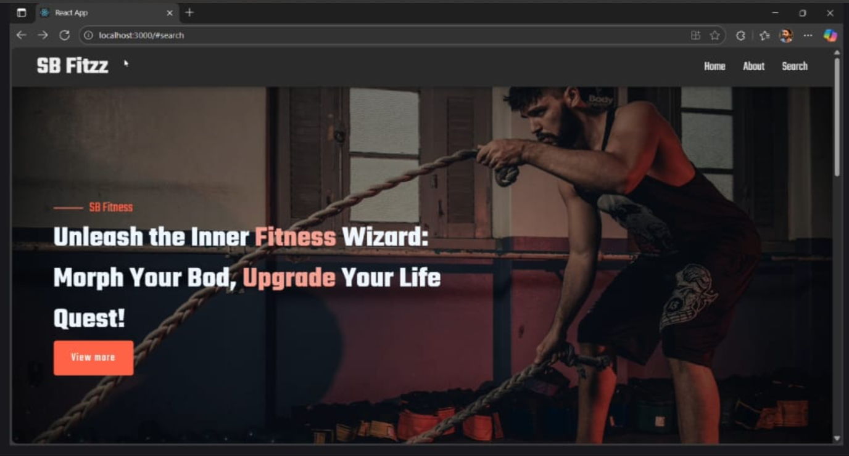

**12. Known Issues**

Pending integration with wearable devices (fitness bands, smartwatches)

Limited offline support

**13. Future Enhancements**

* + AI-based personalized workout & meal suggestions
  + Integration with fitness trackers (Fitbit, Apple Watch)
  + Community forum for user interaction
  + Gamification features (badges, challenges)