WEEK-7

REACT

9. REACTJS-HOL

CODE:

IndianPlayers.js

import React from 'react';

const IndianPlayers = () => {

  const oddPlayers = ["Rohit", "Gill", "Pant", "Hardik", "Shami"];

  const evenPlayers = ["Kohli", "Rahul", "Jadeja", "Kuldeep", "Bumrah", "Shreyas"];

  const [odd1, odd2, ...restOdd] = oddPlayers;

  const [even1, even2, ...restEven] = evenPlayers;

  const T20players = ["Rohit", "Gill", "Hardik"];

  const RanjiTrophyPlayers = ["Shaw", "Sarfaraz", "Jaiswal"];

  const merged = [...T20players, ...RanjiTrophyPlayers];

  return (

    <div>

      <h2>Odd Team Players (Destructuring)</h2>

      <p>First Two: {odd1}, {odd2}</p>

      <p>Rest: {restOdd.join(', ')}</p>

      <h2>Even Team Players (Destructuring)</h2>

      <p>First Two: {even1}, {even2}</p>

      <p>Rest: {restEven.join(', ')}</p>

      <h2>Merged Players (Spread)</h2>

      <p>{merged.join(', ')}</p>

    </div>

  );

};

export default IndianPlayers;

ListofPlayers.js

import React from 'react';

const ListofPlayers = () => {

  const players = [

    { name: "Rohit", score: 85 },

    { name: "Kohli", score: 95 },

    { name: "Gill", score: 45 },

    { name: "Rahul", score: 67 },

    { name: "Pant", score: 88 },

    { name: "Hardik", score: 50 },

    { name: "Jadeja", score: 72 },

    { name: "Shreyas", score: 63 },

    { name: "Bumrah", score: 78 },

    { name: "Kuldeep", score: 60 },

    { name: "Shami", score: 90 },

  ];

  // Filter players with score < 70 using arrow function

  const below70 = players.filter(player => player.score < 70);

  return (

    <div>

      <h2>All Players (using map)</h2>

      {players.map((p, index) => (

        <p key={index}>{p.name} - {p.score}</p>

      ))}

      <h2>Players with Score Below 70 (using arrow function)</h2>

      {below70.map((p, index) => (

        <p key={index}>{p.name} - {p.score}</p>

      ))}

    </div>

  );

};

export default ListofPlayers;

EvenPlayers.js

function EvenPlayers(players) {

  return (

    <ul>

      {players.filter((_, i) => i % 2 !== 0).map((p, i) => (

        <li key={i}>

          {i === 0 && "Second"}{i === 1 && "Fourth"}{i === 2 && "Sixth"} : {p}

        </li>

      ))}

    </ul>

  );

}

export default EvenPlayers;

OddPlayers.js

function OddPlayers(players) {

  return (

    <ul>

      {players.filter((_, i) => i % 2 === 0).map((p, i) => (

        <li key={i}>

          {i === 0 && "First"}{i === 2 && "Third"}{i === 4 && "Fifth"} : {p}

        </li>

      ))}

    </ul>

  );

}

export default OddPlayers;

Scorebelow70.js

// src/components/Scorebelow70.js

import React from 'react';

const Scorebelow70 = ({ players }) => {

  const filtered = players.filter(player => player.score < 70);

  return (

    <div>

      {filtered.map((player, index) => (

        <p key={index}>{player.name} - {player.score}</p>

      ))}

    </div>

  );

};

export default Scorebelow70;

ListofIndianPlayers.js

import React from 'react';

const ListofIndianPlayers = ({ IndianPlayers }) => {

  return (

    <ul>

      {IndianPlayers.map((player, i) => (

        <li key={i}>{player}</li>

      ))}

    </ul>

  );

};

export default ListofIndianPlayers;

App.js

import React from 'react';

import ListofPlayers from './Components/ListofPlayers';

import Scorebelow70 from './Components/Scorebelow70';

import OddPlayers from './Components/OddPlayers';

import EvenPlayers from './Components/EvenPlayers';

import ListofIndianPlayers from './Components/ListofIndianPlayers';

function App() {

  const flag = true;

  const players = [

    { name: "Rohit", score: 85 },

    { name: "Kohli", score: 95 },

    { name: "Gill", score: 45 },

    { name: "Pant", score: 88 },

    { name: "Hardik", score: 50 },

  ];

  const IndianTeam = ["Sachin1", "Dhoni2", "Virat3", "Rohit4", "Yuvaraj5", "Raina6"];

  const IndianPlayers = ["Mr. First Player", "Mr. Second Player", "Mr. Third Player", "Mr. Fourth Player", "Mr. Fifth Player", "Mr. Sixth Player"];

  if (flag === true) {

    return (

      <div>

        <h1>List of Players</h1>

        <ListofPlayers players={players} />

        <hr />

        <h1>List of Players having Scores Less than 70</h1>

        <Scorebelow70 players={players} />

      </div>

    );

  } else {

    return (

      <div>

        <div>

          <h1>Indian Team</h1>

          <h1>Odd Players</h1>

          {OddPlayers(IndianTeam)}

          <hr />

          <h1>Even Players</h1>

          {EvenPlayers(IndianTeam)}

        </div>

        <hr />

        <div>

          <h1>List of Indian Players Merged:</h1>

          <ListofIndianPlayers IndianPlayers={IndianPlayers} />

        </div>

      </div>

    );

  }

}

export default App;

OUTPUT:

When flag=true

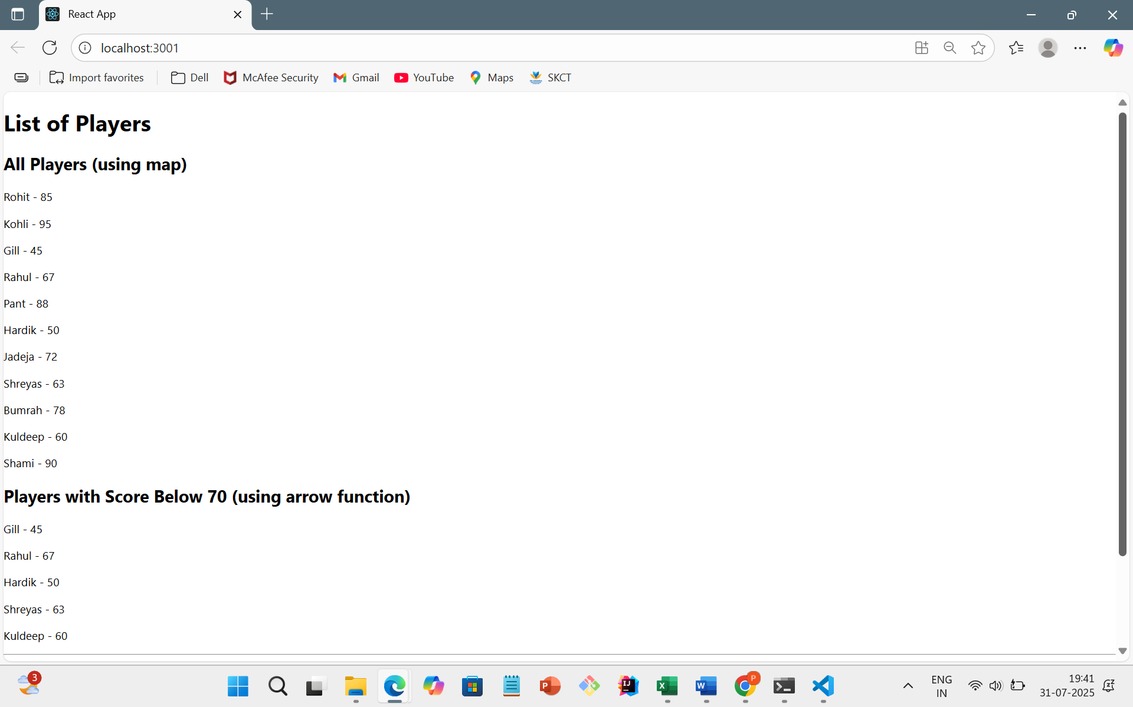

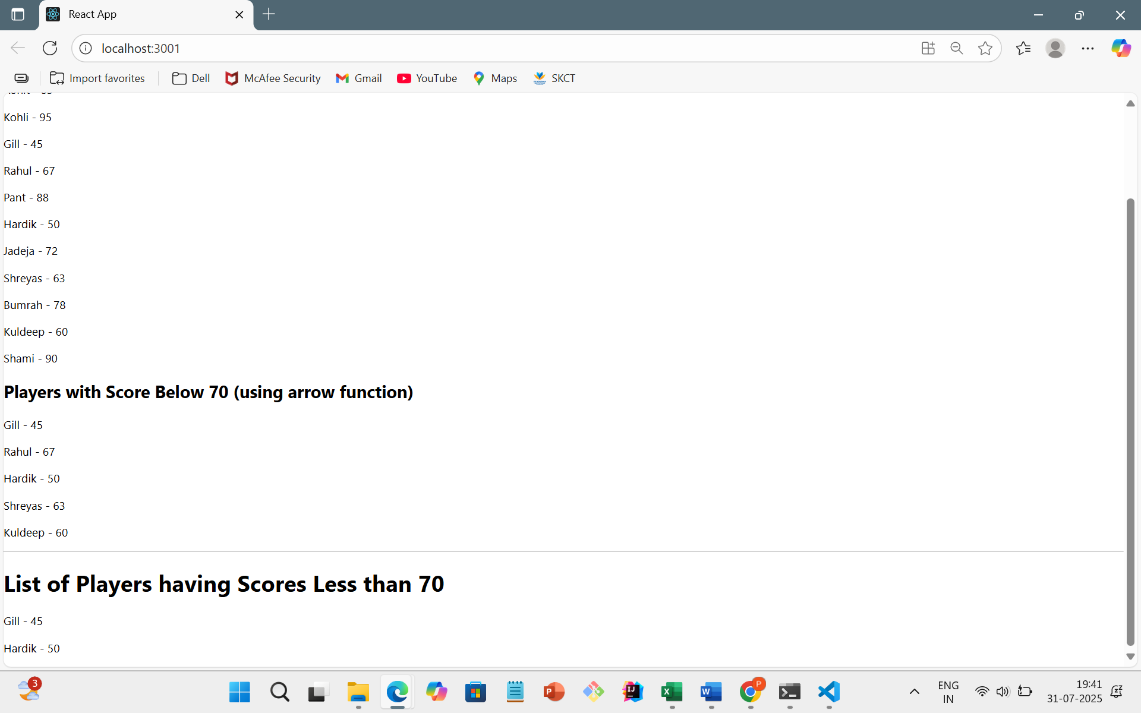

When flag=false

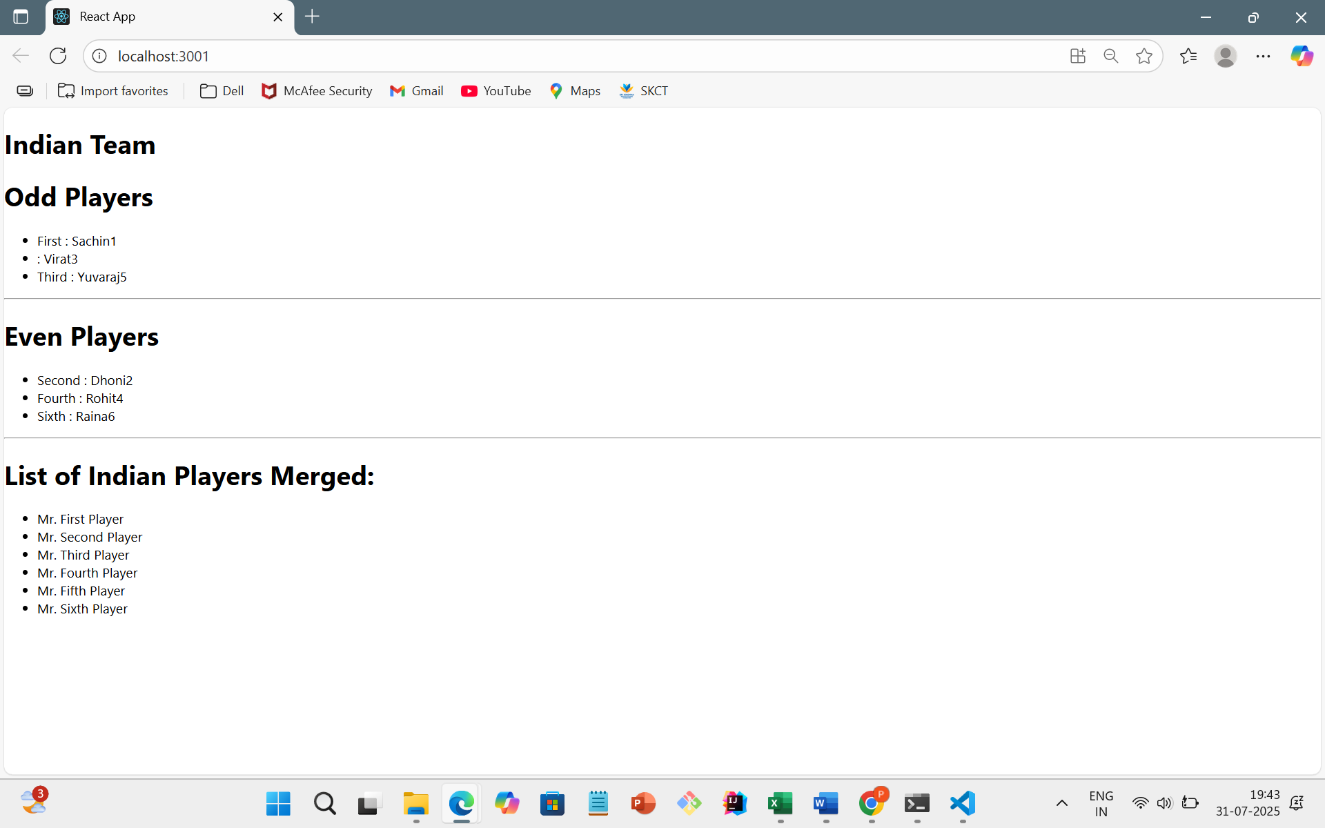

10.REACTJS-HOL

CODE:

App.js

import React from 'react';

function App() {

  const office = {

    name: "Executive Suite",

    rent: 55000,

    address: "Tower 5, TechPark, Mumbai"

  };

  const officeList = [

    {

      name: "Premium Office",

      rent: 75000,

      address: "Cyber City, Gurugram"

    },

    {

      name: "Budget Workspace",

      rent: 45000,

      address: "StartHub, Pune"

    },

    {

      name: "Luxury Space",

      rent: 90000,

      address: "Infinity Tower, Bangalore"

    }

  ];

  const getRentStyle = (rent) => {

    return {

      color: rent > 60000 ? 'green' : 'red',

      fontWeight: 'bold'

    };

  };

  return (

    <div

      style={{

        display: 'flex',

        justifyContent: 'center',

        alignItems: 'center',

        minHeight: '100vh',

        backgroundColor: '#f9f9f9',

        fontFamily: 'Arial'

      }}

    >

      <div style={{ width: '90%', maxWidth: '600px', textAlign: 'center' }}>

        <h1>Office Space Rental Listings</h1>

        <img

          src="https://img.freepik.com/premium-photo/modern-corporate-architecture-can-be-seen-cityscape-office-buildings_410516-276.jpg"

          alt="Office Space"

          width="100%"

          style={{ borderRadius: '10px', marginBottom: '20px' }}

        />

        <h2>Featured Office:</h2>

        <p><strong>Name:</strong> {office.name}</p>

        <p><strong>Rent:</strong> <span style={getRentStyle(office.rent)}>{office.rent}</span></p>

        <p><strong>Address:</strong> {office.address}</p>

        <hr />

        <h2> Available Offices:</h2>

        {officeList.map((item, index) => (

          <div key={index} style={{ marginBottom: '20px' }}>

            <p><strong>Name:</strong> {item.name}</p>

            <p><strong>Rent:</strong> <span style={getRentStyle(item.rent)}>{item.rent}</span></p>

            <p><strong>Address:</strong> {item.address}</p>

            <hr />

          </div>

        ))}

      </div>

    </div>

  );

}

export default App;

OUTPUT:

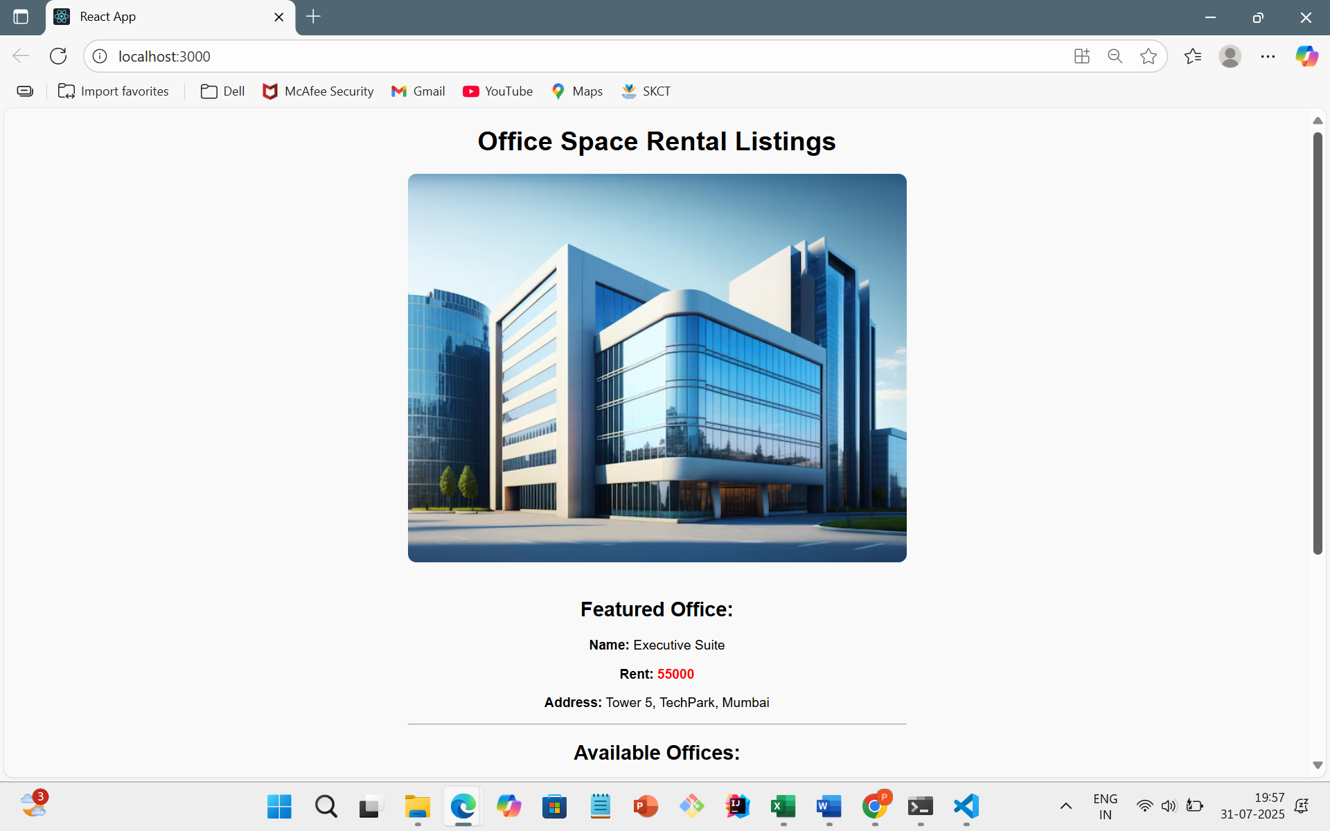

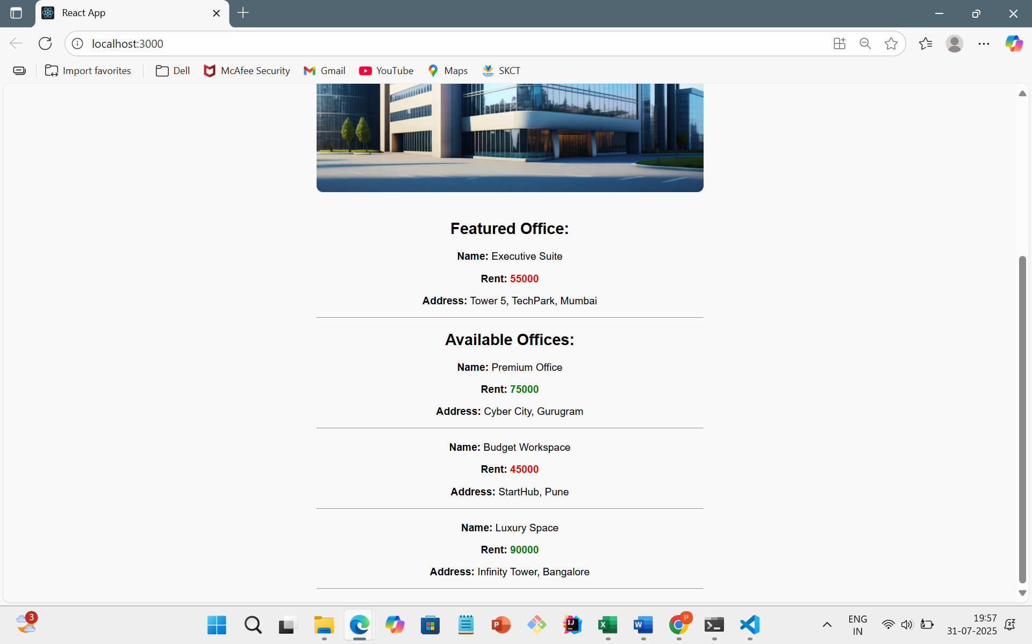

11.REACTJS-HOL

CODE:

CurrencyConvertor.js

import React, { Component } from 'react';

class CurrencyConvertor extends Component {

  constructor() {

    super();

    this.state = {

      rupees: '',

      euro: ''

    };

  }

  handleChange = (event) => {

    this.setState({ rupees: event.target.value });

  };

  handleSubmit = () => {

    const rate = 0.011; // Conversion rate

    const converted = (this.state.rupees * rate).toFixed(2);

    this.setState({ euro: converted });

    // ✅ Show popup message after conversion

    alert(`Converting ₹${this.state.rupees} to €${converted}`);

  };

  render() {

    return (

      <div>

        <h2>💱 Currency Converter</h2>

        <input

          type="number"

          placeholder="Enter Rupees"

          value={this.state.rupees}

          onChange={this.handleChange}

        />

        &nbsp;

        <button onClick={this.handleSubmit}>Convert</button>

        {this.state.euro && (

          <p>Converted Value: <strong>€ {this.state.euro}</strong></p>

        )}

      </div>

    );

  }

}

export default CurrencyConvertor;

App.js

import React, { Component } from 'react';

import CurrencyConvertor from './CurrencyConvertor';

class App extends Component {

  constructor() {

    super();

    this.state = {

      count: 0

    };

  }

  // a. Increment counter

  increment = () => {

    this.setState({ count: this.state.count + 1 }, () => {

      this.sayHello(); // b. call second method

    });

  };

  // b. Say Hello message

  sayHello = () => {

    alert("Hello! This is a static message.");

  };

  // Decrement counter

  decrement = () => {

    this.setState({ count: this.state.count - 1 });

  };

  // Say welcome with an argument

  sayWelcome = (message) => {

    alert(message);

  };

  // Synthetic event handler

  handleSyntheticClick = (event) => {

    alert("I was clicked");

    console.log("Synthetic Event object:", event);

  };

  render() {

    return (

      <div style={{ textAlign: 'center', padding: '30px', fontFamily: 'Arial' }}>

        <h1>React Event Examples</h1>

        {/* Counter Section */}

        <h2>Counter: {this.state.count}</h2>

        <button onClick={this.increment}>Increment</button>&nbsp;

        <button onClick={this.decrement}>Decrement</button>

        <hr />

        {/* Welcome Button */}

        <button onClick={() => this.sayWelcome("Welcome to React Event Lab!")}>

          Say Welcome

        </button>

        <hr />

        {/* Synthetic Event Button */}

        <button onClick={this.handleSyntheticClick}>

          Synthetic Event (onPress)

        </button>

        <hr />

        {/* Currency Converter */}

        <CurrencyConvertor />

      </div>

    );

  }

}

export default App;

OUTPUT:

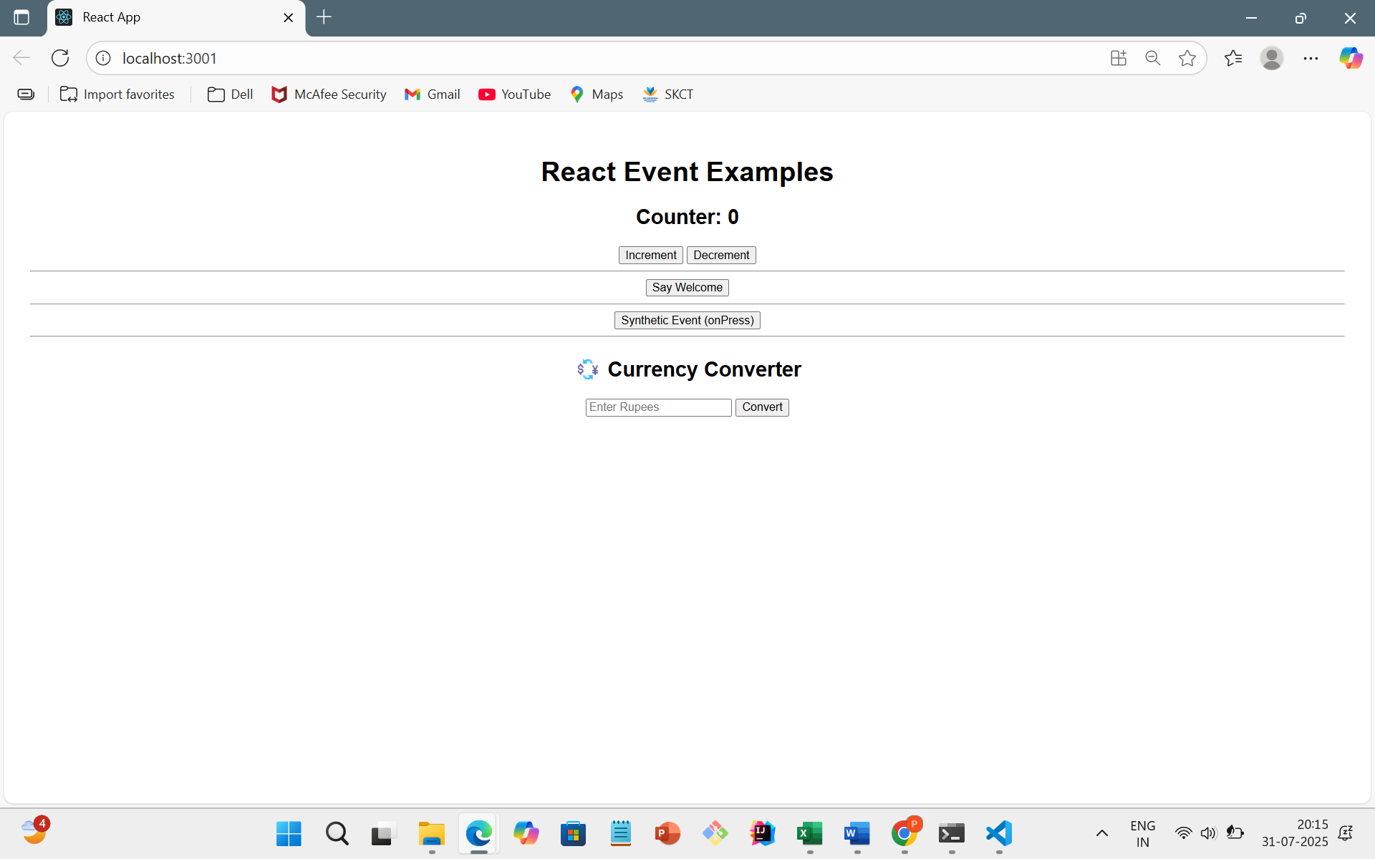

While Clicking Increment

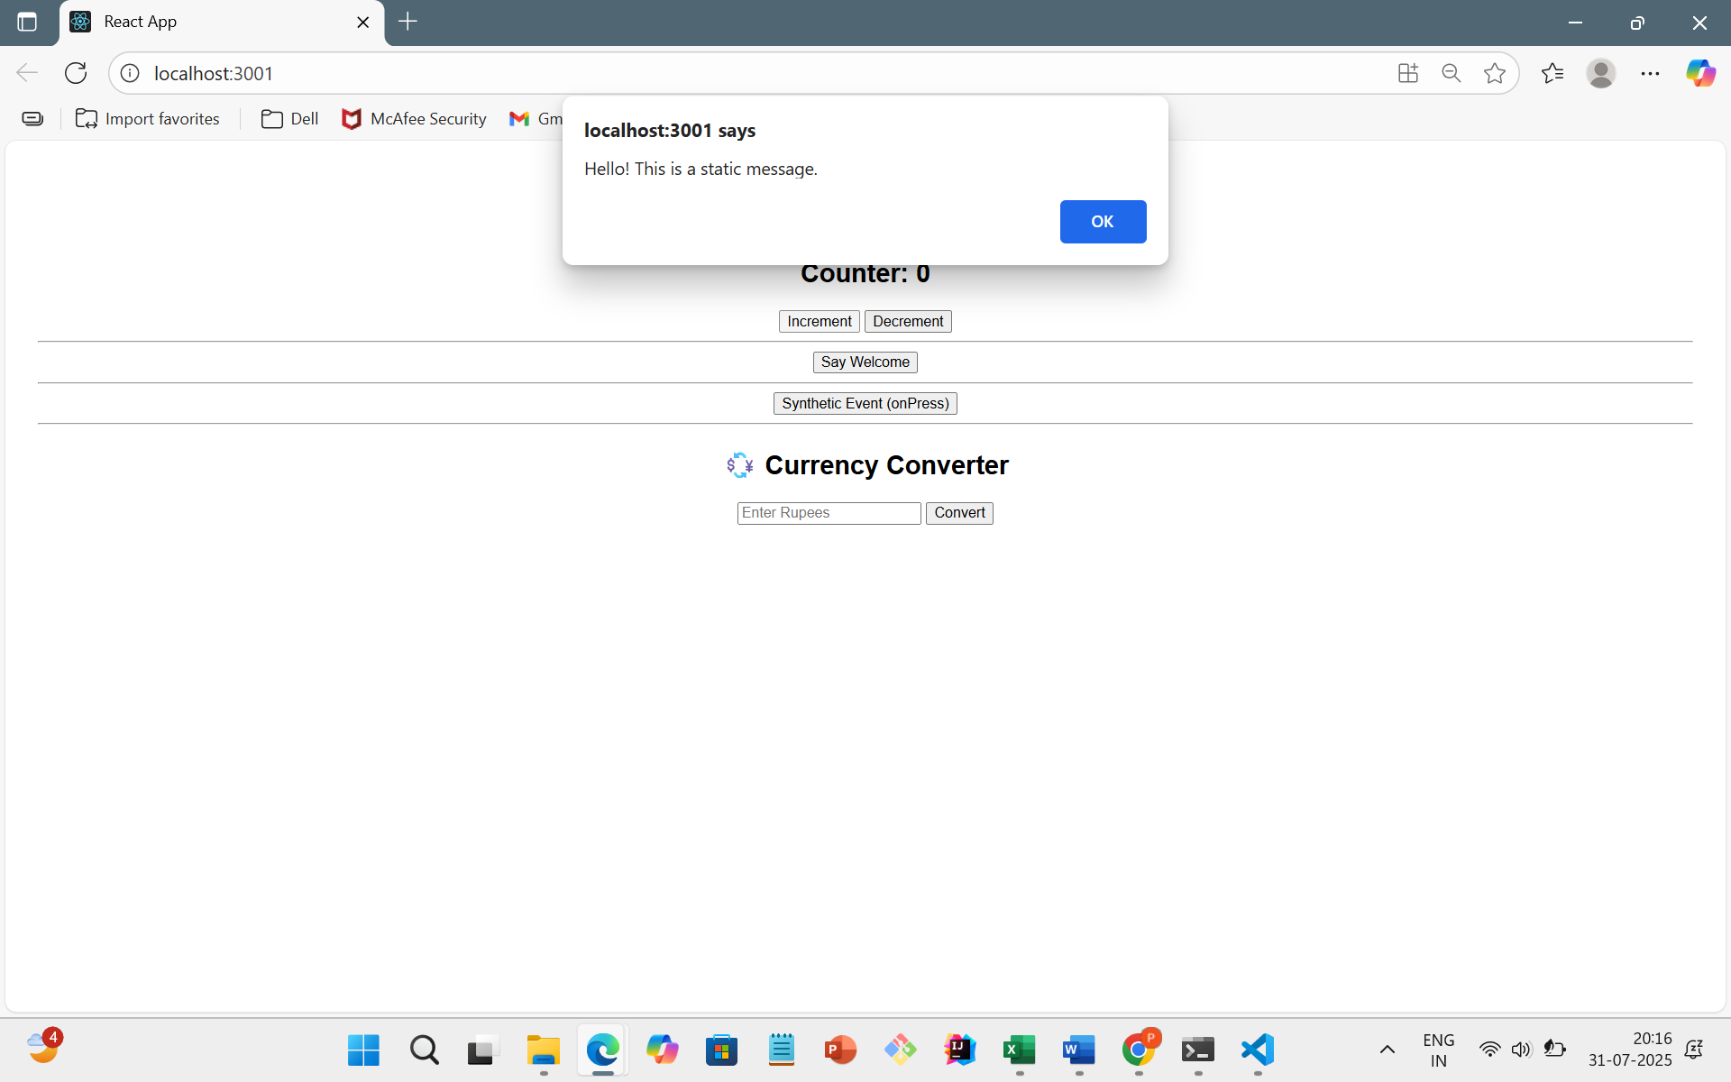

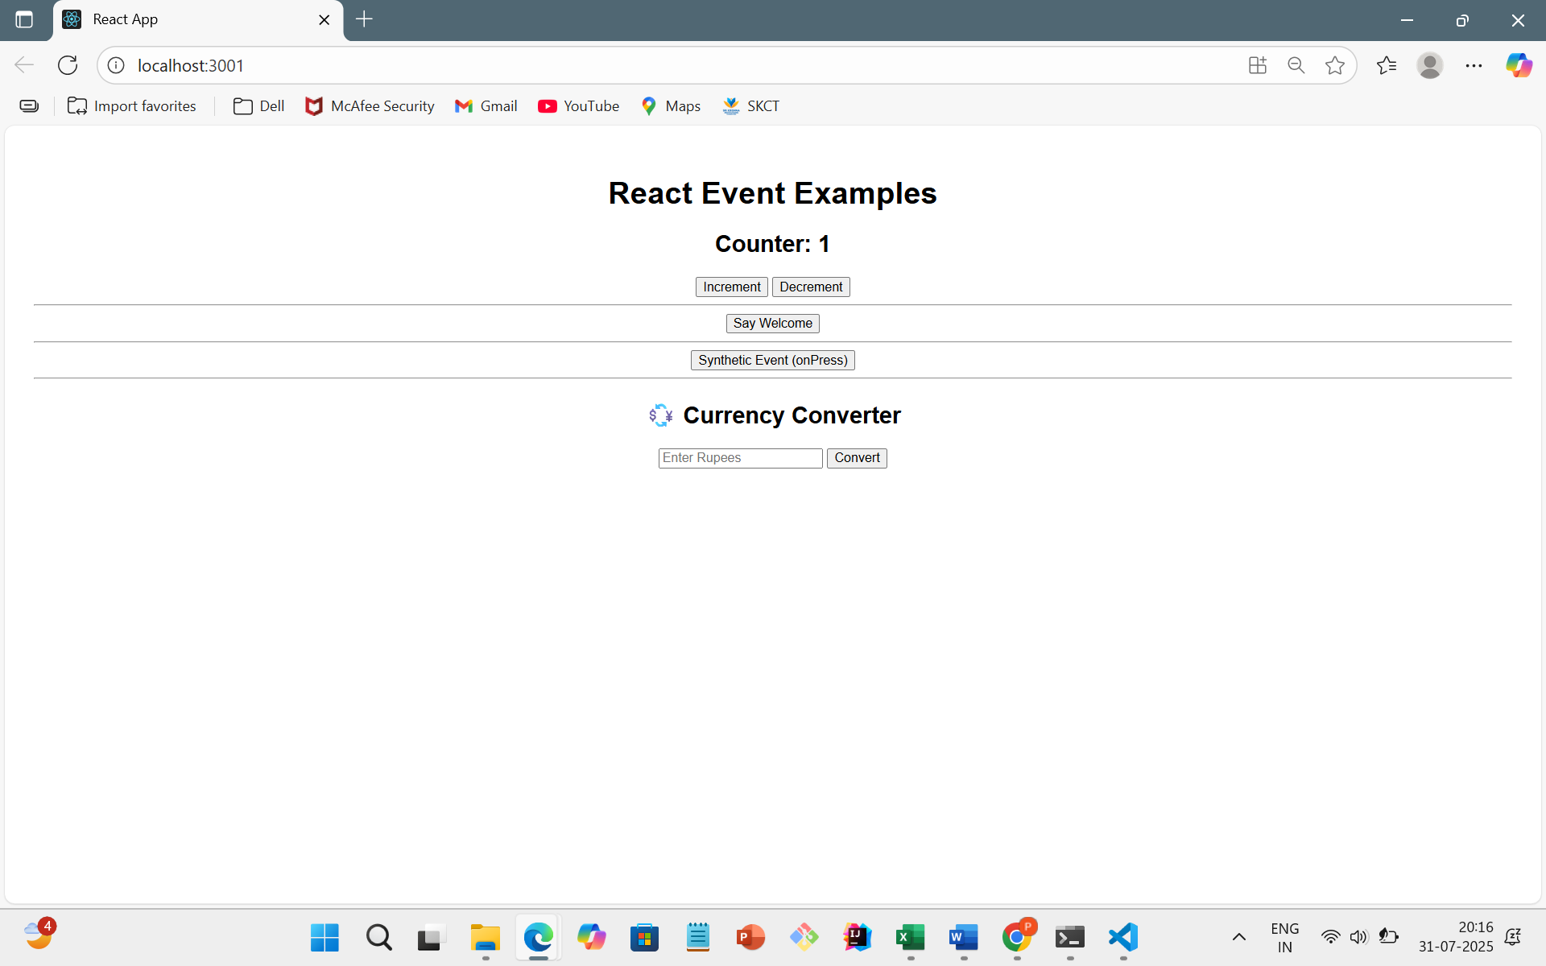

While Clicking Say Welcome

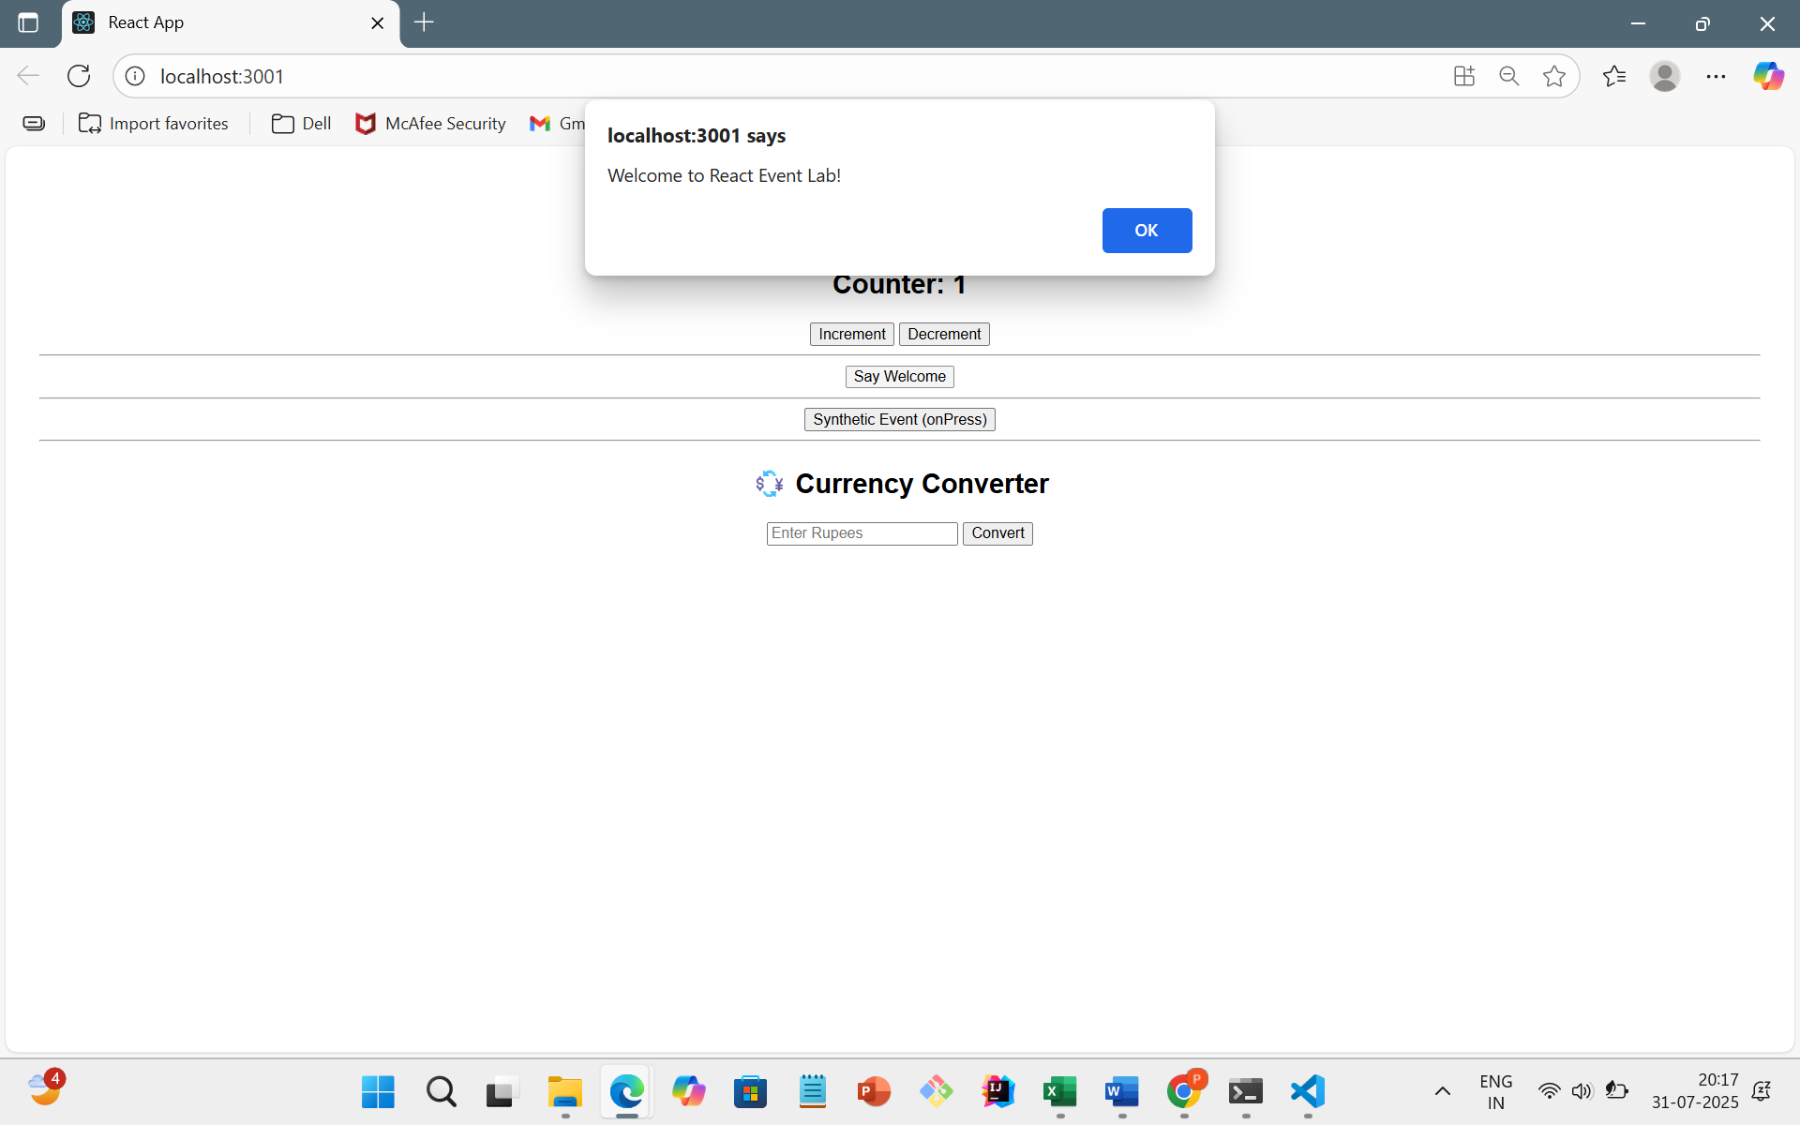

While Clicking Synthetic Event

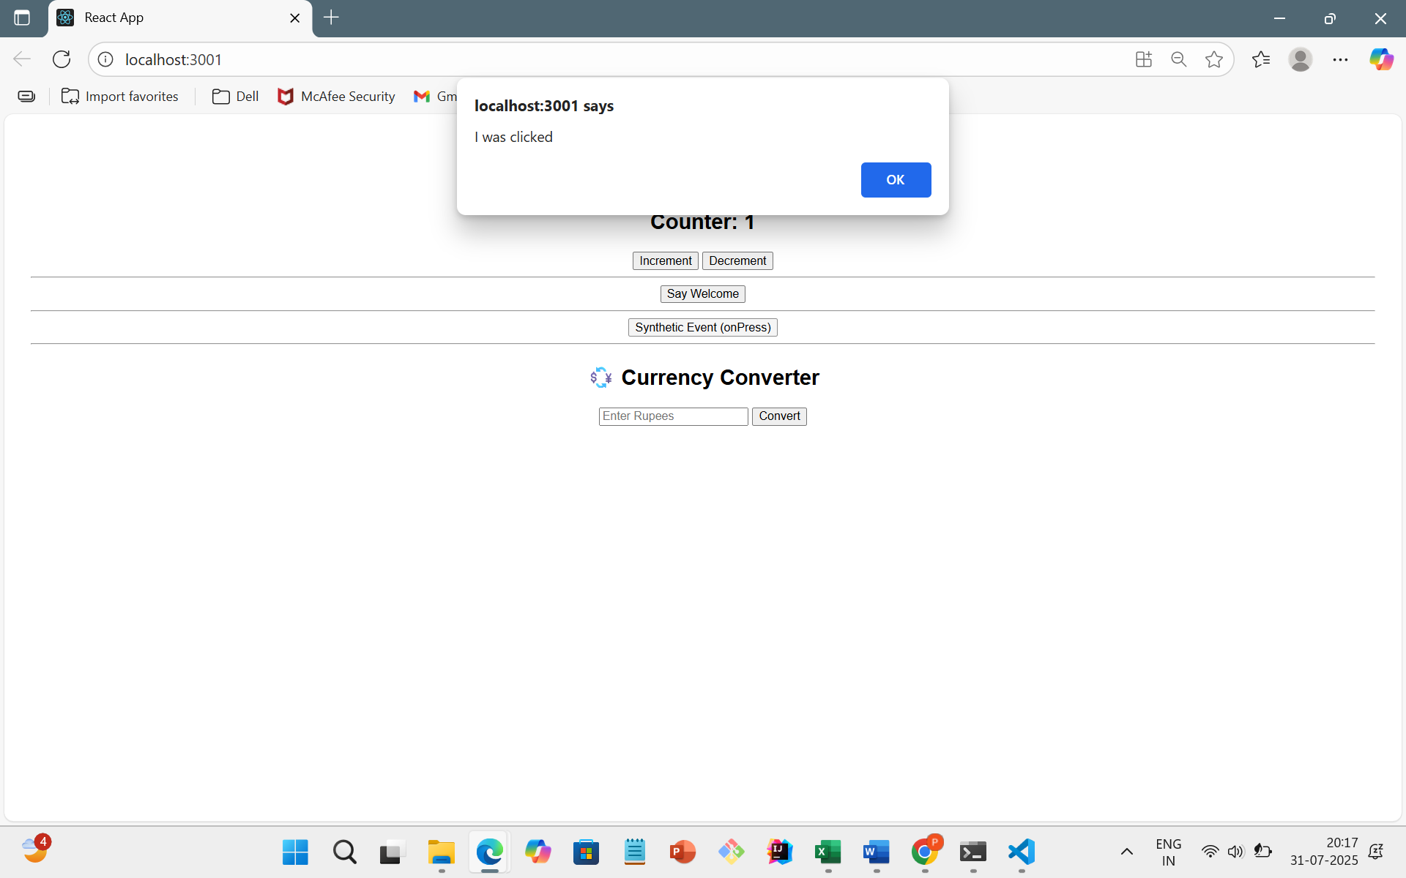

Currency Converter

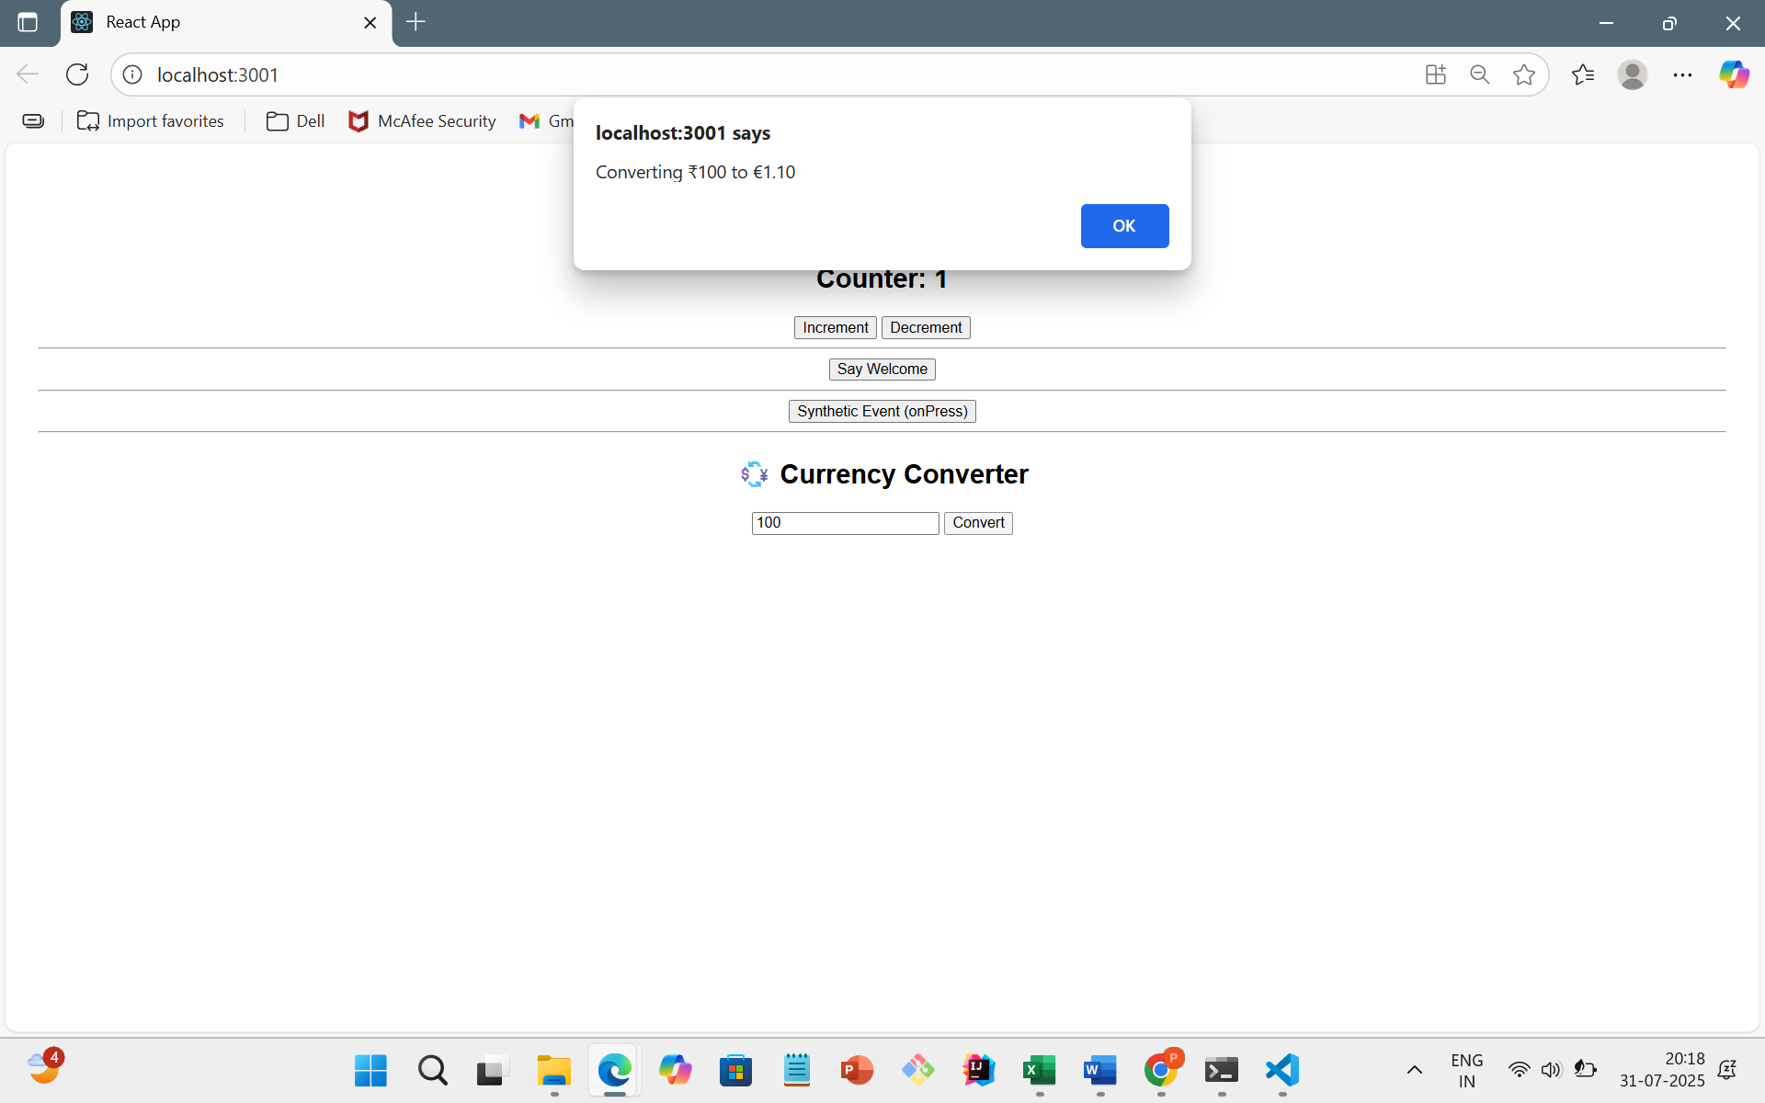

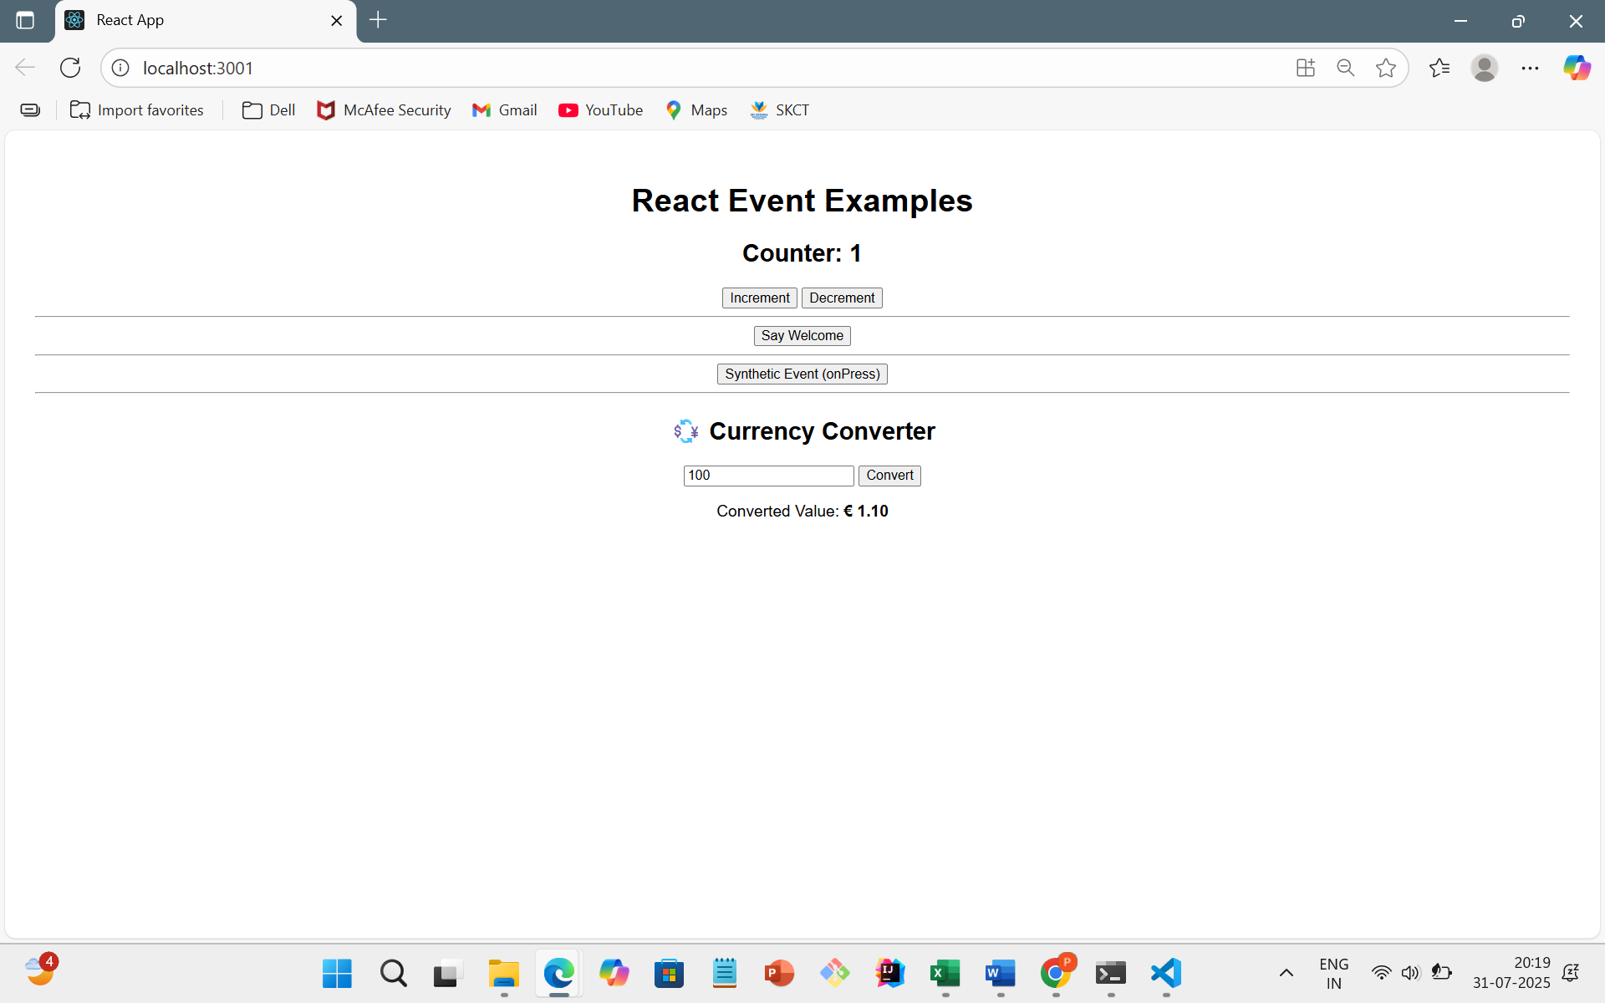

12.REACTJS-HOL

CODE:

App.js

import React, { useState } from 'react';

// Guest Page Component

function GuestPage() {

  return (

    <div>

      <h2>✈️ Welcome Guest!</h2>

      <p>You can browse available flights below:</p>

      <ul>

        <li>Flight 1: Chennai to Mumbai - 9:00 AM</li>

        <li>Flight 2: Delhi to Bangalore - 1:00 PM</li>

        <li>Flight 3: Hyderabad to Kolkata - 6:30 PM</li>

      </ul>

    </div>

  );

}

// User Page Component

function UserPage() {

  return (

    <div>

      <h2>👤 Welcome, User!</h2>

      <p>You are now logged in. You can book your flight below:</p>

      <button>🛫 Book Ticket</button>

    </div>

  );

}

// Main App

function App() {

  const [isLoggedIn, setIsLoggedIn] = useState(false);

  // Toggle Login Status

  const handleLogin = () => setIsLoggedIn(true);

  const handleLogout = () => setIsLoggedIn(false);

  // Choose what to render based on login state

  let content;

  if (isLoggedIn) {

    content = <UserPage />;

  } else {

    content = <GuestPage />;

  }

  return (

    <div style={{ textAlign: 'center', fontFamily: 'Arial', padding: '20px' }}>

      <h1>Ticket Booking App</h1>

      {/* Login/Logout Buttons */}

      {isLoggedIn ? (

        <button onClick={handleLogout}>🚪 Logout</button>

      ) : (

        <button onClick={handleLogin}>🔑 Login</button>

      )}

      <hr />

      {/* Conditional Content */}

      {content}

    </div>

  );

}

export default App;

OUTPUT:

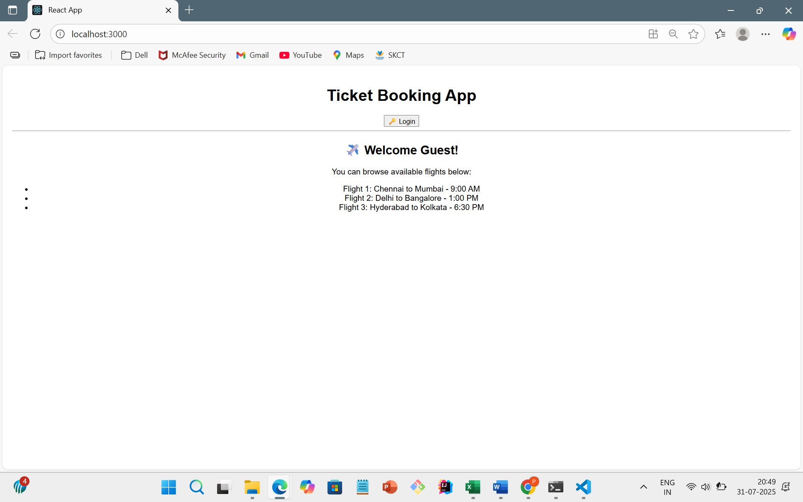

ON CLICKING LOGIN

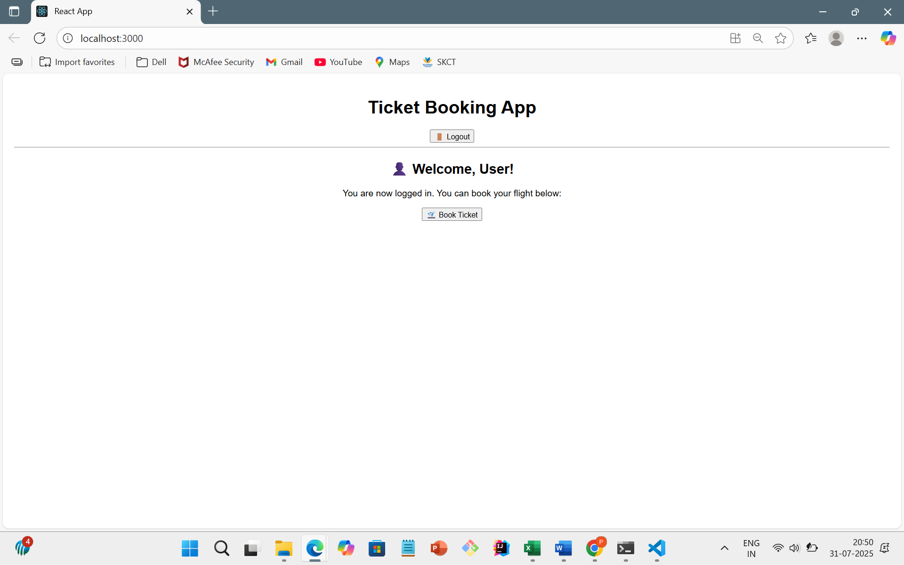

13.REACTJS-HOL

CODE:

App.js

import React, { useState } from 'react';

import BookDetails from './components/BookDetails';

import BlogDetails from './components/BlogDetails';

import CourseDetails from './components/CourseDetails';

function App() {

  const [activeComponent, setActiveComponent] = useState('book');

  // 1. Element variable approach

  let content;

  if (activeComponent === 'book') {

    content = <BookDetails />;

  } else if (activeComponent === 'blog') {

    content = <BlogDetails />;

  } else if (activeComponent === 'course') {

    content = <CourseDetails />;

  }

  // 2. Inline if rendering + ternary for title

  const title = activeComponent === 'book'

    ? "Book Section"

    : activeComponent === 'blog'

    ? "Blog Section"

    : "Course Section";

  return (

    <div style={{ textAlign: 'center', fontFamily: 'Arial', padding: '20px' }}>

      <h1>Blogger App - {title}</h1>

      {/* Buttons to switch components */}

      <button onClick={() => setActiveComponent('book')}> Books</button>&nbsp;

      <button onClick={() => setActiveComponent('blog')}> Blogs</button>&nbsp;

      <button onClick={() => setActiveComponent('course')}> Courses</button>

      <hr />

      {/* Render selected component */}

      {content}

    </div>

  );

}

export default App;

OUTPUT:

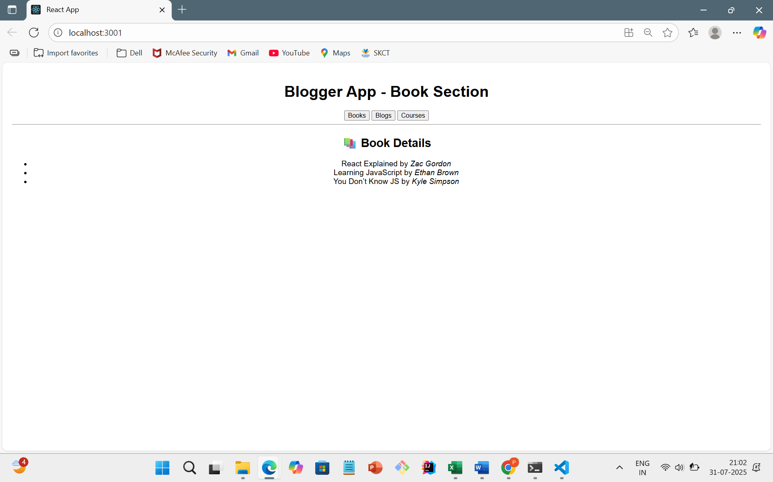

ON CLICKING BLOGS

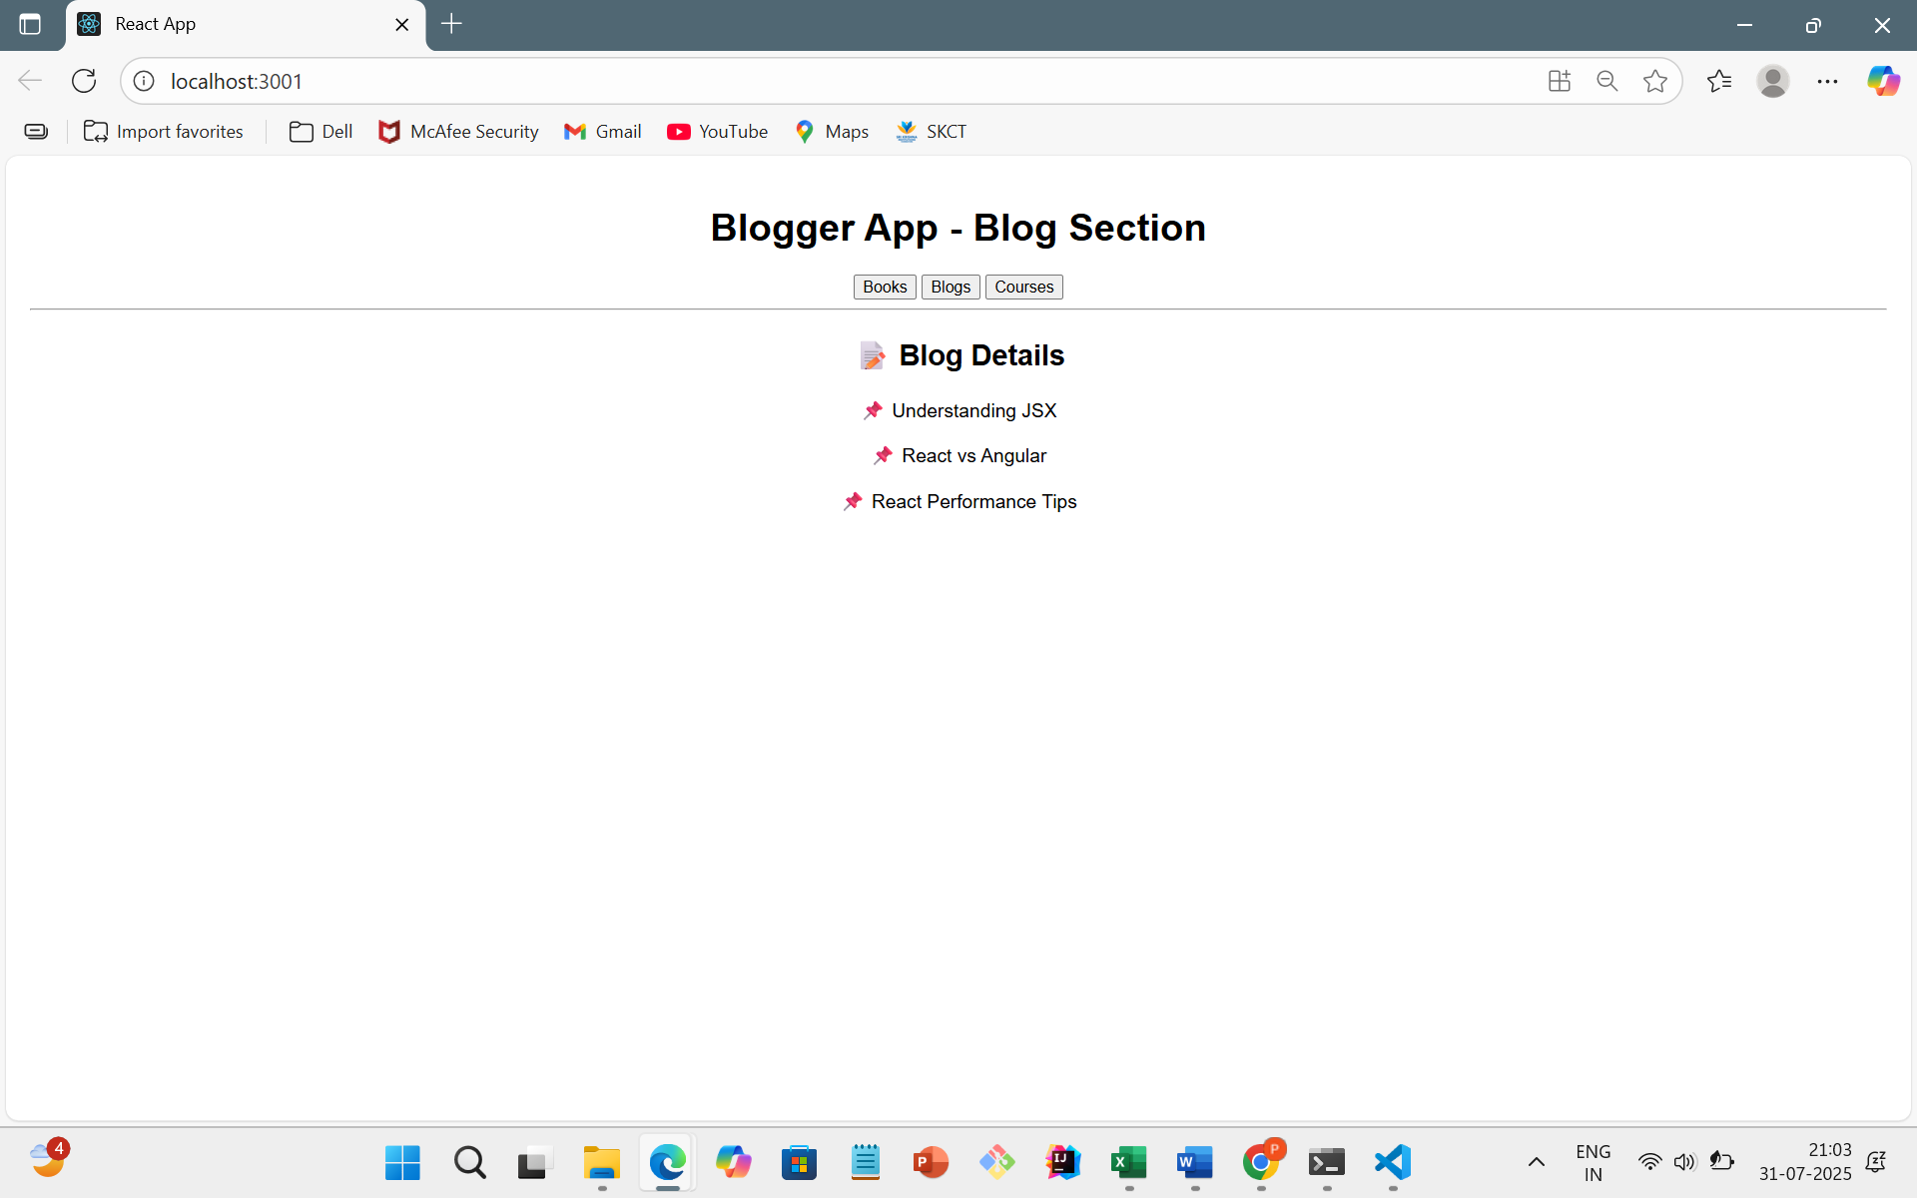

ON CLICKING COURSES

