Software Engineering

Lab-08
22-10-2026

SRN: PES1UG24CS599
Name: Preetham V
Class: J

Static Code Analysis

Executing the file before any changes

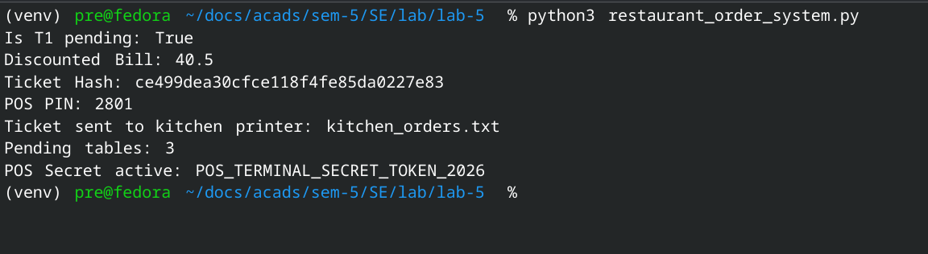

creating .txt reports before changes

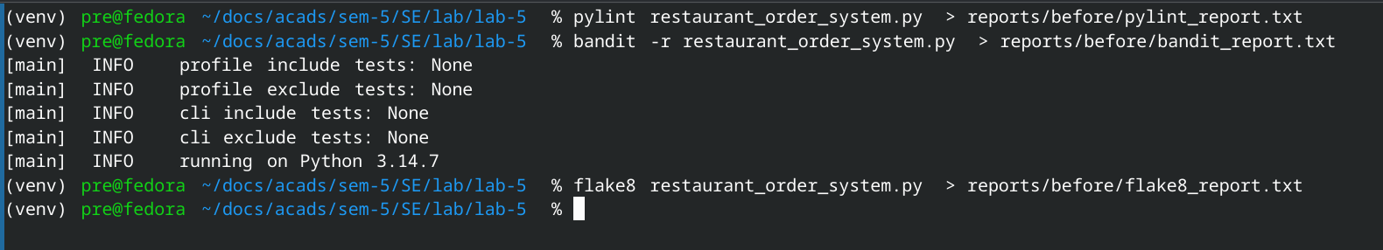
viewing all the reports
