Edge Intelligence Lab
P Sasi Preetham Reddy
25MML0037

Design - You may draw using any tool.

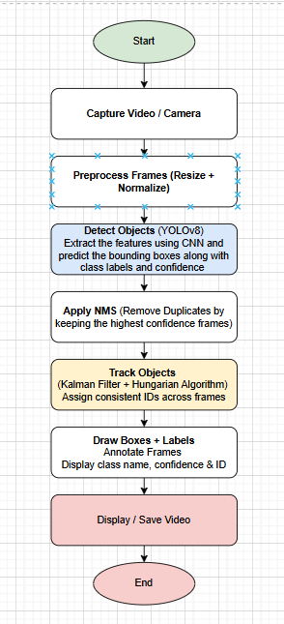

- Start
The system initializes by loading required libraries, configuring parameters, and loading the trained YOLOv8 model into memory for processing.
- Capture Video / Camera
Frames are continuously captured from a live camera or video file and processed sequentially to enable real-time or offline analysis.
- Preprocess Frames (Resize + Normalize)
Before feeding frames into the YOLOv8 model, they must be preprocessed to match the model’s input requirements. The frames are resized to a fixed resolution (commonly 640×640) to ensure consistency across inputs and optimize computational performance. Additionally, pixel values are normalized, typically scaling them from the range 0–255 to 0–1, which improves numerical stability during neural network computations. In some cases, padding (letterboxing) is applied to preserve the aspect ratio. This preprocessing step ensures that the input data is standardized and suitable for accurate detection.
- Detect Objects (YOLOv8)
This is the core stage where object detection is performed using the YOLOv8 model. The preprocessed frame is passed through a convolutional neural network (CNN), which extracts hierarchical features such as edges, textures, and shapes. These features are then processed through detection layers that predict bounding boxes, class labels, and confidence scores for objects present in the frame. YOLOv8 uses an anchor-free detection mechanism and multi-scale feature representation to efficiently detect objects of varying sizes. The output of this stage consists of multiple candidate detections for each frame.
- Apply NMS (Non-Maximum Suppression)
After detection, multiple overlapping bounding boxes may be predicted for the same object. Non-Maximum Suppression (NMS) is applied to eliminate these redundant detections. The algorithm works by selecting the bounding box with the highest confidence score and removing other boxes that have a high overlap (measured using Intersection over Union, IoU) with it. This process is repeated until only the most relevant bounding boxes remain. NMS ensures that each object is represented by a single, accurate detection, improving clarity and reducing false positives.
- Track Objects (Kalman Filter + Hungarian Algorithm)
Object tracking is responsible for maintaining consistent identities of detected objects across consecutive frames. First, a Kalman Filter is used to predict the future position of each object based on its previous motion, allowing the system to handle noise and temporary occlusions. Then, the Hungarian Algorithm is applied for data association, matching current frame detections with previously tracked objects by minimizing a cost function (such as distance or IoU). Once matched, each object is assigned a unique ID that persists across frames. This step transforms independent detections into continuous object trajectories, enabling applications like counting, behavior analysis, and motion tracking.
- Draw Boxes + Labels (Annotation)
In this stage, the processed results are visualized on the frame. Bounding boxes are drawn around detected objects, and relevant information such as class labels (e.g., person, car), confidence scores, and tracking IDs are displayed. This annotation provides an intuitive understanding of what the model has detected and how objects are being tracked over time. Visualization is typically performed using drawing functions from libraries like OpenCV, ensuring that the output is clear and informative for users.
- Display / Save Video
Annotated frames are displayed in real-time or saved as a video file for further use.
- End
The process terminates after all frames are processed, and system resources are released properly.

Implementation - yolov8 model from Ultralytics

Input Video Link : https://pixabay.com/videos/road-asphalt-traffic-street-132849/

