Error Report
- Extra character in the link
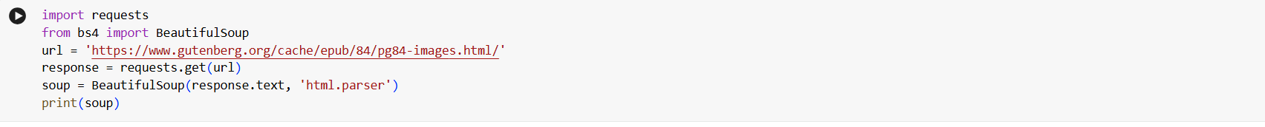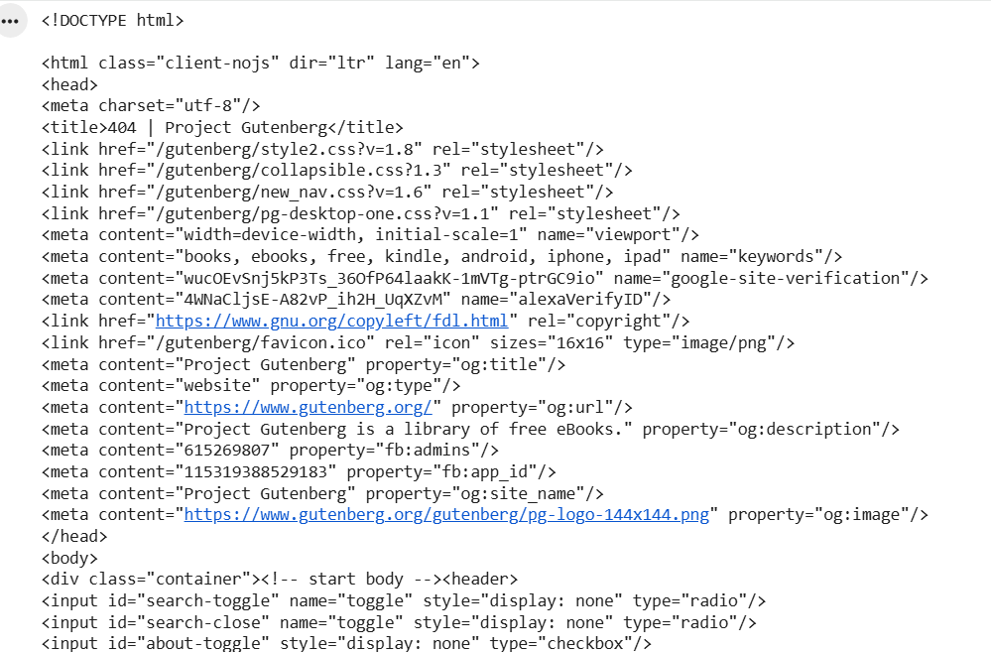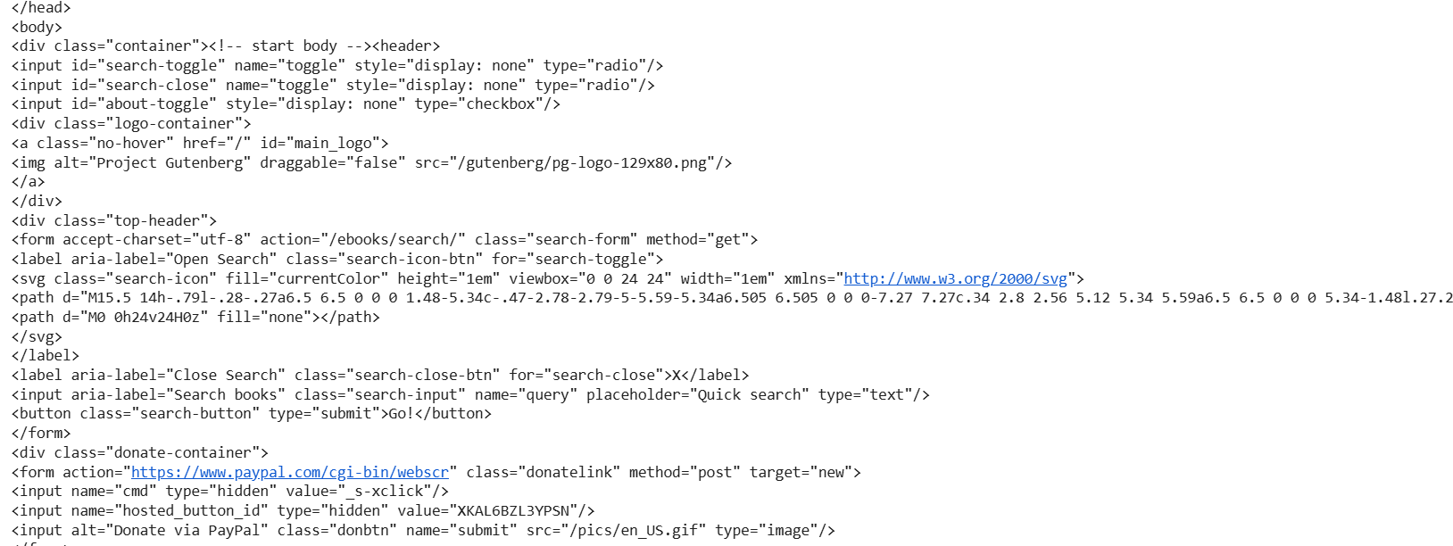
Error : In the above code snippet the output we got is nothing but the html content only but bot the text . this error occurred due to the wrong link (extra slash at the end ) that was given to requests module

This is corrected using the below code snippet 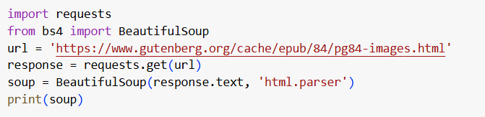

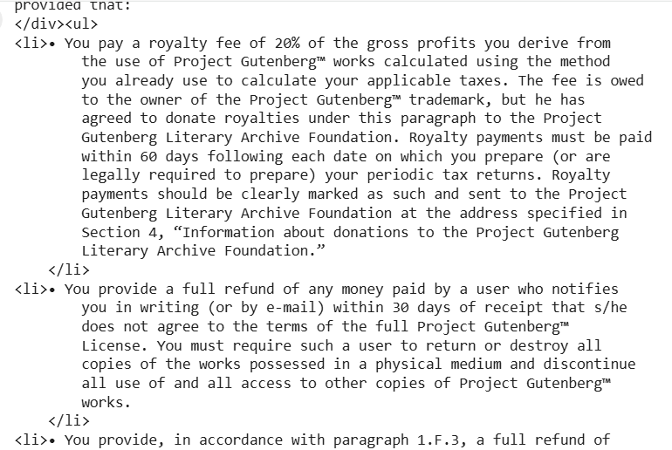
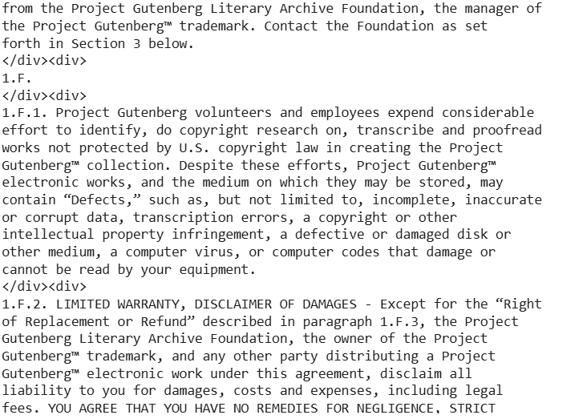

Now got the output like this

- Lack of packages error
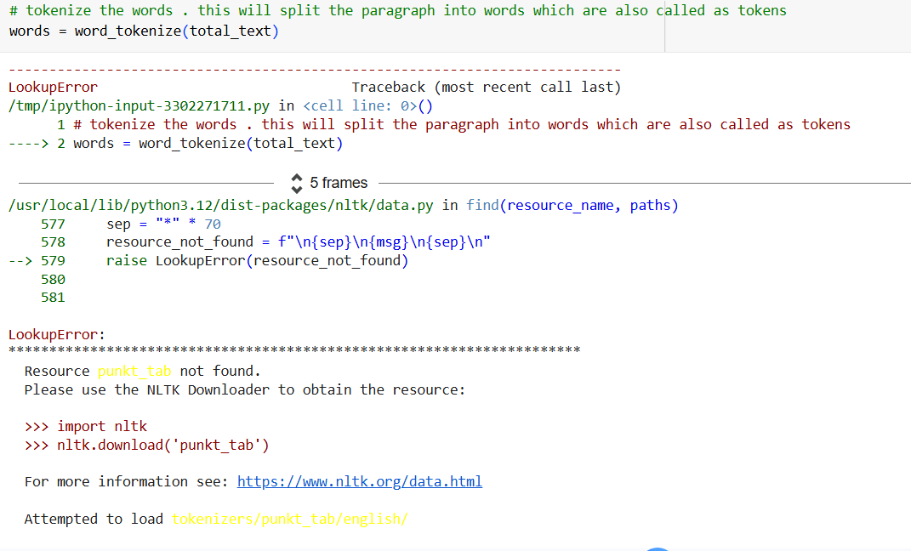

This is because even though we have imported the necessary libraries we have to download even more sub resources every time . this code is corrected using the following code

