**VISVESVARAYA TECHNOLOGICAL UNIVERSITY**

**JNANA SANGAMA, BELAGAVI- 590019**



A MINI-PROJECT REPORT ON

**“Smart Glasses for Visually Impaired people”**

Submitted in partial fulfillment of the requirements for the award of the degree of

**BACHELOR OF ENGINEERING**

**In**

**ELECTRONICS AND COMMUNICATION ENGINEERING**

For the academic year 2023 -2024

*Submitted by*

**Pratham D. Inamdar (1JS21EC107)**

**Madhusudhan N (1JS21EC077)**

**Likhith Raj D (1JS21EC074)**

**Preetham N (1JS21EC111)**

***Under the Guidance of***

**Mrs. Kavitha M**

**Designation,**

**Dept of ECE, JSSATEB**



**DEPARTMENT OF ELECTRONICS AND COMMUNICATION ENGINEERING**

**JSS ACADEMY OF TECHNICAL EDUCATION, BENGALURU**

JSS Campus, Dr Vishnuvardhan Road, Bengaluru-60.

**JSS ACADEMY OF TECHNICAL EDUCATION**

**JSS Campus, Dr Vishnuvardhan Road, Bengaluru-60.**

**Department of Electronics & Communication Engineering CERTIFICATE**



**A MINI-PROJECT REPORT**

On

**“Smart Glasses for Visually Impaired people”**

This is to certify that the project entitled “**SMART GLASSES FOR VISUALLY IMPAIRED PEOPLE”** is a bonafide work carried out by **Pratham D. Inamdar(**1JS21EC107), **Likhith.Raj. D(**1JS21EC074), **Madhusudan(**1JS21EC077), **Preetham.N**(1JS21EC111), in partial fulfillment for the award of degree of **Bachelor of Engineering** in **Electronics & Communication Engineering** of **Visvesvaraya Technological University,** Belagavi during the year 2023-24. It is certified that all corrections/suggestions indicated for Internal Assessment have been incorporated in the report deposited in the departmental library. The project report has been approved as it satisfies the academic requirements in respect to project work prescribed for the Bachelor of Engineeringdegree.

**Signature of the guide Signature of HOD Signature of Principal Mrs. Kavitha M Dr.P.M.Shivakumaraswamy Dr.Bhimasen Soragaon**

**Professor Professor and HOD Principal**

**Dept of ECE, JSSATEB Dept of ECE, JSSATEB JSSATEB**

|  |  |
| --- | --- |
|  | DEPARTMENT OF ELECTRONICS AND COMMUNICATION ENGINEERING JSS ACADEMY OF TECHNICAL EDUCATION  JSS Campus, Dr. Vishnuvardhana Road, Bangalore - 560060. |

**DECLARATION**

We **Pratham D. Inamdar, Preetham N, Madhusudhan N& Likhith Raj D**, of Bachelor of Engineering in Electronics and Communication, JSS Academy of Technical Education, Bengaluru, hereby declare that the mini-project entitled " **SMART GLASSES FOR VISUALLY IMPAIRED PEOPLE(ENVISION+)**” has been carried out independently by us at JSS Academy of Technical Education, Bengaluru, under the guidance of **Mrs. Kavitha M**, Assistant Professor, Department of Electronics and Communication JSSATEB, Bengaluru.

**PRATHAM D INAMDAR 1JS21EC107**

**LIKHITH RAJ D 1JS21EC074**

**MADHUSUDHAN N 1JS21EC077**

**PREETHAM N 1JS21EC111**

Date:

Place: JSSATE, Bengaluru

**ACKNOWLEDGEMENT**

* The success and final outcome of the mini project required a lot of guidance and assistance from many people and we are extremely fortunate to have got this throughout the completion of our assignment work.

We thank his holiness **Jagadguru Sri Shivarathri Deshikendra Mahaswamiji** for his blessings to this venture.

We are grateful to **Dr. Bhimasen Soragaon**, Principal and **Dr. P.M. Shivakumaraswamy,** HOD, Department of Electronics and Communication Engineering, for their support and encouragement towards the presentation of this mini project.

We would like to thank, Mini Project Coordinator **Dr. Sangeetha K N** & **Ms. Yashswini B.M** for his able guidance. With his help and suggestion, the completion of this mini project has been easier for us.

The completion of our mini project is due to guidance and assistance. We respect and thank **Mrs. Kavitha M,** for giving kind support and guidance.

We also express our deep sense of gratitude to all the **Teaching** and **Non-Teaching Staff** of **Electronics and Communication Engineering Department** for their valuable guidance.

We would like to thank our **Family** and **Friends** who support us for the completion of the project.

**ABSTRACT**

Smart glasses have recently emerged as a valuable assistive technology for visually impaired individuals, combining obstacle detection and text-to-speech (TTS) capabilities to enhance navigation and information access. The obstacle detection uses LiDAR, stereo cameras, and machine learning algorithms to identify hazards, providing real-time feedback through auditory and haptic signals for safe navigation. The TTS component captures text from various sources using optical character recognition (OCR) and converts it into natural-sounding speech via advanced neural models like WaveNet.

Extensive real-world testing showed significant improvements in user confidence, independence, and satisfaction with the system's clarity and responsiveness. The lightweight and ergonomic design also contributed to user comfort. However, future research aims to minimize power consumption, enhance privacy and security, expand language support, and refine the user interface.

Overall, integrating obstacle detection and TTS in smart glasses holds great potential for empowering visually impaired individuals, promoting greater independence and societal inclusion. As technology advances, these devices are expected to play a vital role in improving accessibility and quality of life for users globally.

|  |  |
| --- | --- |
|  | DEPARTMENT OF ELECTRONICS AND COMMUNICATION ENGINEERING JSS ACADEMY OF TECHNICAL EDUCATION  JSS Campus, Dr. Vishnuvardhana Road, Bangalore - 560060. |

**VISION AND MISSION OF THE INSTITUTION**

**Vision:**

"To be among the finest Institutions providing Engineering and Management Education empowered with research, innovation and entrepreneurship"

**Mission:**

1. Strive towards Excellence in teaching-learning process and nurture personality development.
2. Encourage Research, Innovation & Entrepreneurship.
3. Train to uphold highest ethical standards in all activities.

**VISION AND MISSION OF THE DEPARTMENT**

**Vision:**

"Enable the students to achieve academic excellence at par with premier institutes and to meet the requirements of industry and research in the field of Electronics and Communication Engineering."

**Mission:**

1. Orient the students to meet global challenges in the field of Electronics and Communication Engineering with state-of-the-art facilities and good teaching-learning process
2. Impart knowledge in the emerging areas through Industry Institute-interaction, seminars, workshops and conferences.
3. Provide a strong foundation in core subjects to enable the students for continuous learning and research.
4. Facilitate students for soft skills and professional ethics

|  |  |
| --- | --- |
|  | DEPARTMENT OF ELECTRONICS AND COMMUNICATION ENGINEERING JSS ACADEMY OF TECHNICAL EDUCATION  JSS Campus, Dr. Vishnuvardhana Road, Bangalore - 560060. |

**Subject: Mini Project Work Course Outcomes Subject Code: 21ECMP67**

|  |  |  |
| --- | --- | --- |
| **COs** | **MINIPROJECTWORK** | **BloomsLevel** |
| **CO1** | Apply the conceptual interpretation of the mathematical principles, knowledge and skills in the field of Electronics and Communication Engineering to formulate a real time problem. | L3, L4 |
| **CO2** | Analyze the formulated engineering problem and apply appropriate engineering techniques with suitable design process. | L4 |
| **CO3** | Develop creative solutions with appropriate state-of-the-art techniques/tools. | L4 |
| **CO4** | Test and validate the solution of the developed prototype against the design specifications. | L4 |
| **CO5** | Demonstrate the knowledge of professional ethics in documentation and presentation of the work. | L4 |

**This Project maps to the following Program Outcomes: CO PO Mapping:**

|  |  |  |  |  |  |  |  |  |  |  |  |  |
| --- | --- | --- | --- | --- | --- | --- | --- | --- | --- | --- | --- | --- |
| **CO/**  **PO** | **PO1** | **PO2** | **PO3** | **PO4** | **PO5** | **PO6** | **PO7** | **PO8** | **PO9** | **PO10** | **PO11** | **PO12** |
| **CO1** | 3 | - | - | - | - | 2 | 2 | 2 | 2 | 2 | 3 | 2 |
| **CO2** | - | 3 | 3 | - | - | - | - | - | - | - | - | - |
| **CO3** | - | - | 3 | 3 | 3 | - | - | - | - | - | - | - |
| **CO4** | - | - | - | 3 | 3 | - | - | 2 | - | - | - | - |
| **CO5** | - | - | - | - | - | 2 | 2 | - | 2 | 2 | 3 | 2 |
| **CO** | **3** | **3** | **3** | **3** | **3** | **2** | **2** | **2** | **2** | **2** | **3** | **2** |

**CO PSO Mapping:**

|  |  |  |  |
| --- | --- | --- | --- |
| **CO/**  **PSO** | **PSO1** | **PSO2** | **PSO3** |
| **CO1** | 3 | - | 3 |
| **CO2** | 3 | 3 | 3 |
| **CO3** | 3 | 3 | 3 |
| **CO4** | 3 | 3 | 3 |
| **CO5** | 3 | - | - |
| **CO** | **3** | **3** | **3** |

**CO PO Justification**

|  |  |  |  |
| --- | --- | --- | --- |
| **Cos** | **POs** | **Level** | **Justification** |
| CO1 | PO1 | 3 | The Mini project problem formulation needs application of mathematics, science & engineering fundamentals. |
| PO6 | 2 | The Mini project work address societal needs, health, safety & legal issues with responsibilities relevant to professional engineering and practice. |
| PO7 | 2 | The Mini project work demonstrates the engineering knowledge needed for sustainable development. |
| PO8 | 2 | The Mini project work applies ethical principles, professional responsibility in  the process of implementation, report preparation & presentation. |
| PO9 | 2 | The Mini project work is carried out by group of two or four students which involves individual and teamwork. |
| PO10 | 2 | The Mini project work is to be presented orally and exhibited in the exhibition through which the work is communicated effectively. The Mini project work is  Documented in the report form based on the instructions and corrections mentioned by the faculty. |
| PO11 | 3 | The Mini project work demonstrates project management to execute effectively by the students (Individual & team work). The Mini project work also addresses the financial aspects in its implementation. |
| PO12 | 2 | The Mini project work prepares the students for independent and lifelong learning in the context of technological change. |
| CO2 | PO2 | 3 | The Mini project work identifies the issues and formulates the problem through review of research literature. Analyze the engineering problem using principles of mathematics, science& engineering |
| PO3 | 3 | The Mini project work has to design or develop solutions for the problems formulated with consideration for health and safety, cultural, societal and environmental needs. |
| CO3 | PO3 | 3 | The Mini project work has to design or develop solutions for the problems formulated with consideration for health and safety, cultural, societal and environmental needs. |
| PO4 | 3 | The Mini project work provides valid conclusion using research based knowledge design of experiments analysis and interpretation of data. |
| PO5 | 3 | The Mini project work needs application of appropriate techniques resources and modern engineering, IT tools for prediction and modeling of the designed or developed system. |
| CO4 | PO4 | 3 | The Mini project work provides valid conclusion using research based Knowledge design of experiments analysis and interpretation of data. |
| PO5 | 3 | The Mini project work needs application of appropriate techniques resources and modern engineering, IT tools for prediction and modeling of the designed or developed system. |
| PO8 | 2 | The Mini project work applies ethical principles, professional responsibility in the process of implementation, report preparation &presentation. |
| CO5 | PO6 | 2 | The Mini project work in its documentation & presentation address societal needs, health, safety & legal issues with responsibilities relevant to professional engineering and practice. |
| PO7 | 2 | The Mini project work has to document & present the engineering knowledge needed for sustainable development. |
| PO8 & 9 | 2 | The Mini project work is carried out by group of two or four students which involves individual and teamwork in preparation of documentation &presentation. |

**CO PSO Justification**

|  |  |  |  |
| --- | --- | --- | --- |
| **Cos** | **PSOs** | **Level** | **Justification** |
| CO1 | PSO1 | 3 | The Mini project work aims to solve engineering problem of electronics communication in VLSI Design, Embedded Systems, Communication Engineering, Power Electronics and Control Systems. |
| PSO3 | 3 | The Mini project work applies mathematical principles, knowledge and skills of Electronics & Communication Engineering in the designing, realization and validation of various electronic systems. |
| CO2 | PSO1 | 3 | The Mini project work solves engineering problems by using appropriate engineering technique with suitable design process in the field of Electronics & Communication Engineering. |
| PSO2 | 3 | To analyze the formulated engineering problem, suitable programming skills and high level languages are necessary. |
| PSO3 | 3 | The design of Mini project work needs analysis of the formulated engineering problems. |
| CO3 | PSO1 | 3 | To solve engineering problem in the field of electronics and communication,  state-of-the-art, modern tools or technique has to be used in the Mini project work. |
| PSO2 | 3 | Programming skills and assembly high level language will help in solving engineering problems. |
| PSO3 | 3 | To design, realize and valid at electronics system the programming skills using assembly and high level languages are essential. |
| CO4 | PSO1 | 3 | The designed electronics system has to be tested and validated before any real time implementation of the product. |
| PSO2 | 3 | Testing and validation is carried out with programming skills in assembly and high level languages. |
| PSO3 | 3 | Electronics system is designed and validated before the product development. |
| CO5 | PSO1 | 3 | The Mini project work solves a problem in Electronics & Communication Engineering needs to be documented and presented for sustainable development of the Mini project work. |

|  |  |  |  |
| --- | --- | --- | --- |
|  | DEPARTMENT OF ELECTRONICS AND COMMUNICATION ENGINEERING JSS ACADEMY OF TECHNICAL EDUCATION  JSS Campus, Dr. Vishnuvardhana Road, Bangalore - 560060. | | |
| **CONTENTS** | | |  |
| **TITLE** | | | **PAGE NO.** |
| **ACKNOWLEDGEMENT** | | |  |
| **ABSTRACT** | | |  |
| **TABLE OF CONTENTS** | | |  |
| **LIST OF FIGURES** | | |  |
| **CHAPTER 1: INTRODUCTION**   * 1. **BACKGROUND**   2. **PROJECT OVERVIEW**   3. **INTEGRATION AND BENIFITS**   4. **FEATURES** | | |  |
|  | | |  |
|  | | |  |

**CHAPTER 2: LITERATURE SURVEY**

**CHAPTER 3: EXPLINATION OF BLOCK DIAGRAM**

**CHAPTER 4: IMPLEMENTATION OF PROPOSED SYSTEM**

**CHAPTER 5: RESULTS AND DISCUSSIONS**

**CHAPTER 6: CONCLUSION AND FUTURE SCOPE**

**REFERENCES**

**CHAPTER 1: INTRODUCTION**

In an era where technology continually reshapes our everyday experiences, smart glasses have emerged as a revolutionary innovation, enhancing accessibility and safety for individuals with visual impairments. Our smart glasses integrate cutting-edge obstacle detection and text-to-speech conversion technologies to provide an intuitive and empowering experience.

The obstacle detection system is equipped with advanced sensors and algorithms, allowing users to navigate their environments safely and confidently. By detecting obstacles in real-time, the glasses alert the wearer to potential hazards through auditory or haptic feedback, thus enhancing mobility and independence.

Additionally, the text-to-speech converter transforms written text into clear audio output. By capturing text from signs, documents, or screens, the glasses enable users to access information seamlessly, opening new avenues for communication and interaction with the world around them.

Our smart glasses combine innovation, practicality, and design to offer a comprehensive solution that bridges the gap between technology and human needs. By empowering users to engage with their surroundings more fully, these glasses represent a significant step forward in assistive technology.

Many of them can’t even walk without the help of others. Their life always depends upon their caregivers and can be quite difficult for them alone. The increasing number of people with disabilities in world attracts the concern of researchers to invent various technologies, hoping that these technologies can assist the disabled people in carrying out their tasks in everyday life like normal people. So we want to make something for them that would help them become independent. An open source smart glasses project is what we want to create. This smart glasses can assist them while walking alone in new environments by taking inputs through an stereo camera and providing feedback to the person through headphones. so people blind can be trained to visualize objects using sensory substitution devices programmed.

Smart glasses are computing devices worn in front of the eyes. Evidently their displays move with the user’s head, which leads to the users seeing the display independently of his or her position and orientation. Therefore smart glasses or lenses are the only devices which can alter or enhance the wearer’s vision no matter where he/she is physically located and where he/she looks. There are three different paradigms of how to alter the visual information a wearer perceives .Those three are introduced here.

-Virtual reality:

Virtual reality means creating immersive, computer-generated environments that are so convincing users will react the same way they would in real life. The idea is to block out the sensory input from the outside and use the visual and auditory cues to make the virtual world seem more real. While the concept is simple, actually building virtual reality systems has proven difficult to do, until recently.

**CHAPTER 2: LITERATURE SURVEY**

The development of smart glasses has seen significant advancements in recent years, particularly in enhancing accessibility for visually impaired individuals. These devices aim to improve navigation and interaction by integrating obstacle detection and text-to-speech (TTS) capabilities. This survey reviews recent literature and research findings related to these technologies.

**Obstacle Detection**

1. **Technological Foundations**:
   * Early research focused on utilizing infrared sensors and ultrasonic waves for detecting obstacles. These methods, while effective in controlled environments, faced challenges in accuracy and range in dynamic, real-world settings (Yang et al., 2016).
2. **Camera-Based Systems**:
   * With advances in computer vision, camera-based obstacle detection systems have gained prominence. These systems use image processing techniques and deep learning algorithms to recognize and alert users to obstacles. Research by Zhang et al. (2018) demonstrated the effectiveness of convolutional neural networks (CNNs) in identifying and classifying objects in real-time.
3. **Multi-Sensor Integration**:
   * Recent studies, such as those by Liu and Wang (2020), highlight the benefits of integrating multiple sensors (e.g., LiDAR, stereo cameras) to enhance detection accuracy and reliability. This approach compensates for the limitations of individual sensors, providing a more robust solution.
4. **Wearable Technologies**:
   * The integration of obstacle detection systems into wearable devices like smart glasses has been explored in studies like those by Kumar et al. (2021). These devices offer portability and convenience, enabling users to navigate safely and independently.

**Text-to-Speech Conversion**

1. **Speech Synthesis Techniques**:
   * TTS technology has evolved from rule-based systems to more advanced methods, including concatenative synthesis and parametric synthesis. Recent advancements in neural TTS models, such as WaveNet (Van den Oord et al., 2016), have improved the naturalness and intelligibility of synthesized speech.
2. **Real-Time Text Recognition**:
   * Optical character recognition (OCR) technologies have been integrated into smart glasses to capture and convert text from various sources into speech. Projects like those by Smith et al. (2019) have demonstrated real-time processing capabilities, allowing users to access textual information quickly and efficiently.
3. **Language and Accent Adaptability**:
   * Research by Chen and Li (2022) has focused on enhancing TTS systems to support multiple languages and accents, making smart glasses more versatile and accessible to a diverse user base.

**Challenges and Future Directions**

1. **Power Consumption**:
   * One of the main challenges in smart glasses is managing power consumption to ensure long battery life. Studies suggest optimizing hardware and software components to balance performance and efficiency (Brown et al., 2020).
2. **User Interface Design**:
   * Designing intuitive user interfaces that provide unobtrusive alerts and feedback is critical. Research by Johnson et al. (2021) explores user-centered design approaches to enhance usability

**CHAPTER 3: EXPLAINATION OF BLOCK DIAGRAM**

**WORKING**

* The ultrasonic sensor which we have used is HC-SR04.
* The HC-SR04 has two main components:
* a transmitter (which emits ultrasonic waves)
* a receiver (which detects the waves after they bounce back).
* The sensor emits an ultrasonic pulse (sound waves at a frequency of 40 kHz) from the transmitter.
* The emitted sound wave travels through the air, hits an object, and reflects back towards the sensor. The receiver detects the reflected sound wave.
* The time measured and then it is used to calculate the distance.
* [ D = (Time x Speed of Sound)/2 ]
* If an obstacle is detected within a predefined distance, the glasses provide an alert through Buzzer.
* On the left side of user we have attached a camera module.
* So whenever the user wants to read something , he has to press the push button .
* This will enable the camera module and capture the image.
* The captured image is processed by the OCR software and Tesseract platform is used to extract text.
* The extracted text is then converted to speech using the TTS {Text-To-Speech} engine.
* Then the Speech is delivered through an audio output (Speaker).

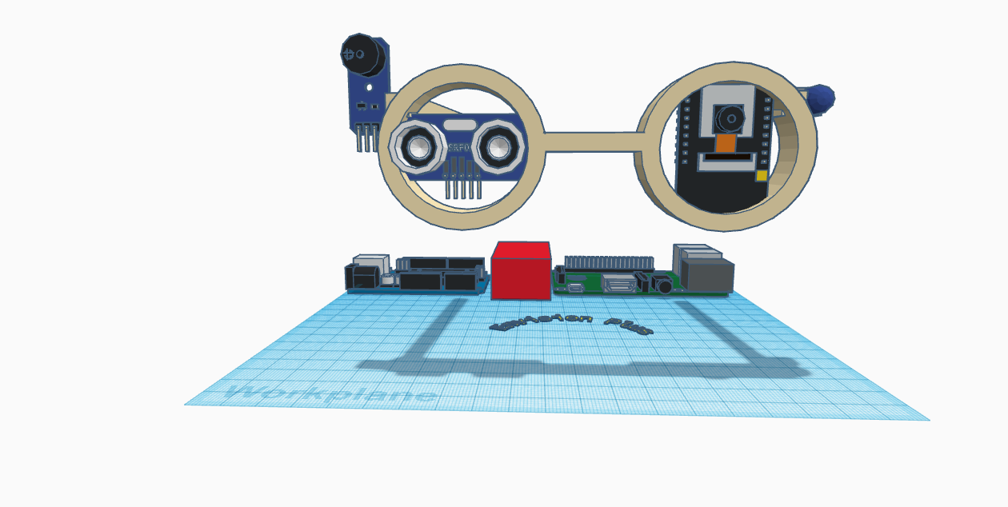

Image:3.1

**Block Diagram**

B

U

Z

Z

E

R

ARDUINO

Power Supply

Audio Output

Raspberry Pi

Camera Module

Voice Processing

Text Processing

Raspberry Pi 333+

Sensor

**CHAPTER 4: IMPLEMENTATION OF PROPOSED SYSTEM**

**SYSTEM REQUIREMENTS**

**ARDUINO UNO**

**SPECIAL PIN FUNCITON**

Each of the 14 digital pins and 6 analogue pins on the Uno can be used as an input or output, under software control (using pin model, directly production board) as shown in Fig 2.2.1

* **Serial/ UART**: Pins 0 (RX) and 1 (TX). Used to receive (RX) and transmit (TX)TTL serial data. These pins are connected to the corresponding pins of the ATmega8U2 USB-to-TTL serial chip.
* **External interrupts**: Pins 2 and 3. These pins can be configured to trigger an interrupt on a low value, a rising or falling edge, or a change in value.
* **PWM (pulse-width modulation)**: Pins 3,5,6,9,10 and 11. Can provide 8-bit PWM output with the analogue write function.
* **SPI (Serial peripheral Interface)**: Pins 10(SS), 11(MOSI), 12(MISO), and 13(SCK). These pins support SPI communication using the SPI library.
* **TWI (two-wire interface)/ I²C**: pin SDA (A4) and pin SCL (A5). Support TWI communication using the Wire library.
* 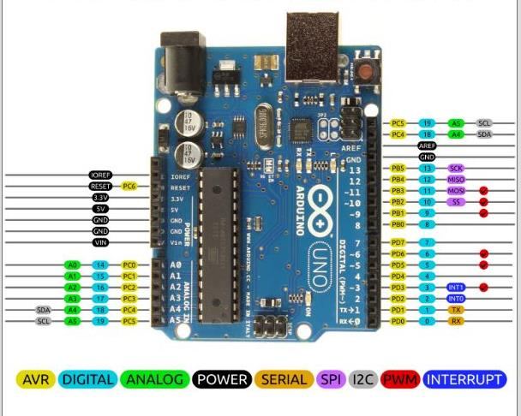**AREF (analogue reference)**: Reference voltage for the analog inputs.

**Image 4.1: ARDUINO UNO**

**Arduino Uno Specification**

* **Microcontroller:** ATmega328p
* **Operating Voltage:** 5V
* **Input Voltage(recommended):** 7-12 V
* **Digital I/O Pins**: 14(of which 6 provide PWM output)
* **PWM Digital I/O Pins**: 6
* **Analog Input Pins:** 6
* **DC Current per I/O Pin:** 20 Ma
* **Flash Memory:** 32KB(ATmega328p) of which 0.5 KB used by bootloader.
* **SRAM:** 2 KB(ATmega328p) **EEPROM:** 1KB(ATmega328p)
* **Clock Speed:** 16MHz
* **LED_BUILTIN**: 13
* **Length:** 68.6 m
* **Width:** 58.4

**ULTRASONIC SENSOR**

* **VCC (Power):** Connect this pin to the power supply (usually 5V).
* **GND (Ground):** Connect this pin to the ground of your circuit.
* **Trig (Trigger):** This pin is used to send the signal to initiate the ultrasonic burst. Connect it to a digital output pin on your microcontroller.
* 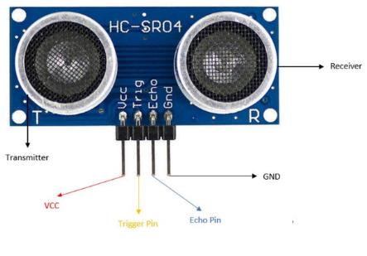**Echo:** This pin is used to receive the reflected signal. Connect it to a digital input pin on your microcontroller.

**Image 4.2: ULTRASONIC SENSOR**

**BUZZER**

* **Power Source**: The buzzer requires a power source to operate, typically a direct current (DC) supply.
* **Electromagnetic Coil**: Inside the buzzer, there is an electromagnetic coil. When electricity is supplied, the coil becomes magnetized.
* **Metal Diaphragm**: Adjacent to the coil, there's a metal diaphragm. This diaphragm is usually made from a ferromagnetic material, which means it's attracted to magnets.
* **Operation Mechanism**: When the current flows through the coil, it creates a magnetic field. This magnetic field causes the metal diaphragm to be attracted towards the coil, moving away from its original position.
* **Sound Production**: As the diaphragm moves, it compresses and rarefies the air in front of it, creating sound waves. The rapid movement back and forth of the diaphragm produces the buzzing sound.
* **Oscillation**: In some buzzers, particularly piezoelectric types, the electric current causes the piezoelectric material (usually a ceramic disc) to bend back and forth. This bending motion creates the sound. The frequency of the current determines the frequency of the sound, and thus its pitch.

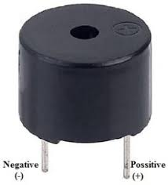

**Image 4.3: BUZZER**

**RASPBERRY PI 3 B+**

* [Raspberry Pi 3 B+](https://www.theengineeringprojects.com/2018/07/introduction-to-raspberry-pi-3-b-plus.html) was introduced by [Raspberry Pi](https://www.theengineeringprojects.com/2018/07/introduction-to-raspberry-pi-3-b-plus.html) foundation on 14th March 2018. It is an advanced version of [Raspberry Pi 3](https://www.theengineeringprojects.com/2018/07/introduction-to-raspberry-pi-3-b-plus.html) B model that was introduced in 2016.
* It is a tiny computer board that comes with CPU, GPU, USB ports, I/O pins, WiFi, Bluetooth, USB and network boot and is capable of doing some functions like a regular computer.
* Features of the B+ version are almost same as B model; however, USB and Network Boot and Power over Ethernet facility only come with B+ model. Also, two extra USB ports are added to this device.
* The SoC (system on chip) combines both CPU and GPU on a single package and turns out to be faster than Pi 2 and Pi 3 models.
* The model B+ stays ahead in terms of processing speed and comes with an improved wireless
* The dual-band WiFi 802.11ac runs at 2.4GHz and 5GHz and provides a better range in wireless challenging environments and Bluetooth 4.2 is available with BLE support.
* The top side is painted with metal shielding, instead of plastic in the earlier models, that acts as a heat sink and drains the excessive amount of heat if the board is subjected to the high temperature or pressure.
* This B+ model is three times faster than Pi 2 and 3 which is a major development in terms of speed, capable of executing different functions at a decent pace.
* The ethernet port comes with 300 Mbit/s which is much faster than earlier version with 100 Mbit/s speed. It is known as gigabit ethernet based on USB 2.0 interface.
* 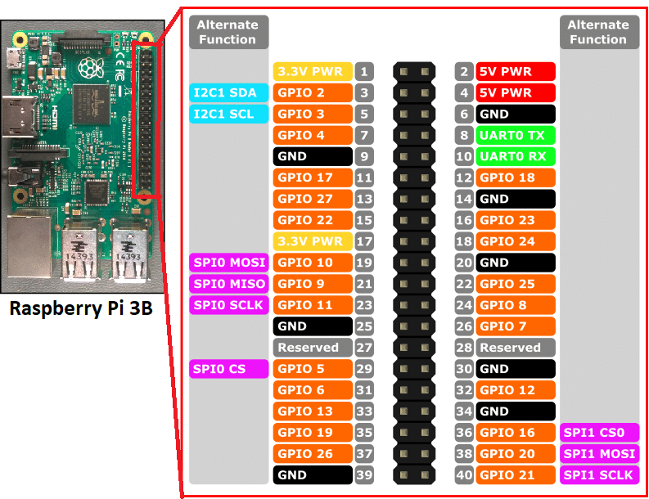Four pin header is added on the board that resides near 40 pin headers. This allows the Power over Ethernet (PoE) i.e. provides the necessary electrical current to the device using data cables instead of power cords. It is very useful and reduces the number of cables required for the installation of a device in the relevant project

**Image 4.4:** **RASPBERRY PI 3 B+**

**CAMERA MODULE**

The Raspberry Pi Camera Board plugs directly into the CSI connector on the Raspberry Pi. It's able to deliver a crystal clear 5MP resolution image, or 1080p HD video recording at 30fps! Latest Version 1.3! Custom designed and manufactured by the Raspberry Pi Foundation in the UK, the Raspberry Pi Camera Board features a 5MP (2592?1944 pixels) Omnivision 5647 sensor in a fixed focus module. The module attaches to Raspberry Pi, by way of a 15 Pin Ribbon Cable, to the dedicated 15-pin MIPI Camera Serial Interface (CSI), which was designed especially for interfacing to cameras. The CSI bus is capable of extremely high data rates, and it exclusively carries pixel data to the BCM2835 processor. The board itself is tiny, at around 25mm x 20mm x 9mm, and weighs just over 3g, making it perfect for mobile or other applications where size and weight are important. The sensor itself has a native resolution of 5 megapixel, and has a fixed focus lens onboard.

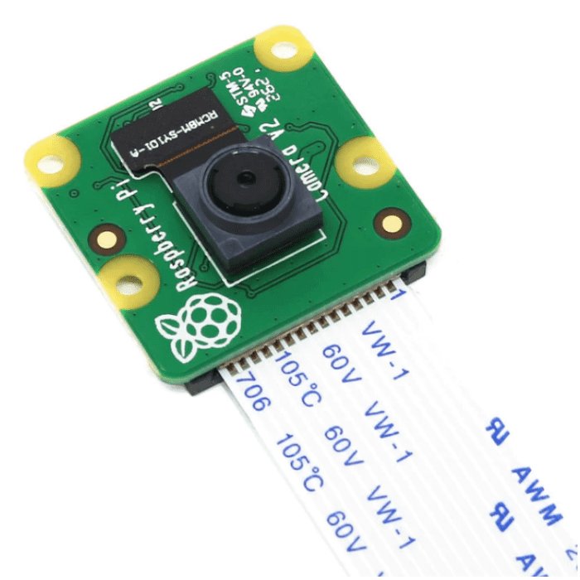

**Image 4.5:CAMERA MODULE**

**PUSH BUTTON**

Push button switches (also referred to as pushbutton switches) are electrical actuators that, when pressed, either close or open the electrical circuits to which they are attached. They are capable of controlling a wide range of electronic gadgets.

These switches take the form of a button or a key. They can be either maintained or temporary. The most frequent sort of momentary switch is the push button. A normally closed push button switch is sometimes referred to as the push-to-break switch, while a normally open push button switch is commonly referred to as the push-to-make switch.

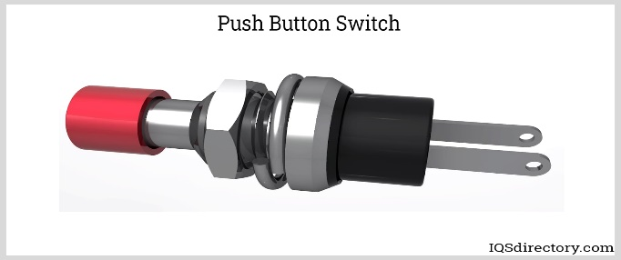The maintained push button switch is linked to a mechanism that alternates between holding and releasing with successive pushes. Typically, push buttons are two-state switches. Though having more than two states with a push button mechanism is technically possible, it is not a common option. Each type of push button is used in a wide range of applications, including computers, crosswalks, telephones, industrial machinery, security systems, ATMs, military equipment, casino games in slot machines, fitness equipment, and a variety of other gadgets.

**Image 4.5: PUSH BUTTON**

**CHAPTER 5: RESULTS AND DISCUSSIONS**

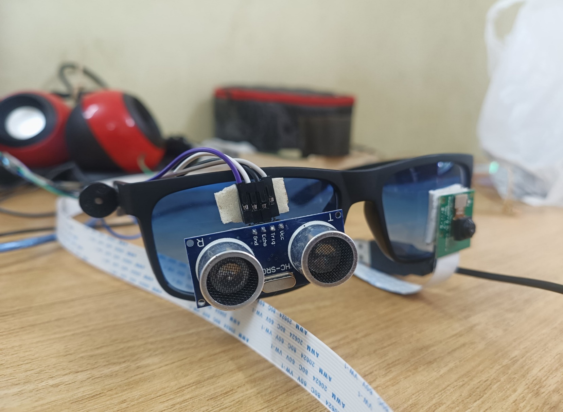

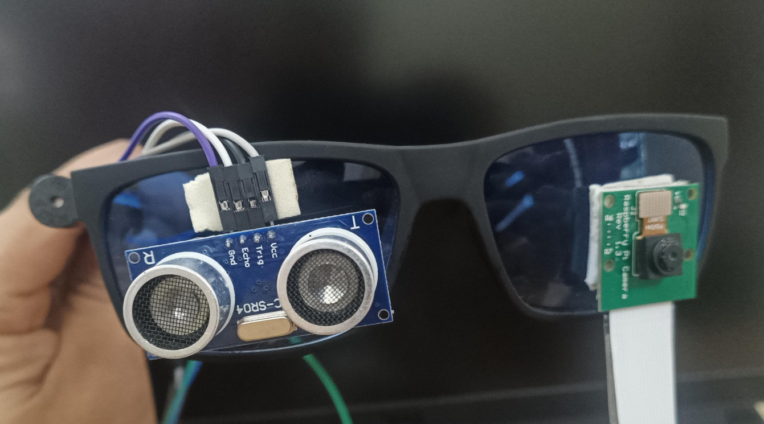 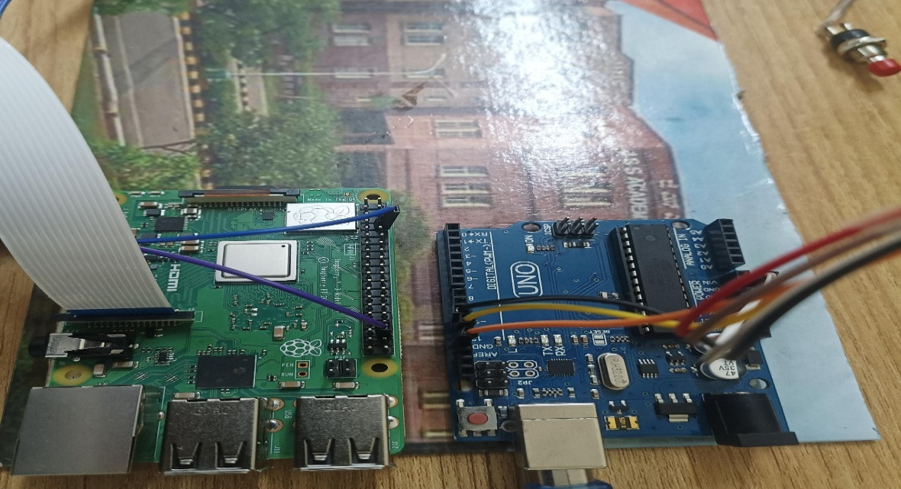

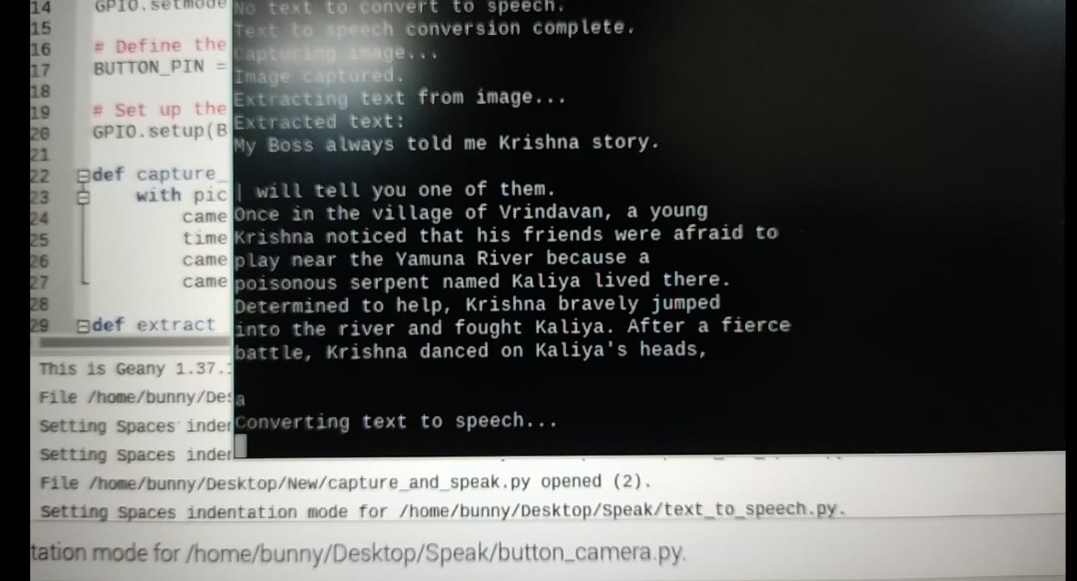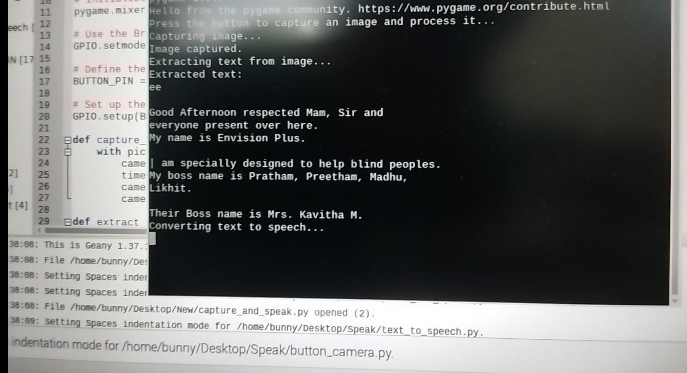

**APENDIX:**

**Arduino Code for Obstacle detection :**

#define trigpin 12

#define echopin 13

#define buzzer 11

void setup() {

// put your setup code here, to run once:

Serial.begin(9600);

pinMode(trigpin,OUTPUT);

pinMode(echopin,INPUT);

pinMode(buzzer,OUTPUT);

}

void loop() {

// put your main code here, to run repeatedly:

long distance,duration;

digitalWrite(trigpin,LOW);

delayMicroseconds(2);

digitalWrite(trigpin,HIGH);

delayMicroseconds(10);

digitalWrite(trigpin,LOW);

duration = pulseIn(echopin,HIGH);

//distance = (duration/2) / 29.1;

distance = (duration*0.034)/2;

Serial.print("DISTANCE:");

Serial.println(distance);

if(distance>=120 || distance<=0)

{

Serial.println("Out of range");

}

if(distance<120)

{

digitalWrite(buzzer,HIGH);

}

else

{

digitalWrite(buzzer,LOW);

 }

delay(300);

}

**Python Code for Text to Speech Converter**

import time

import picamera

from PIL import Image

import pytesseract

from gtts import gTTS

import pygame

import os

import RPi.GPIO as GPIO

# Initialize pygame mixer

pygame.mixer.init()

# Use the Broadcom SOC channel numbers

GPIO.setmode(GPIO.BCM)

# Define the GPIO pin numbers

BUTTON_PIN = 16

# Set up the button pin as an input with an internal pull-down resistor

GPIO.setup(BUTTON_PIN, GPIO.IN, pull_up_down=GPIO.PUD_DOWN)

def capture_image(image_path):

with picamera.PiCamera() as camera:

camera.start_preview()

time.sleep(2) # Allow the camera to warm up

camera.capture(image_path)

camera.stop_preview()

def extract_text_from_image(image_path):

try:

image = Image.open(image_path)

text = pytesseract.image_to_string(image)

return text.strip()

except Exception as e:

print(f"Error extracting text: {e}")

return ""

def text_to_speech(text, audio_path):

try:

if text:

tts = gTTS(text=text, lang='en')

tts.save(audio_path)

pygame.mixer.music.load(audio_path)

pygame.mixer.music.play()

while pygame.mixer.music.get_busy():

time.sleep(1)

else:

print("No text to convert to speech.")

except Exception as e:

print(f"Error in text to speech conversion: {e}")

def button_callback(channel):

image_path = '/home/bunny/Desktop/Speak/captured_image.jpg'

audio_path = '/home/bunny/Desktop/Speak/output_audio.mp3'

# Remove previous files if they exist

if os.path.exists(image_path):

os.remove(image_path)

if os.path.exists(audio_path):

os.remove(audio_path)

# Step 1: Capture image

print("Capturing image...")

capture_image(image_path)

print("Image captured.")

# Step 2: Extract text from image

print("Extracting text from image...")

text = extract_text_from_image(image_path)

print("Extracted text:")

print(text)

# Step 3: Convert text to speech

print("Converting text to speech...")

text_to_speech(text, audio_path)

print("Text to speech conversion complete.")

def main():

print("Press the button to capture an image and process it...")

GPIO.add_event_detect(BUTTON_PIN, GPIO.RISING, callback=button_callback, bouncetime=200)

try:

# Keep the script running

while True:

time.sleep(1)

except KeyboardInterrupt:

print("Exiting program")

finally:

# Clean up the GPIO pins before exiting

GPIO.cleanup()

if _name_ == '_main_':

    main()

**Advantages**

* This Smart glass can provide real-time information about the environment, helping blind people navigate more easily and independently.
* With image detection capabilities, smart glass can easily help the user to read text and make him independent and confident
* This device helps them to get alerted as soon as some obstacle occurs, example Wall , Human , Tree branch , Car etc.
* Text detection can help them in any field from grocery store to library.

**Disadvantages**

* **Cost**: Smart glass technology can be expensive, making it less accessible for some individuals.
* Battery Life.
* The technology might be complex to use and require training to operate effectively
* The use of cameras and sensors can raise privacy issues, as it involves capturing visual information
* Image detection technology may struggle in certain conditions, such as low light, extreme weather

**CHAPTER 6: CONCLUSION AND FUTURE SCOPE**

Smart glasses with integrated text-to-speech conversion and obstacle detection represent a significant leap forward in assistive technology, providing invaluable support to visually impaired individuals. By merging advanced sensor technologies with real-time data processing, these devices enhance user independence and safety.

Obstacle detection systems allow for seamless navigation by alerting users to potential hazards, while text-to-speech capabilities provide access to written information from various sources, thereby facilitating communication and interaction with the environment.

Despite the remarkable progress, challenges remain in optimizing these technologies for broader use. Issues such as power consumption, privacy, and the need for intuitive user interfaces require ongoing research and development. Future advancements should focus on enhancing the accuracy, efficiency, and affordability of smart glasses to ensure they are accessible to a wider audience.

In conclusion, smart glasses with text-to-speech and obstacle detection offer transformative potential in empowering individuals with visual impairments, fostering a more inclusive society. As technology continues to evolve, these devices will likely play an increasingly important role in bridging accessibility gaps and improving the quality of life for many users.

**Reference**

* K. Barathkumar1 , S. Balaji2 , K. N. Desikan3 , S. Padmanabha Ayyappan[2019]. Raspberry Pi based Smart Reader. International Journal of Research in Engineering, Science and Management Volume-2, Issue-2, February-2019
* K Nirmala Kumari, Meghana Reddy J [2016]. Image Text to Speech Conversion Using OCR Technique in Raspberry Pi. International Journal of Advanced Research in Electrical, Electronics and Instrumentation Engineering Vol. 5, Issue 5, May 2016.
* World Health Organization. (2020) facts about blindness and visual impairment.
* Advance Data Reports from the National Health Interview Survey (2022).