**WEB SCRAPING**

## **WORKSHEET – 1**

**In Q1 to Q9, only one option is correct, Choose the correct option:**

1. Which of the following extracts information from user generated content?

A) Java script tagging B) Web scraping

C) A/B testing D) MROCs

1. Which of the following is not a web scraping library in python?

A) selenium B) Beautiful soup

C) Requests C) scrapy

1. Selenium tests __________?

A) Browser based applications B) DOS applications

C) GUI applications D) All of the above

1. Task of crawling is performed by a complex software which is known as:

A) Scraper B) Crawler

C) Boat D) Spider

1. Which of the following commands is used to access name of a tag in Beautiful Soup?

A) tag.attrs B) tag.name

C) tag,id C) tag[‘id’]

1. Which of the following is the default parser in Beautiful Soup?

A) html.parser B) html5lib

C) lxml D) lxml-xml

1. In selenium the webdriver is used to?

A) design a test using selenese

B) test a web application on firefox only

C) execute tests on HtmlUnit browser

D) to download any content from a webpage

1. In selenium, driver**.find_elements_by_xpath(‘given xpath’)** returns:

A) the first webelement associated with the ‘given xpath’

B) the url of first webelement associated with the ‘given xpath’

C) the list of all webelements associated with the ‘given xpath’

D) all the attributes of the first webelement associated with the ‘given xpath’

1. The script **‘window.scrollBy(0,a)** scrolls the webpage by?

A) **‘a’** number of horizontal spaces

B) **‘a’** number of lines

C) **‘a’** number of pixels horizontally

D) **‘a’** number of pixels vertically

**In Q10, more than one options are correct, Choose all the correct options:**

1. Which of the following is(are) tags of HTML?

A) <a> B) <b>

C) <image> D) <href>

**Q10 to Q13 are subjective answer type questions, Answer them briefly.**

1. What is the main difference between a web scraper and a web crawler?

The main difference is that web crawlers usually focus on indexing the web while web scrapers extract or scrape data from webpages.

Web Scraping is a technique used to extract a large amount of data from websites and then saving it to the local machine in the form of XML, excel or SQL. The tools used for web scraping are known as web scrapers.

Web Crawling is analogous to a spider crawling but the place of crawling here is the web!. It basically visits a website and read web pages for the purpose of building entries for search engine index. The tools that are used for web crawling are known as web crawlers or spiders.

1. What is **‘robots.txt’** file? What is the use of **‘robots.txt’** file?

A robots.txt file is a simple text file which webmasters can create to tell web crawlers which parts of a website should be crawled and which should not. The file is stored in the main directory (root) on the server. When a crawler arrives at a website, it first reads the robots.txt file to determine which parts of the website it should crawl and which parts it should ignore, according to the so-called Robots Exclusion Standard Protocol. You don’t have to create a robots.txt file but it’s often advisable to do so.

1. What are static and dynamic web pages?

Static Web pages are very simple. It is written in languages such as HTML, JavaScript, CSS, etc. For static web pages when a server receives a request for a web page, then the server sends the response to the client without doing any additional process. And these web pages are seen through a web browser. In static web pages, Pages will remain the same until someone changes it manually.

Dynamic Web Pages are written in languages such as CGI, AJAX, ASP, ASP.NET, etc. In dynamic web pages, the Content of pages is different for different visitors. It takes more time to load than the static web page. Dynamic web pages are used where the information is changed frequently, for example, stock prices, weather information, etc.

**Q14 and Q15 are programming practice questions. Solve it using JUPYTER NOTEBOOK and paste the solution in your answer sheets.**

1. Write a python program to check whether a webpage contains a title or not.

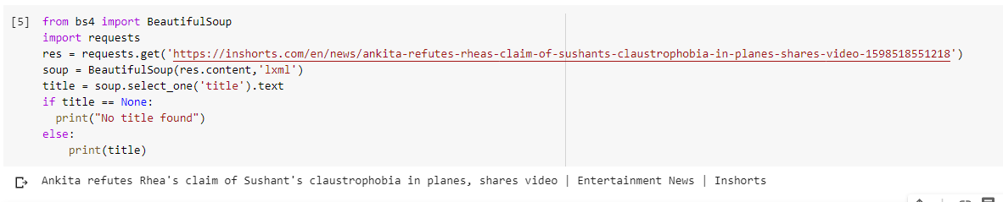

1. Write a python program to access the search bar and search button on images.google.com.

