**CSc 2720 - Data Structures: Lab 5**

**Deadline to Submit: [2/12/2021] [11:00 pm] ET(US)**

Failure to submit will result in a zero for this lab.

**Refresher:**

We have seen in class that deletion and insertion operations in a linked list necessitate a curr and prev pointers. To delete a node which curr references: **prev.next = curr.next;**

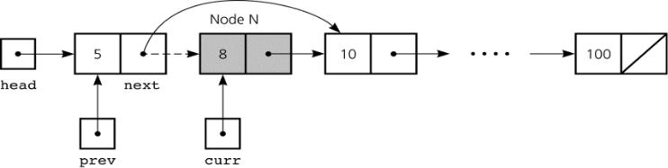

**Problem 1 [100 points]:**

Write a function deleteAtIndex that takes a linked list head and an integer index as an argument, looks for the node in the linked list at index index and delete the node from the linked list (disconnect it from the list).

**Assumptions:**

* Users always gives a valid index.
* User will **never delete the head/first node** in the list. (i.e: the user will never enter index=0).
* The linked list will have at least two elements.

**Example:** Given linked list -- [1,2,3], which looks like the following:

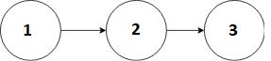

**Input:** index = 1

**Output:** List After Deletion: 1 3

--------------------------------------------Node Class---------------------------------------------

**public class** Node {

**int** item;

Node next;

* Node Constructor Node(**int** d) {

item = d; next=**null**;

}

}

------------------------------------------Tester Class---------------------------------------------

**public class** Tester{

**public static void** main(String[]args){

Node head = **new** Node(1);

Node second = **new** Node(2);

Node third = **new** Node(3);

head.next = second;

second.next = third;

/* The current linked list is as follows:

head second third

| | |

| | |

+----+------+ +----+------+ +----+------+

| 1 | o-------->| 2 | o-------->| 3 | null |

+----+------+ +----+------+ +----+------+ */

System.***out***.println("List Before Deletion"); *printLinkedList*(head);// Should be 1 2 3

* User wants to delete at index 2 *deleteAtIndex*(2,head);System.***out***.println("List After Deletion at index 2");

printLinkedList(head); // Should be 1 2

* User wants to delete at index 1 *deleteAtIndex*(1,head);System.***out***.println("List After Deletion at index 1");

printLinkedList(head); // Should be 2

}

* To pass the linked list to a function, you only need to pass the **head** **public static void** *deleteAtIndex*(**int** value, Nodehead){

Node prev, curr;

**int** counter= 0;// increment count as you traverse the list

* + INSERT CODE HERE

}

// Node traversal and printing

**public static void** printLinkedList(Nodehead){ **for**(Nodecur=head;cur!=**null**;cur=cur.next){System.***out***.print(cur.item+" ");

}

System.***out***.println();

}

}