1.

Code: 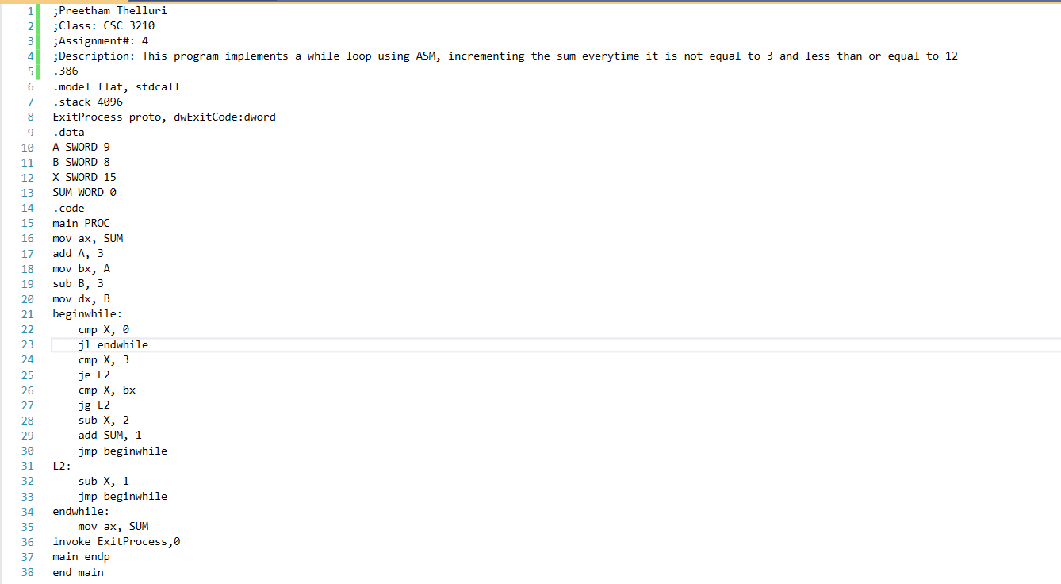

Value (I forgot to add comments at the time of this screenshot):

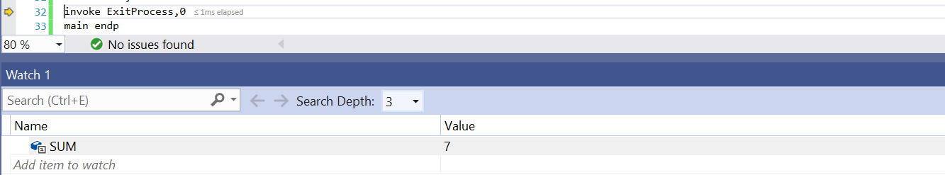

2.

Code:

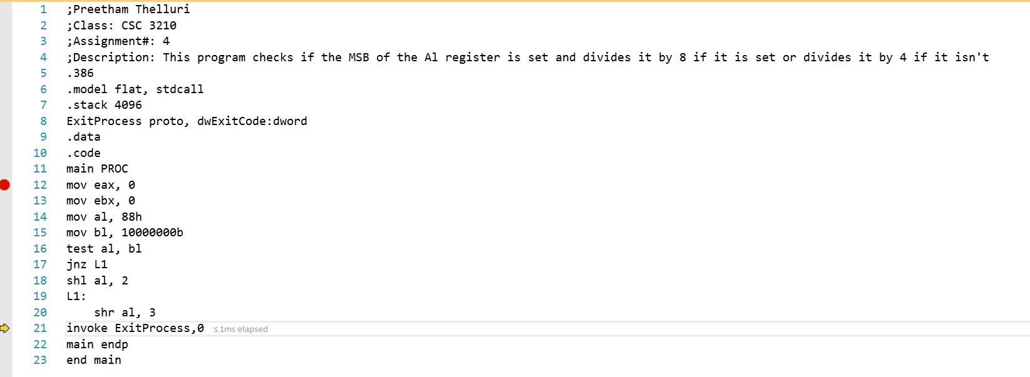

Value:

