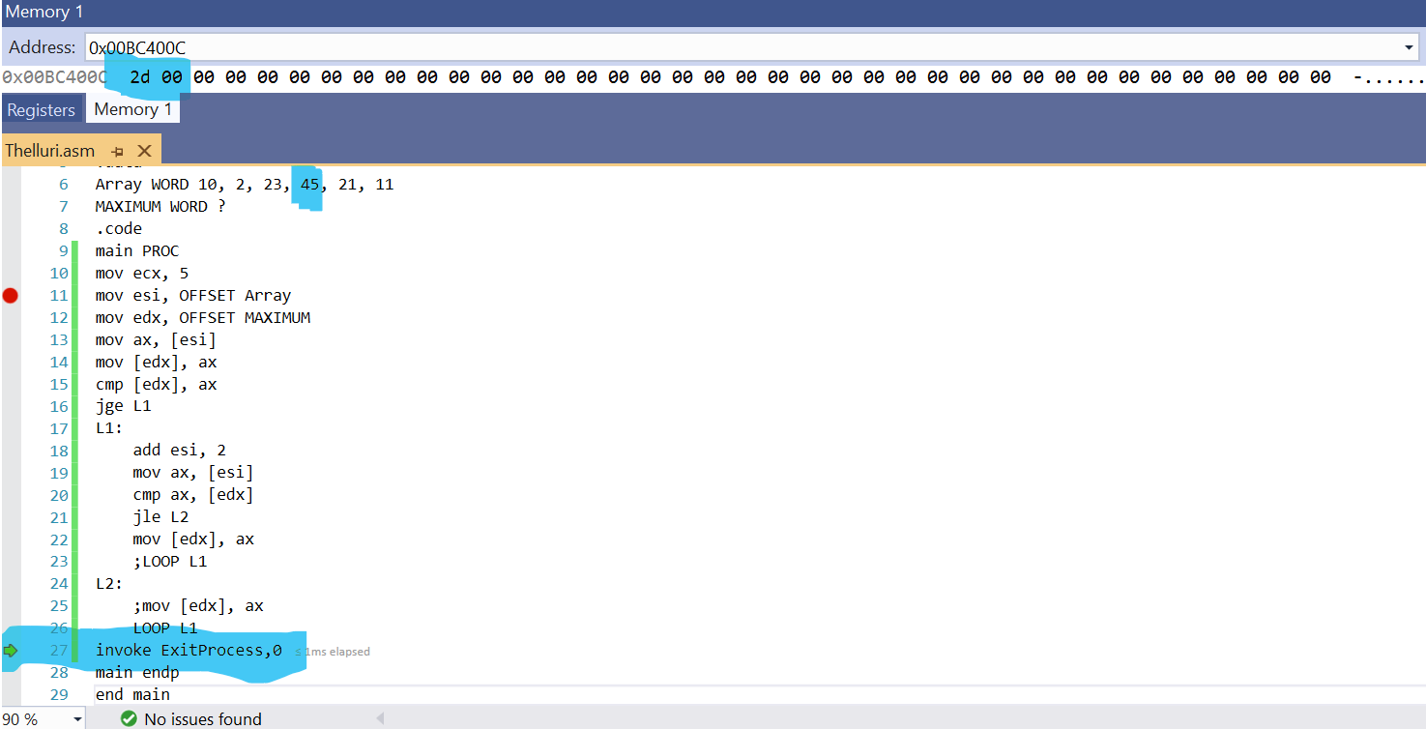

Source code:

.386

.model flat, stdcall

.stack 4096

ExitProcess proto, dwExitCode:dword

.data

Array WORD 10, 2, 23, 45, 21, 11

MAXIMUM WORD ?

.code

main PROC

mov ecx, 5

mov esi, OFFSET Array

mov edx, OFFSET MAXIMUM

mov ax, [esi]

mov [edx], ax

cmp [edx], ax

jge L1

L1:

add esi, 2

mov ax, [esi]

cmp ax, [edx]

jle L2

mov [edx], ax

;LOOP L1

L2:

;mov [edx], ax

LOOP L1

invoke ExitProcess,0

main endp

end main