CSC 3210

Computer Organization and Programming

Lab 4

Answer Sheet

Student Name: Preetham Thelluri

Section: CRN 19371

Debug through each line of code.

Take screenshot that includes code and register window.

Record the register content.

and explain the register contents.

Code:

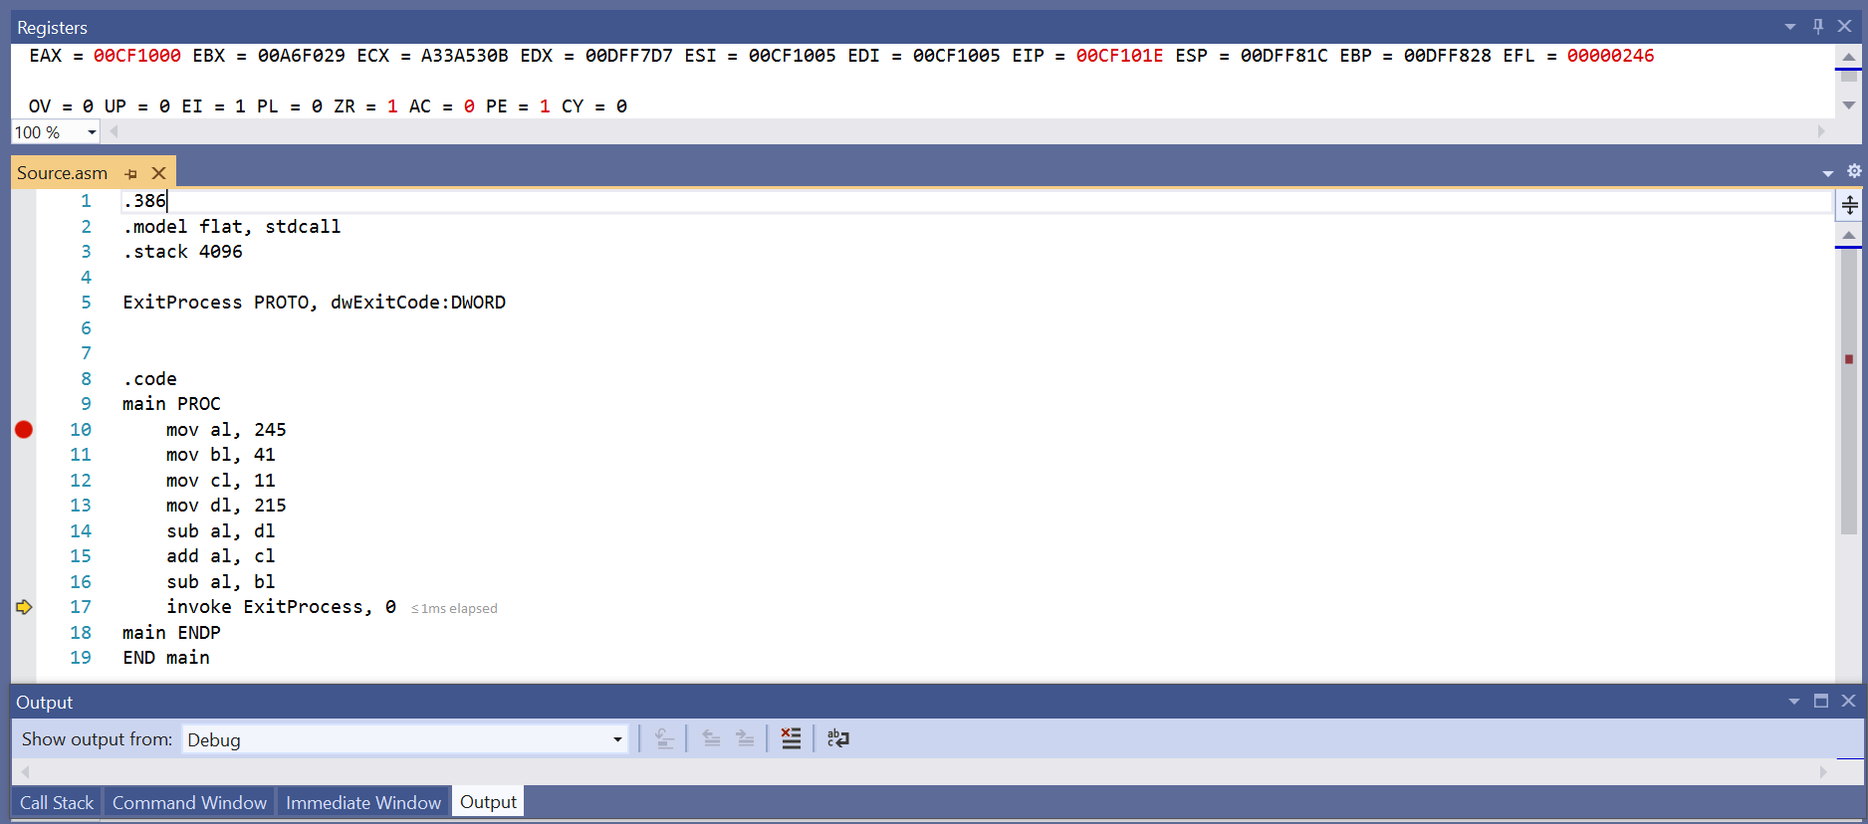

Line number: 10

Instruction: MOV AL, 245

Register values: EAX = _ _ _ _ _ _ F5

Screenshot: 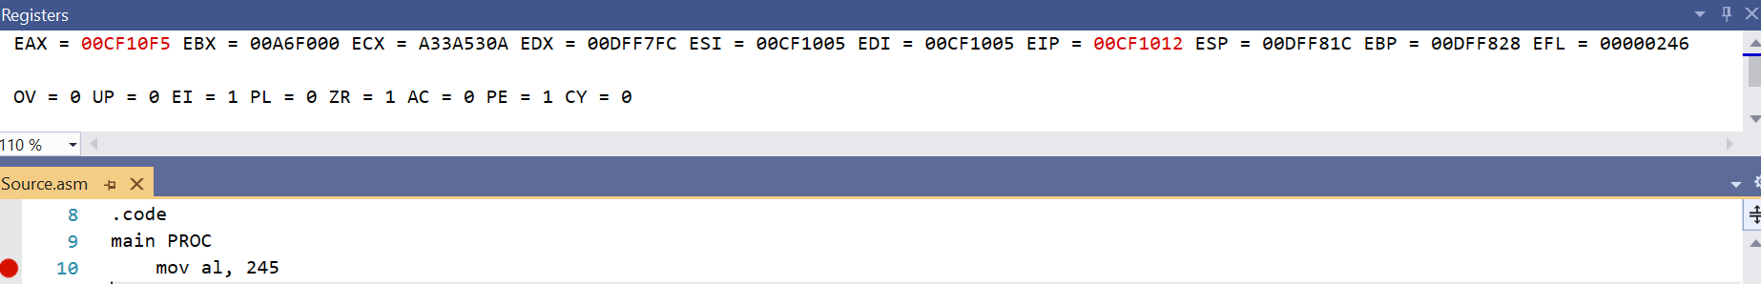

Explanation: The value 245 is being moved to the AL register inside the EAX register. I have included certain blank spaces because the remaining values in the EAX register are garbage values. 245 in hexadecimal is F5, that has been moved to the AL register. The other registers except for EIP contain garbage values.

Line number: 11

Instruction: MOV BL, 41

Register values: EAX = _ _ _ _ _ _ F5, EBX = _ _ _ _ _ _ 29

Screenshot: 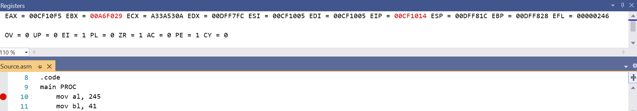

Explanation: The value 41 is being moved to the BL register inside the EBX register. I have included certain blank spaces because the remaining values in the EBX register are garbage values. 41 in hexadecimal is 29, that has been moved to the BL register. The other registers except for EIP and EAX contain garbage values and haven’t been initialized yet.

Line number: 12

Instruction: MOV CL, 11

Register values: EAX = _ _ _ _ _ _ F5, EBX = _ _ _ _ _ _ 29, ECX = _ _ _ _ _ _ 0B

Screenshot: 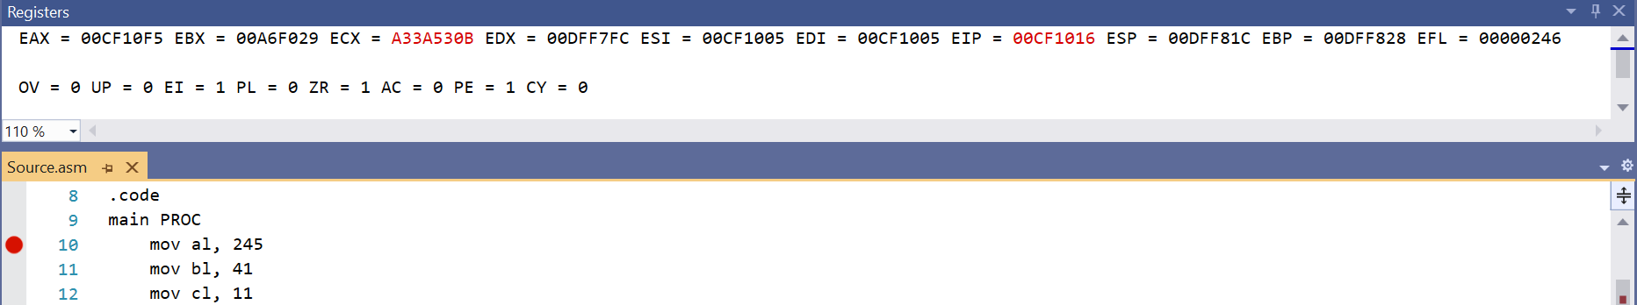

Explanation: The value 11 is being moved to the CL part of the ECX register. I included blank spaces because the remaining values in the ECX register are garbage values. 11 in hexadecimal is 0B, that has been moved to the CL register. The other registers except for EAX, EBX, and EIP contain garbage values and haven’t been initialized yet.

Line number: 13

Instruction: MOV DL, 215

Register values: EAX = _ _ _ _ _ _ F5, EBX = _ _ _ _ _ _ 29, ECX = _ _ _ _ _ _ 0B, EDX = _ _ _ _ _ _ D7

Screenshot: 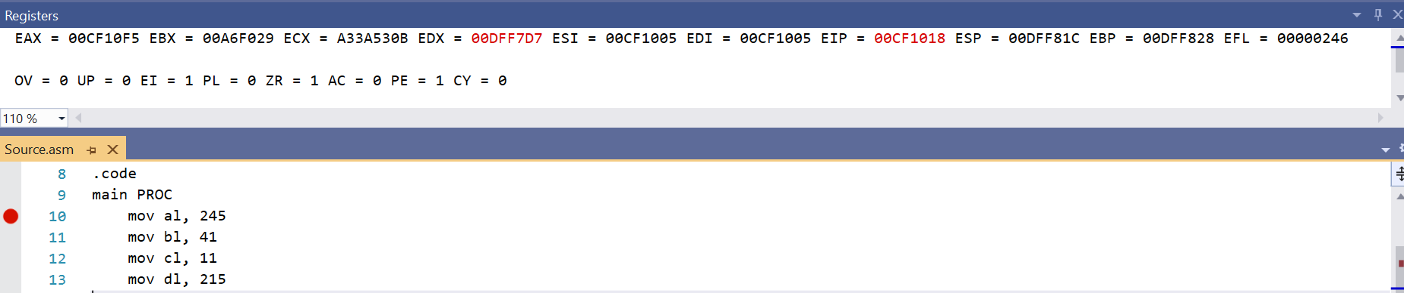

Explanation: The value 215 is being loaded into the DL part of the EDX register. I included blank spaces because the remaining values in the EDX register are garbage values. 215 in hexadecimal is D7, that has been moved to the DL register. The other registers except EAX, EBX, ECX, and EIP contain garbage values and haven’t been initialized yet.

Line number: 14

Instruction: SUB AL, DL

Register values: EAX = _ _ _ _ _ _ 1E, EBX = _ _ _ _ _ _ 29, ECX = _ _ _ _ _ _ 0B, EDX = _ _ _ _ _ _ D7

Screenshot: 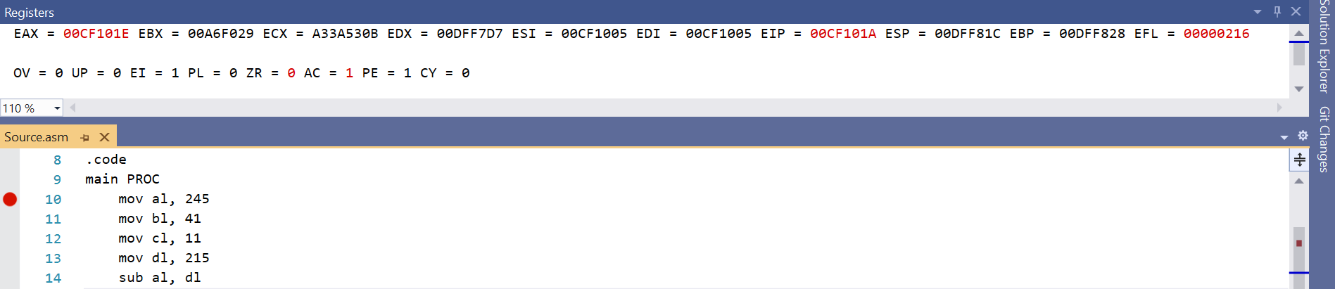

Explanation: The value in the DL register is being subtracted from the value in the AL register. DL contains 215 (D7) and Al contains 245 (F5), F5 – D7. 2’s complement of D7 is 28. F5 + 28 = 1E (the carry is discarded, as we only have 8 bits). This difference is being moved to AL, which now has a value of _ _ _ _ _ _ 1E. The other registers have been initialized and are not disturbed yet.

Line number: 15

Instruction: ADD AL, CL

Register values: EAX = _ _ _ _ _ _ 29, EBX = _ _ _ _ _ _ 29, ECX = _ _ _ _ _ _ 0B, EDX = _ _ _ _ _ _ D7

Screenshot: 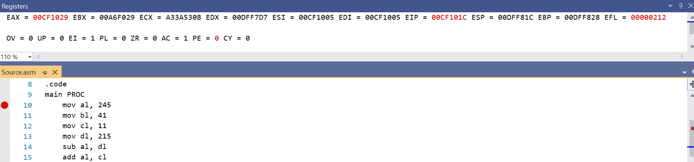

Explanation: The value in the CL register is being added to the value in the AL register. CL contains 11 (0B) and AL contains 30 (1E). 1E + 0B = 29. 14+11 = 25, 25 % 16 = 9. The 1 is a carry, and it adds to the 1. The final sum is 29. The sum is being moved to AL, which has a value of _ _ _ _ _ _ 29 now. The other registers have been initialized and are not disturbed yet.

Line number: 16

Instruction: SUB AL, BL

Register values: EAX = _ _ _ _ _ _ 00, EBX = _ _ _ _ _ _ 29, ECX = _ _ _ _ _ _ 0B, EDX = _ _ _ _ _ _ D7

Screenshot: 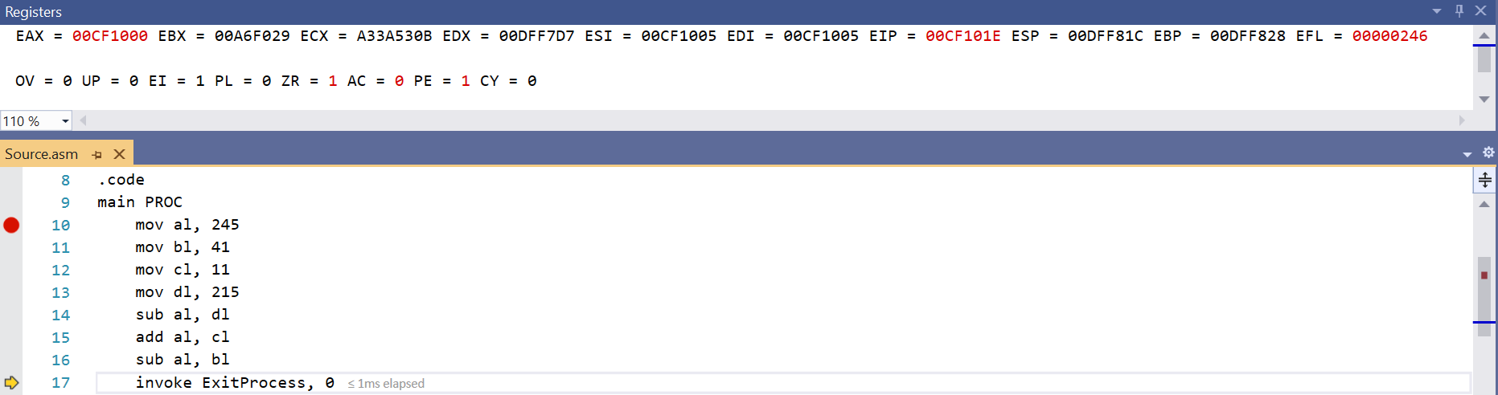

Explanation: The value in the BL register is being subtracted from the value in the AL register. BL contains 41 (29) and AL also contains 41 (29). The difference is 29 – 29. The 2’s complement of 29 is D6. 29 + D6 = 00 (the overflowed bit, 1, is being off-loaded because we only have 8 bits). This difference is being moved to AL, which now has a value of 0. The other registers have been initialized and are not disturbed.

(Copy this format for each line of code or instruction in your program)