RESEARCH GAP ANALYSIS
Phishing Email Detection
Comparative Analysis of Base Papers, Themed Studies, and Research Opportunities

Document purpose
A structured synthesis of the handwritten research notes supplied for the phishing-email detection study. The report consolidates stated limitations, paper-to-paper comparisons, research gaps, and the proposed direction without fabricating experimental results.

Prepared for: Phishing Email Detection
Prepared by: Manthena Rishikesh
Institution: Keshav Memorial Engineering College
Academic Year: 2026
Document status: Research-gap synthesis / working technical report

Executive Summary
The supplied research notes identify a recurring limitation across several phishing-email detection approaches: strong performance is often obtained from a narrow representation of the email, while important complementary signals remain underused. The notes specifically point to gaps in URL-specific analysis, explicit email-header modelling, character-level representations, stylistic/linguistic analysis, explainability, AI-generated phishing evaluation, cross-domain validation, class-imbalance handling, and practical lightweight deployment.
The most consequential opportunity is therefore not simply to build a larger or deeper neural network. A stronger research contribution would be to test whether complementary email evidence—semantic content, URL characteristics, header information, and stylistic/linguistic indicators—can be fused in an interpretable architecture while remaining practical to deploy.
Core research opportunity
Move from single-view detection toward evidence fusion: semantic email representation + URL-aware signals + header/metadata features + stylistic/linguistic cues, with explainability and robustness evaluated explicitly.

Key Findings at a Glance
Dimension | Observed limitation in notes | Opportunity
Input representation | Several approaches are text-centric or use a single feature family. | Fuse heterogeneous email evidence.
URL analysis | A dedicated URL branch is absent in the stated base-paper limitations. | Model URL tokens/structure as a separate signal.
Email headers | Explicit header-structure representation is identified as missing. | Include sender/header/metadata features where available.
Stylistics | Character-level and stylistic/linguistic cues are repeatedly identified as gaps. | Add interpretable linguistic indicators.
AI-generated phishing | Some notes use generated phishing samples, but broader evaluation and explicit coverage remain limited. | Stress-test against multiple LLM-generated phishing variants.
Explainability | Explainability is noted as absent or limited in the compared work. | Use LIME or a comparable post-hoc explanation layer.
Generalization | Cross-domain/generalization validation is identified as limited. | Use source/domain-aware validation and external testing.
Deployment | Some deep architectures are considered heavy for practical deployment. | Benchmark a lightweight, interpretable deployment path.

1. Scope, Evidence, and Interpretation Rules
This document is derived from the handwritten research notes/images supplied in the conversation. The notes contain paper titles, architecture sketches, feature lists, limitations, and proposed research directions. Where a paper title, model name, count, or acronym is unclear in the handwriting, the report preserves the substance without inventing missing details.
- Source-derived statements are presented as findings recorded in the notes.
- Interpretive synthesis is clearly framed as a research opportunity rather than as an already-proven result.
- No accuracy, F1-score, dataset size, or deployment benchmark is fabricated.
- Paper metadata not present in the notes is marked as [Not Provided].
- The supplied images are treated as evidence and are included in the appendix for traceability.

1.1 Evidence Register
Evidence item | What the notes contain | Use in this report
Base-paper limitations | Eight stated limitations including text-centric processing, missing URL/header/character branches, heavy architecture, Kaggle-only evaluation, missing XAI, and no explicit AI-generated phishing architecture. | Gap synthesis.
URL-focused paper | URL → URL group → NLP/word-vector features → ML classifier; notes emphasize URL-specific information. | URL branch comparison.
AI-generated phishing paper | Stylistic/linguistic features; classifiers including LR, SVM, RF, XGBoost; notes mention generated phishing and safe emails. | AI-generated phishing gap.
Explainable AI + web deployment | Email parsing → TF-IDF/word2vec → SVM/RF/NB → LIME → web app. | Explainability and deployment comparison.
BERT + CNN paper | Email → BERT → extracted features → CNN → classification; described as comparatively simple. | Lightweight architecture direction.
HELP4ED / hybrid ensemble note | Email body/header/URL/syntactic/word-vector features; broader email feature coverage than the base paper. | Hybrid feature comparison.
Adaptive optimization paper | BERT → multi-head attention → CNN → GRU → fully connected layer; MGO used for parameter optimization. | Deep architecture comparison.
Persuasion studies | Psychological principles, persuasion cues, and limitations around urgency, generated phishing, and cross-domain validation. | Behavioral feature gap.

2. Base Paper: Limitation Analysis
The first set of notes records eight limitations for the base paper. These are reproduced as a structured analytical list below.
# | Limitation | Research implication
1 | Primarily text-centric processing | The notes state that processing is centered primarily on email text.
2 | No dedicated URL analysis branch | URL-specific information is not represented through a dedicated branch.
3 | No explicit email-header structure | Header information is not explicitly modelled as a separate structured input.
4 | No character-level branch | Character-level representations are identified as absent.
5 | Heavy architecture | The architecture is characterized in the notes as computationally heavy.
6 | Evaluation centered on a single Kaggle corpus | The notes flag reliance on one Kaggle corpus as a limitation for generalization.
7 | No XAI in the current model | Explainability is identified as missing.
8 | No explicit AI-generated phishing architecture | The notes identify a lack of an explicit architecture dedicated to AI-generated phishing emails.

Interpretation
Taken together, these limitations suggest a representation problem as much as a model problem: the detector may learn powerful patterns from text while failing to exploit other evidence available in a real email object.

3. Comparative Analysis of Themed Papers
The following comparisons consolidate the paper-level observations recorded in the notes. They are intentionally framed as comparisons of the documented approaches, not as independently verified bibliographic claims.
Study/theme | Pipeline / architecture | Primary evidence | Strength | Gap relative to proposed direction
URL-focused ML phishing detection | URL/grouping → NLP/word-vector features → ML classifier | URL-specific information; domain structure; subdomains; URL tokens; suspicious words | Dedicated URL signal | Does not by itself cover the full email body/header context.
AI-generated phishing / stylistic detection | Stylistic/linguistic features → LR/SVM/RF/XGBoost | Operative verbs, clause density/punctuation, first-person pronouns, sentence structure | Explicit stylistic signals; generated-phishing focus | Notes flag limited breadth and lack of a broader multimodal email representation.
Explainable AI + web deployment | Email parsing → TF-IDF/word2vec → SVM/RF/NB → LIME → web app | Email text | Explainability + practical web deployment | Classical representation; limited heterogeneous feature fusion.
BERT + CNN | Email → BERT → extracted features → CNN → classification | Email semantics | Simple relative architecture; CNN-based feature extraction | Does not inherently solve URL/header/stylistic fusion or explainability.
HELP4ED / hybrid ensemble learning | Hybrid email features → ensemble/deep processing | Body, header, URL, syntactic and word-vector features | Broader email feature coverage | Notes indicate less advanced semantic modelling than the deepest base-paper approach.
Adaptive optimization deep model | BERT → multi-head attention → CNN → GRU → FC; MGO optimisation | Deep semantic sequence representation | Strong architectural sophistication + adaptive parameter optimisation | Heavier architecture; notes raise deployment/generalization questions.
Persuasion analysis | Content/subject-line analysis of persuasion principles | Authority, distraction, deception, social proof, integrity | Psychological/behavioral explanation of phishing | Not a complete operational detector on its own.
Psychology + LLM simulation | Persuasion quantification + LLM-based simulation | Psychological persuasion cues | Behavioral framing and LLM simulation | Notes flag urgency discrimination, generated-phishing coverage, and cross-domain validation gaps.

4. Visual Evidence from the Research Notes
The images below preserve the original research-note evidence. Each is accompanied by a concise transcription/synthesis so the report remains useful even when the handwritten source is not immediately available.
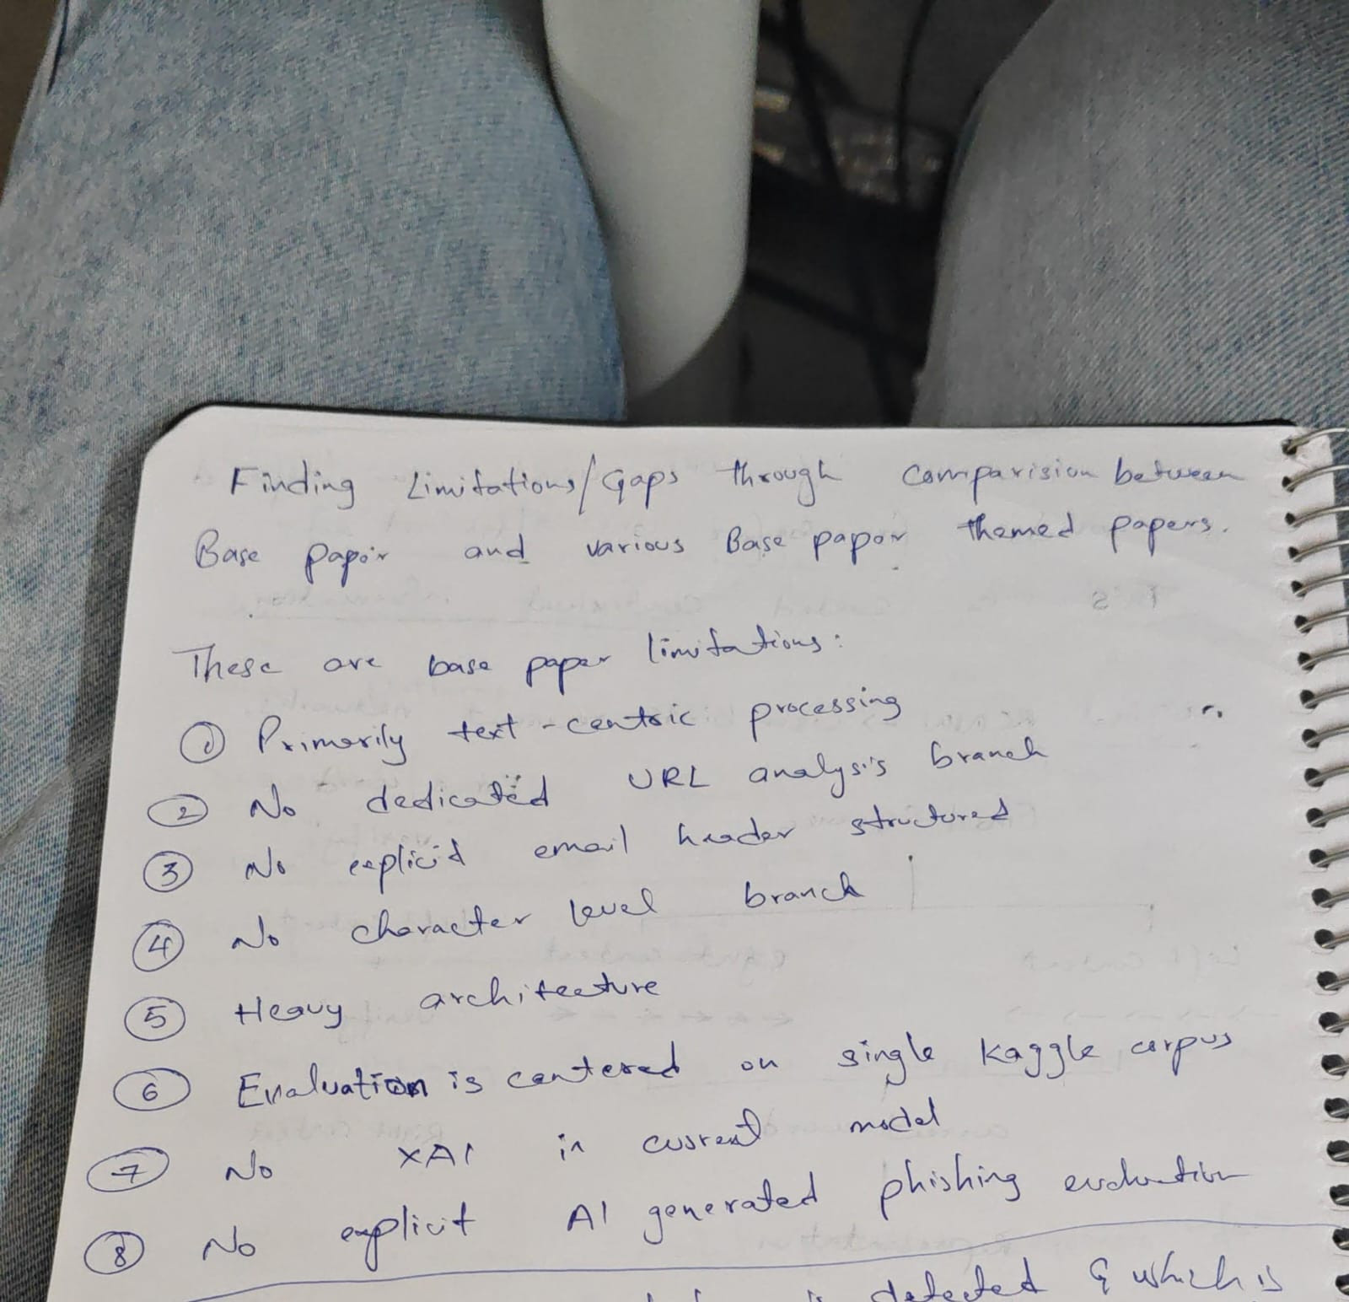
Figure 4: Base-paper limitations: text-centric processing, missing URL/header/character branches, heavy architecture, single-corpus evaluation, missing XAI, and missing explicit AI-generated-phishing architecture.
The notes identify eight limitations that form the main gap framework.
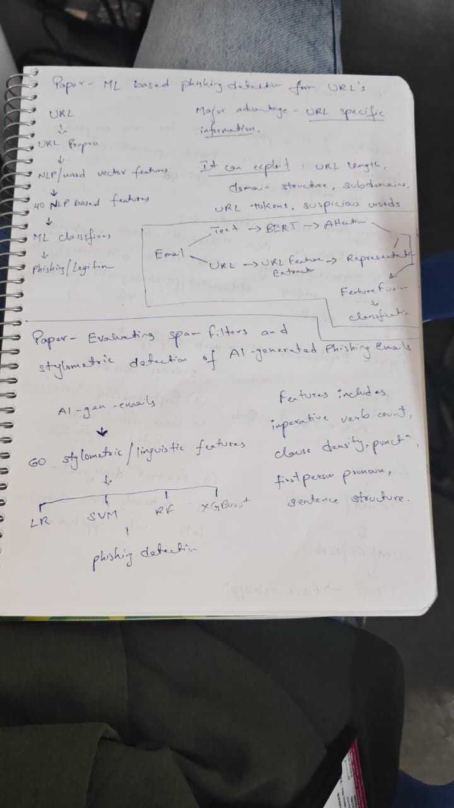
Figure 5: URL-focused detection and stylistic detection of AI-generated phishing emails.
The notes contrast URL-specific information with linguistic/stylistic features.


Figure 6: AI-generated phishing and explainable-AI deployment notes.
The page connects generated phishing, linguistic features, classical classifiers, LIME, and a practical web application.
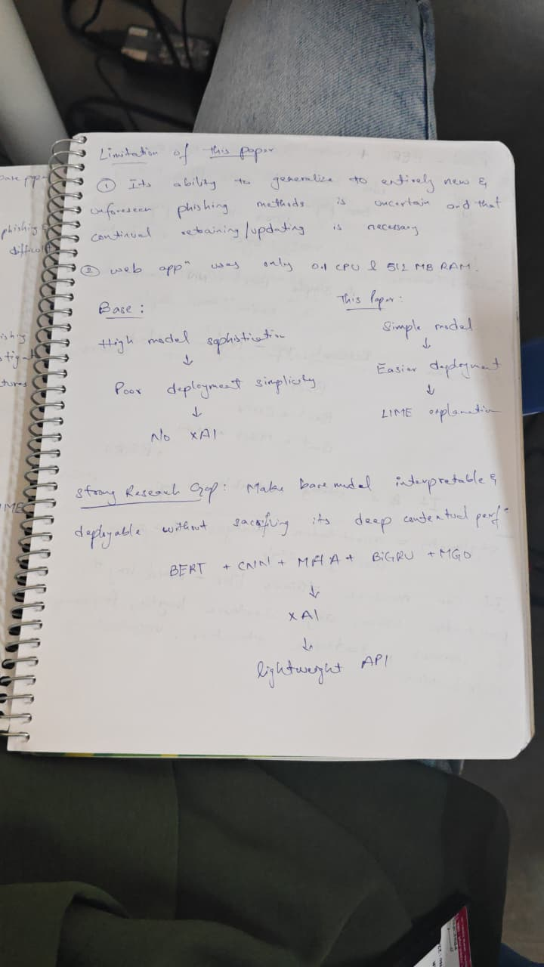
Figure 7: Generalization, deployment, and proposed research direction.
The notes contrast a heavy base architecture with a simpler interpretable deployment and suggest combining BERT/CNN/MHA/BiGRU/MGO concepts.


Figure 8: BERT + CNN comparison and research-gap notes.
The notes characterize BERT + CNN as a simple architecture and list possible extensions such as BERT + CNN, BERT + MHA + CNN + BiGRU, and MGO.
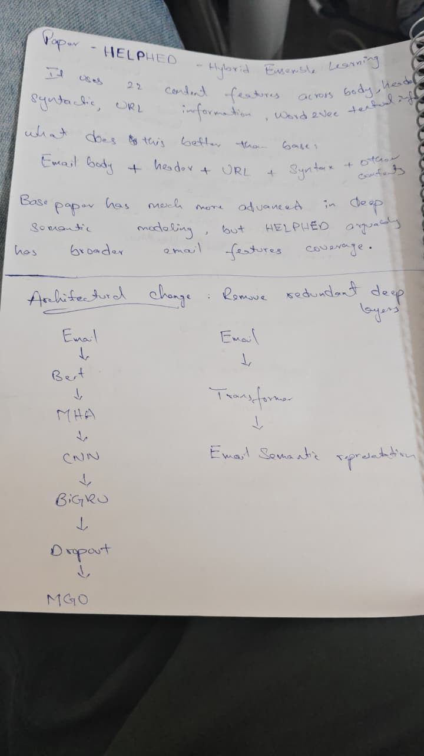
Figure 9: Hybrid ensemble learning (HELP4ED) comparison.
The notes emphasize broader feature coverage—body, header, URL, syntactic and word-vector information—while contrasting it with deeper semantic modelling.
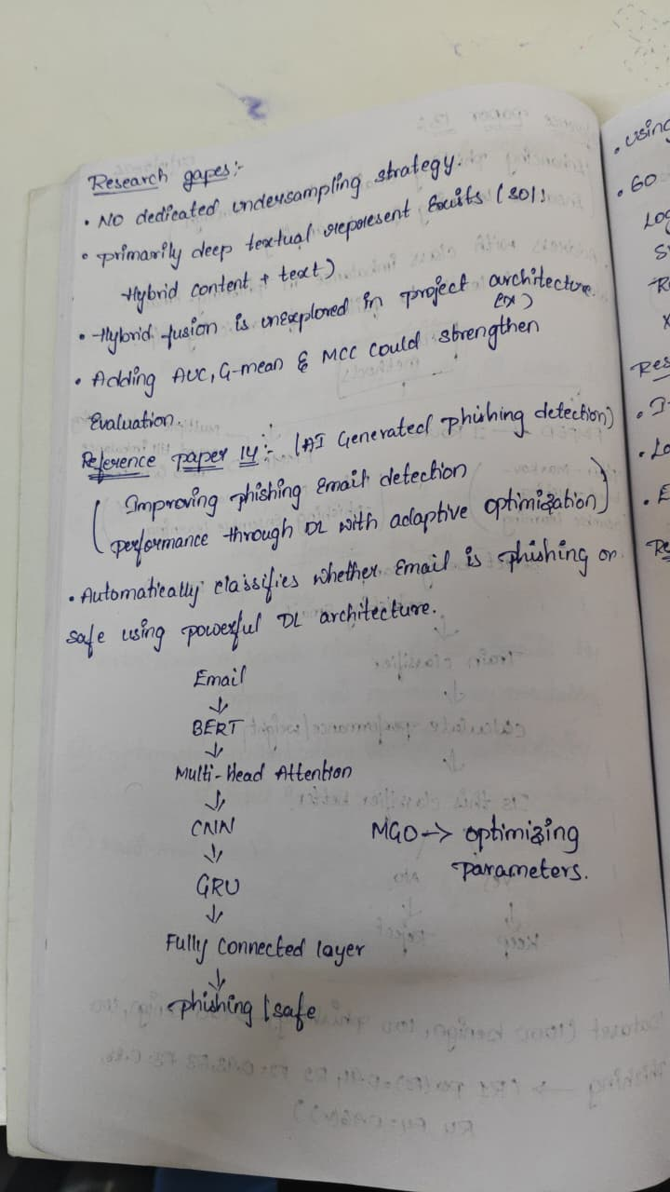
Figure 10: Adaptive-optimization phishing detection paper.
The notes describe a BERT → multi-head attention → CNN → GRU → fully connected pipeline with MGO parameter optimization and generated/safe-email testing.
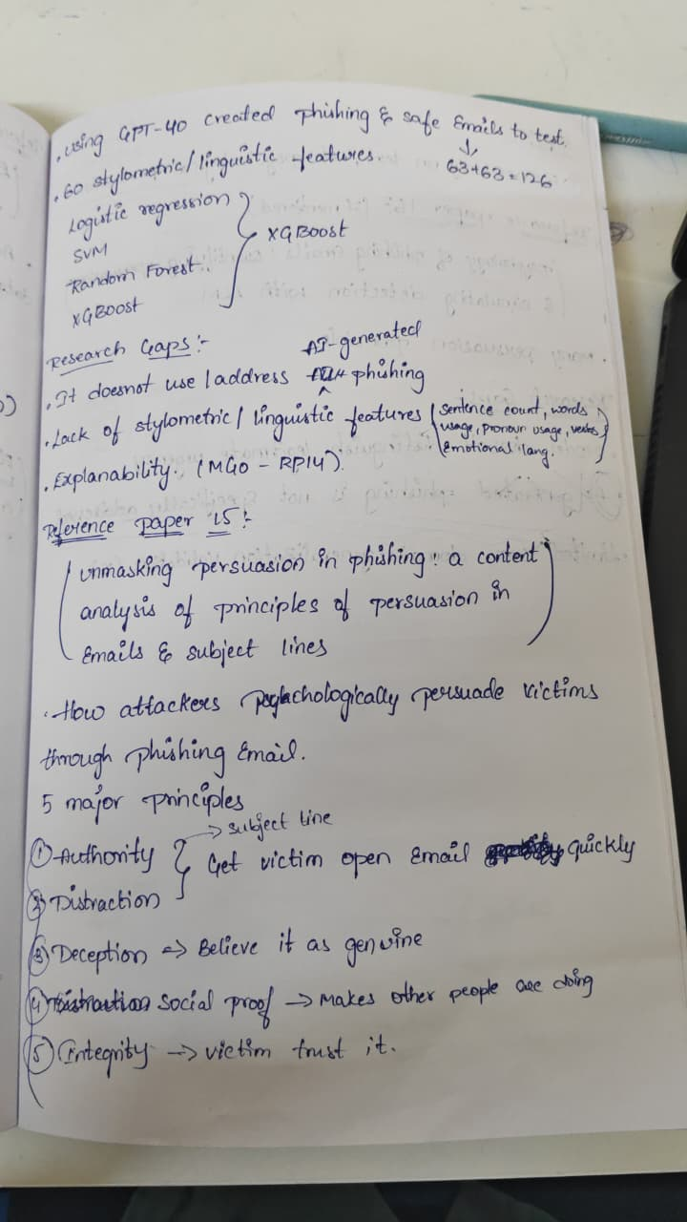
Figure 11: LLM-generated phishing and persuasion-analysis research gaps.
The notes identify missing stylistic features, explainability, and explicit AI-generated phishing treatment, then summarize persuasion principles.
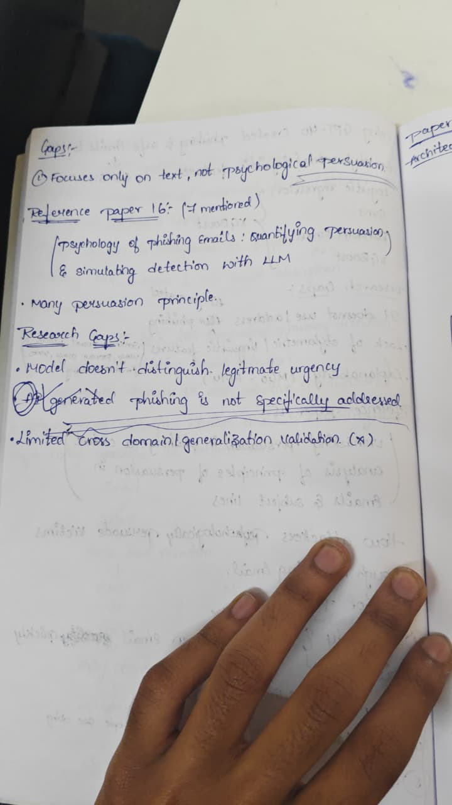
Figure 12: Psychological persuasion and cross-domain research gaps.
The notes highlight urgency discrimination, AI-generated phishing coverage, and limited cross-domain validation.

5. Consolidated Research Gaps
The individual limitations become more meaningful when grouped into research dimensions. This section converts the scattered notes into a single gap map.
ID | Gap | Evidence from notes | Potential response
G1 | Heterogeneous feature fusion | Text, URL, header, syntactic and stylistic signals are not consistently combined. | Unified multi-view representation of the email.
G2 | URL-aware modelling | A dedicated URL branch is explicitly identified as missing in the base-paper notes. | Separate URL encoder/feature branch with late or gated fusion.
G3 | Header-aware modelling | Explicit email-header structure is identified as absent. | Structured metadata/header feature extraction.
G4 | Character-level robustness | Character-level processing is identified as absent. | Character/subword signals for obfuscation and spelling variants.
G5 | Stylistic / linguistic cues | Stylistic indicators appear in themed papers but are not integrated into the base architecture. | Interpretable linguistic feature branch.
G6 | AI-generated phishing robustness | Notes indicate limited or non-explicit treatment of AI-generated phishing across compared approaches. | Dedicated evaluation protocol using generated phishing variants.
G7 | Psychological persuasion | Persuasion literature is discussed separately from operational detection. | Test whether persuasion cues improve detection or explanation.
G8 | Explainability | XAI is explicitly listed as absent from the base model; LIME appears in a separate web-deployment paper. | Explanation layer linked to model evidence.
G9 | Cross-domain generalization | Limited cross-domain validation is explicitly noted. | Domain-aware split + external/cross-source test.
G10 | Class imbalance | The notes explicitly mention lack of a dedicated undersampling strategy. | Compare class weighting, undersampling, oversampling and balanced sampling.
G11 | Deployment efficiency | Heavy architectures are contrasted with simpler web-deployable approaches. | Latency, memory and model-size benchmarking.
G12 | Evaluation breadth | Single-corpus evaluation is identified as a weakness. | Multi-source evaluation and ablation studies.

6. Proposed Research Direction
The notes point toward a hybrid detector rather than a single monolithic deep network. The most defensible direction is to combine semantic modelling with explicit structured evidence, then add explainability and robust evaluation.

6.1 Candidate Architecture
Proposed conceptual pipeline
Email → preprocessing/parsing → parallel evidence extraction → semantic branch + URL branch + header/metadata branch + stylistic/linguistic branch → feature fusion → classifier → prediction + explanation.

Branch | Input | Candidate representation | Purpose
Semantic | Subject + body | BERT-family contextual embeddings | Capture contextual meaning and phishing intent.
URL | URLs extracted from email | URL lexical/structural features; optional neural encoding | Capture domain, token, subdomain and suspicious-URL evidence.
Header / metadata | Available email header fields | Structured numerical/categorical features | Capture sender, routing and metadata anomalies where available.
Stylistic / linguistic | Body + subject | Counts and linguistic indicators | Capture writing style, sentence structure and persuasive cues.
Fusion | Outputs of all branches | Concatenation / gated attention / learned fusion | Combine heterogeneous evidence.
Decision | Fused representation | Binary classifier | Predict phishing vs legitimate.
Explanation | Model evidence | LIME or comparable post-hoc explanation | Expose influential words/features/branches.

6.2 Architecture Choices: What to Keep and What to Challenge
Component | Rationale | Risk / challenge | Recommendation
BERT | Strong semantic representation in the notes. | Compute and latency. | Use a compact variant if deployment is a priority.
CNN | Useful for local feature extraction; appears in multiple notes. | Potential redundancy after transformer encoding. | Validate through ablation rather than assuming it helps.
MHA | Explicitly used in the adaptive-optimization paper. | Adds complexity and may duplicate transformer attention. | Use only if empirical ablation justifies it.
BiGRU | Captures sequence dependencies and appears in the adaptive architecture notes. | Adds recurrent compute after BERT. | Treat as an experimental component, not a mandatory layer.
MGO | Notes identify it as a parameter optimizer in the adaptive model. | Optimization overhead and reproducibility. | Compare against a strong conventional optimizer baseline.
LIME | Provides practical post-hoc explanations. | Can be unstable or local. | Report explanation stability and use it as a supporting XAI method.

Important challenge to the current idea
Do not assume that stacking BERT + MHA + CNN + BiGRU + MGO automatically creates a stronger contribution. That is a complexity increase, not a research result. The contribution becomes defensible only if controlled ablations show which added component improves robustness, generalization, explainability, or deployment efficiency.

7. Recommended Experimental Design
The following design is a research recommendation derived from the identified gaps. It is not an experimental result and should be treated as a proposed protocol.

7.1 Dataset and Split Strategy
- Use multiple legitimate/phishing sources rather than relying exclusively on one corpus.
- Keep source/domain identity available so cross-domain evaluation can be performed.
- Prevent duplicate or near-duplicate leakage across train and test sets.
- Create a conventional train/validation/test split and a separate cross-source or cross-domain test where feasible.
- Evaluate imbalance explicitly rather than reporting accuracy alone.

7.2 Ablation Matrix
ID | Configuration | Change | Research question
A0 | Text-only baseline | Semantic text representation | Reference point
A1 | Text + URL | Add URL branch | Measure URL contribution
A2 | Text + header | Add structured header features | Measure metadata contribution
A3 | Text + stylistic | Add linguistic/stylistic branch | Measure style contribution
A4 | All features | Semantic + URL + header + style | Test feature fusion
A5 | All + XAI | Add explanation layer | Measure explainability/practicality
A6 | All + optimization | Add adaptive optimization | Test optimization benefit
A7 | Lightweight alternative | Simplified architecture | Compare deployment trade-off

7.3 Metrics
- Precision, recall and F1-score for phishing detection.
- ROC-AUC and, where class imbalance is substantial, PR-AUC.
- Confusion matrix to expose false-positive and false-negative trade-offs.
- Per-domain/source performance for generalization analysis.
- Model size, inference latency and memory footprint for deployment analysis.
- Explanation quality/stability if XAI is evaluated.

8. Threat Model and Real-World Relevance
The notes repeatedly focus on phishing as a social-engineering problem, including urgency, deception, authority, social proof, and other persuasion principles. This suggests that a detector should not be evaluated only as a text-classification problem.
Threat / variation | Why it matters | Detection evidence to test
AI-generated phishing | Generated text may be fluent and stylistically different from legacy phishing. | Semantic + stylistic robustness.
URL manipulation | Malicious intent can be expressed through URLs even when body text looks plausible. | URL lexical/structural features.
Header/sender anomalies | Metadata can provide evidence not present in body text. | Structured header features.
Urgent but legitimate email | Urgency alone should not be treated as proof of phishing. | Contextual semantic and persuasion-aware features.
Domain shift | Language, organizations and campaigns change over time. | Cross-domain/source evaluation.
Class imbalance | A detector can appear strong while missing the minority class. | Recall, PR-AUC and balanced evaluation.

9. Limitations of the Current Research Notes
- The notes do not provide complete bibliographic metadata for every paper; formal citation details therefore cannot be reconstructed reliably.
- Some model names and acronyms are handwritten and may be ambiguous. The report avoids expanding uncertain acronyms as facts.
- The notes provide qualitative comparisons but not enough verified experimental tables to establish which architecture is statistically superior.
- Several proposed components are ideas rather than demonstrated improvements.
- The report does not independently verify the cited paper claims; it organizes the evidence supplied in the notes.

10. Conclusion
The supplied notes establish a coherent research-gap narrative: phishing-email detection can be strengthened by moving beyond single-view text classification toward heterogeneous evidence fusion. URL structure, email headers, character-level signals, stylistic/linguistic indicators, and psychological persuasion cues represent complementary information sources. The notes also identify two practical dimensions that are often separated from detection performance—explainability and deployability.
The strongest research path is therefore not to maximize architectural depth indiscriminately. A more defensible contribution is to construct a controlled hybrid architecture, compare it against simpler baselines, conduct feature-level ablations, test AI-generated phishing and domain shift, explicitly address class imbalance, and provide model explanations. This design turns the scattered gaps recorded in the notes into testable research questions.

11. Research Questions and Hypotheses
RQ | Research question | Testable expectation
RQ1 | Does adding URL-specific evidence improve phishing detection over semantic text alone? | The fused model should improve at least one minority-class metric without unacceptable false positives.
RQ2 | Does explicit header information improve cross-domain generalization? | Header-aware models should retain useful performance under source/domain shift.
RQ3 | Do stylistic/linguistic features help detect AI-generated phishing? | Stylistic features should provide complementary signal beyond semantic embeddings.
RQ4 | Does feature fusion outperform deeper single-stream architectures? | A well-designed hybrid may achieve better robustness at lower complexity.
RQ5 | Does explainability improve practical usefulness? | Explanations should identify meaningful evidence without materially harming deployment feasibility.
RQ6 | Does adaptive optimization provide measurable benefit over standard optimization? | Any improvement should be demonstrated through controlled comparison, not assumed.

12. Traceability Matrix: Gap → Evidence → Experiment
Gap | Evidence recorded in notes | Proposed experiment | Primary metric
URL branch missing | Base-paper limitation #2 | Text-only vs text+URL | F1 / PR-AUC
Header structure missing | Base-paper limitation #3 | Text+URL vs text+URL+header | F1 / cross-domain F1
Character-level branch missing | Base-paper limitation #4 | Subword/character ablation | Recall / robustness
Heavy architecture | Base-paper limitation #5 | Deep vs lightweight model | F1 + latency + memory
Single-corpus evaluation | Base-paper limitation #6 | Cross-source test | Per-source F1
No XAI | Base-paper limitation #7 | Add LIME/comparable explanation | Explanation stability + overhead
No explicit AI-generated architecture | Base-paper limitation #8 | Generated phishing stress test | Recall / PR-AUC
No dedicated undersampling | Research-gap note | Sampling/weighting comparison | Balanced metrics
Limited hybrid fusion | HELP4ED comparison | Multi-branch fusion ablation | Macro-F1 / PR-AUC
Persuasion separated from detection | Persuasion papers | Add persuasion/stylistic features | Incremental F1 / error analysis

13. References / Papers Identified in the Notes
The following titles/themes are transcribed from the supplied notes. Complete author, venue, DOI, URL, and publication-year metadata were not consistently provided and are therefore intentionally omitted.
- ML-based phishing detection from URLs — URL-focused feature and machine-learning approach.
- Evaluating spam filters and stylometric detection of AI-generated phishing emails — stylistic/linguistic feature comparison.
- Explainable AI + web deployment — TF-IDF/word2vec with classical classifiers and LIME-based explanation.
- BERT + CNN — semantic transformer representation followed by CNN-based feature extraction/classification.
- HELP4ED — hybrid ensemble-learning approach with broader email feature coverage as recorded in the notes.
- Improving phishing email detection performance through deep learning with adaptive optimization — BERT + multi-head attention + CNN + GRU + fully connected architecture; MGO-based parameter optimization as recorded in the notes.
- Unmasking persuasion in phishing: a content analysis of principles of persuasion in emails & subject lines.
- Psychology of phishing emails: quantifying persuasion & simulating detection with LLM.
Bibliographic completion required
Before final academic submission, replace the above working references with verified author lists, publication years, venues, DOI/URL, and exact paper titles from the original sources.

Appendix A — Source Image Index
Source image | Primary content captured | Used in
Image 1 | Base-paper limitations | Sections 2 and 5
Image 2 | URL-focused and AI-generated phishing comparisons | Section 3
Image 3 | AI-generated phishing + explainable deployment | Section 3
Image 4 | Generalization/deployment and proposed architecture | Sections 5–7
Image 5 | BERT + CNN and research-gap extensions | Sections 3 and 6
Image 6 | HELP4ED hybrid ensemble comparison | Sections 3 and 5
Image 7 | Adaptive optimization architecture | Sections 3 and 6
Image 8 | AI-generated phishing and persuasion gaps | Sections 5 and 8
Image 9 | Psychological persuasion and validation gaps | Sections 5 and 8

Appendix B — Concise Project Blueprint
Recommended blueprint
1) Build a strong text-only baseline → 2) add URL evidence → 3) add header evidence → 4) add stylistic/linguistic evidence → 5) test feature fusion → 6) evaluate AI-generated phishing → 7) perform cross-domain validation → 8) add XAI → 9) benchmark deployment cost → 10) report ablations and error analysis.

This sequence minimizes the risk of building an unnecessarily complex architecture before establishing which information sources actually contribute to detection.

Appendix C — Quality and Evidence Checklist
- ✓ All major limitations recorded in the notes are represented.
- ✓ Paper comparisons distinguish documented strengths from proposed opportunities.
- ✓ No unsupported accuracy or performance values are reported.
- ✓ Uncertain bibliographic details are explicitly marked as not provided.
- ✓ Research gaps are translated into testable experiments.
- ✓ Architecture complexity is treated as a variable to validate, not an automatic benefit.
- ✓ Explainability, generalization, AI-generated phishing, imbalance, and deployment are explicitly addressed.
- ✓ All supplied research-note images are indexed and included for traceability.

