SIMATS ENGINEERING
ASSESSMENT TOOL 1: AI Model Design Exercise
COURSE NAME: ARTIFICIAL INTELLIGENCE COURSE CODE: MLA01
AND EXPERT SYSTEMS

COURSE OUTCOME COVERED
CO4: Develop intelligent software agents using suitable agent architectures and learning techniques.(BTL 3)
Assessment Tool Weightage: 40 %

Total Marks: 100 Time: 90 Mins
No. of Questions: 1
Annexure A
AI Model Design Exercise

Code of Conduct:
I __K.Nagapreetham(192525242)__ (Name / Reg No) certify that this submission is my original work and that I have adhered to the guidelines specified for this assessment. I understand that any violation of academic integrity rules will result in disciplinary action.
Signature of the student:
Criterion | Weightage | Marks Obtained
1. Problem Analysis and Domain Understanding | 10%
2. Dataset Selection and Data Understanding | 10%
3. Data Preprocessing and Feature Engineering | 10%
4. AI Technique Selection and Justification | 10%
5. Model Design / Architecture | 10%
6. Algorithm / Pseudocode Development | 5%
7. Model Implementation and GitHub Repository | 15%
8. Experimental Design and Results | 10%
9. Performance Evaluation and Metrics | 10%
10. Result Analysis and Interpretation | 5%
11. Limitations and Future Enhancements | 5%
12. Documentation and Technical Presentation | 10%
Total | 100%
Signature of the Faculty Total Marks Awarded ANSWER ANY ONE QUESTION

S.No. | Scenario / Problem Statement | AI Model /  Technique to be  Developed | Expected Development Outcome
1 | Smart Loan Approval:  A bank wants to automatically determine whether a customer is eligible for a loan using income, credit score, employment status, loan amount, and repayment history. | Decision Tree | Design and implement a  decision-tree-based AI model and determine the most suitable attribute-selection measure such as Information Gain, Gain Ratio, or Gini Index.
2 | Student Performance  Prediction:  A university wants to predict whether a student is likely to pass or fail a course using attendance, internal marks, assignment performance, study hours, and previous academic performance. | Inductive  Learning | Construct a predictive model from training examples and derive generalized decision rules from the learned patterns.
3 | Disease Risk Prediction:  A healthcare system needs to classify patients into low-risk and high-risk categories based on clinical measurements. | Statistical  Learning | Design a statistical learning model, train it using patient data, and evaluate its generalization ability on unseen data.
4 | Image Recognition System:  An organization wants to automatically classify images into categories such as vehicles, animals, and buildings. | Neural Network | Design and implement a neural-network classifier by specifying the network architecture, activation functions, loss function, optimizer, and training procedure.
5 | Handwritten Character  Recognition:  A system must recognize handwritten characters from scanned images. | Multilayer Neural  Network | Develop a multilayer neural network and demonstrate how backpropagation updates weights to minimize classification error.
6 | Non-Linear Classification:  A dataset contains two classes that cannot be separated using a straight-line decision boundary. | SVM with Kernel  Method | Design an SVM-based classifier using an appropriate kernel function and justify the selected kernel based on the characteristics of the dataset.
7 | Intelligent Recommendation Agent:  An online platform wants an agent that learns which recommendations to provide based on user responses. | Reinforcement  Learning | Design an RL model by defining the states, actions, rewards, policy, and learning strategy, and demonstrate how the agent learns from user feedback.
8 | Autonomous Game Agent:  An AI agent must learn to play a game where successful actions receive positive rewards and unsuccessful actions receive penalties. | Reinforcement  Learning | Develop an RL-based game agent and demonstrate how its policy and performance improve through repeated interaction with the environment.
9 | Explainable Diagnosis System:  A medical AI system predicts a disease but must also provide an explanation for its prediction. | Explanation-Base d Learning | Design an explanation-based learning approach using domain knowledge and training examples to generate an understandable justification for the prediction.
10 | AI Model Selection Challenge:  A company provides a dataset for predicting customer churn. | Comparative AI  Model Design | Design and compare at least two learning approaches from decision trees, statistical learning, neural networks, or kernel methods. Select the best model based on accuracy, interpretability, computational requirements, and generalization ability.

Structure of the Report:

S.No. | Report Component | What the Student Should Include
1 | Problem Statement | Clearly describe the real-world problem, input data, expected output, and AI task to be solved.
2 | Objectives | State the specific goals of developing the AI model and expected outcomes.
3 | Dataset Description | Provide dataset source, number of instances, features, target variable, data types, and important attributes.
4 | Data Preprocessing | Explain data cleaning, missing-value handling, encoding, normalization/scaling, feature selection, and train-test splitting.
5 | Selected AI  Technique and  Justification | Identify the selected AI technique and justify its suitability for the problem.
6 | Model Design /  Architecture | Present the model structure, components, input/output, parameters, hyperparameters, and architecture/flow diagram.
7 | Algorithm /  Pseudocode | Provide the algorithmic steps or pseudocode showing model training and prediction/decision-making.
8 | Implementation | Provide programming language, libraries/tools, important code sections, and implementation details.
9 | Experimental  Results | Present results using tables, graphs, sample predictions, learning curves, confusion matrices, or other relevant outputs.
10 | Performance  Evaluation | Evaluate the model using appropriate performance metrics such as accuracy, precision, recall, F1-score, MSE, RMSE, or cumulative reward.
11 | Result Analysis | Interpret results, identify important patterns, compare actual and predicted outcomes, and discuss strengths and weaknesses.
12 | Limitations | Discuss limitations related to dataset, model complexity, computational resources, accuracy, generalization, or deployment.
13 | Future  Enhancements | Suggest improvements such as additional data, feature engineering, hyperparameter tuning, alternative algorithms, or deployment.
14 | Conclusion | Summarize the problem, methodology, major findings, model performance, and overall effectiveness.
15 | References | List datasets, research papers, books, websites, documentation, libraries, and other sources used.
16 | GitHub Repository  Link | Provide the public GitHub repository URL containing the complete source code, dataset information/source, implementation, results, README, and supporting files.

Question 1: Smart Loan Approval Using Decision Tree
1. Problem Statement:
A bank receives loan applications from customers and needs to determine whether a customer is eligible for a loan. Manual loan approval can be time-consuming and may lead to inconsistent decisions.
The proposed system uses a Decision Tree-based Artificial Intelligence model to automatically classify a customer as:
- Loan Approved
- Loan Rejected
The decision is based on customer attributes such as:
- Income
- Credit Score
- Employment Status
- Loan Amount
- Repayment History

2. Objectives:
The main objectives of the proposed system are:
- To develop an AI-based loan approval system.
- To use a Decision Tree classification algorithm.
- To identify the most important attributes affecting loan approval.
- To automatically classify loan applications.
- To reduce manual decision-making.
- To improve consistency and efficiency.
- To evaluate the performance of the developed model.

3. Dataset Description:
The dataset contains customer information related to loan applications.
Attribute | Description | Type
Income | Customer's annual/monthly income | Numerical
Credit Score | Creditworthiness of customer | Numerical
Employment Status | Employed/Unemployed/Self-employed | Categorical
Loan Amount | Amount requested by customer | Numerical
Repayment History | Previous repayment behavior | Categorical
Loan Approval | Final decision | Target

Target Variable
The target variable is:
Loan Approval = Approved / Rejected
The input attributes are used by the Decision Tree to predict the target variable.

4. Data Preprocessing:
Before training the Decision Tree, the dataset must be cleaned and prepared.

Step 1: Handle Missing Values:
Missing values in attributes such as income or credit score can be handled using:
- Mean/median for numerical values
- Mode for categorical values

Step 2: Remove Duplicate Records:
Duplicate loan applications should be identified and removed.

Step 3: Encode Categorical Data:
Categorical values can be converted into numerical form.
Example:
Employment Status
- Employed → 1
- Unemployed → 0
- Self-employed → 2

Step 4: Feature Selection:
Important features such as:
- Credit Score
- Income
- Repayment History
are selected because they can strongly influence loan approval.

Step 5: Train-Test Split:
The dataset can be divided into:
- 80% Training Data
- 20% Testing Data
The training data is used to construct the Decision Tree, while testing data is used to evaluate its performance.
These preprocessing activities align with the report requirements in the PDF, which specifically mention cleaning, missing-value handling, encoding, scaling, feature selection, and train-test splitting.

5. Selected AI Technique and Justification
Decision Tree :
A Decision Tree is selected for this problem because it is a supervised machine-learning algorithm used for classification.
It represents decisions in the form of a tree:
Root Node → Decision Nodes → Branches → Leaf Nodes

For example:
Credit Score
/ \
High Low
/ \
Income Reject
/ \
High Low
| |
Approve Reject

Why Decision Tree?
Decision Tree is suitable because:
- It can handle numerical and categorical attributes.
- It is easy to understand.
- Its decisions can be represented visually.
- It requires relatively little preprocessing.
- It can identify important attributes.
- The resulting rules are easy to explain.

6. Mathematical Model – Information Gain:
One suitable attribute-selection measure is Information Gain.
Entropy
Entropy measures the impurity or uncertainty in the dataset.
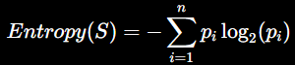
For binary classification:
Where:
- Papproved= proportion of approved applications
- Prejected= proportion of rejected applications

Information Gain:
Information Gain determines how useful an attribute is for splitting the dataset.
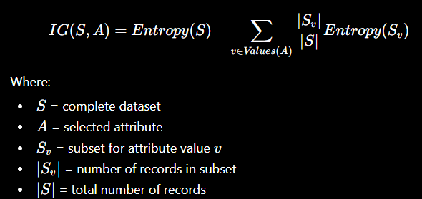
The attribute having the highest Information Gain is selected as the decision node.

7. Example Calculation:
Consider a small dataset containing:
- 10 total customers
- 6 Approved
- 4 Rejected
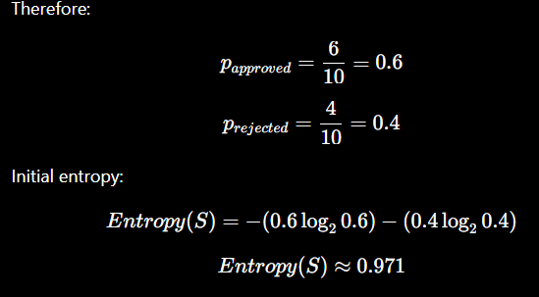
Suppose we divide the dataset based on Credit Score.
After splitting, assume:
Credit Score | Approved | Rejected | Total
High | 5 | 1 | 6
Low | 1 | 3 | 4

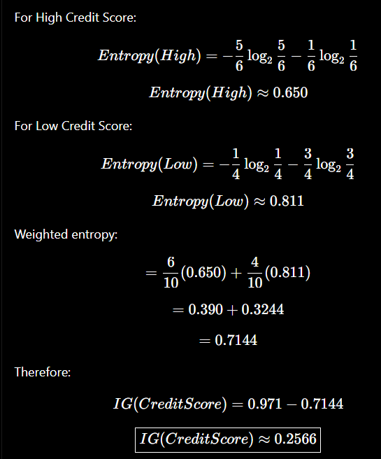
The Information Gain is calculated for other attributes such as Income, Loan Amount and Repayment History. The attribute with the highest Information Gain becomes the root node.

8. Model Design / Architecture:
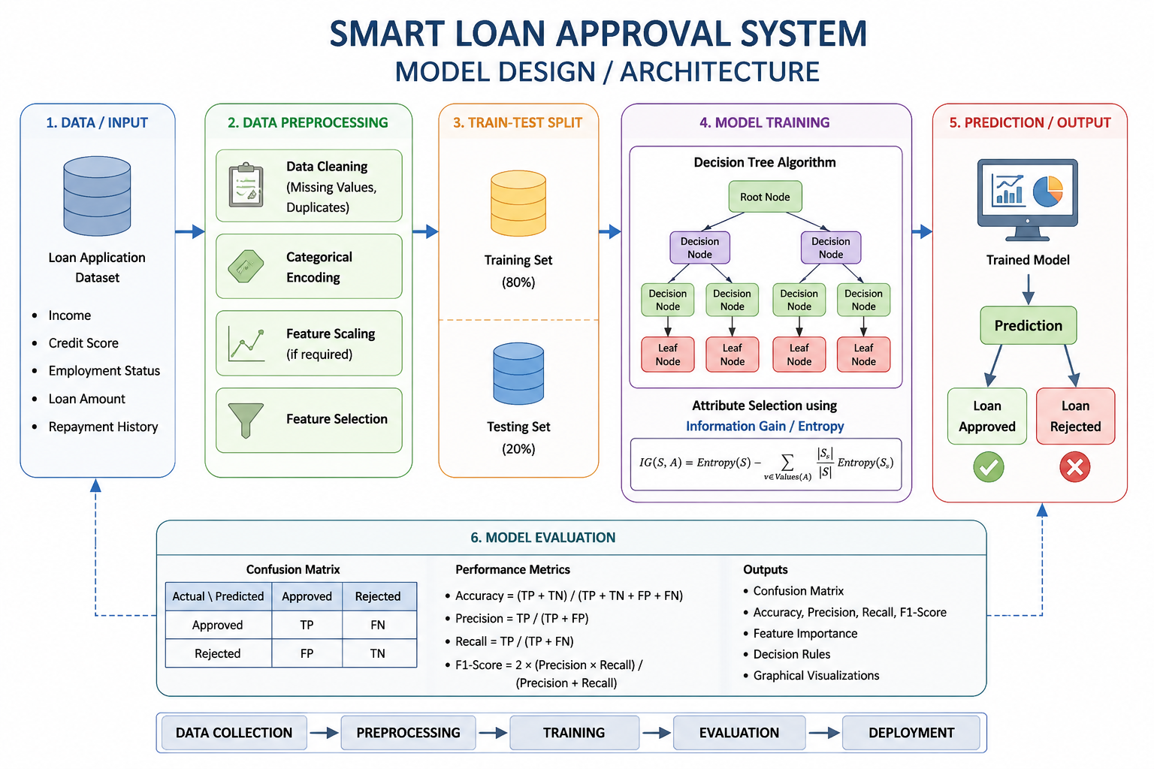

The proposed architecture is:
Decision Tree Components
Input:
- Income
- Credit Score
- Employment Status
- Loan Amount
- Repayment History
Processing:
Decision Tree algorithm calculates the best attribute using Information Gain.
Output:
- Loan Approved
- Loan Rejected

9. Algorithm / Pseudocode:
ALGORITHM: Smart Loan Approval Using Decision Tree

INPUT:
Loan dataset containing:
Income
Credit Score
Employment Status
Loan Amount
Repayment History
Loan Approval

OUTPUT:
Loan Approval Prediction
→ Approved / Rejected

BEGIN

1. Load the loan application dataset.

2. Check the dataset for:
a. Missing values
b. Duplicate records
c. Incorrect data

3. Clean the dataset:
Remove duplicates
Handle missing values

4. Convert categorical attributes into numerical values.

5. Select input features:
Income
Credit Score
Employment Status
Loan Amount
Repayment History

6. Select target variable:
Loan Approval

7. Split the dataset into:
Training Set = 80%
Testing Set = 20%

8. Calculate the Entropy of the training dataset.

9. For each attribute:
Calculate Information Gain.

10. Select the attribute having the
highest Information Gain.

11. Create the root node using the selected attribute.

12. Split the dataset according to the
selected attribute values.

13. Repeat Steps 8–12 for each subset
until the stopping condition is reached.

14. Generate the final Decision Tree.

15. Train the Decision Tree using
the training dataset.

16. Give the testing dataset to the
trained Decision Tree.

17. For each test customer:
Read customer attributes.
Traverse the Decision Tree.
Reach the corresponding leaf node.

18. Predict:
IF leaf node = Approved
THEN Loan = APPROVED
ELSE
Loan = REJECTED

19. Calculate model performance:
Accuracy
Precision
Recall
F1-Score

20. Generate:
Confusion Matrix
Feature Importance
Decision Tree Rules

21. For a new customer:
Input Income
Input Credit Score
Input Employment Status
Input Loan Amount
Input Repayment History

22. Pass the customer data to the
trained Decision Tree.

23. Display final prediction:
"LOAN APPROVED"
OR
"LOAN REJECTED"

END

11. Experimental Results:
The model should be tested using unseen test data.
A sample result format is:
Actual | Predicted | Result
Approved | Approved | Correct
Rejected | Rejected | Correct
Approved | Rejected | Incorrect
Rejected | Approved | Incorrect

Sample Prediction:
Suppose a customer has:
Income = High
Credit Score = High
Employment = Employed
Loan Amount = Moderate
Repayment History = Good

The Decision Tree may produce:
Prediction = Loan Approved

Another customer with:
Income = Low
Credit Score = Low
Employment = Unemployed
Loan Amount = High
Repayment History = Poor

may receive:
Prediction = Loan Rejected

12. Performance Evaluation:
The Decision Tree can be evaluated using the following metrics.
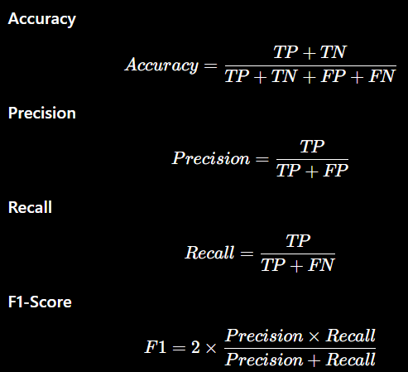
Where:
- TP = True Positive
- TN = True Negative
- FP = False Positive
- FN = False Negative

13. Result Analysis and Interpretation:
The Decision Tree provides an understandable method for loan approval.
The model can identify which attributes are most influential in making the decision. For example, if Credit Score obtains the highest Information Gain, it becomes an important decision attribute.
The model can also generate understandable rules such as:
IF Credit Score = High
AND Repayment History = Good
AND Income = High
THEN Loan = Approved

Another rule may be:
IF Credit Score = Low
AND Repayment History = Poor
THEN Loan = Rejected
Thus, the Decision Tree provides both prediction and interpretability.

14. Limitations:
The proposed system has some limitations:
- Accuracy depends on the quality of the dataset.
- An imbalanced dataset may affect predictions.
- A very deep tree may overfit the training data.
- Changes in economic conditions may affect loan decisions.
- Historical bias in the dataset can affect the model.
- The model may not consider every factor used by human loan officers.

15. Future Enhancements:
The system can be improved by:
- Using a larger real-world dataset.
- Applying hyperparameter tuning.
- Using Random Forest or Gradient Boosting for comparison.
- Performing feature engineering.
- Handling class imbalance.
- Adding explainable AI techniques.
- Deploying the model as a web application.
- Periodically retraining the model using new loan data.

16. Conclusion:
The proposed Smart Loan Approval System uses a Decision Tree classification algorithm to automatically determine whether a customer should be approved or rejected for a loan. Customer information such as income, credit score, employment status, loan amount and repayment history is used as input.
Information Gain can be used to select the most suitable decision attributes. The resulting Decision Tree provides an interpretable classification model that can help banks make faster and more consistent loan decisions.
The model can be evaluated using accuracy, precision, recall and F1-score. With a larger dataset, proper preprocessing and further optimization, the system can be improved for practical deployment.

17. References:

- Quinlan, J. R. (1993). C4.5: Programs for Machine Learning. Morgan Kaufmann. This is a major reference for decision-tree learning and attribute-selection methods.
- Mitchell, T. M. (1997). Machine Learning. McGraw-Hill. Chapter 3 covers Decision Tree Learning and is particularly relevant to your model.
- scikit-learn Developers. Decision Trees — scikit-learn Documentation. This provides the technical documentation for DecisionTreeClassifier, entropy, Gini impurity, tree construction, and evaluation-related implementation.
- scikit-learn Developers. DecisionTreeClassifier Documentation. This documents the DecisionTreeClassifier, including the criterion="entropy" option used in your Python implementation.
- Quinlan, J. R. (1993). C4.5: Programs for Machine Learning, Chapter 2, “Constructing Decision Trees.” This chapter discusses evaluating tests and constructing decision trees using attribute-selection criteria.

Evaluation Rubrics:

Criterion | Weightage (%) | Excellent | Good | Average | Poor
1. Problem  Analysis and  Understanding | 10% | 9–10% – Clearly analyzes the real-world problem, objectives, inputs, outputs, constraints, and expected AI outcome. | 7–8% – Understands the problem and objectives with minor omissions. | 5–6% – Shows  partial understanding with some important elements missing. | 0–4% – Problem is poorly understood or incorrectly defined.
2. Dataset  Selection and  Understanding | 10% | 9–10% – Selects a highly relevant dataset and clearly explains features, target, source, size, and characteristics. | 7–8% – Appropriate dataset with adequate description and minor omissions. | 5–6% – Dataset is usable but description or relevance is limited. | 0–4% – Dataset is inappropriate, poorly described, or missing.
3. Data Preprocessing and Feature Engineering | 10% | 9–10% – Performs appropriate cleaning, transformation, encoding, scaling, feature selection, and data splitting with clear justification. | 7–8% – Performs most required preprocessing correctly with minor issues. | 5–6% – Basic preprocessing is performed but important steps are missing. | 0–4% – Preprocessing is inadequate, incorrect, or absent.
4. AI Technique  Selection and  Justification | 10% | 9–10% – Selects the most appropriate AI technique and provides strong technical justification based on the problem and dataset. | 7–8% – Appropriate technique selected with reasonable justification. | 5–6% – Technique is acceptable but justification is limited. | 0–4% – Inappropriate technique or no meaningful justification.
5. Model Design  / Architecture | 10% | 9–10% – Develops a clear, technically sound model architecture with appropriate components, parameters, and workflow. | 7–8% – Model  is well designed with minor omissions. | 5–6% – Basic model design is presented but lacks technical depth. | 0–4% – Model design is unclear, incomplete, or inappropriate.

6. Algorithm /  Pseudocode | 5% | 5% –  Algorithm/pseudocod e is complete, logically correct, structured, and clearly represents the model development process. | 4% – Mostly correct with minor omissions. | 2–3% – Basic algorithm provided but contains gaps. | 0–1% – Algorithm is missing or substantially incorrect.
7.  Implementation and GitHub Repository | 15% | 13–15% – Fully functional implementation with clean, organized, reproducible code and a complete GitHub repository with  README and  supporting files. | 10–12% – Functional implementatio n and well-organized repository with minor issues. | 7–9% – Partially functional implementation or incomplete repository documentation. | 0–6% –  Implementation is incomplete/non-functi onal or GitHub repository is missing.
8. Experimental  Design and  Results | 10% | 9–10% – Conducts meaningful experiments with appropriate test cases and clearly presents results using tables, graphs, or visualizations. | 7–8% – Appropriate experiments with clearly presented results. | 5–6% – Limited experiments or basic result presentation. | 0–4% – Insufficient, incorrect, or missing experimental results.
9. Performance  Evaluation | 10% | 9–10% – Uses appropriate evaluation metrics and provides comprehensive quantitative analysis of model performance. | 7–8% – Uses suitable metrics and provides adequate evaluation. | 5–6% – Basic evaluation with limited metrics or analysis. | 0–4% – Inappropriate metrics or performance evaluation is missing.
10. Result  Analysis and  Interpretation | 5% | 5% – Provides insightful analysis of results, identifies patterns, errors, strengths, weaknesses, and explains model behavior. | 4% – Provides good interpretation with minor gaps. | 2–3% – Basic interpretation with limited analysis. | 0–1% – Results are not meaningfully analyzed.
11. Limitations and Future  Enhancements | 5% | 5% – Clearly  identifies realistic limitations and proposes technically relevant and feasible improvements. | 4% – Identifies relevant limitations and reasonable improvements. | 2–3% – Provides basic limitations and future suggestions. | 0–1% – Missing, unrealistic, or poorly explained.
12.  Documentation and Technical Presentation | 10% | 9–10% – Report is comprehensive, well organized, technically accurate, professionally presented, and properly referenced. | 7–8% – Well documented with minor presentation or referencing issues. | 5–6% – Adequate documentation with several gaps. | 0–4% – Poorly documented, unclear, or incomplete report.
Total | 100%

