SIMATS ENGINEERING
ASSESSMENT TOOL 2: Industry Problem-Based Assignment
COURSE NAME: ARTIFICIAL INTELLIGENCE COURSE CODE: MLA0104
AND EXPERT SYSTEMS

COURSE OUTCOME COVERED
CO 5: Construct rule-based expert systems using production rules, forward and backward chaining, and by distinguishing procedural and non-procedural paradigms across development stages.(BTL 3)
Assessment Tool Weightage: 40%

Total Marks: 100 Time: 90 Mins
No. of Questions: 1
Annexure A
Industry Problem-Based Assignment

Code of Conduct:
I _K.Nagapreetham(192525242)_ (Name / Reg No) certify that this submission is my original work and that I have adhered to the guidelines specified for this assessment.
I understand that any violation of academic integrity rules will result in disciplinary action. Signature of the student:
Criterion | Weightage | Marks Obtained
1. Problem Analysis and Domain Understanding | 10%
2. Knowledge Acquisition and Knowledge  Representation | 10%
3. Production Rule / Knowledge Base Design | 15%
4. Prolog Implementation and Programming | 15%
5. Forward Chaining Implementation and Demonstration | 10%
6. Backward Chaining Implementation and  Demonstration | 10%
7. Procedural and Non-Procedural Paradigm Analysis | 10%
8. Unification, Backtracking and Inference Accuracy | 10%
9. Testing, Results and System Demonstration | 5%
10. Documentation, GitHub Repository and Technical  Presentation | 5%
Total | 100%
Signature of the Faculty Total Marks Awarded
ANSWER ANY ONE OF THE FOLLOWING

S.No. | Industry Domain | Real-World Problem Statement
1 | Automobile  Industry | A vehicle service center receives customer complaints such as engine overheating, difficulty starting, abnormal noise, low mileage, and warning-light activation. Develop a Prolog-based expert system that identifies probable vehicle faults and recommends appropriate diagnostic actions using production rules and logical inference.
2 | Healthcare | A hospital wants to assist preliminary diagnosis by analyzing symptoms such as fever, cough, breathing difficulty, body pain, and fatigue. Develop a rule-based diagnostic system that identifies possible conditions and explains the reasoning behind its conclusions using Prolog.
3 | Banking | A bank needs an automated loan pre-screening system that evaluates customer income, credit score, employment status, existing loans, and repayment history. Develop a Prolog-based decision-support system that determines loan eligibility and provides reasons for the decision.
4 | Cybersecurity | A Security Operations Center receives events such as repeated failed logins, unusual login locations, privilege escalation, suspicious file access, and abnormal network traffic. Develop an expert system that identifies possible security threats and recommends appropriate actions.
5 | Manufacturing | A manufacturing plant experiences unexpected machine failures. Operators provide observations such as abnormal vibration, excessive temperature, unusual noise, pressure changes, and reduced production speed. Develop a machine-fault diagnosis expert system that identifies probable faults and suggests maintenance actions.
6 | Agriculture | Farmers observe symptoms such as yellow leaves, spots, wilting, poor growth, and pest infestation. Develop a crop-disease advisory expert system that identifies possible diseases based on crop, soil, weather, and visible symptoms and recommends suitable actions.
7 | Telecommunication  s | A telecom provider receives complaints about slow internet, frequent call drops, poor signal strength, and network unavailability. Develop an expert troubleshooting system that identifies probable network problems and recommends troubleshooting steps.
8 | E-Commerce | An online retailer wants to recommend products based on customer preferences, purchase history, budget, product category, and previous interactions. Develop a rule-based recommendation system that generates personalized recommendations and explains why each product was recommended.
9 | Power & Energy | A power distribution company monitors voltage, current, frequency, temperature, and load conditions. Develop an expert system for fault diagnosis that identifies possible overload, voltage instability, equipment failure, or abnormal operating conditions and recommends corrective actions.
10 | Human Resources | An organization wants to identify suitable training programs for employees based on job role, technical skills, performance, experience, and competency gaps. Develop a rule-based employee training recommendation system that recommends appropriate training and explains the reasoning.

Structure of the Report:

S.No. | Report Section | Expected Content
1 | Title, Abstract & Introduction | Project title, brief abstract, industry background, problem context, and importance of the selected problem.
2 | Problem Statement &  Objectives | Clearly define the real-world industry problem, inputs, expected outputs, stakeholders, and specific objectives.
3 | Domain Analysis &  Knowledge Acquisition | Identify entities, facts, conditions, decisions, and explain how domain knowledge was collected from reliable sources.
4 | Knowledge Representation &  Production Rules | Represent domain knowledge using Prolog facts, predicates, and production rules.
5 | Expert System Architecture | Provide and explain the architecture showing the user, knowledge base, inference engine, and output/explanation module.
6 | Inference Mechanism &  Algorithms | Explain and demonstrate forward chaining, backward chaining, unification, and backtracking with suitable algorithms/pseudocode.
7 | Prolog Implementation | Describe the SWI-Prolog implementation, important predicates/rules, queries, and provide the GitHub repository link.
8 | Test Cases & Results | Provide minimum 5 industry-based test cases, queries, expected outputs, actual outputs, and inference traces.
9 | Analysis, Limitations &  Future Enhancements | Analyze system effectiveness and reasoning accuracy; discuss limitations and propose future improvements.
10 | Conclusion & References | Summarize the developed expert system, major findings, industry relevance, and provide properly formatted references.

Prolog-Based Cybersecurity Threat Detection and Response Expert System

Abstract:
The proposed system is a Prolog-based cybersecurity expert system designed to identify possible security threats from observed security events. The system uses facts and production rules to analyze events such as repeated failed logins, unusual login locations, privilege escalation, suspicious file access, and abnormal network traffic.
The system uses logical inference to identify possible threats and recommend suitable actions. Forward chaining is used to derive conclusions from known facts, while backward chaining is used to verify specific security goals. Prolog features such as unification and backtracking support the reasoning process.
The system can assist Security Operations Center analysts by providing consistent rule-based threat identification and recommendations.

Introduction:
Cybersecurity systems continuously receive large amounts of security-related information. Security analysts need to identify suspicious activities and determine appropriate responses.
Common security events include:
- Repeated failed login attempts
- Unusual login locations
- Privilege escalation
- Suspicious file access
- Abnormal network traffic
The assignment problem specifically asks for an expert system that can identify possible security threats from these events and recommend appropriate actions.
A rule-based expert system is suitable because cybersecurity knowledge can be represented using facts and IF–THEN style production rules.

Problem Statement:
A Security Operations Center receives different security events from users, systems and networks. Manually analyzing every event can be time-consuming.
Therefore, a Prolog-based expert system is developed to:
- Accept security events as input.
- Store cybersecurity knowledge as facts.
- Apply production rules.
- Identify possible threats.
- Recommend appropriate security actions.
- Explain the reasoning behind the conclusion.

Objectives:
The main objectives are:
- To develop a cybersecurity expert system using Prolog.
- To represent cybersecurity knowledge using facts and rules.
- To identify possible security threats.
- To implement forward chaining.
- To implement backward chaining.
- To demonstrate unification and backtracking.
- To recommend appropriate security actions.
- To test the system using at least five cybersecurity scenarios.

Domain Analysis:
Input:
The system considers the following security events:
Input Event | Meaning
Failed logins | Multiple unsuccessful login attempts
Unusual location | Login from an unexpected location
Privilege escalation | User obtains higher privileges
Suspicious file access | Unusual or unauthorized file access
Abnormal network traffic | Unusual network communication
Possible Threats
- Brute-force attack
- Account compromise
- Privilege abuse
- Suspicious activity
- Network attack
Output:
The system produces:
Threat → Reason → Recommended Action

Knowledge Representation:
The knowledge base consists of:

Facts:
Facts represent information that is already known.
Example:
failed_logins(user1, 5).
unusual_location(user1).
privilege_escalation(user1).
suspicious_file_access(user1).

failed_logins(user2, 2).
abnormal_network_traffic(user2).

Rules:
Rules represent relationships between facts and conclusions.
For example:
threat(User, brute_force_attack) :-
failed_logins(User, Count),
Count >= 5.
This means:
IF a user has 5 or more failed login attempts
THEN the system identifies a possible brute-force attack.

Production Rules:
Use these rules in your Prolog program:
% Rule 1: Brute-force attack
threat(User, brute_force_attack) :-
failed_logins(User, Count),
Count >= 5.

% Rule 2: Account compromise
threat(User, account_compromise) :-
unusual_location(User),
failed_logins(User, Count),
Count >= 3.

% Rule 3: Privilege abuse
threat(User, privilege_abuse) :-
privilege_escalation(User).

% Rule 4: Suspicious activity
threat(User, suspicious_activity) :-
suspicious_file_access(User).

% Rule 5: Network attack
threat(User, network_attack) :-
abnormal_network_traffic(User).

Recommended Actions:
Add the following rules:
action(brute_force_attack,
'Block the account and investigate repeated login attempts.').

action(account_compromise,
'Verify user identity and reset account credentials.').

action(privilege_abuse,
'Review privileges and investigate unauthorized privilege escalation.').

action(suspicious_activity,
'Investigate suspicious file access and check the affected system.').

action(network_attack,
'Monitor network traffic and investigate the affected system.').

Main Expert-System Predicate:
Create a predicate that connects the threat and recommendation:
security_check(User, Threat, Action) :-
threat(User, Threat),
action(Threat, Action).
Now you can ask Prolog:
?- security_check(user1, Threat, Action).

Expert System Architecture:
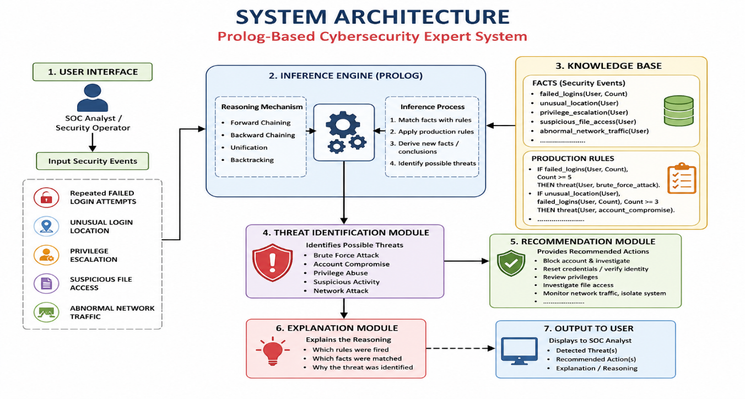

Forward Chaining:
Definition
Forward chaining starts with known facts and applies rules to derive new conclusions.

Example
Suppose:
failed_logins(user1, 5).
The system checks:
IF failed login count >= 5
THEN brute-force attack
Therefore:
failed_logins(user1,5)
↓
Rule is satisfied
↓
brute_force_attack
↓
Block account and investigate
Simple Algorithm
1. Start with known facts.
2. Check applicable rules.
3. Apply a matching rule.
4. Generate a new conclusion.
5. Continue until no new conclusion is produced.
6. Display the final result.

Backward Chaining:
Backward chaining starts with a goal and searches for facts that can prove that goal.
Example:
?- threat(user1, brute_force_attack).
Prolog starts with:
Goal:
brute_force_attack(user1)
Then checks the rule:
failed_logins(User, Count),
Count >= 5
It searches for:
failed_logins(user1, Count)
It finds:
failed_logins(user1, 5)
Then:
5 >= 5
is true.
Therefore:
brute_force_attack(user1)
is concluded.

Unification:
Unification is the process of matching variables with values so that two expressions become compatible.
Example:
failed_logins(User, Count)
matches:
failed_logins(user1, 5)
Therefore:
User = user1
Count = 5
This allows Prolog to apply the appropriate rule.

Backtracking:
Prolog uses backtracking when it needs to search for alternative solutions.
For example, user1 may have several security events:
5 failed logins
Unusual location
Privilege escalation
Suspicious file access
The system can therefore find more than one applicable threat.
Backtracking allows Prolog to return to previous decision points and search for other matching rules.

Complete Prolog Program:
Put this into a file named:
cybersecurity_expert.pl
% ==========================================
% CYBERSECURITY EXPERT SYSTEM
% ==========================================

% ----------- FACTS -----------

failed_logins(user1, 5).
unusual_location(user1).
privilege_escalation(user1).
suspicious_file_access(user1).

failed_logins(user2, 2).
abnormal_network_traffic(user2).

failed_logins(user3, 4).
unusual_location(user3).

privilege_escalation(user4).

suspicious_file_access(user5).

abnormal_network_traffic(user6).

% ----------- THREAT RULES -----------

% Brute-force attack
threat(User, brute_force_attack) :-
failed_logins(User, Count),
Count >= 5.

% Account compromise
threat(User, account_compromise) :-
unusual_location(User),
failed_logins(User, Count),
Count >= 3.

% Privilege abuse
threat(User, privilege_abuse) :-
privilege_escalation(User).

% Suspicious activity
threat(User, suspicious_activity) :-
suspicious_file_access(User).

% Network attack
threat(User, network_attack) :-
abnormal_network_traffic(User).

% ----------- ACTION RULES -----------

action(brute_force_attack,
'Block the account and investigate repeated login attempts.').

action(account_compromise,
'Verify user identity and reset account credentials.').

action(privilege_abuse,
'Review privileges and investigate unauthorized privilege escalation.').

action(suspicious_activity,
'Investigate suspicious file access and check the affected system.').

action(network_attack,
'Monitor network traffic and investigate the affected system.').

% ----------- MAIN SYSTEM -----------

security_check(User, Threat, Action) :-
threat(User, Threat),
action(Threat, Action).

Five Test Cases:
The PDF requires a minimum of five industry-based test cases with queries, expected outputs, actual outputs and inference traces.
Test Case 1 — Brute Force
Query:
?- security_check(user1, Threat, Action).
Expected: Brute-force attack.
Reason: user1 has 5 failed login attempts.

Test Case 2 — Account Compromise
Query:
?- threat(user3, Threat).
Expected:
Threat = account_compromise
Reason: user3 has an unusual login location and 4 failed login attempts.

Test Case 3 — Privilege Abuse
Query:
?- threat(user4, Threat).
Expected:
Threat = privilege_abuse
Reason: Privilege escalation was detected.

Test Case 4 — Suspicious Activity
Query:
?- threat(user5, Threat).
Expected:
Threat = suspicious_activity
Reason: Suspicious file access was detected.

Test Case 5 — Network Attack
Query:
?- threat(user6, Threat).
Expected:
Threat = network_attack
Reason: Abnormal network traffic was detected.

Results and Analysis:
The expert system successfully maps cybersecurity events to probable threats using predefined production rules.
For example:
User | Observed Event | Detected Threat | Action
User1 | 5 failed logins | Brute-force attack | Block account
User3 | Unusual location + failed logins | Account compromise | Verify identity
User4 | Privilege escalation | Privilege abuse | Review privileges
User5 | Suspicious file access | Suspicious activity | Investigate system
User6 | Abnormal network traffic | Network attack | Monitor traffic
The results demonstrate that the rule-based approach can provide consistent conclusions for predefined cybersecurity scenarios.

Limitations:
You can mention:
- The system depends on predefined rules.
- New attack types require new rules.
- It does not automatically learn from new attack data.
- Real-world cybersecurity events can be more complex than the defined scenarios.
- Incorrect or incomplete facts can produce incorrect conclusions.

Future Enhancements:
Possible improvements include:
- Integration with real-time security logs.
- Integration with SIEM systems.
- Addition of machine-learning-based anomaly detection.
- Automatic alert generation.
- Larger cybersecurity knowledge base.
- Real-time monitoring dashboard.
- Integration with network intrusion detection systems.

Conclusion:
The developed Prolog-based cybersecurity expert system demonstrates how artificial intelligence and logical reasoning can be applied to cybersecurity threat detection. The system represents security knowledge through facts and production rules and uses Prolog's inference mechanism to identify possible threats.
Forward chaining demonstrates how conclusions can be derived from known security events, while backward chaining verifies specific threat hypotheses. Unification and backtracking enable Prolog to match facts and explore alternative solutions.
The system provides a simple decision-support mechanism for Security Operations Centers by identifying probable threats and recommending appropriate actions.

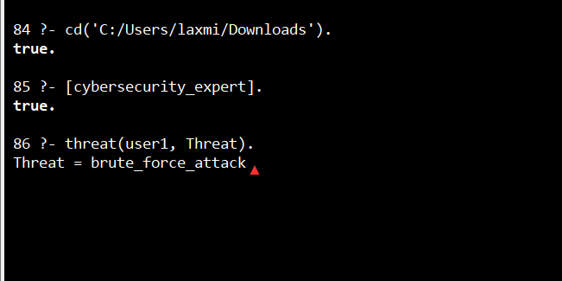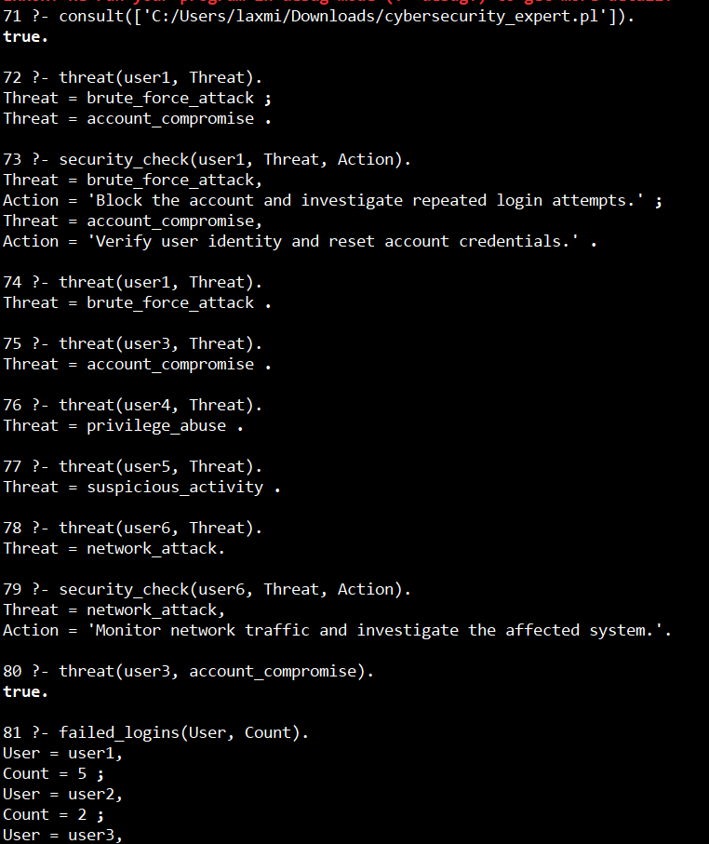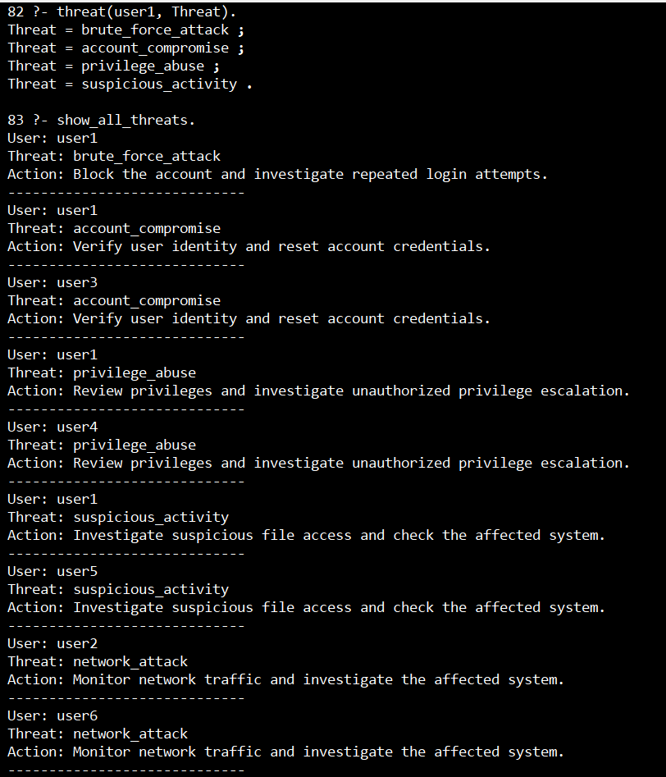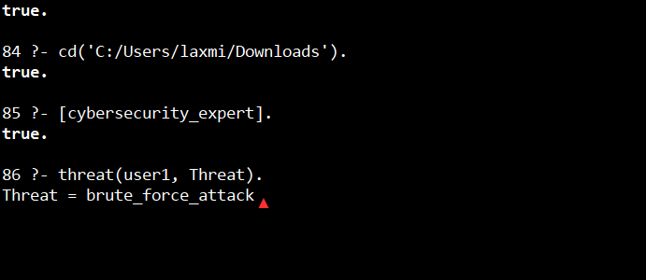

EVALUATION RUBRICS:

Criterion | Weightage  (%) | Excellent | Good | Average | Poor
1. Industry  Problem  Analysis and  Understanding | 10% | 9–10% – Clearly identifies a relevant real-world industry problem, stakeholders, constraints, inputs, and expected decisions. | 7–8% – Good understanding with minor omissions. | 5–6% – Basic understanding with limited analysis. | 0–4% – Problem  is unclear, inappropriate, or poorly analyzed.
2. Domain  Knowledge and  Knowledge  Acquisition | 10% | 9–10% – Acquires comprehensive and reliable domain knowledge and  identifies relevant facts, entities, and relationships. | 7–8% –  Relevant knowledge is acquired with minor gaps. | 5–6% – Basic domain knowledge with limited sources. | 0–4% –  Insufficient, unreliable, or inappropriate domain knowledge.
3. Knowledge Representation and Production  Rules | 15% | 13–15% – Develops a complete, consistent, and well-structured Prolog knowledge base with appropriate facts, predicates, and production rules. | 10–12% – Well-designed knowledge base with minor omissions or inconsistencie  s. | 7–9% – Basic knowledge base with several missing or unclear rules. | 0–6% –  Incomplete, inconsistent, or inappropriate knowledge representation.
4. Forward and  Backward  Chaining | 15% | 13–15% – Correctly implements and clearly demonstrates both forward and backward chaining with appropriate industry scenarios and reasoning traces. | 10–12% – Both mechanisms  are demonstrated with minor limitations. | 7–9% – Basic implementation with incomplete demonstration. | 0–6% – Chaining mechanisms are missing or incorrectly implemented.
5. Prolog Implementation and Inference | 15% | 13–15% – Effectively uses Prolog facts, rules, predicates, unification, backtracking, and inference to generate accurate conclusions. | 10–12% – Functional implementatio n with minor technical issues. | 7–9% – Basic implementation with limited use of Prolog features. | 0–6% –  Implementation is incomplete, incorrect, or non-functional.
6.  Industry-Based  Test Cases and  Results | 10% | 9–10% – Provides  diverse and realistic test cases with accurate queries, outputs, and detailed inference | 7–8% – Provides relevant test cases with mostly | 5–6% – Limited test cases and basic results. | 0–4% –  Insufficient or inappropriate testing.
 |  | traces. | accurate results.
7. Analysis and Interpretation of Results | 10% | 9–10% – Provides insightful analysis of reasoning accuracy, consistency, rule coverage, and practical industry usefulness. | 7–8% – Good analysis with minor gaps. | 5–6% – Basic analysis with limited interpretation. | 0–4% – Results are poorly analyzed or not interpreted.
8. Procedural and  Non-Procedural  Paradigm  Understanding | 5% | 5% – Clearly explains and demonstrates the distinction between procedural and declarative/non-procedu ral approaches in the developed system. | 4% – Good conceptual distinction with minor gaps. | 2–3% – Basic understanding but limited application. | 0–1% – Incorrect or missing explanation.
9.  Documentation  , GitHub and  Technical  Presentation | 5% | 5% – Complete, well-organized report and GitHub repository with clear code, documentation, references, and professional presentation. | 4% – Good documentatio n and repository with minor issues. | 2–3% – Basic documentation with some missing components. | 0–1% – Poor documentation or missing GitHub repository.
10. Limitations,  Future  Enhancements and Conclusion | 5% | 5% – Clearly identifies practical limitations and proposes realistic, technically relevant future enhancements. | 4% –  Identifies relevant limitations and improvements  . | 2–3% – Basic discussion of limitations and future scope. | 0–1% –  Discussion is missing or unrealistic.
Total | 100%

