Bank Term Deposit Prediction
This report summarizes a binary classification workflow for predicting whether a bank customer subscribes to a term deposit.

Dataset
Training data: bank-full.csv. The pipeline uses a stratified holdout test set (80/20) and fits preprocessing only on the training partition.

Model Comparison
model | accuracy | precision | recall | f1 | roc_auc
random_forest | 0.9042 | 0.5844 | 0.6285 | 0.6056 | 0.9305
logistic_regression | 0.8457 | 0.4182 | 0.8147 | 0.5527 | 0.9079

Selected Model Test Results
Class | Precision | Recall | F1-score
0 | 0.9503 | 0.9408 | 0.9455
1 | 0.5844 | 0.6285 | 0.6056
macro avg | 0.7673 | 0.7847 | 0.7756
weighted avg | 0.9075 | 0.9042 | 0.9057

Visualizations

Target Class Distribution
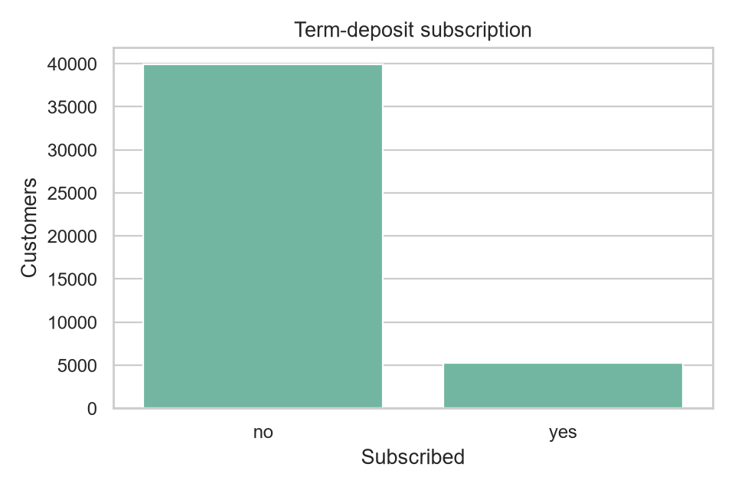

Age vs Subscription
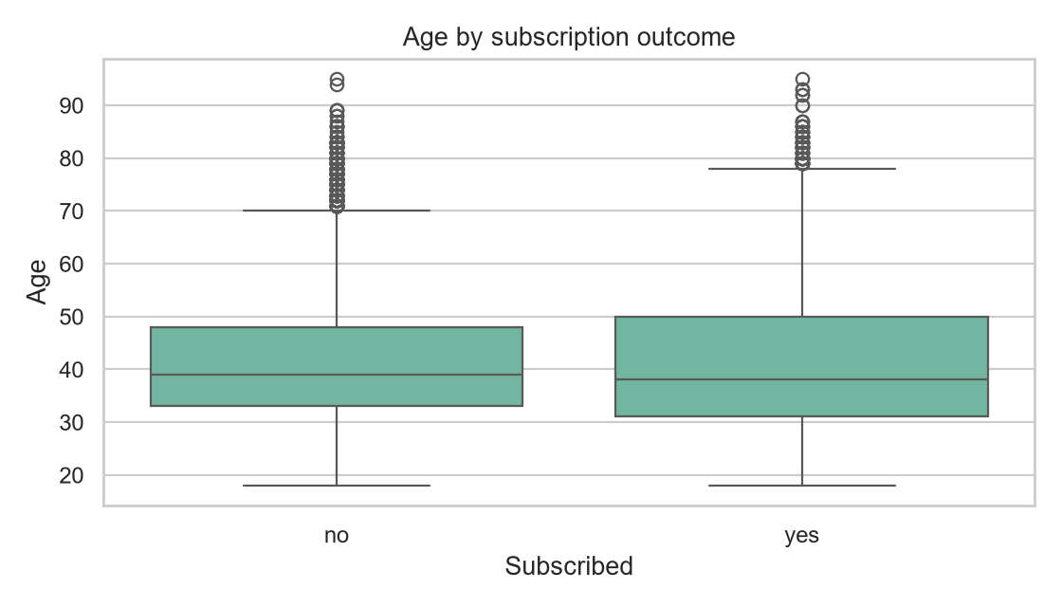

Subscription Rate by Job
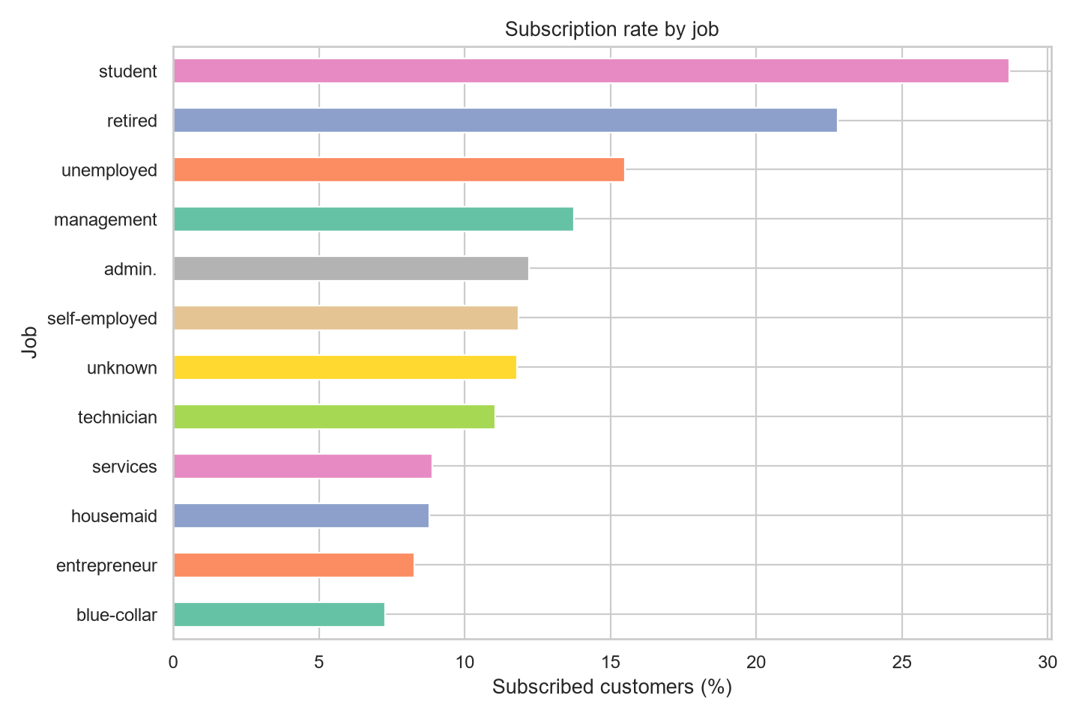

Confusion Matrix
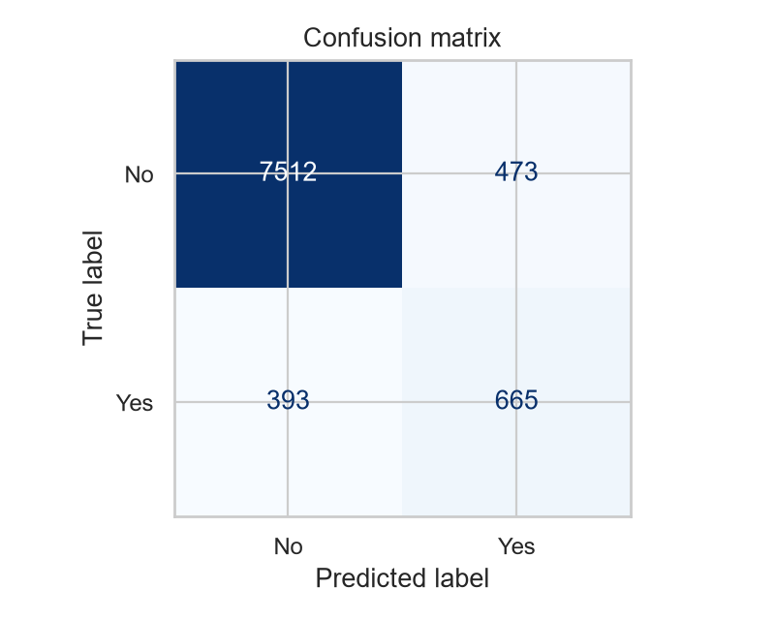

Top Feature Importance
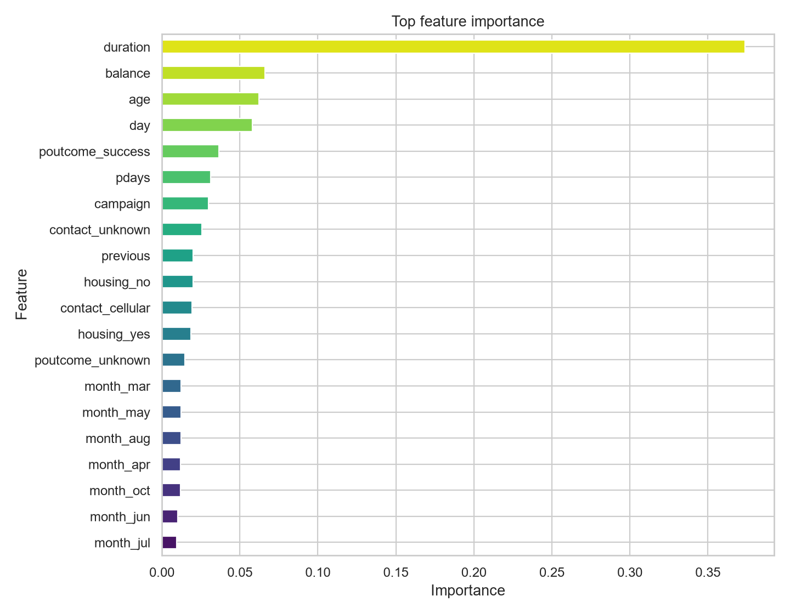

Key Considerations
Note: the campaign-duration feature is included when present in the supplied data. It is only known after a call, so exclude it for pre-call predictions to avoid target leakage.

