**RV COLLEGE OF ENGINEERING   
Bengaluru-560 059**

**REPORT ON**

**EXPERIENTIAL LEARNING / PROJECT BASED LEARNING**

**ACY 2023-24**

**THEME**

*ENERGY*

**Title of the Project**

POWER GENERATION FROM TIDAL/WATER MOTION

**Students Group**

|  |  |  |  |
| --- | --- | --- | --- |
| **SL. No.** | **USN** | **Name** | **Prog.** |
| **1** | **1RV23ET042** | **SHIVEN SINGH** | **ETE** |
| **2** | **1RV23ET030** | **PREETHAM V** | **ETE** |
| **3** | **1RV23IS081** | **PARTHIV PRATIM M** | **ISE** |
| **4** | **1RV23IS108** | **SATHWIK PAI** | **ISE** |

**Project Evaluators**

|  |  |
| --- | --- |
| **SL. No.** | **Name of the Evaluators (Enter the Names in Capitals)** |
|  | **DR GIRISH KUMAR R** |
|  | **DR NIRANJANA K M** |
|  | **DR SOUMYA .A** |
|  | **PROF PRIYA T V** |

**Table of Contents**

|  |  |  |
| --- | --- | --- |
| **S.No.** | **Topic** | **Page No.** |
| **1** | **Introduction** | **1** |
| **2** | **Problem Definition** | **3** |
| **3** | **Objectives** | **3** |
| **4** | **Methodology** | **4** |
| **5** | **Project Execution** | **5** |
| **6** | **Tools and Technique used** | **6** |
| **7** | **Results and Discussion** | **7** |
| **8** | **Prototype** | **8** |
| **9** | **Conclusion** | **9** |

**INTRODUCTION:**

Our project is dedicated to harnessing the immense power of ocean tides through advanced magnetic induction technology to generate clean and renewable electricity. The core idea is to capitalize on the natural, predictable motion of tidal currents, which offer a consistent and reliable source of kinetic energy. By deploying innovative electromagnetic generators, we aim to efficiently convert this kinetic energy into electrical power.

The technology at the heart of our project relies on electromagnetic induction, a principle where a changing magnetic field induces an electric current in a conductor. Our generators are designed to be placed in locations with strong tidal currents, where the movement of water will drive the motion of magnetic components within the generators. As the tides ebb and flow, these components move in a manner that continuously changes the magnetic field, thus inducing an electric current.

One of the key advantages of using magnetic induction technology in tidal energy generation is its efficiency and robustness. Unlike traditional tidal power systems that rely on mechanical components like turbines, electromagnetic generators can be more resilient to the harsh marine environment, reducing maintenance costs and increasing operational longevity. Moreover, the absence of large moving parts minimizes the risk of disrupting marine life, making this approach more environmentally friendly.

Our project aims to create a scalable and adaptable solution for tidal energy generation. By tapping into the abundant and predictable energy provided by tidal movements, we seek to develop a sustainable energy source that can be integrated into the existing power grid. This integration not only helps in reducing dependence on fossil fuels but also contributes to a diversified energy portfolio, enhancing energy security.

**PROBLEM STATEMENT**

This project focuses on optimizing a wave power generator with buoyant tube connected to a magnet. Key challenges include improving efficiency, ensuring reliable performance in varied wave conditions, enhancing durability, and reducing costs. The goal is to create a more efficient, reliable, and economically viable wave energy solution.

**OBJECTIVES**

To design and optimize a tidal energy harvesting system that efficiently converts tidal energy into electrical power, with a focus on maximizing energy output, minimizing environmental impact, and ensuring cost-effectiveness.

Our objective is to efficiently generate clean, renewable electricity by harnessing tidal currents through advanced magnetic induction technology, contributing to sustainable energy solutions while minimizing environmental impact and promoting energy independence for coastal communities.

**METHODOLOGY**

We used the following two methods for generating electricity from tidal energy:

1)Coil Suspension

2)Underwater Coil

**Coil Suspension**

At one end of the tank, a handle moves up and down to create water waves. The wave power generator consists of one buoyant tube connected to a magnet. The coil is suspended via a wires, such that the magnets pass through the centre of the coil. Waves cause a disturbance, making the buoyant tube move causing the magnets to move within the coil and generate electricity. A meter displays the voltage.

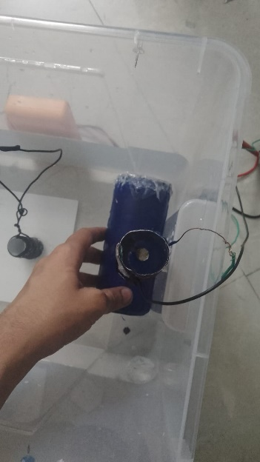

**Underwater Coil**

In this method we use an insulated coil which is kept underwater and is stuck to the container. A buoyant device hosts the magnets, the magnets are submerged in water such that they pass through the centre of the coil. The waves cause a disturbance, hence the magnets attached to the buoyant move up and down causing a change in the magnetic flux which causes current at the coil which is shown with the help of a multi-meter. The pictures attached in the next slide will provide a better understanding.

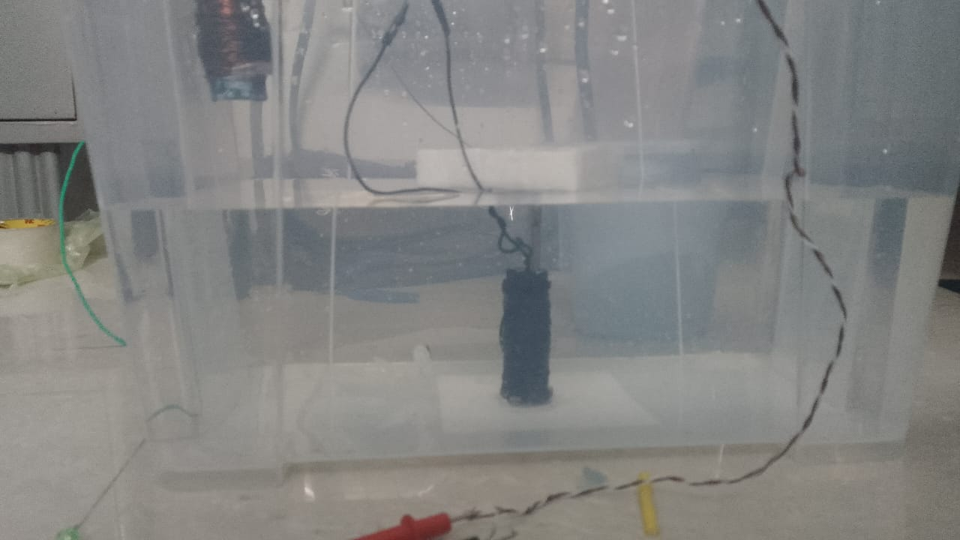

**PROJECT EXECUTION**

The project was planned in a way such that it fulfils the main purpose of efficiently generating clean, renewable electricity by harnessing tidal currents through advanced magnetic induction technology.

We came with ideas of coil suspension for deep waters and underwater coil for shallow waters. Our prototype was designed not only for oceans but also for streams, channels and isolated water bodies. The disturbance in the water bodies would facilitate the movement of magnets into the coil, producing an output voltage. Our aim was to work on a simple and small model, which can lay a foundation and provide future scope of research and investigation

**TOOLS AND TECHNIQUES USED**

1.CUBOID PLASTIC CONTAINER

2. LEDS

3.COPPER COIL

4.STRONG MAGNETS

5.WAVEMAKER

6.CAN AND BOTTLE

7.WATER

8.MOTOR

9.FLOATATION DEVICE

10.ANCHOR

11.COPPER WIRE

**RESULTS AND DISCUSSION**

We were successfully able to generate 5-8mA of current using a small prototype. Moreover, we learnt the practical application of electromagnetic induction and how to integrate it with power generation from tidal motion. We were also able to explore tidal energy harvesting which has immense potential to be a reliable as well as renewable source of energy. Our mentors recommended us to provide a source of battery as well as a method of rectifying the varying current using bridge rectifier and smoothing capacitor. We were also asked to improve the flux change in our coil rather than concentrating on strength of field due to the magnet.

**PROTOTYPE**



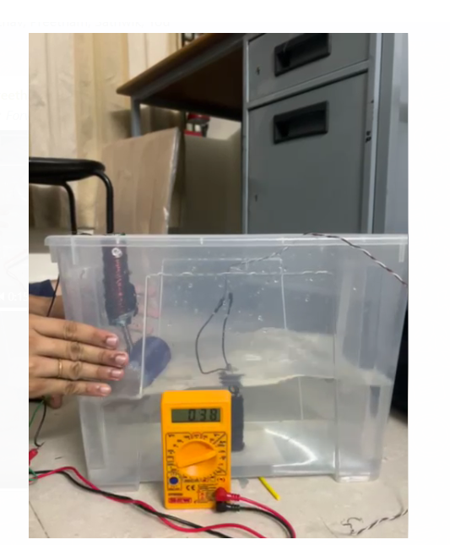

**CONCLUSION**

In conclusion, our project aims to revolutionize renewable energy generation by leveraging the predictable and abundant power of ocean tides through magnetic induction technology. This innovative approach promises to deliver efficient, sustainable, and environmentally friendly electricity. By tapping into the natural motion of tidal currents, we can convert kinetic energy into electrical power with minimal environmental impact, preserving marine ecosystems.

Our technology's efficiency and resilience ensure a robust and reliable energy source, reducing maintenance costs and operational disruptions. This project not only supports the global shift towards greener energy solutions but also enhances energy security and independence for coastal regions. By providing a scalable and adaptable solution, we contribute to a diversified energy portfolio, mitigating reliance on fossil fuels and promoting long-term sustainability.