**John Paul Garcia**

**Preetham Wilfred John**

**Big Data Analytics**

**Assignment Number: 1**

**Dr. Boetticher**

**Ms. Rekha Sampangiramaiah**

**Question 4:**

**Dataset: dblp-ref-3.json**

**Python Files:**

**topInfluentialPaperMapper.py**

**topInfluentialPaperReducer.py**

**Running the script through Hadoop:**

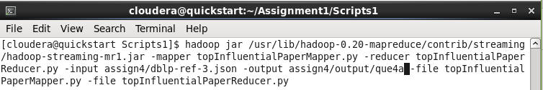

**Output:**

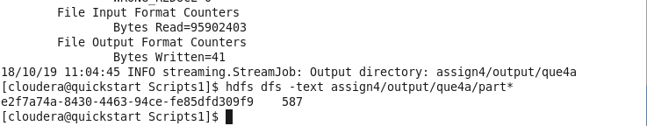

**Question 5:**

**Dataset: dblp-ref-3.json**

**Python Files:**

**top5InfluentialPaperMapper.py**

**top5InfluentialPaperReducer.py**

**Running the script through Hadoop:**

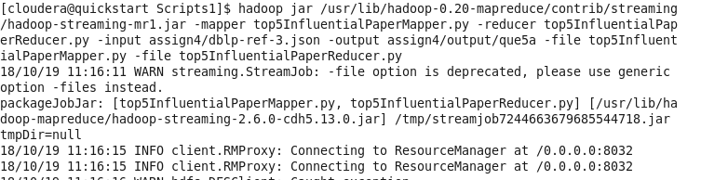

**Output:**

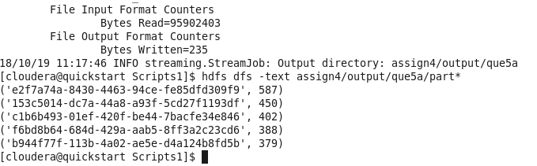

**Question 6:**

**Dataset: dblp-ref-3.json**

**Python Files:**

**authorsPaperMapper.py**

**authorsPaperReducer.py**

**Running the script through Hadoop:**

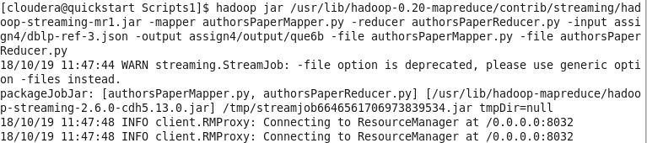

**Output:**

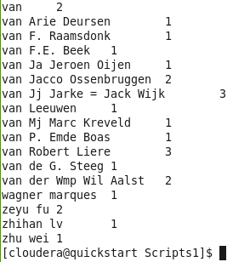

**Question 7:**

**Dataset: dblp-ref-3.json**

**Python Files:**

**top5InfluentialAuthorMapper.py**

**top5InfluentialAuthorReducer.py**

**Running the script through Hadoop:**

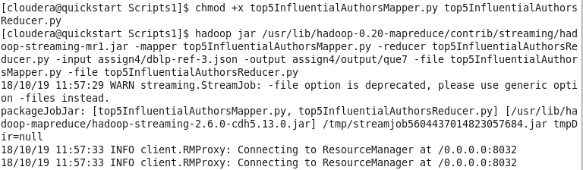

**Output:**

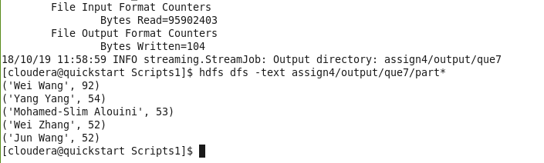

**Question 8:**

**Dataset: dblp-ref-veryshort.json**

**Creating Inputs for the MapReduce by running the files below and downloading to local and uploading to HDFS under a single directory**

**authorMapper.py**

**authorReducer.py**

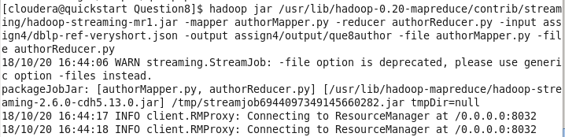

**Copying output:**

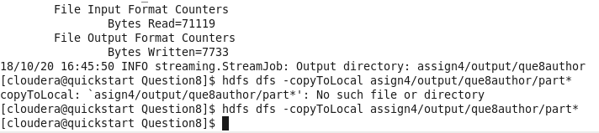

**paperMapper.py**

**paperReducer.py**

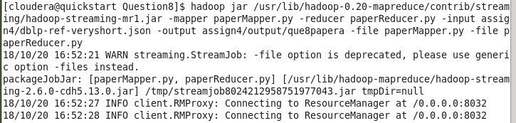

**Copying Output:**

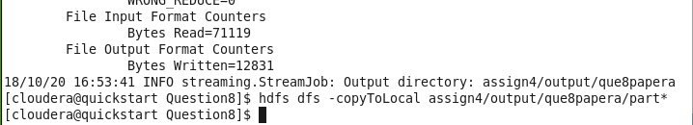

**Loading to HDFS:**



**Running the Join program to combine both the results generated in previous steps.**

**joinMapper.py**

**joinReducer.py**

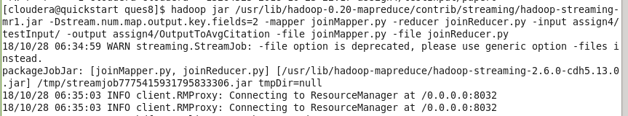

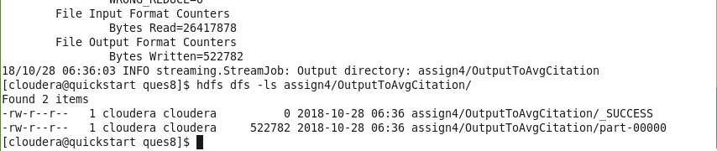

**Copying Output and loading to HDFS:**

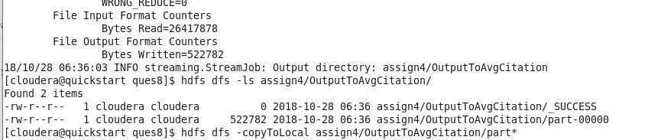

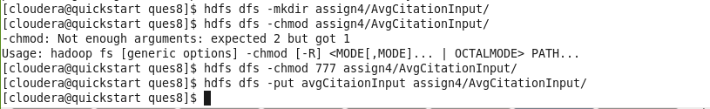

**Running the final programs by providing the input as the above path where the joined file is stored**

**authorAvgCitationMapper.py**

**authorAvgCitationReducer.py**

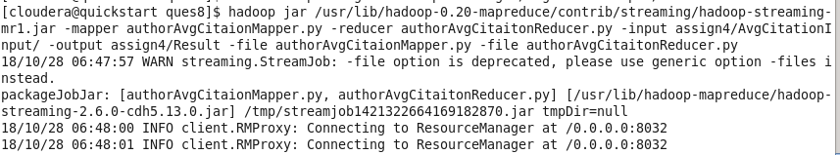

**Output:**

