Step 1: Compile the johnP2Service program using rmic from command prompt to generate the stub.

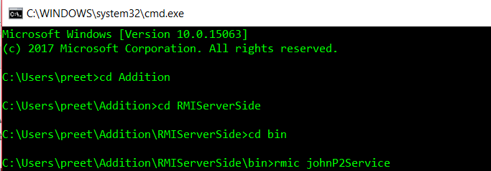

Step 2: Start the RMI Registry

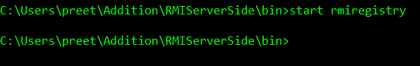

Step 3: Compile and run CourseValue.java which will display the following output.

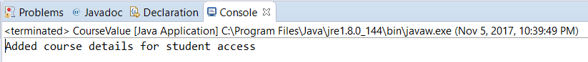

Step 4: Compile and run Server.java

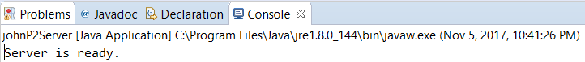

Step 5: Compile and run the client program.

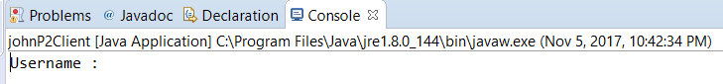

Step 6: Enter the Client user name and password  
Client: username is aos and password as project2

Upon successful validation list of courses will be displayed.

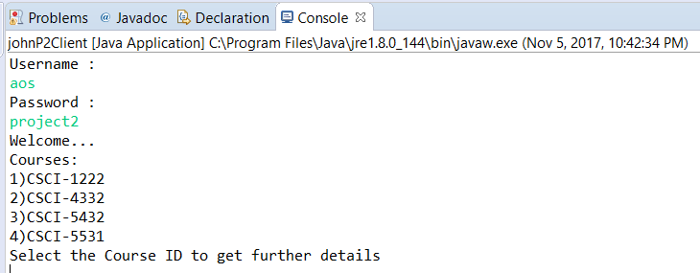

Step 7: Choose the course to get more details

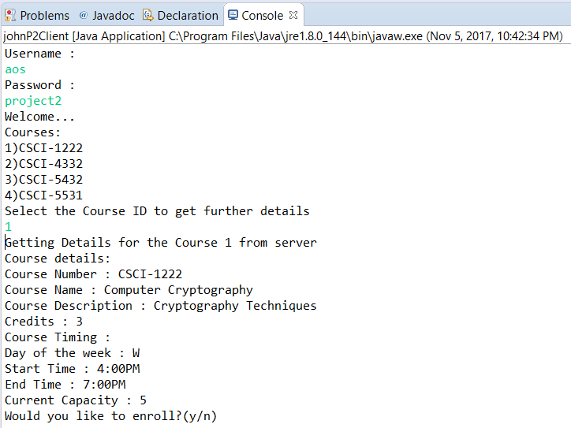

Step 8: Enter y to enroll and n to check details of other courses

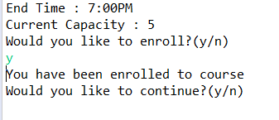

Step 9: To continue enrolling for other courses type y else n to go to next section

Step 10: If you chose n next it will ask if you want to drop courses.

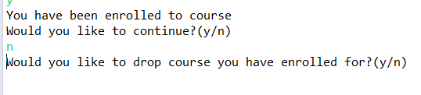

Step 11: If chosen y then enter the course name to drop. For example: “CSCI-1222”

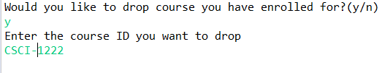  
Step 12: Course will be dropped and will be asked for dropping other courses enrolled.

